Supplementay Information
Migratory passerines share localized movement strategies but differ in activity timing and habitat use during post-breeding stopover

Methods
Study site
The study took place on the Island of Montreal, Quebec within the boundaries of Canada’s second largest city (~3.75 million people). On the western tip of the island (45.43◦N, 73.94◦W) a large peri-urban green space hosts a banding station, the McGill Bird Observatory (MBO). The station itself is in a limited access greens pace dedicated to research that is characterized by a mix of shrubland, mature deciduous forests, hawthorn tracts, suman stands, small wetlands, and an old apple orchard [1]. Surrounding the area are agricultural fields managed by McGill University, two nature reserves (Morgan Arboretum and Bois-de-la-Roche Park) open for recreational purposes to the public, and further afield are suburban housing development, industrial parks, and two highly used highways. The MBO has been part of the Canadian Migration Monitoring Network (CMMN) since 2005, with standardized monitoring during the spring and fall migration since that time, except for closure during the spring of 2020 due to the Covid-19 pandemic. The site has been actively studying migration using radio-telemetry technology since 2017, and has been identified as an important stopover site for several migratory birds [2], including neotropical moult migrants [3–6].

Banding and telemetry tracking
Birds were captured using 30 mm mist nets and banded with numbered aluminum leg bands. Tags were attached to each bird using a figure eight leg-loop harness made from nylon-elastic thread (Rappole and Tipton 1991). Standard banding measurements were taken, including: sex, age based on plumage and skull ossification, mass, fat, and wing chord length. Birds were identified, aged, and sexed by experienced banders, consistent with Pyle et al. (1997). As moult migrants are known to occur on site (Junda et al. 2020), we excluded from this study any birds that were actively moulting. Birds were banded under Animal Use Protocol 2007-5447 from McGill University and federal banding permits 10743B and 10743T issued by the Canadian Wildlife Service, and radio-tagged under Animal Use Protocol 22BF01 and 23BF01 from Environment and Climate Change Canada.
Tag burst rate varied among the species, ranging from ~ 4.3 s for Hermit Thrush to ~ 14.9 s for Magnolia Warblers. Longer burst intervals were set for smaller birds because they were constrained to smaller tags with shorter battery lives. Tags were detected by an array of permanent and ‘pop-up’ Motus automated telemetry towers, including at the MBO (45.4307◦N, −73.9385◦W), at the McGill University Macdonald Campus (45.4079◦N, −73.939◦W), at the Bois-de-la-Roche nature park (45.4403◦N, −73.9407◦W), and in a suburban area to the south of the study site (45.4109◦N, −73.9301◦W). While detections at the towers allowed us to identify bird departures from the site and (when detected) provided some information of bird movements and general locations (i.e., which antenna direction of strongest signal), they did not provide robust location data. For this we used daily manual tracking starting the day after the bird’s initial capture and tagging, until the bird was confirmed to have departed from the site or was not detected either by the towers or through manual tracking for > 5 days. Using a 3-element Yagi and a receiver (Lotek SRX 800 or Lotek SRX 1200) tagged birds were tracked and their daily locations were recorded as a GPS point when the signal was at least 130 dB (Lotek SRX 800) or 200 dB (Lotek SRX 1200) at a gain (precision) between 9 and 40 dB.
Stopover durations from tracking data
Stopover durations for telemetry tracked birds were quantified using departure dates and times collected from the four Motus wildlife tracking towers described above. We considered migratory departure to occur when a rapid increase in signal strength from all antennas from one of the towers to which the tagged bird was closest to (typically the MBO tower) was followed by a decrease in signal strength until it disappeared (Packmor et al. 2020). In most cases (110/113) we were able to detect a similar change in signal from one or more of the local towers as the birds migrated southwest. Individuals who departed before 19:00 were excluded from the analyses as nocturnal migrants generally depart after sunset (Cooper et al. 2023a). Departure night was considered as the last night a bird was detected at the stopover landscape prior to a confirmed departure from the Motus data. Stopover length was calculated as the departure night – capture day + 1, providing the minimum duration of the stopover bout (Dossman et al. 2016)
Fuel load calculations
We calculated body mass variables for all birds of the five target species captured and banded on site from 2004 – 2023, including those tagged and tracked with Motus tags. For each bird we estimated lean body mass (LBM; Owen and Moore 2006) by fitting a species-specific regression of body mass on wing length for all birds with a fat score of 0 (no measurable fat). Fuel load (FL) was then quantified for each individual as the difference between the measured body mass at time of capture, minus the estimated LBM for the species, divided by the LBM, and multiplied by 100 to obtain a percentage [8].
Change point activity analysis
Change points were extracted for each day a bird was at stopover at MBO by first de-trending values of signal strength (sig) by taking the first differences (d_{i} = sig_{i} - sig_{i-1}, for observation i) for each antenna on the MBO Motus station. Values of d among all antennas were then pooled and sorted by timestamp, after which the square-root of the absolute value of d (sqrt(|d|)) was calculated. This process reduces the major difference in sig among the receiver antennas as well as any change in signal strength over time that are likely the result of longer movements made by tagged birds at the study site. Square root transformation emphasises the difference in the mean and variance of sig between activity states [9], further demarcating the change in activity pattern.
Using separate automated process for the onset and end of activity, we first filtered any onset or end periods with fewer than 800 detections total to exclude periods with poor signal coverage. The function cpt.meanvar was then used to extract a single change point time (cpt) in the mean and variance of sqrt(|d|) within the six-hour period, specifying an asymptotic penalty value of 0.001 and a minimum segment length of 20. These parameters performed well to reliably identify the transition between activity states. For most change points, mean sqrt(|d|) was < 1 before the cpt and > 0.5 after the onset of activity, and mean sqrt(|d|) ranged between 0 and 2 before the cpt and < 1 after for the end of activity.
Post cpt extraction, filtering was conducted to exclude questionable change points, attributable primarily to gaps in the detection record. For activity onset change points, we removed any with a pre-cpt mean sqrt(|d|) > 1, post-cpt mean sqrt(|d|) < 0.5, a pre-cpt mean sqrt(|d|) > post-cpt mean sqrt(|d|), or a pre-cpt variance sqrt(|d|) > post-cpt variance sqrt(|d|). For activity end change points, we removed any with a post-cpt mean sqrt(|d|) > 1, a pre-cpt mean sqrt(|d|) < post-cpt mean sqrt(|d|), or a pre-cpt variance sqrt(|d|) < post-cpt variance sqrt(|d|).
Following automated change point extraction and post-filtering, change points were plotted with the Motus telemetry data to visually inspect changepoints marked for removal during post-filtering. Any remaining questionable change points were also manually removed, and instances of change points not determined using the automated process were added where they could readily be identified in the telemetry data.

Tables and Figures

Table S1 – Ecological traits of study focal species.

Species | Scientific Name | Migration Strategy | Average Weight | Diet | Foraging Behaviour
Blue-headed Vireo | Vireo solitarius | Medium-distance migrant | 13–17 g | Insects, caterpillars, berries | Slow and deliberate foliage gleaner and frequent aerial sallying [10]
Yellow-rumped Warbler | Setophaga coronata | Short- to medium-distance migrant | 10–16 g | Insects, berries, wax-myrtle fruits | Active generalist forager with some hawking; may switch to mainly fruit during migration [11]
Magnolia Warbler | Setophaga magnolia | Long-distance migrant | 7–9 g | Insects, spiders, berries | Active canopy forager primarily gleaning [12]
Song Sparrow | Melospiza melodia | Short-distance migrant | 20–28 g | Seeds, insects, fruits | Moderate-paced ground forager [13]
Hermit Thrush | Catharus guttatus | Medium-distance migrant | 28–37 g | Insects, berries, small invertebrates | Slow-to-moderate ground forager with frequent stops [14]

Table S2 – Activity onset and end (cessation) for migratory birds during stopover during the 2022-2023 fall migratory period in Montreal, Quebec, Canada. Activity onset and end calculated using changepoint analysis for signal strength of telemetry tagged birds using Motus tags.

Activity period | Species | # individuals | # changepoints | Activity onset/end relative to sunrise/sunset
 |  |  |  | Mean | Range  (min-max)
Onset | Blue-headed Vireo | 3 | 20 | 12.4 | -21.3 – 88.4
 | Hermit Thrush | 38 | 306 | -28.1 | -147.0 – 143.0
 | Magnolia Warbler | 9 | 29 | -16.6 | -23.0 – 0
 | Yellow-rumped Warbler | 23 | 141 | -14.9 | -125.0 – 88.8
 | Song Sparrow | 13 | 128 | -21.6 | -136.0 – 176.0
End | Blue-headed Vireo | 8 | 34 | -36.0 | -119.0 – 7.37
 | Hermit Thrush | 40 | 334 | 10.6 | -93.6 – 77.5
 | Magnolia Warbler | 8 | 28 | 3.9 | -8.2 – 24.7
 | Yellow-rumped Warbler | 26 | 164 | 4.9 | -77.9 – 95.1
 | Song Sparrow | 13 | 137 | 17.1 | -88.8 – 177.0

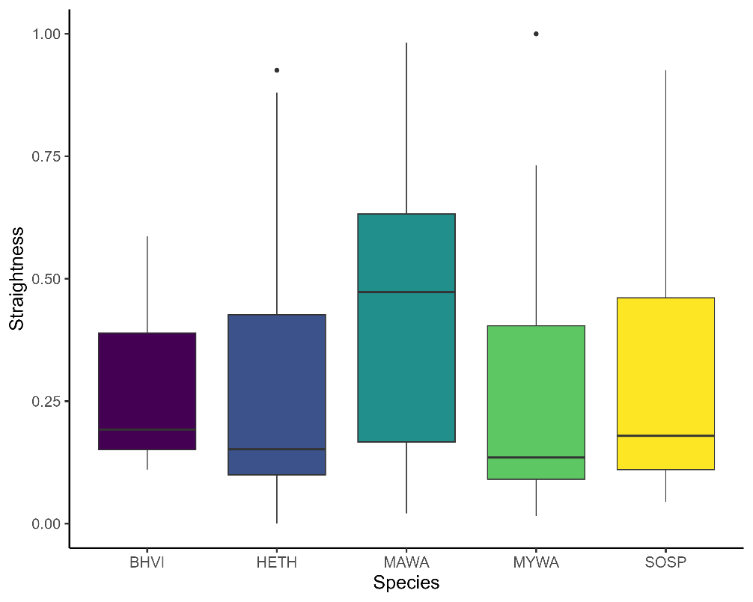
Figure S1. Comparison of straightness index calculated from telemetry tracked individuals during the 2022-2023 fall migratory period in Montreal, Quebec, Canada. (BHVI = Blue-headed Vireo; HETH = Hermit Thrush; MAWA = Magnolia Warbler; MYWA = Yellow-rumped (Myrtle) Warbler; SOSP = Song Sparrow).

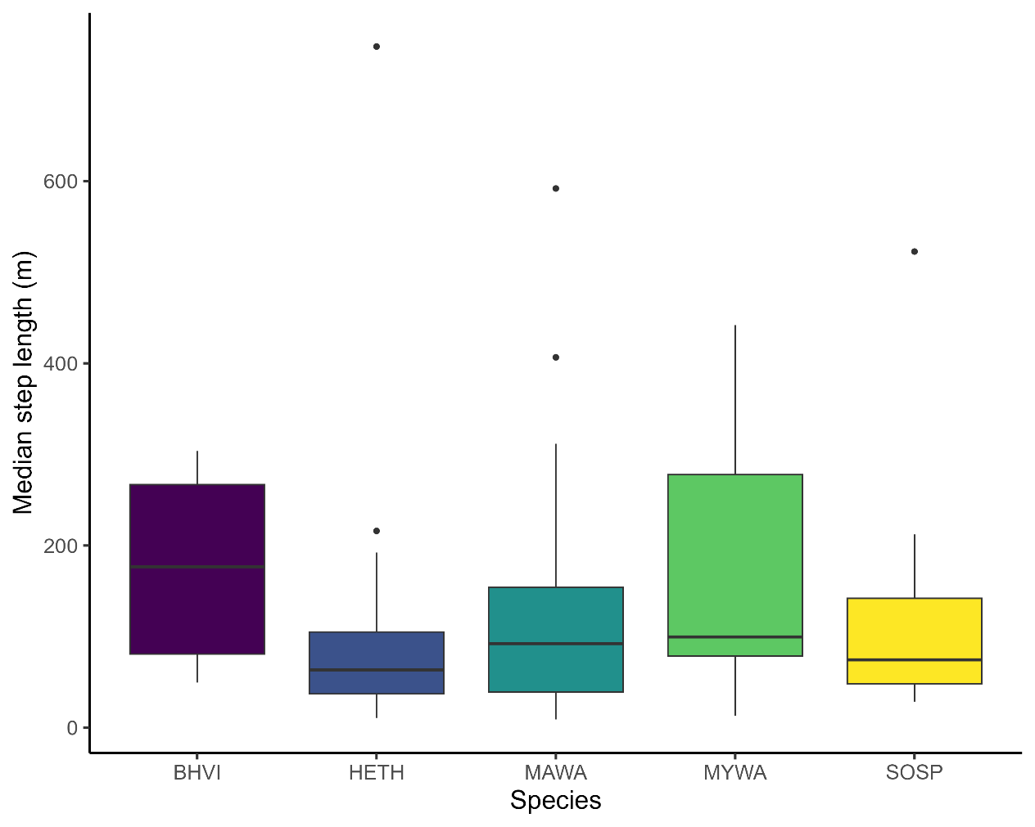

Figure S2. Comparison of median step length calculated from telemetry tracked individuals during the 2022-2023 fall migratory period in Montreal, Quebec, Canada. (BHVI = Blue-headed Vireo; HETH = Hermit Thrush; MAWA = Magnolia Warbler; MYWA = Yellow-rumped (Myrtle) Warbler; SOSP = Song Sparrow).

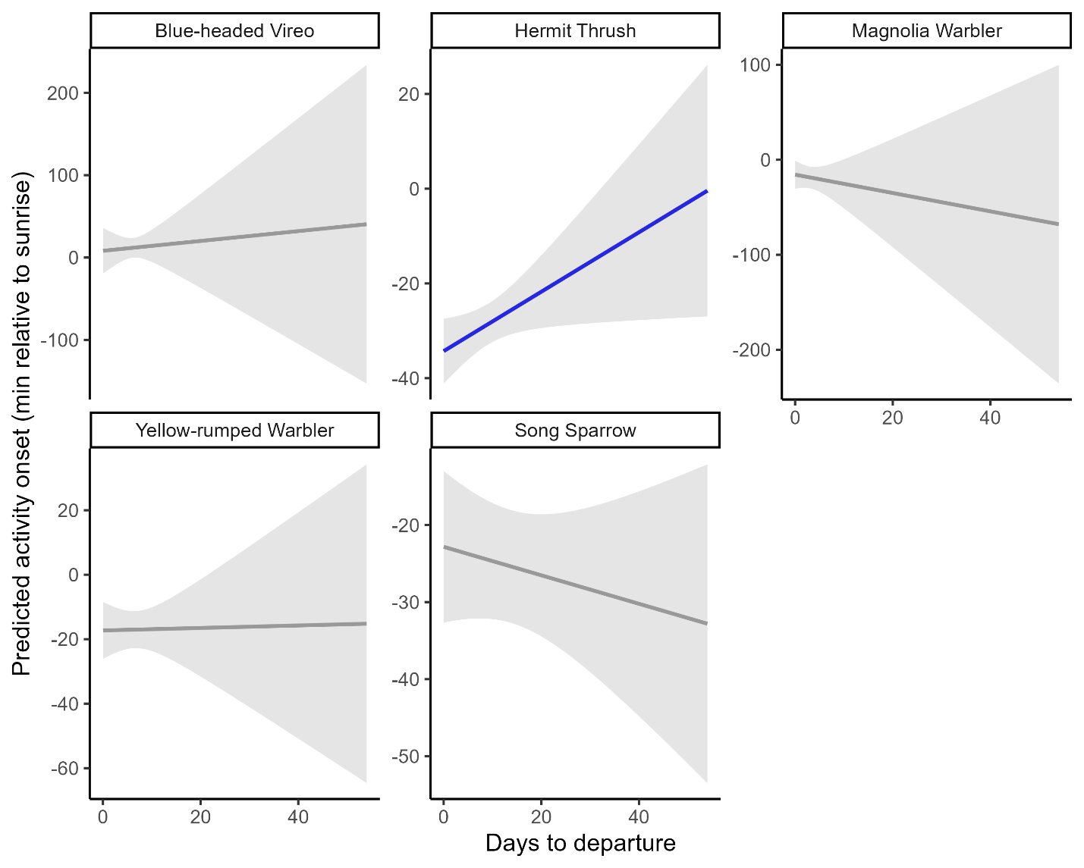
Figure S3. Predicted activity onset (minutes relative to sunrise) as a function of days to departure from stopover site based on Motus tagged individuals and changepoint analysis during the 2022-2023 fall migratory period in Montreal, Quebec, Canada using GAMMs. Blue lines indicate a significant relationship with negative values of activity onset being activity starting before sunrise and positive values of activity onset being activity starting after sunrise.

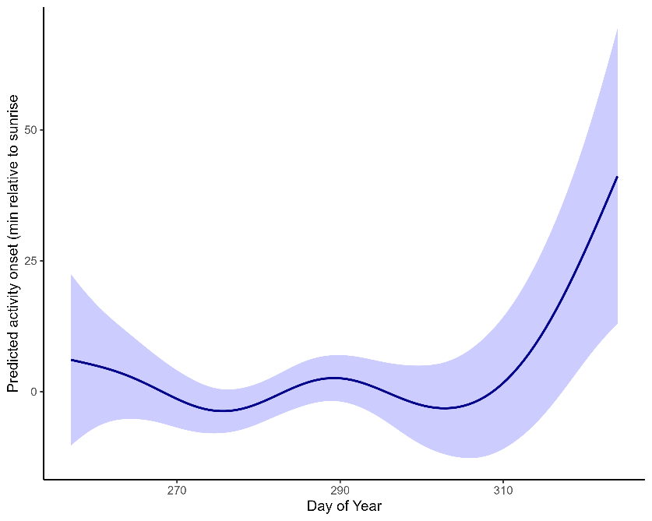
Figure S4. Predicted activity onset (minutes relative to sunrise) as a function of seasonality (day of year) for migratory birds during the 2022-2023 fall stopover period in Montreal, Quebec, Canada, using GAMMs. Increase in activity onset means later morning activity starts.

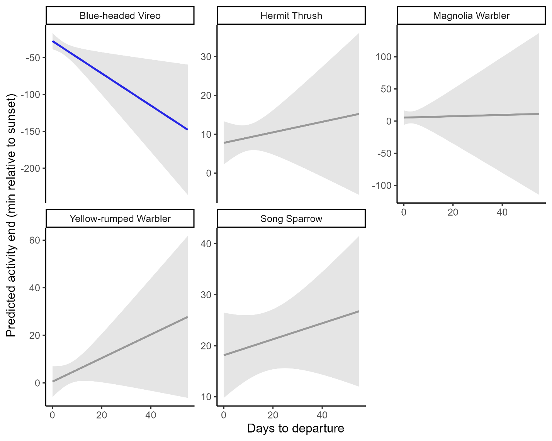

Figure S5. Predicted activity end (minutes relative to sunset) as a function of days to departure from stopover site based on Motus tagged individuals and changepoint analysis during the 2022-2023 fall migratory period in Montreal, Quebec, Canada using GAMMs. Blue lines indicate a significant relationship with negative values being activity ending before sunset and positive values being activity ending after sunset.

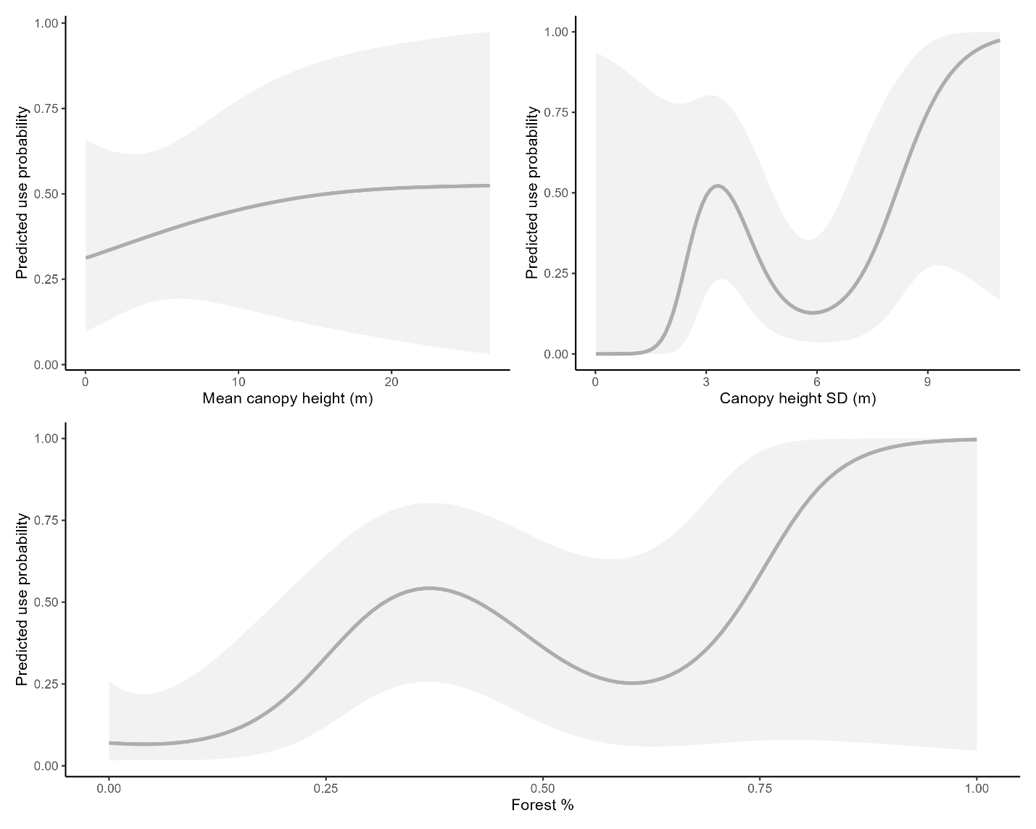
Figure S6. Predicted use probabilities of habitat covariates from general additive models (GAMs) of resource selection functions for Motus-tagged Blue-headed Vieros during the 2022-2023 fall stopover period in Montreal, Quebec, Canada. Blue lines and 95% confidence intervals show statistically significant relationships (α = 0.05); grey lines and 95% confidence intervals show non-statistically significant relationships.

Literature Cited
1. Bardo L, Goulet L, Hibbert A, Lukasik V, Poitras K. Ecological assessment of the Stoneycroft Wildlife Area. Internal Report. Department of Natural Resource Sciences, McGill University. 2003.
2. Jarjour C, Frei B, Elliott KH. Associations between sex, age and species-specific climate sensitivity in migration. Animal Migration. De Gruyter; 2017;4:23–36. https://doi.org/https://doi.org/10.1515/ami-2017-0004
3. Junda JH, Duval S, Gahbauer MA. Use of discrete molting grounds by migrant passerines undergoing prebasic molt in southern Quebec. The Wilson Journal of Ornithology. 2020;132:72. https://doi.org/10.1676/1559-4491-132.1.72
4. Morales A, Frei B, Mitchell GW, Bégin-Marchand C, Elliott KH. Reduced diurnal activity and increased stopover duration by molting Swainson’s Thrushes. Ornithology. 2022;ukab083. https://doi.org/10.1093/ornithology/ukab083
5. Poirier V, Frei B, Lefvert M, Morales A, Elliott KH. Moult migrant Tennessee Warblers undergo extensive stopover in peri-urban forests of southern Quebec. Can J Zool [Internet]. NRC Research Press; 2023 [cited 2024 Feb 1]; https://doi.org/10.1139/cjz-2023-0109
6. Poirier V, Elliott KH, Frei B. Peri-urban forest margins are important stopover sites for moult-migrating songbirds. Journal for Nature Conservation. 2023;126539. https://doi.org/10.1016/j.jnc.2023.126539
7. Owen JC, Moore FR. Seasonal Differences in Immunological Condition of Three Species of Thrushes. The Condor. American Ornithological Society; 2006;108:389–98.
8. De Zwaan DR, Huang A, McCallum Q, Owen K, Lamont M, Easton W. Mass gain and stopover dynamics among migrating songbirds are linked to seasonal, environmental, and life-history effects. Ornithology. 2022;139:ukac027. https://doi.org/10.1093/ornithology/ukac027
9. Morbey YE, Beauchamp AT, Bonner SJ, Mitchell GW. Evening locomotor activity during stopover differs on pre-departure and departure days in free-living songbirds. Journal of Avian Biology [Internet]. 2020 [cited 2020 Nov 23];51. https://doi.org/https://doi.org/10.1111/jav.02448
10. Morton ES, James RD. Blue-headed Vireo (Vireo solitarius), version 1.0. Birds of the World [Internet]. Cornell Lab of Ornithology, Ithaca, NY, USA; 2020 [cited 2026 Mar 11]; https://doi.org/10.2173/bow.buhvir.01
11. Hunt PD, Flaspohler DJ. Yellow-rumped Warbler (Setophaga coronata), version 1.0. Birds of the World [Internet]. Cornell Lab of Ornithology, Ithaca, NY, USA; 2020 [cited 2025 Apr 4]; https://doi.org/10.2173/bow.yerwar.01
12. Dunn EH, Hall GA. Magnolia Warbler - Setophaga magnolia. Birds of the World [Internet]. Ithaca, NY, USA: Cornell Lab of Ornithology; 2020 [cited 2026 Mar 11]; https://birdsoftheworld.org/bow/species/magwar/cur/introduction. Accessed 11 Mar 2026
13. Arcese P, Sogge MK, Marr AB, Patten MA. Song Sparrow (Melospiza melodia). Birds of the World [Internet]. Cornell Lab of Ornithology, Ithaca, NY, USA; 2020 [cited 2026 Mar 11]; https://doi.org/10.2173/bow.sonspa.01
14. Dellinger R, Bohall Wood P, Jones PW, Donovan TM. Hermit Thrush - Catharus guttatus. Birds of the World [Internet]. Ithaca, NY, USA: Cornell Lab of Ornithology; 2020 [cited 2026 Mar 11]; https://birdsoftheworld.org/bow/species/herthr/cur/introduction. Accessed 11 Mar 2026

