Facile Synthesis and Cytotoxic evaluation of Mercapto conjugates of Betulinicacid : Anti proliferative and Anti metastatic effect on Prostrate Cancer Cells PC-3
Henna Amin ^{a#}, Gursimar Kaur ^{b#}, AnindyaGoswami^{*b#}andKhursheed Ahmad Bhat ^{*a#}
ªBioorganic Chemistry Division, Indian Institute of Integrative Medicine (CSIR), Srinagar, Jammu & Kashmir-190005, India a, e-mail*
((kabhat@iiim.res.in))
#Academy of Scientific & Innovative Research (AcSIR), Ghaziabad, 201002, India b, e-mail* ((agoswami@iiim.ac.in))
^{b} Pharmacology Division, CSIR-Indian Institute of Integrative Medicine, Jammu-180001, India

Table of Contents
NMR Spectra and MS of representative merapto conjugates of betulinic acid
Gels and Blot Images

¹HNMR, ¹³CNMR of synthesized mercaptoconjugates of betulinic acid
BT1

BT2:

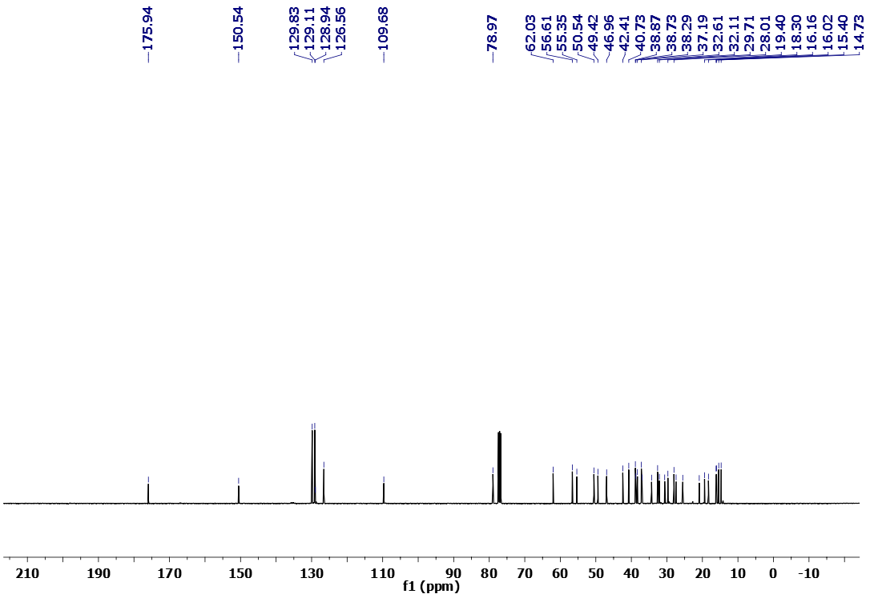

BT4:

BT5:

BT6
BT7

BT8

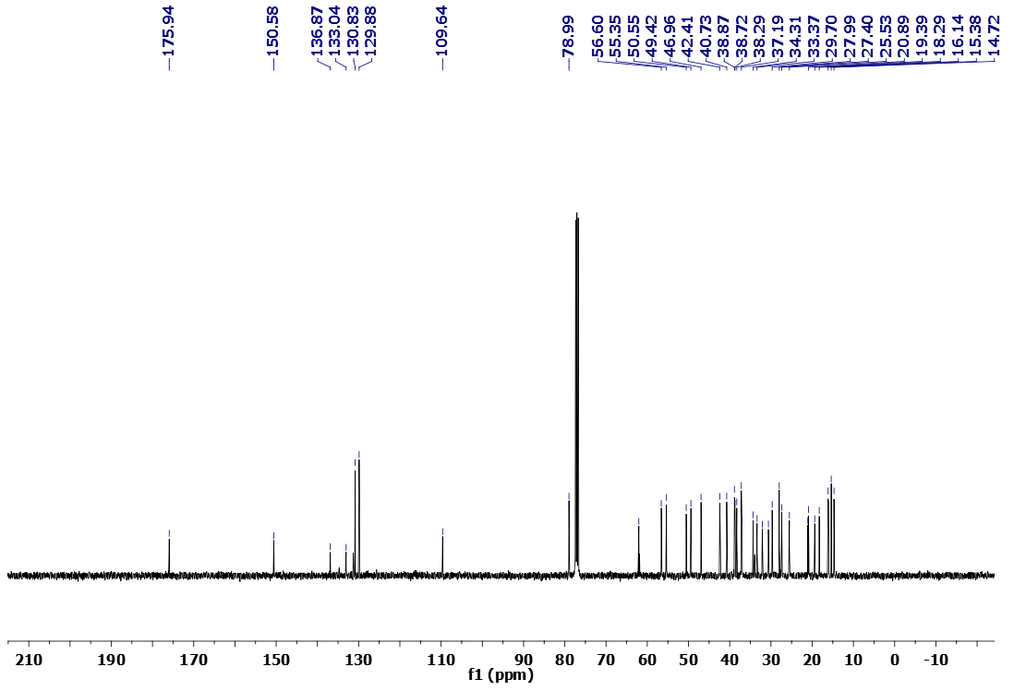
BT9

BT11:

BT12:

BT13:

BT14:

MASS OF COMPOUNDS:
BT4
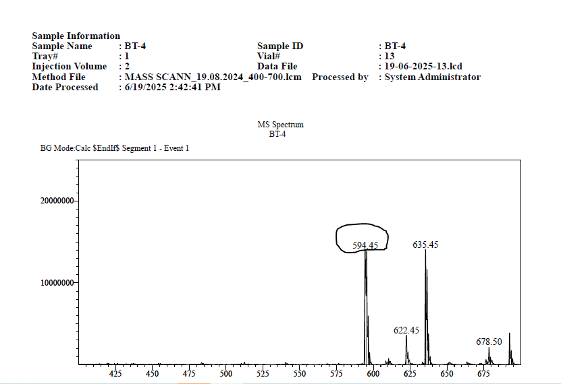

BT11
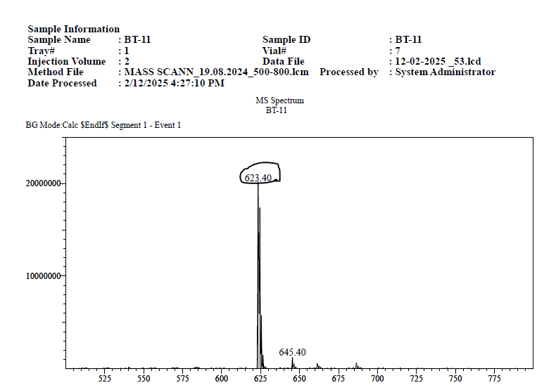
BT12
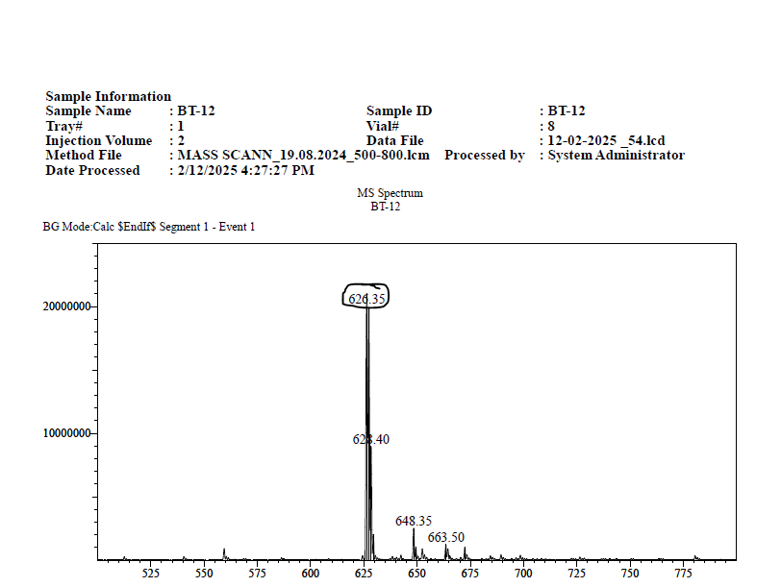

BT13
