S5. Gels for isolation and purification of Proteins:
S5.1 NRF2 Digestion & Capta Column Elution:
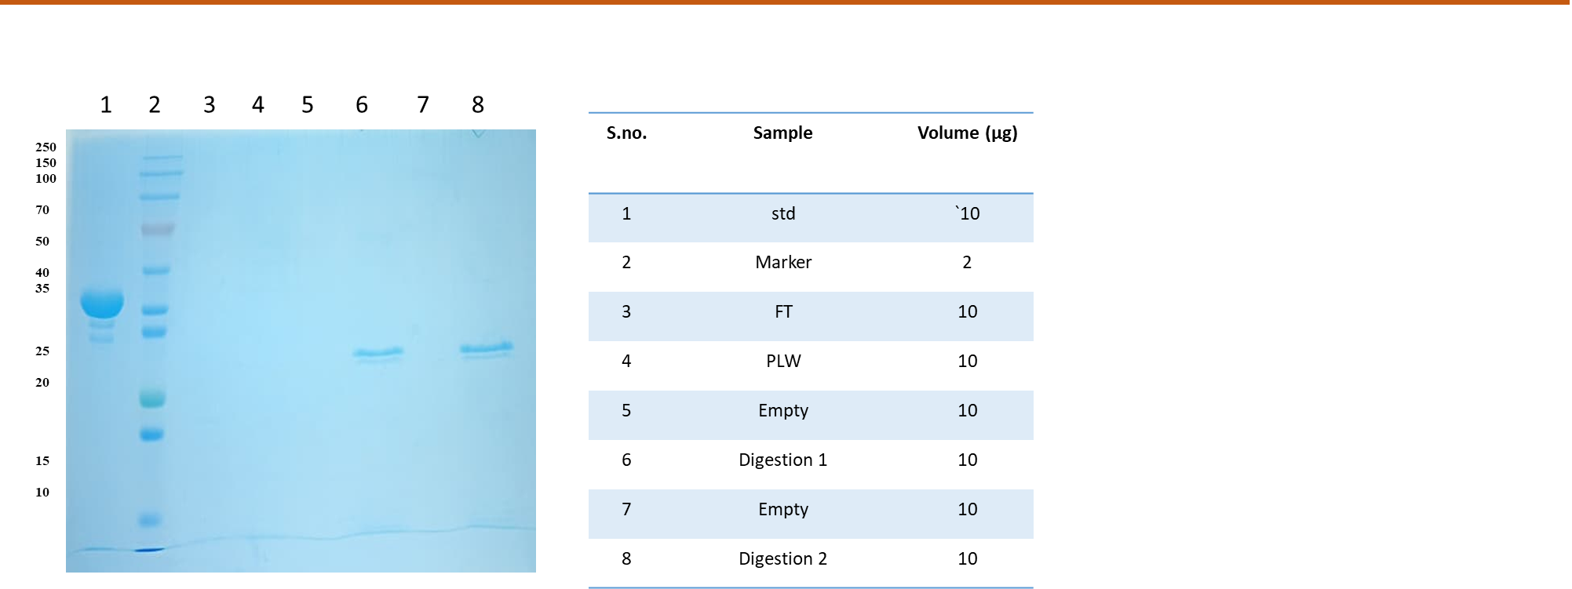
Figure S1: SDS–PAGE analysis of NRF2 digestion. Lane 1: molecular weight marker (Std); Lane 3: digested NRF2 (FT); Lanes 5 and 7: empty fractions. A distinct band corresponding to NRF2 (~68 kDa) is observed in the FT lane, with no detectable bands in the empty fractions.
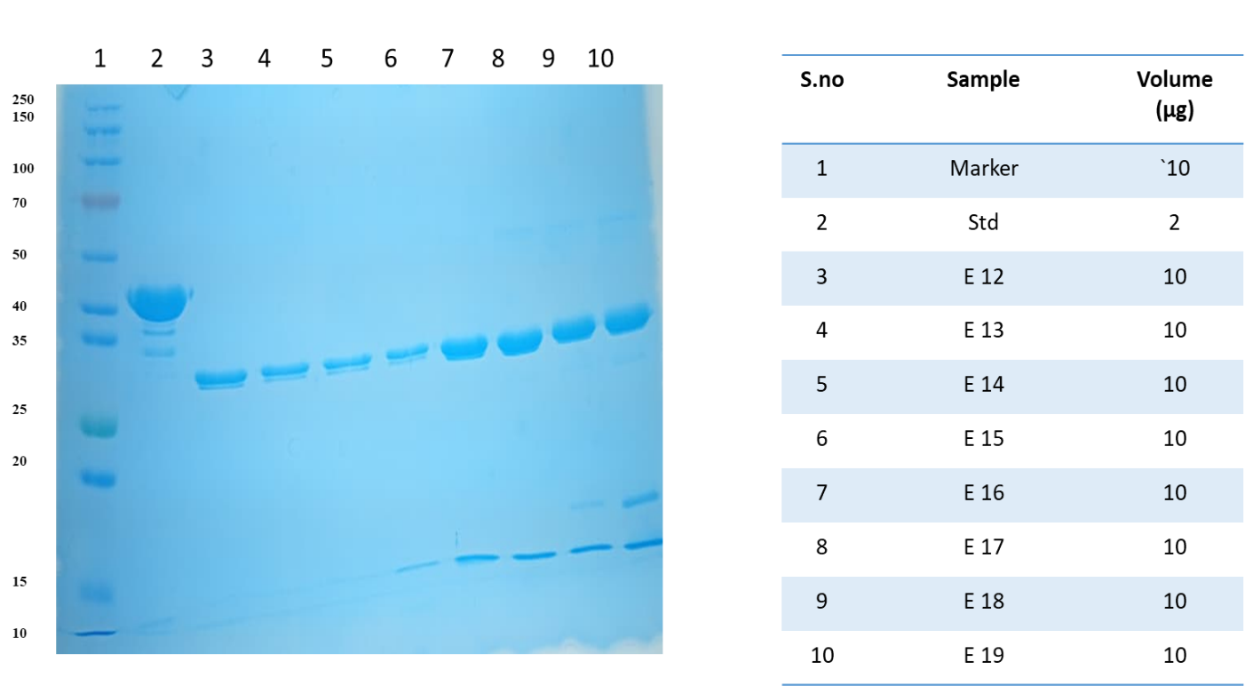
Figure S2. SDS–PAGE analysis of NRF2 purification and elution fractions. Lane 1: molecular weight marker; Lane 3: Elution fraction 12 (E12); Lane 5: Elution fraction 14 (E14); Lane 7: Elution fraction 16 (E16); Lane 9: Elution fraction 18 (E18). A prominent band corresponding to NRF2 (~68 kDa) is observed across elution fractions, with increasing intensity in later fractions, indicating successful purification and elution.
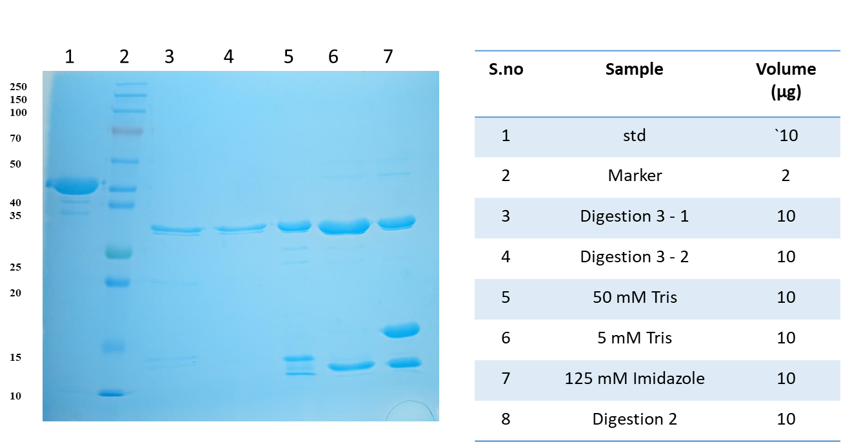
Figure S3. SDS–PAGE analysis of HO-1 protein digestion and elution. Lane 1: molecular weight marker (Std); Lane 3: Digestion (3:1); Lane 5: 50 mM Tris fraction; Lane 7: 125 mM imidazole fraction. A prominent band corresponding to HO-1 (~32 kDa) is observed in the digestion and imidazole-eluted fractions, indicating successful cleavage and recovery of the target protein.
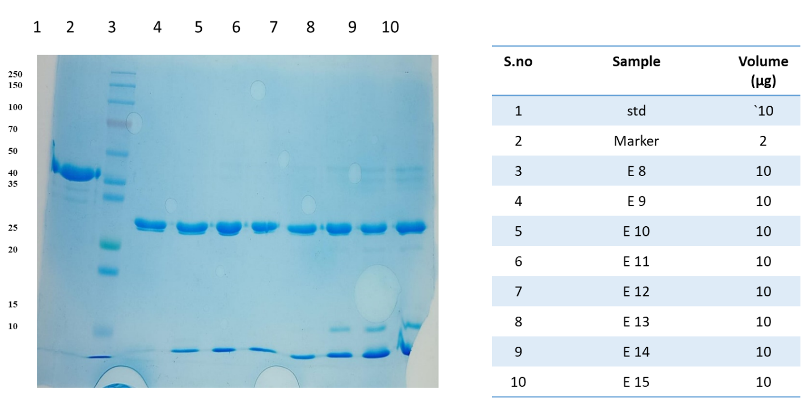
Figure S4. SDS–PAGE analysis of purification and elution fractions. Lane 1: molecular weight marker (Std); Lane 3: Elution 8 (E8); Lane 5: Elution 10 (E10); Lane 7: Elution 12 (E12); Lane 9: Elution 14 (E14). A prominent band corresponding to the target protein (~32 kDa for HO-1) is observed across elution fractions, confirming successful purification and recovery.
Figure S5. SDS–PAGE analysis of NQO1 digestion and purification. Lane 1: molecular weight marker (Std); Lane 3: Digestion (3:1); Lane 5: 50 mM Tris fraction; Lane 7: 125 mM imidazole fraction. A distinct band corresponding to NQO1 (~31 kDa) is observed in the digestion and imidazole-eluted fractions, confirming successful cleavage and recovery of the target protein.
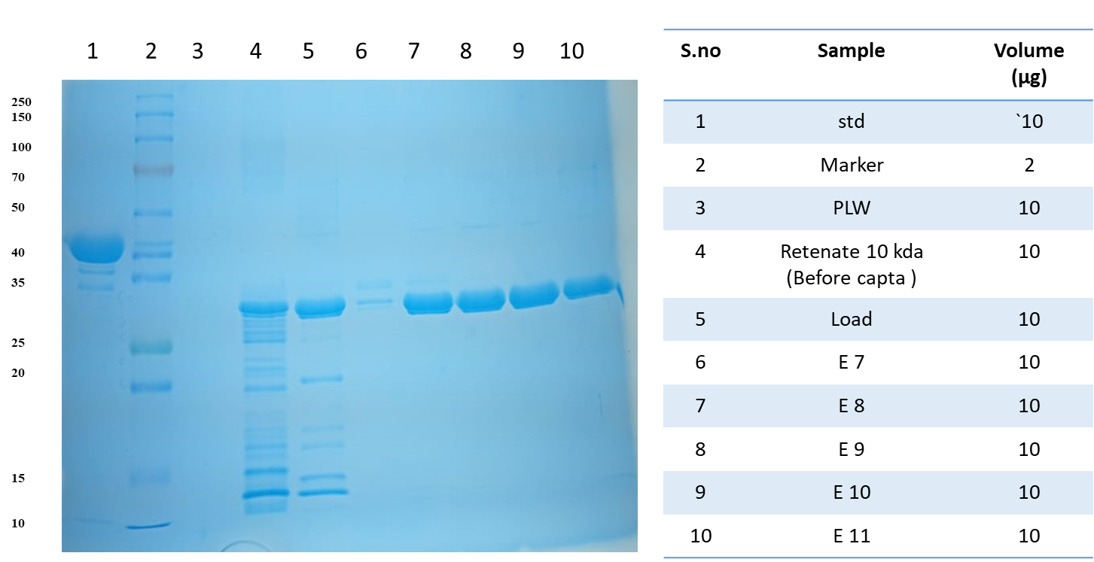
Figure S6. SDS–PAGE analysis of purification and elution fractions. Lane 1: molecular weight marker (Std); Lane 3: post-lysis wash (PLW); Lane 5: Load; Lane 7: Elution 8 (E8); Lane 9: Elution 10 (E10). A prominent band corresponding to the target protein (~31–32 kDa for NQO1, if applicable) is enriched in the elution fractions, confirming successful purification.

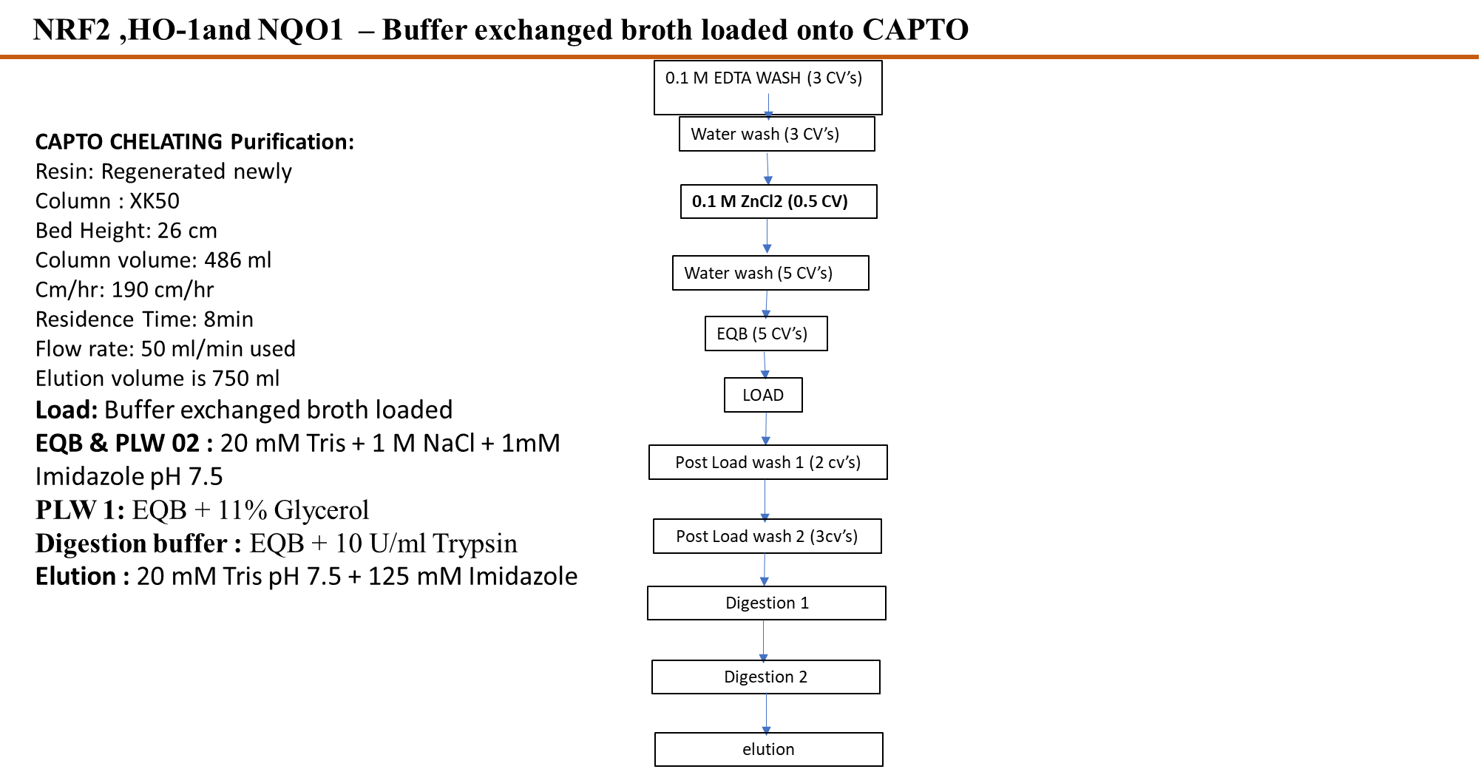

Figure S7. Schematic representation of ZnCl₂ treatment protocol. Cells were treated with 0.1 M ZnCl₂ (0.5 CV), followed by sequential processing steps as indicated by arrows. The diagram outlines the workflow used for chemical treatment and downstream analysis.

