Supplementary Materials
Synthesis and study of new supramolecular systems based on cucurbit[5,7]urils, zoledronic acid, and silver nitrate
Saule B. Zhautikova², Alexey N. Guslyakov³, Saule K. Kabiyeva*¹, Rymgul K. Zhaslan*¹, Andrey D. Puntus³, Victor S. Malkov³, Khlysh B. Omarov⁴, Abdigali A. Bakibaev³
¹ Karaganda Industrial University, 101400 Temirtau, Kazakhstan; e-mail: kabieva.s@mail.ru (S.K.K.); rymgul.zhaslan@mail.ru (R.K.Zh.)
² Karaganda Medical University, 100008 Karaganda, Kazakhstan; saulezautikova@gmail.com (S.B.Z.)
³ Faculty of Chemistry, National Research Tomsk State University, 634050 Tomsk, Russia;
guslyakov.aleksej@bk.ru (A.N.G.); vuriis00@mail.ru (A.D.P.); bakibaev@mail.ru (A.A.B.); malkov.tsu@yandex.ru (V.S.M.)
⁴ K. Kulazhanov Kazakh University of Technology and Business, 010000 Astana, Kazakhstan; (K.B.O.)
* Correspondence: kabieva.s@mail.ru; rymgul.zhaslan@mail.ru
Experimental section
Synthesis of cucurbit[5-8]urils. The synthesis and isolation of individual macrocycles was carried out according to the well-known method [1]. To synthesize a mixture of cucurbit[5-8]urils, 100 g (0.704 mol) of glycoluril was taken and dissolved in 142 ml of concentrated hydrochloric acid, and then 42.2 g (1.407 mol) of paraformaldehyde was added in portions. After the addition of paraformaldehyde was completed, the mixture turned into a gel. The resulting gel was heated to 95° C and kept at this temperature for 18 hours. After the time elapsed, the reaction mass was cooled to room temperature and kept for 3 days to form cucurbit[6]uril crystals. The precipitated crystals were filtered out and recrystallized from a 9M hydrochloric acid solution, yielding 17 g of cucurbit[6]uril.
Isolation of cucurbit[8]uril. The mother liquor obtained after removal of cucurbit[6]uril crystals was concentrated to form a sticky solid yellow mass consisting of CB[5], CB[7], CB[8] and CB[6] residues. The resulting yellow mass was dissolved in 160 ml of 40% formic acid. The resulting suspension was stirred for 2 hours, after which it was filtered out and a white amorphous powder of cucurbit[8]uril was obtained. It was recrystallized from concentrated hydrochloric acid to obtain 8 g of crystalline CB[8].
Purification of cucurbit[6]uril. The mother liquor obtained after removing cucurbit[8]uril was evaporated until dryness. 400 ml of distilled water was added to the resulting dry mass and stirred for 12 hours. The precipitate was filtered out and an additional 150 ml of water was added, then the suspension was ultrasonically treated twice for 30 minutes at a temperature of approximately 55˚C to remove the residual amount of cucurbit[7]uril. The suspension was filtered out, and the precipitate was recrystallized from a 9M hydrochloric acid solution, obtaining an additional 21 g of cucurbit[6]uril.
Isolation of cucurbit[7]uril. The solution obtained by removing CB[6] was concentrated to 100 ml on a rotary evaporator. 800 ml of methanol was added to the concentrate and the mixture was stirred for 12 hours. After that, slow precipitation of an amorphous white powder representing cucurbit[7]uril was observed. The precipitate was filtered and washed three times with 50 ml of methanol. Then it was placed in a vacuum cabinet and kept for three days at 70℃ and a residual pressure of 100 mbar. 16 grams of white amorphous powder of cucurbit[7]uril were obtained.
Purification of cucurbit[5]uril. The mother liquor obtained after removal of cucurbit[7]uril was concentrated on a rotary evaporator to 100 ml. 800 ml of acetone was added to the concentrate and stirred for 12 hours, after which the cucurbit[5]uril crystal precipitate was filtered. The precipitate was recrystallized from a 6M hydrochloric acid solution to produce 13 grams of cucurbit[5]uril.
Powder X-ray diffraction for CB[5-8, 10] compounds was recorded on a Shimadzu XRD 7000 diffractometer using Cu Kα radiation at λ = 1.54053 Å. Reflections were collected from 5 to 50 in 2θ with a step of 0.014, a sweep rate of 20°/min, and a step time of 21.49 s at 17 °C.
The structures of individual macrocycles were confirmed by powder X-ray diffraction by comparing the diffractograms of the cucurbituriles obtained by us and the diffractograms of the database CCDC. CB[5] № 883370 (Figures S1), CB[6] № 7209204 (Figures S2), CB[7] № 1428201 (Figures S3), CB[8] № 883371 (Figures S4), CB[10] № 169807 (Figures S9).
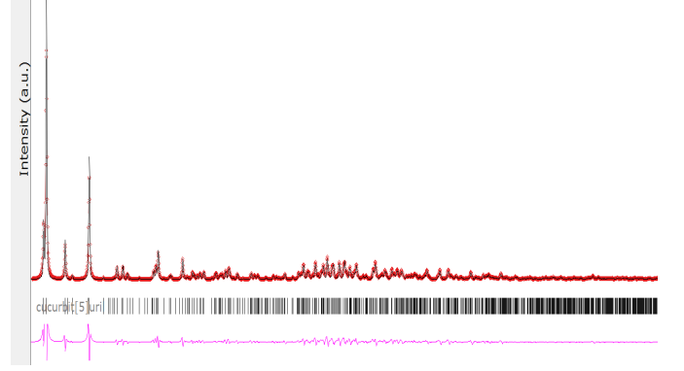
Fig. S1 Diffractogram of cucurbit[5]uril. The red line is theoretical, and the black line is experimental.
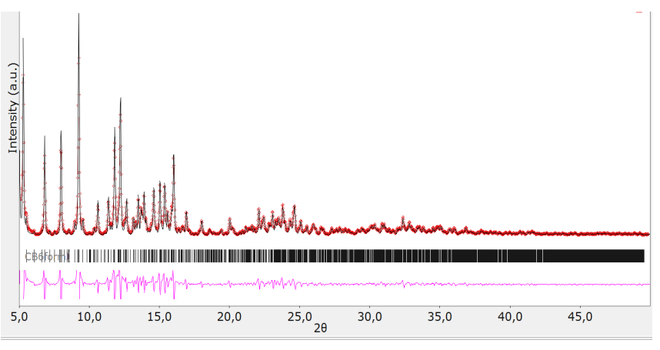
Fig. S2. Diffractogram of cucurbit[6]uril. The red line is theoretical, and the black line is experimental.
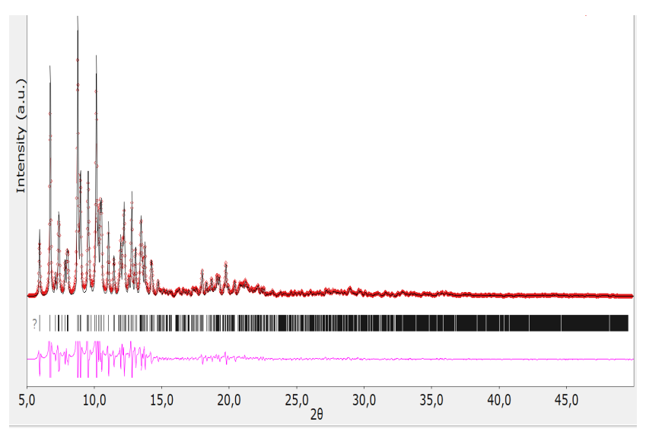
Fig. S3 Diffractogram of cucurbit[7]uril. The red line is theoretical, and the black line is experimental.
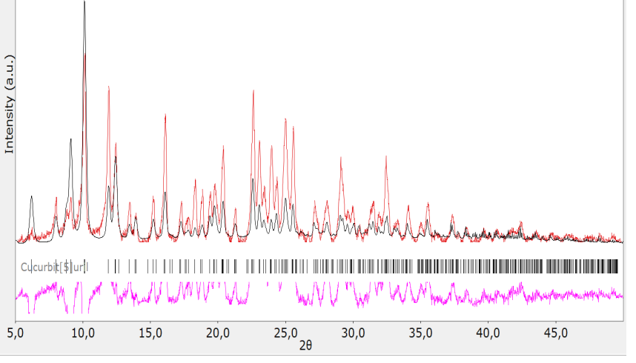
Fig. S4 Diffractogram of cucurbit[8]uril. The red line is theoretical, and the black line is experimental.
¹H NMR spectra of the synthesized cucurbit[n]urils (n = 5–8, 10) were recorded on a Bruker Avance400 III HD NMR spectrometer in D₂O at 25 °C, with a ¹H operating fre-quency of 400 MHz; the internal standard for ¹H was tetramethylsilane.
NMR-Spectroscopy. The CB[5-8, 10] have been characterized by NMR spectroscopic method:
CB[5]: ¹H NMR (400 MHz, D₂O) δ 4.35 (d, 10H, J = 15.6 Hz, CH₂), 5.55 (s, 10H, CH), 5.65 (d, 10H, J = 15.7 Hz, CH₂). (Figure S5)
CB[6]: ¹H NMR (400 MHz, D₂O) δ 4.28 (d, 12H, J=15.1 Hz, CH₂), 5.54 (s, 12H, CH), 5.69 (d, 12H, J = 15.5 Hz, CH₂). (Figure S6)
CB[7]: ¹H NMR (400 MHz, D₂O) δ 4.23 (d, 14H, J=15.2 Hz, CH₂), 5.52 (s, 14H, CH), 5.75 (d, 14H, J = 15.4 Hz, CH₂). (Figure S7)
CB[8]: ¹H NMR (400 MHz, D₂O) δ 4.21 (d, 16H, J = 15.5 Hz, CH₂), 5.53 (s, 16H, CH), 5.78 (d, 16H, J = 15.3 Hz, CH₂). (Figure S8)
CB[10]: ¹H NMR (400 MHz, D₂O) δ 4.27 (d, 20H, J = 15.5 Hz, CH₂), 5.57 (s, 20H, CH), 5.77 (d, 20H, J = 14.9 Hz, CH₂). (Figure S10)
Figure S5. ¹H NMR spectrum of cucurbit[5]uril.
Figure S6. ¹H NMR spectrum of cucurbit[6]uril.
Figure S7. ¹H NMR spectrum of cucurbit[7]uril.
Figure S8. ¹H NMR spectrum of cucurbit[8]uril.
Figure S9. Diffractogram of cucurbit[10]uril. The red line is theoretical, and the black line is experimental.
Figure S10. ¹H NMR spectrum of cucurbit[10]uril.
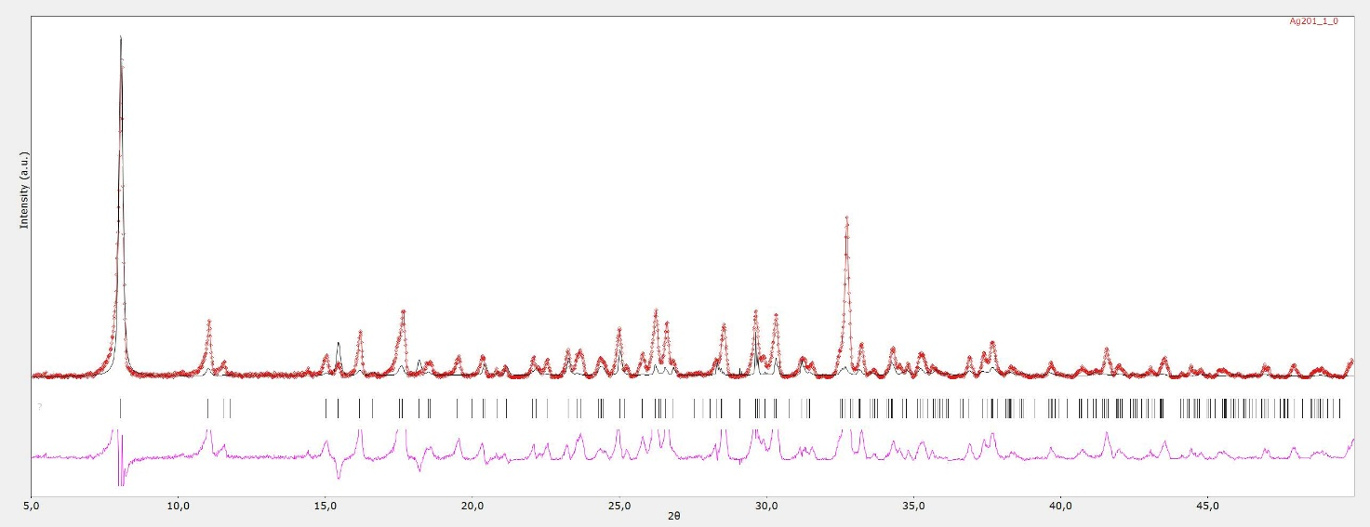
Figure S11. Diffractogram of coordination polymer II (AgZol) The red line is theoretical, and the black line is experimental.
Figure S12. Comparative IR spectrum of coordination polymer II, supramolecular complex III, and cucurbit[5]uril.
Figure S13. Comparative IR spectrum of supramolecular complex IV, coordination polymer II, and cucurbit[7]uril.

