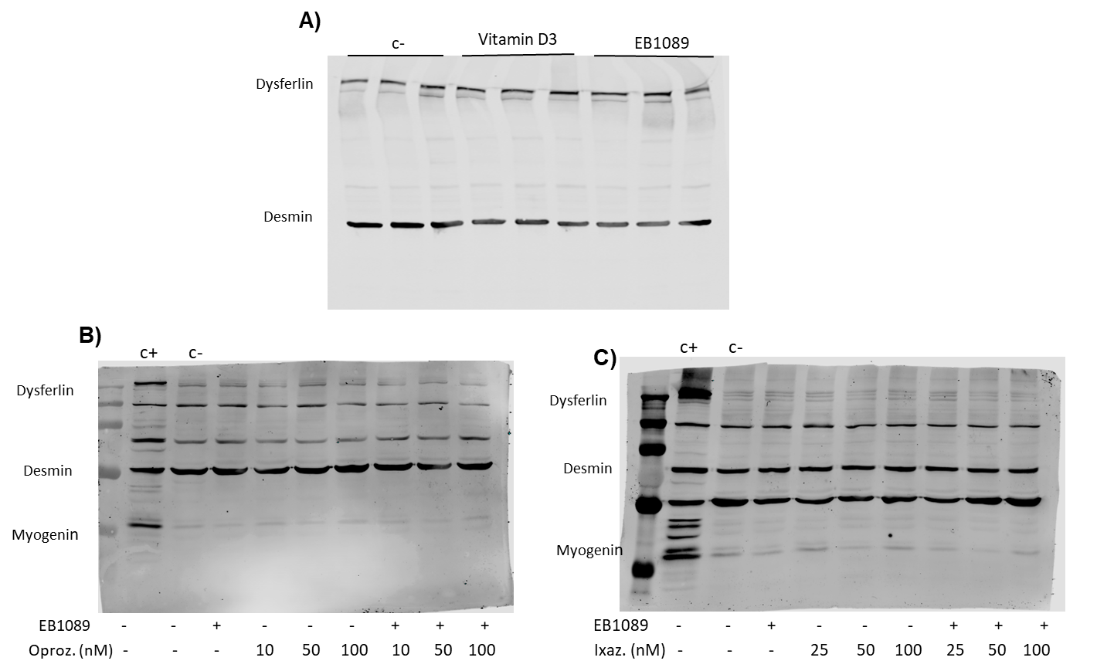

Supplementary figure 1. Dysferlin and myogenin expression in dysf mut/mut muscle cells. A) Representative full blot of dysferlin with vitamin D3 and EB1089 treatment. Desmin was used as a loading control. B) Representative full blot of myogenin and dysferlin with oprozomib and EB1089 treatment. C) Representative full blot of myogenin and dysferlin with ixazomib and EB1089 treatment.

