Supplementary material
Table S1 Estimated edge weights of the network in the total sample (N = 734)
 | MIS | SOM | PSY | ANX | OBS | INT | PHO | HOS | DEP | PAR
MIS | 0.00
SOM | 0.20 | 0.00
PSY | 0.18 | 0.07 | 0.00
ANX | 0.11 | 0.28 | 0.15 | 0.00
OBS | 0.03 | 0.03 | 0.01 | 0.17 | 0.00
INT | 0.00 | -0.05 | 0.13 | 0.05 | 0.20 | 0.00
PHO | 0.03 | 0.15 | 0.06 | 0.04 | 0.08 | 0.21 | 0.00
HOS | 0.06 | 0.08 | 0.01 | 0.06 | -0.05 | 0.11 | 0.01 | 0.00
DEP | 0.18 | 0.00 | 0.10 | 0.24 | 0.17 | 0.22 | 0.05 | 0.05 | 0.00
PAR | 0.00 | 0.00 | 0.26 | 0.04 | 0.10 | 0.29 | 0.01 | 0.27 | 0.01 | 0.00
Note: Abbreviation of each node: SOM, somatization; OBS, obsessive-compulsive symptoms; INT, interpersonal sensitivity; DEP, depression; ANX, anxiety; HOS, hostility; PHO, phobic anxiety; PAR, paranoid ideation; PSY, psychoticism; MIS, other reflecting sleep and diet.

Table S2 Estimated edge weights of the network in males (N = 240)
 | MIS | SOM | PSY | ANX | OBS | INT | PHO | HOS | DEP | PAR
MIS | 0.00
SOM | 0.17 | 0.00
PSY | 0.18 | 0.12 | 0.00
Table S2 Estimated edge weights of the network in males (N = 240) (continue)
 | MIS | SOM | PSY | ANX | OBS | INT | PHO | HOS | DEP | PAR
ANX | 0.05 | 0.23 | 0.13 | 0.00
OBS | 4.71×10⁻³ | 0.01 | 0.06 | 0.17 | 0.00
INT | 0.04 | 0.00 | 0.21 | 0.00 | 0.18 | 0.00
PHO | 0.05 | 0.07 | 0.00 | 0.18 | 0.08 | 0.22 | 0.00
HOS | 0.07 | 0.00 | 0.00 | 0.08 | 0.00 | 0.04 | 0.01 | 0.00
DEP | 0.21 | 0.01 | 0.07 | 0.25 | 0.17 | 0.20 | 0.00 | 0.07 | 0.00
PAR | 0.00 | 0.00 | 0.20 | 0.12 | 0.10 | 0.24 | 0.00 | 0.28 | 0.03 | 0.00
Note: Abbreviation of each node: SOM, somatization; OBS, obsessive-compulsive symptoms; INT, interpersonal sensitivity; DEP, depression; ANX, anxiety; HOS, hostility; PHO, phobic anxiety; PAR, paranoid ideation; PSY, psychoticism; MIS, other reflecting sleep and diet.

Table S3 Estimated edge weights of the network in females (N = 494)
 | MIS | SOM | PSY | ANX | OBS | INT | PHO | HOS | DEP | PAR
MIS | 0.00
SOM | 0.22 | 0.00
PSY | 0.18 | 0.02 | 0.00
ANX | 0.13 | 0.32 | 0.16 | 0.00
OBS | 0.04 | 0.05 | 0.00 | 0.16 | 0.00
INT | -4.83×10⁻³ | -0.12 | 0.08 | 0.09 | 0.21 | 0.00
PHO | 0.02 | 0.19 | 0.08 | 0.00 | 0.06 | 0.21 | 0.00
Table S3 Estimated edge weights of the network in females (N = 494) (continue)
 | MIS | SOM | PSY | ANX | OBS | INT | PHO | HOS | DEP | PAR
HOS | 0.03 | 0.14 | 0.07 | 0.02 | -0.03 | 0.15 | 0.00 | 0.00
DEP | 0.16 | 0.00 | 0.11 | 0.23 | 0.17 | 0.22 | 0.07 | 0.03 | 0.00
PAR | 0.00 | 0.05 | 0.28 | 0.00 | 0.08 | 0.33 | 0.01 | 0.23 | 0.00 | 0.00
Note: Abbreviation of each node: SOM, somatization; OBS, obsessive-compulsive symptoms; INT, interpersonal sensitivity; DEP, depression; ANX, anxiety; HOS, hostility; PHO, phobic anxiety; PAR, paranoid ideation; PSY, psychoticism; MIS, other reflecting sleep and diet.

Table S4 Edge weight comparisons between male and female psychological problems networks
Edge | Male weight | Female weight | Difference | Adjusted p-value
MIS–SOM | 0.17 | 0.22 | -0.05 | 1.00
MIS–PSY | 0.18 | 0.18 | 0.00 | 1.00
SOM–PSY | 0.12 | 0.02 | 0.10 | 1.00
MIS–ANX | 0.05 | 0.13 | -0.07 | 1.00
SOM–ANX | 0.23 | 0.32 | -0.09 | 1.00
PSY–ANX | 0.13 | 0.16 | -0.03 | 1.00
MIS–OBS | 0.01 | 0.04 | -0.04 | 1.00
SOM–OBS | 0.01 | 0.05 | -0.04 | 1.00
PSY–OBS | 0.06 | 0.00 | 0.06 | 1.00
ANX–OBS | 0.17 | 0.16 | 0.00 | 1.00
MIS–INT | 0.04 | -0.01 | 0.04 | 1.00
Table S4 Edge weight comparisons between male and female psychological problems networks (continued)
Edge | Male weight | Female weight | Difference | Adjusted p-value
SOM–INT | 0.00 | -0.12 | 0.12 | 1.00
PSY–INT | 0.21 | 0.08 | 0.13 | 1.00
ANX–INT | 0.00 | 0.09 | -0.09 | 1.00
OBS–INT | 0.18 | 0.21 | -0.03 | 1.00
MIS–PHO | 0.05 | 0.02 | 0.04 | 1.00
SOM–PHO | 0.07 | 0.20 | -0.13 | 1.00
PSY–PHO | 0.00 | 0.09 | -0.09 | 1.00
ANX–PHO | 0.18 | 0.00 | 0.18 | 1.00
OBS–PHO | 0.08 | 0.07 | 0.02 | 1.00
INT–PHO | 0.22 | 0.21 | 0.02 | 1.00
MIS–HOS | 0.07 | 0.03 | 0.03 | 1.00
SOM–HOS | 0.00 | 0.14 | -0.14 | 1.00
PSY–HOS | 0.00 | 0.07 | -0.07 | 1.00
ANX–HOS | 0.08 | 0.02 | 0.06 | 1.00
OBS–HOS | 0.00 | -0.03 | 0.03 | 1.00
INT–HOS | 0.04 | 0.15 | -0.10 | 1.00
PHO–HOS | 0.01 | 0.00 | 0.01 | 1.00
MIS–DEP | 0.20 | 0.16 | 0.04 | 1.00
SOM–DEP | 0.01 | 0.00 | 0.01 | 1.00
PSY–DEP | 0.07 | 0.11 | -0.04 | 1.00
Table S4 Edge weight comparisons between male and female psychological problems networks (continued)
Edge | Male weight | Female weight | Difference | Adjusted p-value
ANX–DEP | 0.25 | 0.23 | 0.02 | 1.00
OBS–DEP | 0.17 | 0.17 | 0.00 | 1.00
INT–DEP | 0.20 | 0.22 | -0.02 | 1.00
PHO–DEP | 0.00 | 0.07 | -0.07 | 1.00
HOS–DEP | 0.07 | 0.03 | 0.04 | 1.00
MIS–PAR | 0.00 | 0.00 | 0.00 | 1.00
SOM–PAR | 0.00 | 0.05 | -0.05 | 1.00
PSY–PAR | 0.20 | 0.28 | -0.08 | 1.00
ANX–PAR | 0.12 | 0.00 | 0.12 | 1.00
OBS–PAR | 0.10 | 0.08 | 0.02 | 1.00
INT–PAR | 0.24 | 0.33 | -0.10 | 1.00
PHO–PAR | 0.00 | 0.01 | -0.01 | 1.00
HOS–PAR | 0.28 | 0.23 | 0.04 | 1.00
DEP–PAR | 0.03 | 0.00 | 0.03 | 1.00

Note: Abbreviation of each node: SOM, somatization; OBS, obsessive-compulsive symptoms; INT, interpersonal sensitivity; DEP, depression; ANX, anxiety; HOS, hostility; PHO, phobic anxiety; PAR, paranoid ideation; PSY, psychoticism; MIS, other reflecting sleep and diet.
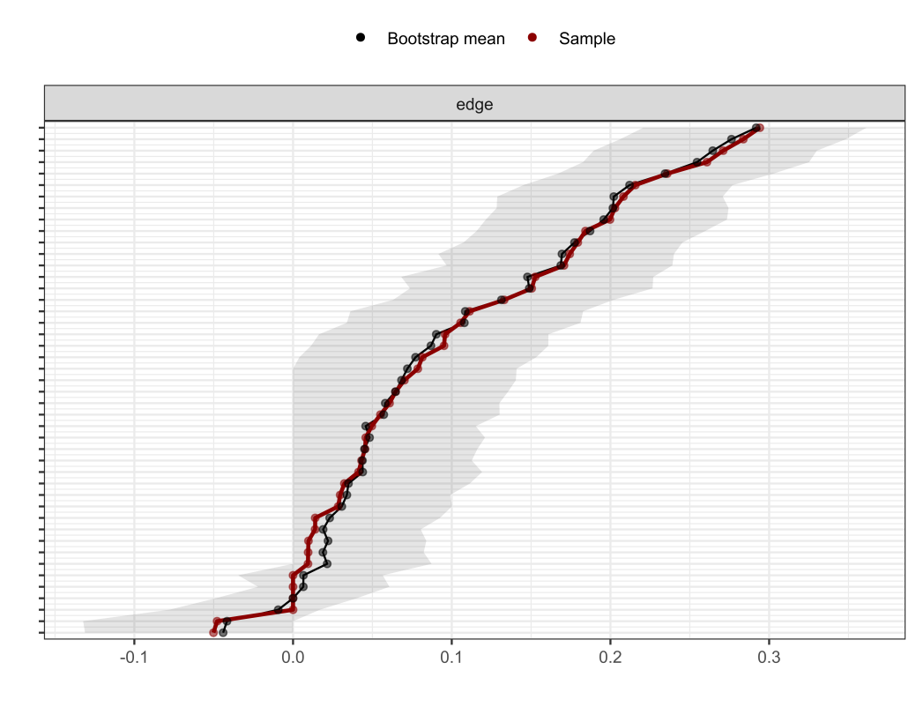
Fig. S1 Nonparametric bootstrapped difference test for stability of edge weights in the total sample (N = 734)
Notes: The x-axis indicates the edge weights and the y-axis indicates the nodes linked by the edges. The black dots denote the mean value of the bootstrapped edge weights and the red dots denote the edge weights from current sample. Gray area indicates the 95% confidence intervals of the bootstrapped sample.

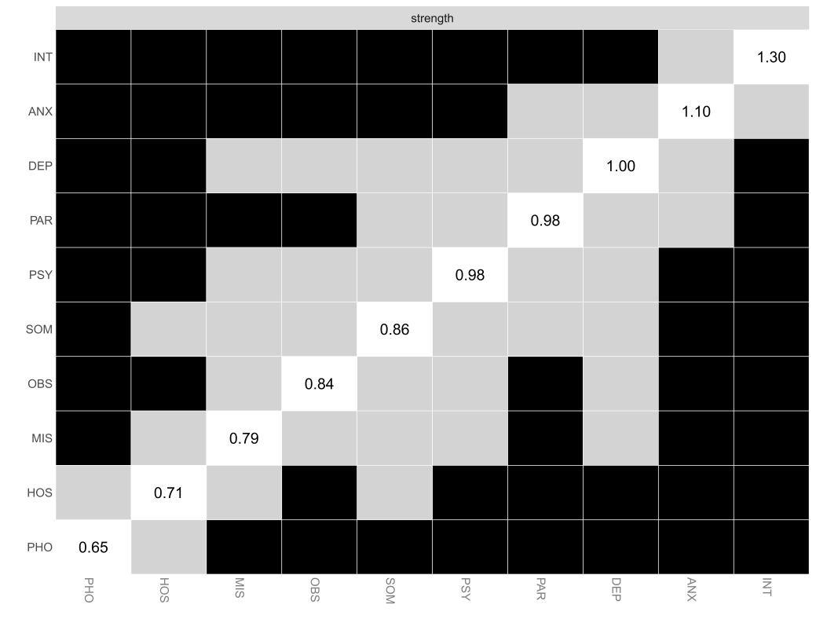
Fig. S2 Estimation of node strength difference by bootstrapped difference test in the total sample (N = 734)
Notes: Bootstrapped difference tests between node strength of the 10 nodes. Gray boxes represent the nodes that do not significantly differ from one-another, whereas black boxes represent significant difference. White boxes represent the values of node strength. Abbreviation of each node: SOM, somatization; OBS, obsessive-compulsive symptoms; INT, interpersonal sensitivity; DEP, depression; ANX, anxiety; HOS, hostility; PHO, phobic anxiety; PAR, paranoid ideation; PSY, psychoticism; MIS, other reflecting sleep and diet.
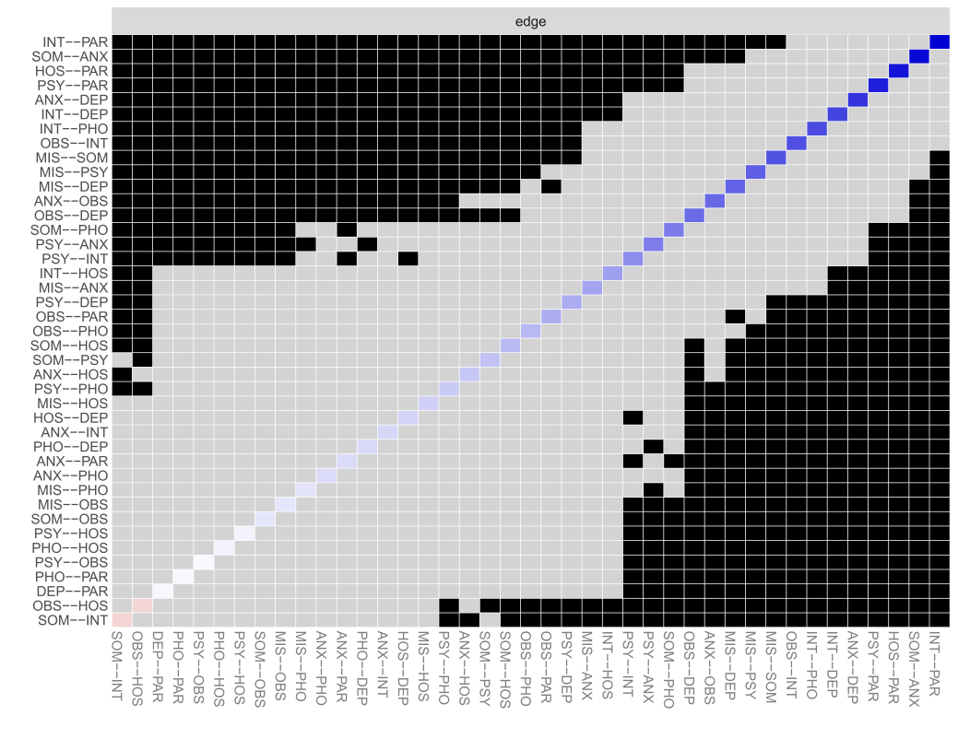
Fig. S3 Estimation of edge weight difference by bootstrapped difference test in the total sample (N = 734)
Notes: Bootstrapped difference tests between edge weights in the network. Gray boxes represent the edges do not significantly differ from one-another. Black boxes represent significant difference. Blue boxes in the edge-weight plot correspond to positive correlations. Abbreviation of each node: SOM, somatization; OBS, obsessive-compulsive symptoms; INT, interpersonal sensitivity; DEP, depression; ANX, anxiety; HOS, hostility; PHO, phobic anxiety; PAR, paranoid ideation; PSY, psychoticism; MIS, other reflecting sleep and diet.
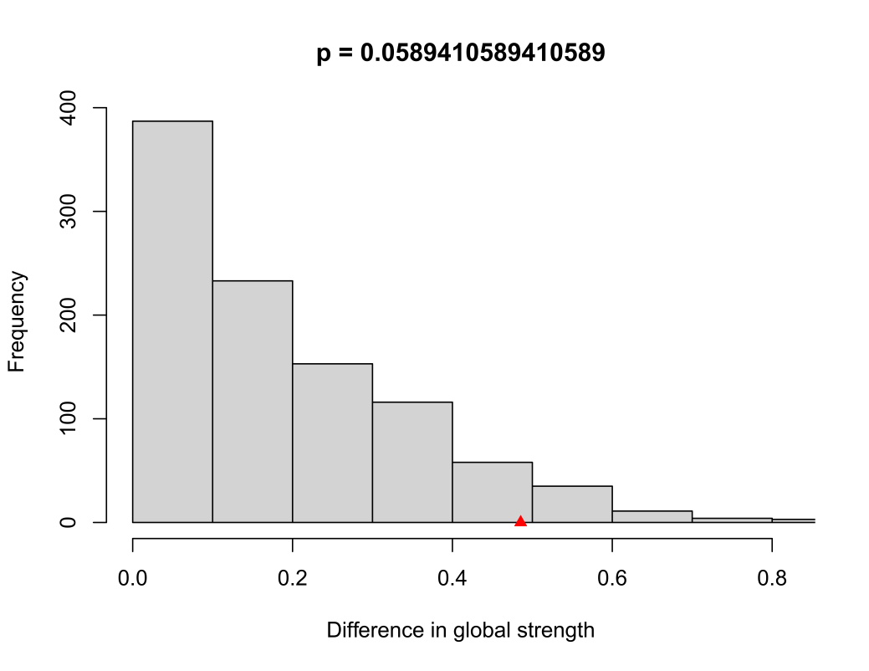
Fig. S4. Permutation distribution of the difference in global strength between male and female symptom psychological problems networks
Notes: Permutation distribution from 1000 randomizations testing global strength invariance between male (n = 240) and female (n = 494) symptom psychological problems networks. The red triangle indicates the observed difference in the original data (S = 0.485, P = 0.059). No significant difference was found. Abbreviation of each node: SOM, somatization; OBS, obsessive-compulsive symptoms; INT, interpersonal sensitivity; DEP, depression; ANX, anxiety; HOS, hostility; PHO, phobic anxiety; PAR, paranoid ideation; PSY, psychoticism; MIS, other reflecting sleep and diet.
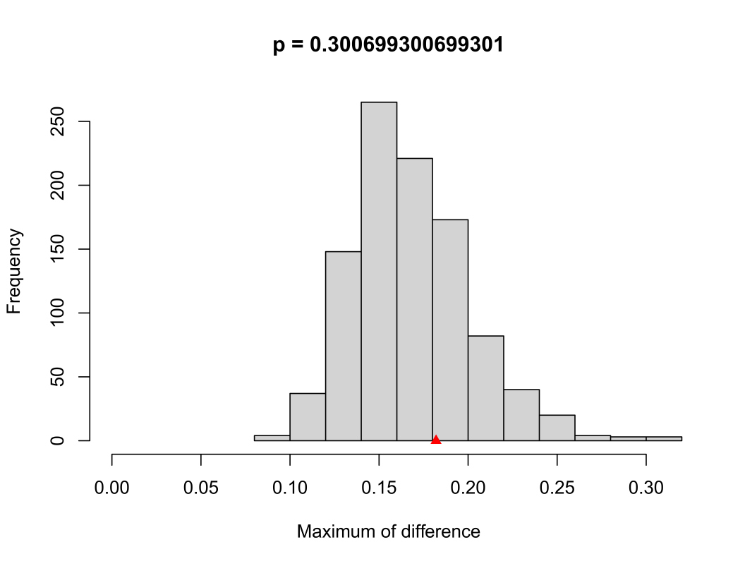
Fig. S5 Permutation distribution of the maximum difference in network structure between male and female symptom psychological problems networks
Notes: Permutation distribution from 1000 randomizations testing network structure invariance between male (n = 240) and female (n = 494) symptom psychological problems networks. The red triangle indicates the observed maximum difference in the original data (M = 0.182, P = 0.301). No significant difference was found. Abbreviation of each node: SOM, somatization; OBS, obsessive-compulsive symptoms; INT, interpersonal sensitivity; DEP, depression; ANX, anxiety; HOS, hostility; PHO, phobic anxiety; PAR, paranoid ideation; PSY, psychoticism; MIS, other reflecting sleep and diet.

