Table 1 Species, gene ID, and nomenclature of ND genes used for phylogenetic analysis.
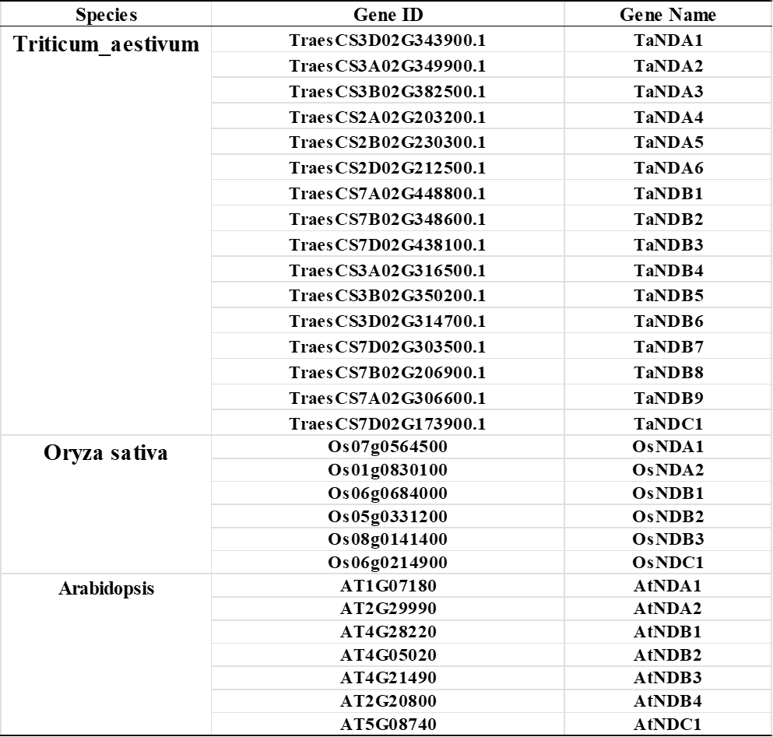
Table 2 Physical and Chemical Properties of TaNDs
