Supplementary Material

Supplementary Figure S1A. 90-day Kaplan-Meier survival curves
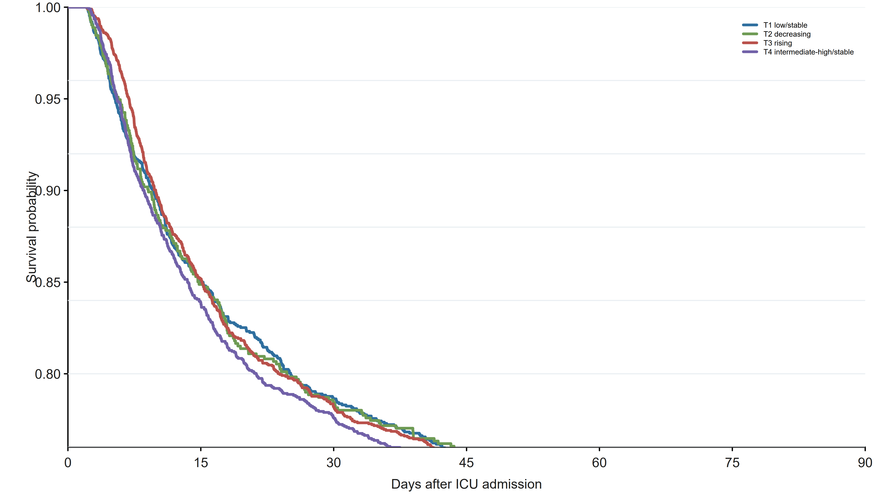
Secondary outcome survival curves by BCR trajectory group.

Supplementary Figure S1B. Number at risk for 90-day Kaplan-Meier analysis
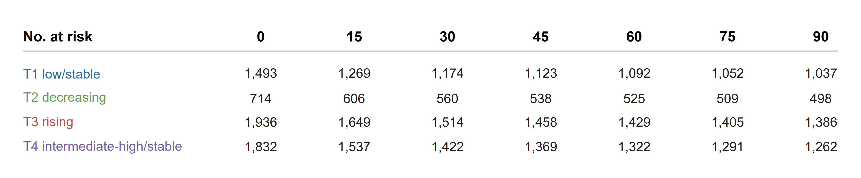
Numbers at risk are displayed at prespecified follow-up times for each BCR trajectory group.

Supplementary Figure S2. Exploratory subgroup forest plot
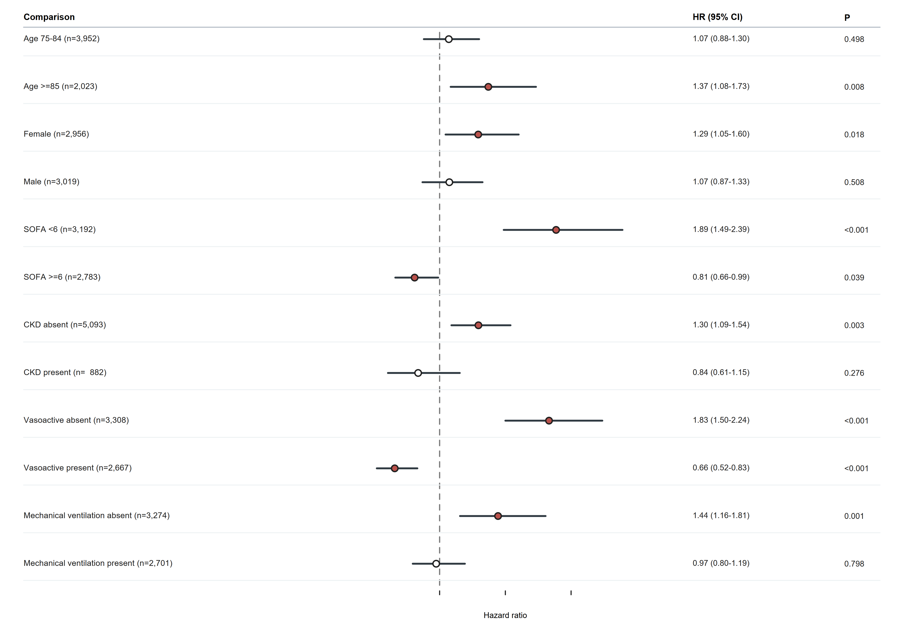
Subgroup analyses are exploratory and should not be interpreted as confirmatory interaction tests.

Supplementary Figure S3. Restricted cubic spline for day-0 BCR
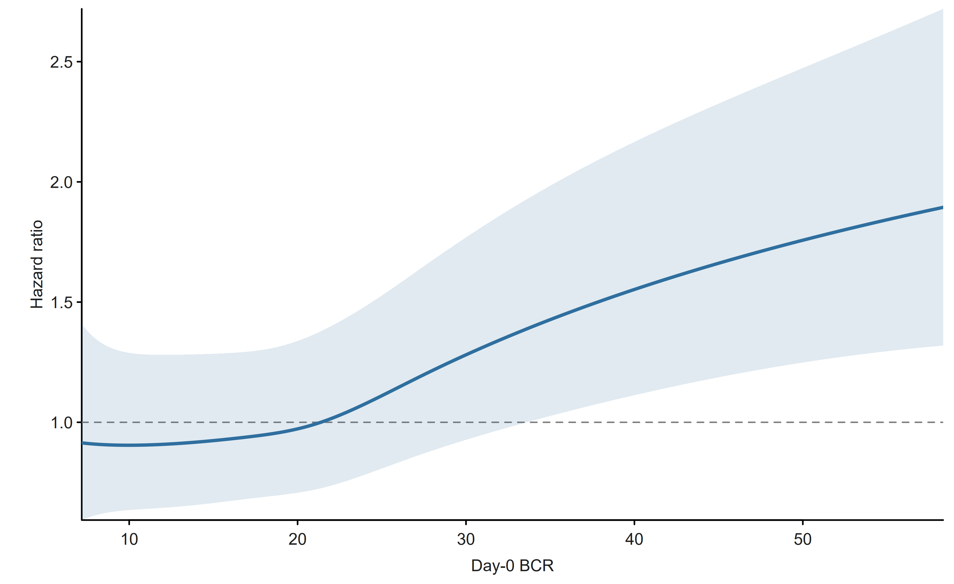
Static baseline BCR dose-response analysis for comparison with the trajectory approach.

Supplementary Figure S4. Alternative 3-class BCR trajectory solution
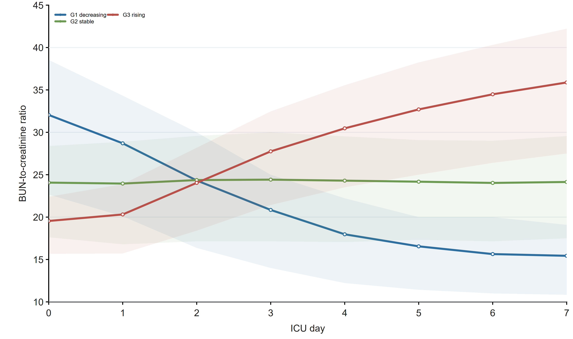
Alternative trajectory solution used only as sensitivity analysis.

Supplementary Table S1. Patient flow counts
step | n
Age >= 75, Sepsis-3, first ICU stay, ICU LOS >= 24 h, no malignancy | 6492
Available BUN/creatinine ratio during ICU day 0-7 | 6477
At least 3 days of valid BCR measurements | 5975
Assigned to the selected 4-class GBTM solution | 5975
Included in primary 28-day Cox analysis | 5975
Included in day-7 landmark sensitivity analysis | 5568

Supplementary Table S1B. Detailed patient flow counts
1 | ICU stays in MIMIC-IV | 94458
2 | Sepsis-3 ICU stays | 41296 | 53162
3 | Age >=75 years | 12049 | 29247
4 | First ICU stay only | 8707 | 3342
5 | ICU LOS >=24 h | 7697 | 1010
6 | No malignancy | 6492 | 1205
7 | At least 1 valid BCR day during ICU days 0-7 | 6477 | 15
8 | At least 3 valid BCR days during ICU days 0-7 | 5975 | 502
9 | Selected 4-class GBTM / primary 28-day Cox cohort | 5975 | 0

Supplementary Table S2. Trajectory model selection
model | conv | AIC | BIC | entropy | min_class_pct | mean_max_posterior | selected
1-class | 1 | 11941.92 | 11975.40 |  | 100.00 |  | No
2-class | 1 | 2674.06 | 2741.01 | 0.723 | 39.20 | 0.915 | No
3-class | 1 | -824.08 | -723.65 | 0.743 | 12.17 | 0.876 | No
4-class | 1 | -2111.60 | -1977.69 | 0.666 | 11.95 | 0.798 | Yes

Supplementary Table S3. Posterior classification probability by class
trajectory_group | patients | percent | mean_max_posterior_probability
T1_lowest | 1493 | 25.0 | 0.753
T2_middle | 714 | 11.9 | 0.878
T3_middle | 1936 | 32.4 | 0.856
T4_highest | 1832 | 30.7 | 0.741

Supplementary Table S4. Exploratory subgroup Cox estimates
subgroup | patients | deaths_28d | comparison | HR (95% CI) | P | HR | lower95 | upper95 | p_value
Age 75-84 | 3952 | 737 | T3_middle vs T1_lowest | 1.07 (0.88-1.30) | 0.498 | 1.0698335751254624 | 0.8799763420825607 | 1.3006530104628033 | 0.4982595512424254
Age >=85 | 2023 | 542 | T3_middle vs T1_lowest | 1.37 (1.08-1.73) | 0.008 | 1.3705705325771573 | 1.0839252231886698 | 1.7330195336194927 | 0.008458892191623497
Female | 2956 | 631 | T3_middle vs T1_lowest | 1.29 (1.05-1.60) | 0.018 | 1.2937112593430429 | 1.0451691049687066 | 1.6013569618488428 | 0.01798697977812699
Male | 3019 | 648 | T3_middle vs T1_lowest | 1.07 (0.87-1.33) | 0.508 | 1.0739456005785233 | 0.869490170476358 | 1.3264775062035339 | 0.5079137883774292
SOFA <6 | 3192 | 553 | T3_middle vs T1_lowest | 1.89 (1.49-2.39) | <0.001 | 1.8859312943964124 | 1.4876128032933464 | 2.3909022827107016 | 1.5954719768376395e-7
SOFA >=6 | 2783 | 726 | T3_middle vs T1_lowest | 0.81 (0.66-0.99) | 0.039 | 0.8098384805535853 | 0.6629380420155745 | 0.98929058678146 | 0.038881626071780286
CKD absent | 5093 | 1003 | T3_middle vs T1_lowest | 1.30 (1.09-1.54) | 0.003 | 1.295163114290728 | 1.0897869933360265 | 1.5392434511301156 | 0.0033238404046597577
CKD present | 882 | 276 | T3_middle vs T1_lowest | 0.84 (0.61-1.15) | 0.276 | 0.8366123081845631 | 0.6068937123874574 | 1.153282922395898 | 0.276048800577683
Vasoactive absent | 3308 | 750 | T3_middle vs T1_lowest | 1.83 (1.50-2.24) | <0.001 | 1.8321749813740786 | 1.5001903363533133 | 2.2376261738447316 | 2.910724498237548e-9
Vasoactive present | 2667 | 529 | T3_middle vs T1_lowest | 0.66 (0.52-0.83) | <0.001 | 0.6586066216864049 | 0.5221546072344669 | 0.8307169488105344 | 4.222515785147888e-4
Mechanical ventilation absent | 3274 | 626 | T3_middle vs T1_lowest | 1.44 (1.16-1.81) | 0.001 | 1.444388223719044 | 1.1552169305932936 | 1.8059442218759723 | 0.0012556622615994223
Mechanical ventilation present | 2701 | 653 | T3_middle vs T1_lowest | 0.97 (0.80-1.19) | 0.798 | 0.9739764274148637 | 0.7956681309215247 | 1.1922434043715429 | 0.7982671680757183

Supplementary Table S5. Outcomes by trajectory group
trajectory_group | patients | 28-day death, n (%) | 90-day death, n (%) | ICU death, n (%) | ICU LOS, median (IQR)
T1_lowest | 1493 | 315 (21.1) | 456 (30.5) | 164 (11.0) | 3.2 (1.9-6.5)
T2_middle | 714 | 151 (21.1) | 216 (30.3) | 69 (9.7) | 2.8 (1.8-4.8)
T3_middle | 1936 | 411 (21.2) | 550 (28.4) | 215 (11.1) | 4.4 (2.3-8.9)
T4_highest | 1832 | 402 (21.9) | 570 (31.1) | 167 (9.1) | 3.2 (2.0-5.5)

Supplementary Table S6. Trajectory day-0 and day-7 BCR summary
trajectory_group | day0_mean | day7_mean
T1_lowest | 22.05076894839771 | 23.98196217676979
T2_middle | 32.548633893685256 | 15.393098262609598
T3_middle | 19.13638584155854 | 36.064970750489145
T4_highest | 25.766326845495072 | 24.93880707984406

Supplementary Table S7. Vital-sign quality control
variable | lower_bound | upper_bound | original_missing | implausible_low | implausible_high | clean_missing
hr_mean | 20 | 220 | 4 | 0 | 1 | 5
map_mean | 30 | 130 | 0 | 0 | 4 | 4
map_min | 20 | 130 | 20 | 189 | 0 | 209
resp_rate_mean | 4 | 80 | 13 | 1 | 1 | 15
temperature_c_mean | 30 | 43 | 334 | 11 | 7 | 352
spo2_mean | 50 | 100 | 4 | 0 | 4 | 8

