Supplementary methods
Immunofluorescence staining of spinal cord tissue from experimental autoimmune encephalomyelitis (EAE) mice
Mice were sacrificed at day 15 post EAE induction and spinal cord tissue was snap frozen. Sections were prepared and dried at RT for 30 min, after which they were fixed in cold acetone (4°C) for 10 min, and subsequently dried at RT for 30 min. Sections were washed three times for 5 min with PBS and blocked with 0.05% Triton-X and 10% Dako protein block (Agilent) in PBS for 20 min at RT. Sections were incubated overnight at 4°C with following primary antibodies: rat anti-MBP (Sigma-Aldrich; #MAB386, 1/500 in block buffer) and rabbit anti-Ly6G (Fisher scientific, Hampton, NH, USA; Clone 1A8, 1/500 in block buffer), followed by 3 PBS washes. Sections were then incubated with following secondary antibodies: AF555 goat anti-rat (1/400 in PBS, Invitrogen) and AF488 goat anti-rabbit (1/500 in PBS, Invitrogen) for 1 h at RT, washed and stained with DAPI for 10 min at RT. Finally, sections were incubated with 0.3% Sudan Black (Merck, Darmstadt, Germany) in 70% ethanol to limit autofluorescence and mounted with Fluoromount-G™ Mounting Medium (Invitrogen). Sections were imaged using a Leica DM2000 LED microscope (Leica Microsystems, Wetzlar, Germany).

Supplementary figures
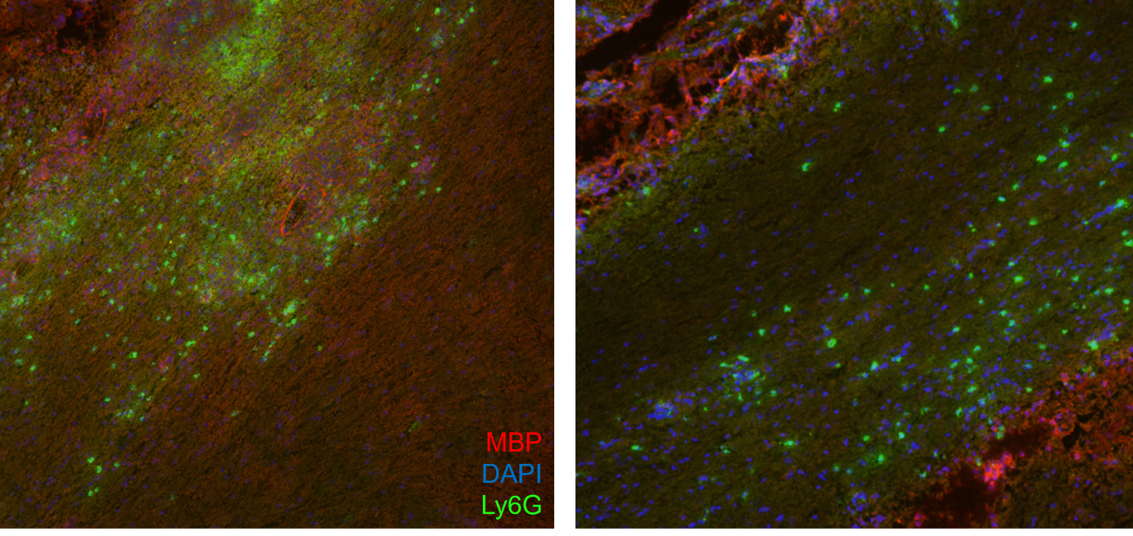
Supplementary Figure 1 | Neutrophils are present in EAE spinal cord tissue in demyelinated regions. Mice with EAE (n=6 per group) were sacrificed at day 15 post EAE induction and spinal cord tissue was fixed (10% paraformaldehyde) and stained. Red = MBP (555), Blue = DAPI, Green = Ly6G (488)

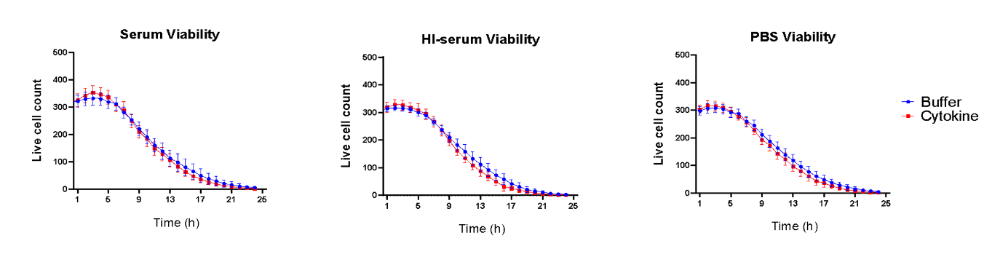
Supplementary figure 2 | Effect of opsonized myelin on neutrophil viability over time. Calcein-labelled purified neutrophils (n=5) from healthy donors were incubated with pHrodo-labelled myelin debris, whereby fluorescent images were generated every hour for 24 h with the IncuCyte imaging system. Viability of human neutrophils (calcein green positive cells) in buffer conditions (PBS) and after addition of cytokines (50 ng/mL TNF-α, 10 ng/mL IFN-γ and 10 ng/mL IL-1β) over 24 h, analyzed with the IncuCyte imaging system. Normally distributed data are represented as the mean ± SEM. HI serum: heat-inactivated serum.

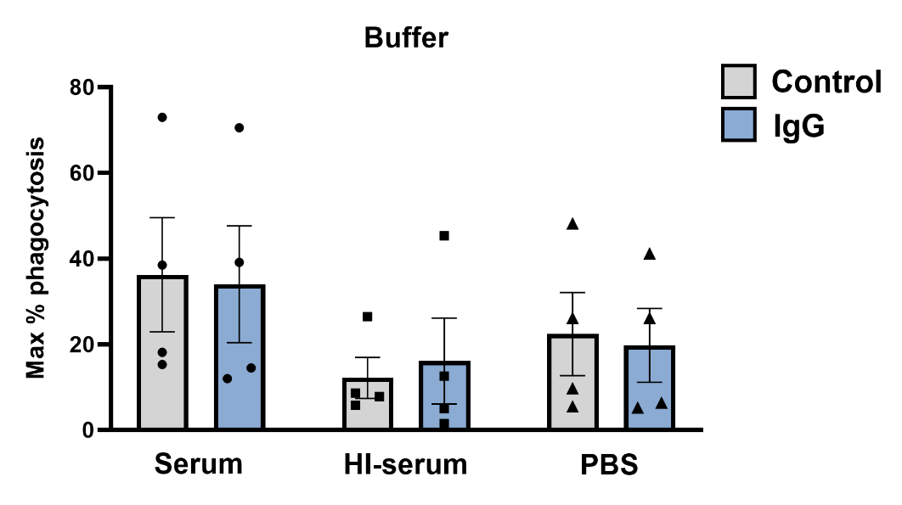
Supplementary figure 3 | Blocking Fc receptors does not impact myelin phagocytosis. Myelin phagocytosis assays with healthy, human neutrophils (n=4) were performed as previously described. Thereby, human neutrophils were pre-treated for 15 min with buffer (control) or IgG antibodies (100 µg/mL) to block Fc receptors. The percentage phagocytosis was calculated as previously described. Normally distributed data are represented as the mean ± SEM. Data were analyzed using the paired Student’s t-test. IgG: Immunoglobulin G, HI serum: heat-inactivated serum.

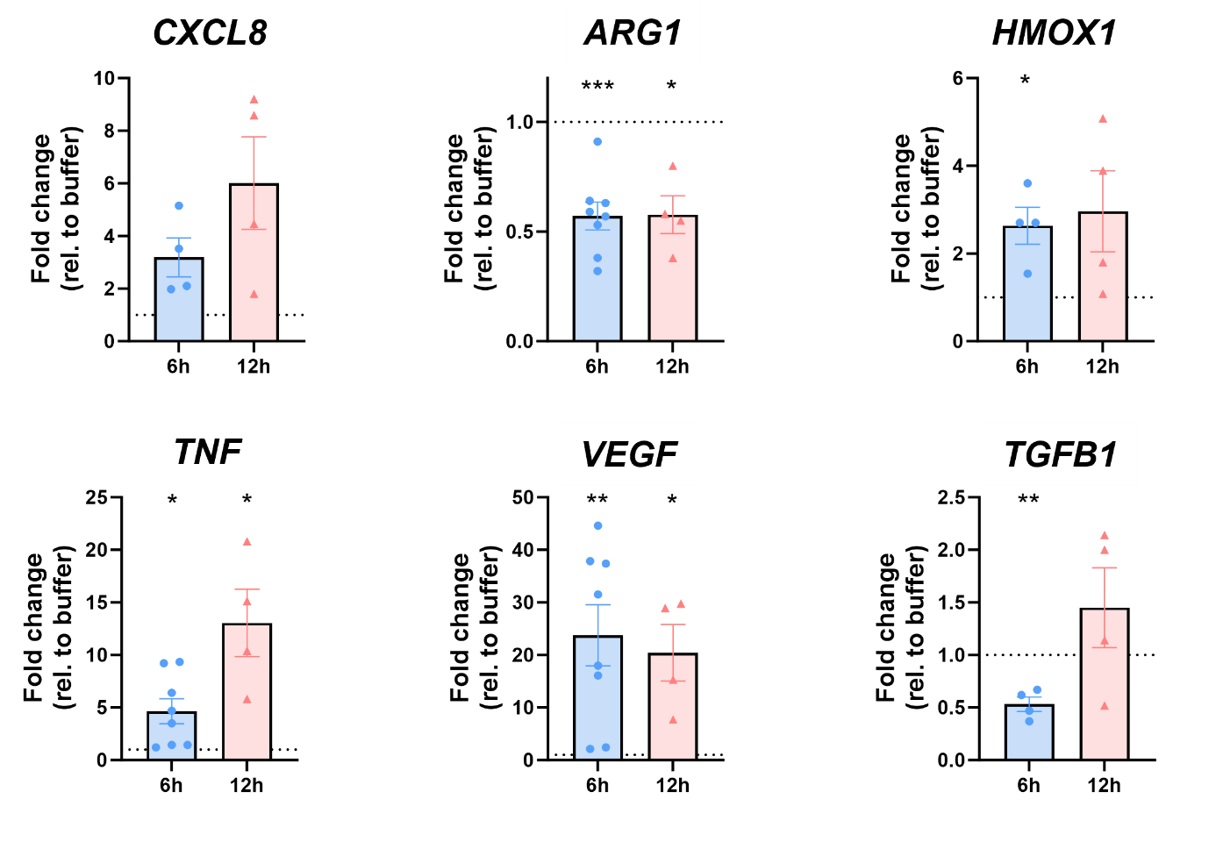
Supplementary figure 4 | Gene expression levels in human neutrophils after 6 or 12 hours of cytokine stimulation. Human neutrophils (n=4) were incubated for 6 or 12 h with a cytokine mix (50 ng/mL TNF-α, 10 ng/mL IFN-γ and 10 ng/mL IL-1β) or RPMI (buffer). Afterwards, mRNA was isolated and qPCR was performed. Data were normalized to the expression of the housekeeping gene 18S and are represented as fold change relative to buffer-stimulated neutrophils, and are represented as the mean ± SEM. Normally distributed data were analyzed using the one-sample Student’s t-test, with comparison value set at 1; *p<0.05, **p<0.01,***p<0.001.

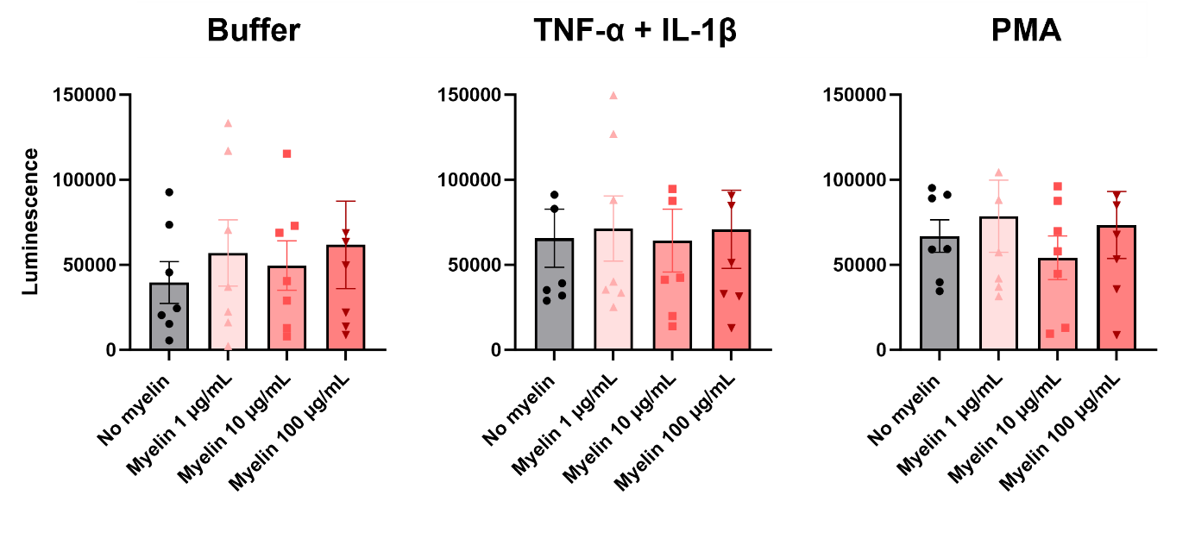
Supplementary figure 5 | The production of reactive oxygen species by neutrophils after 6 hours of myelin uptake. Purified neutrophils from healthy donors (n=7) were cultured with or without serum-opsonized myelin debris at different concentrations (1, 10 or 100 µg/mL) for 6 hours. Afterwards, cells were harvested, counted and a chemiluminescence-based ROS assay was performed. Therefore, 0.1 x 10⁶ cells were added to each well, and stimulated with RPMI buffer, PMA (150 ng/mL) or a combination of cytokines (priming for 10 min with 10 ng/mL TNF-α and subsequent stimulation with 10 ng/mL IL-1β). Afterwards, luminol (2 mM) was added to the cells, and luminescence was measured for 3 hours at 37°C in a CLARIOstar microplate reader. Maximal luminescence values over time are shown. Normally distributed data are represented as the mean ± SEM. Data were analyzed using a one-way ANOVA.

