Schedule 1 REFA classification of workload Grade Work intensity
Grade | Work intensity | Example
0 | Work without special physical strain | Work without load like, for example, desk work
1 | Work with small physical strain | Handling light work pieces; lengthy standing or walking around
2 | Work with moderate physical strain | Handling of 1–3 kg control device; carrying loads of 10–15 kg; climbing stairs or ladders without load
3 | Work with hard physical strain | Carrying loads of 20–30 kg, shovelling, digging, chipping, climbing stairs or ladders with moderate load, moderate work in tense work posture
4 | Work with most heavily physical strain | Carrying loads of more than 50 kg, climbing with heavy load, hard work in tense work posture

Schedule 2 Watanabe classification of discoid lateral meniscus
Type | Description
I | Complete
II | Incomplete
III | Wrisberg ligament variant, lack of posterior meniscotibial attachment to the tibia
Schedule 3 Meniscus tear O'Connor classification
Meniscus tear type | Schematic diagram
longitudinal (/bucket handle) tear | 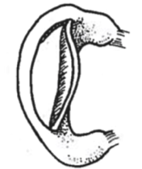
horizontal tear | 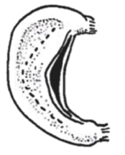
oblique tear | 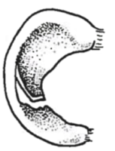
transverse (/radiation) tear | 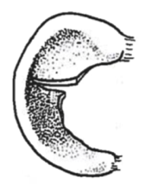
variant tear (including flap,  composite, degenerate meniscus tear) | 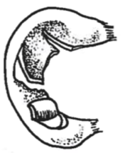

Schedule 4. Outerbridge classification
Grade | Pathology
I | Softening and swelling of articular cartilage
II | Fragmentation and fissuring of articular cartilage affecting an area of less than 0.5 inches
III | Fragmentation and fissuring of articular cartilage affecting an area greater than 0.5 inches
IV | Cartilage erosion to bone

Schedule 5 Kellgren-Lawrence Classification criteria of knee Osteoarthritis
Grade 0 normal
Grade 1 Doubtful narrowing of joint space and possible osteophytic lipping
Grade 2 Definite osteophytes and possible narrowing of joint space
Grade 3 Moderate multiple osteophytes, definite narrowing of joint space and some sclerosis and possible deformity of bone ends
Grade 4 Large osteophytes, marked narrowing of joint space, severe sclerosis and definite deformity of bone ends
Schedule 6. IKDC score system
