Supporting Information

Preparation of Au/RuO₂ multifunctional nanocomposite and its application in chemodynamic-photothermal synergistic antibacterial
Yingying Zhong^{#a,b}, Junsong Yang^{#c}, Jia Liuª, Xiaorui Luª, Chengxin Linª, Sujian Cao,^{d} Minglei Lu^{*e}, Hongwu Wang^{*a,b}
ªSchool of Food & Pharmaceutical Engineering, Zhaoqing University, Zhaoqing, 526061, People’s Republic of China.
^{b}Laboratory of Quality & Safety Risk Assessment for Agro-products (Zhaoqing), Ministry of Agriculture and Rural Affairs, Zhaoqing, 526061, People’s Republic of China.
^{c}School of Environmental and Chemical Engineering, Zhaoqing University, Zhaoqing, 526061, People’s Republic of China
^{d}State Key Laboratory of Respiratory Disease, Guangzhou Medical University, Guangzhou, 510030, People’s Republic of China
^{e}School of Food & Pharmaceutical Science and Technology, Guangzhou College of Technology and Business, Guangzhou, 510850, People’s Republic of China
*Corresponding Author:
Prof. Hongwu Wang
E-mail address: hwwang@zqu.edu.cn
Dr. Minglei Lu
E-mail address: luminglei@gzgs.edu.cn

Experimental section
Materials and instruments
Chloroauric acid (HAuCl₄), ruthenium chloride trihydrate (RuCl₃·xH₂O), disodium citrate sesquihydrate, hydrogen peroxide (H₂O₂), 3,3’,5,5’-tetramethylbenzidine (TMB), 3-[4,5- dimethylt hiazol-2-yl] 2,5-diphenyl-tetrazolium bromide (MTT), dulbecco’s modified Eagle medium (DMEM) were offered by Sigma Aldrich (Shanghai, China). Sodium dihydrogen phosphate, disodium hydrogen phosphate, dimethyl sulfoxide (DMSO), 2,2-dimethyl-3,4-dihydro-2H-pyrrole 1-oxide (DMPO), 4-oxo-2,2,6,6-tetramethylpiperidine (TEMP), crystal violet (CV), acetic acid, cycloheximide were purchased from Aladdin Ltd. (Shanghai, China). Staphylococcus aureus (ATCC 6538) and Escherichia coli (CMCC 44102) were obtained from Guangdong culture collection center.
The morphology and elemental analysis of Au/RuO₂ nanocomposite were monitored by Transmission electron microscope (TEM, HT7700, Hitachi, Japan). The X-ray diffractograms of Au/RuO₂ nanocomposite was gained via X-ray diffraction (XRD, D8 ADVANCE, Bruker, Germany). X-ray photoelectron spectroscopy (XPS, Escalab 250Xi, Thermo Fisher, UK) was applied to determine the Au and Ru valence state of Au/RuO₂ nanocomposite. Microplate reader (Infinite 200, Tecan, Austria) was used for measuring the UV absorption spectra and absorbance of the reaction system, and explore the steady-state kinetic of Au/RuO₂ nanocomposite. Bruker A300 spectrometer (Bruker, Germany) was utilized to monitor the generation of HO∙ and ¹O₂. The photothermal signal was collected by an Hti-HT-A9 thermal infrared imager (Xintai, Dongguan, China). Iphone 14 pro was used for taking the photos.
Investigation of peroxidase-like activity of Au/RuO₂ multifunctional nanocomposite
The peroxidase-like activity of Au/RuO₂ multifunctional nanocomposite prepared under the condition of n_{Au} : n_{Ru} = 1:1 was first evaluated through whether it could catalyze the oxidation of the chromogenic substrate TMB in the presence of H₂O₂. Briefly, the following four different reaction systems were set up: (1) 5 μL of Au/RuO₂ nanocomposite + 200 μL of fresh TMB working solution (containing 10 mM H₂O₂), (2) 5 μL of Au/RuO₂ nanocomposite + 200 μL of fresh TMB working solution (without H₂O₂), (3) 5 μL of Au/RuO₂ nanocomposite + 200 μL of H₂O, (4) 5 μL of H₂O + 200 μL of fresh TMB working solution (containing 10 mM H₂O₂). All the above reaction systems were allowed to react at room temperature (25 ℃) for 10 min. During this period, the absorbance changes of the systems at 650 nm were rapidly measured via a microplate reader (once every 30 s) to plot a time-dependent curve. After 10 min of reaction, the UV-Vis absorption spectra of each group in the range of 450~800 nm were quickly recorded by the microplate reader. The peroxidase-like activity of Au(Ru) nanocomposites prepared with other n_{Au} : n_{Ru} ratios (1:4, 2:3, 3:2 and 4:1) was also measured according to the steps described above.
The catalytic property of Au/RuO₂ multifunctional nanocomposite was further explored by steady-state kinetic assay. In short, 5 μL of Au/RuO₂ nanocomposite solution (50 μg/mL), and 200 μL of reaction substrate solution were reacted at room temperature (25 ℃) for 10 min in 96-well plate. The reaction substrate solution was divided into two groups: one group contained 10 mM H₂O₂ and a series of TMB concentrations (2, 1, 0.5, 0.125, 0.0625 mM), and the other group contained 2.0 mM TMB and a series of H₂O₂ concentrations (10, 5, 2.5, 1.25, 0.625, 0.3125, 0.15625 mM). After that the absorbance of the system was measured at 650 nm using a microplate reader. A group without reaction substrate solution was set as the blank control, and all results obtained were removed the blank value. The concentration of oxTMB (μM) produced during the reaction time was calculated according to the following Lambert-Beer:
$A=ξbc$ (1)
Where A is the absorbance value of the system measured at 650 nm, ξ represents the molar absorption coefficient of oxTMB (3.9×10⁷/mM·cm) [1], b is the thickness of the absorption layer (0.3 cm in the reaction system), and c represents the concentration of oxTMB (μM).
Then the concentration of oxTMB produced per unit time (V₀, μM/min) was obtained on the basis of the following formula:
$V_{0}=\frac{c}{t}$ (2)
Where t is the reaction time, and it is 10 min in this assay.
After that, a double-reciprocal (Lineweaver-Burk) plot was constructed with “1/V₀” as the ordinate and “1/[S]” as the abscissa (where [S] is the substrate concentration, mM). Finally, the maximum reaction velocity V_{max} (mM/s) and the Michaelis constant K_{m} (mM) were obtained from the intercept and slope of the following curve, respectively:
$\frac{1}{V_{0}}=\frac{K_{m}}{V_{max}}（\frac{1}{[S]}+\frac{1}{K_{m}}）$ (3)

Investigation of photothermal performance of Au/RuO₂ multifunctional nanocomposite
The photothermal conversion efficiency (η) can be calculated using the following equation:
$η=\frac{hA\left({ΔT}_{max, sur}- ΔT_{solvent max, sur}\right)}{I\left(1-{10}^{{-A}_{808}}\right)}×100\%$ (4)
where I represents the incident laser power (1 W/cm²) employed and A₈₀₈ is the absorbance intensity of Au/RuO₂ solution (10 μg/mL) at 808 nm. h is the heat transfer coefficient, and A is the surface area of the container, ΔT_{max, sur} refers to the difference between the maximum temperature of Au/RuO₂ solution during the heating process and the ambient temperature of the surrounding, ΔT_{solvent} _{max, sur} is the difference between the maximum temperature of solvent (water) during the heating process and the ambient temperature of the surrounding.
Moreover, the calculation of hA is in accordance with the following equations:
$t=\frac{\sum_{i}{m_{i}C_{p,i}}}{hA}×lnθ$ (5)
$θ=\frac{{ΔT}_{ }}{{ΔT}_{max, sur}}$ (6)
Here t is the cooling time, ΔT refers to the difference between the temperature of Au/RuO₂ solution during the heating process and the ambient temperature of the surrounding, m_{i} and C_{p,i} are the mass and specific heat capacity of the solvent and Au/RuO₂ nanocomposite, respectively. Since the specific heat capacity of the Au/RuO₂ nanocomposite can be ignored, so the term ∑_{i} m_{i} C_{p,i} in equation (5) can be calculated as m_{water} (1.0 g) × C_{p},_{water} (4.2 J/g∙°C) = 4.2 J/°C. Therefore, make t as the vertical axis and ln$θ$ as the horizontal axis to plot, and the hA value can be obtained from the slope of the curve. The photothermal conversion efficiency (η) can then be calculated by substituting this hA value into equation (4).
The photothermal performance of Au(Ru) nanocomposites prepared with other n_{Au} : n_{Ru} ratios (1:4, 2:3, 3:2 and 4:1) was also measured according to the steps described above.
Antibacterial capability of Au/RuO₂ multifunctional nanocomposite
The growth inhibition effects of Au/RuO₂ multifunctional nanocomposite against Staphylococcus aureus (S. aureus) and Escherichia coli (E. coli) were determined at different concentrations (23.08, 11.54, 5.77, 2.88, 1.44, 0.72, 0 μg/mL) under various conditions. Typically, lyophilized S. aureus and E. coli stock (200 μL) was first revived by culturing overnight in Mueller-Hinton (MH) broth media (100 mL). Then, the above high concentration bacterial solution was diluted with MH broth media to a concentration of about 10⁶ ~ 10⁷ CFU/mL, when the optical density of the bacterial solution at 612 nm was about 0.01. Next, the following six experimental groups were set: (1) 200 μL MH broth media + 1100 μL H₂O (blank control group), (2) 200 μL bacterial suspension + 1100 μL H₂O (negative control group), (3) 300 μL Au/RuO₂ multifunctional nanocomposite solution at different concentrations + 200 μL bacterial suspension + 800 μL H₂O (Au/RuO₂ intrinsic antibacterial group), (4) 300 μL Au/RuO₂ multifunctional nanocomposite solution at different concentrations + 200 μL bacterial suspension + 800 μL H₂O + 808 nm laser irradiation (1 W/cm², 10 min) (PTT antibacterial group), (5) 300 μL Au/RuO₂ multifunctional nanocomposite solution at different concentrations + 200 μL bacterial suspension + 800 μL H₂O₂ (2 mM) (CDT antibacterial group), (6) 300 μL Au/RuO₂ multifunctional nanocomposite solution at different concentrations + 200 μL bacterial suspension + 800 μL H₂O₂ (2 mM) + 808 nm laser irradiation (1 W/cm², 10 min) (CDT-PTT synergistic antibacterial group).
After the above treatments, 40 μL mixed solution was taken from each group and spread onto 20 mL of solid agar media. The solid agar media were then placed in a constant temperature incubator at 37 °C and cultured for 24 h. After that, the bacterial colony growth on the solid agar media was observed with a smartphone to obtain the antibacterial effects of the Au/RuO₂ multifunctional nanomaterial at different concentrations under different conditions.
Cytotoxicity of Au/RuO₂ multifunctional nanocomposite
The cytotoxicity of the Au/RuO₂ multifunctional nanocomposite was evaluated using the 3-[4,5- dimethylt hiazol-2-yl] 2,5-diphenyl-tetrazolium bromide (MTT) method on 3T3 (mouse fibroblast) cell line [2]. In short, 3T3 cells were cultured in Dulbecco’s modified Eagle medium (DMEM) with 100 IU/mL of penicillin, 10% of fetal bovine serum (FBS) and 100 IU/mL of streptomycin, and at 37 °C under 5% CO₂. And the cells with the concentration of 1 × 10⁵ cells/mL were plated onto 96-well plate (100 µL/well) and incubated overnight at 37 °C under 5% CO₂. Then supernatant was removed and 200 µL of fresh medium containing 150 µg/mL (or 34.62 µg/mL) of the Au/RuO₂ multifunctional nanocomposite (final concentration 100 µg/mL or 23.08 µg/mL) was added, followed by further incubation for 48 h. After that, the medium was carefully aspirated and 100 µL of MTT solution (0.5 mg/mL) was added. After further incubating for 4 h 100 µL of DMSO was added to dissolve the blue-purple insoluble formazan crystals produced by mitochondrial activity. Finally, the absorbance was measured at 570 nm by using a microplate reader. A group treated with cycloheximide (final concentration 23.08 µg/mL) was served as the positive control, while a group without the Au/RuO₂ nanocomposite and cycloheximide was served as the blank control. All the experiments were performed in triplicate and the cell viability was calculated using the following formula:
$$Cell viability\left(\%\right)=\frac{A_{1}}{A_{0}}×100\%$$
Where A₀ is the absorbance of the blank control group and A₁ is the absorbance of the text group.

Results
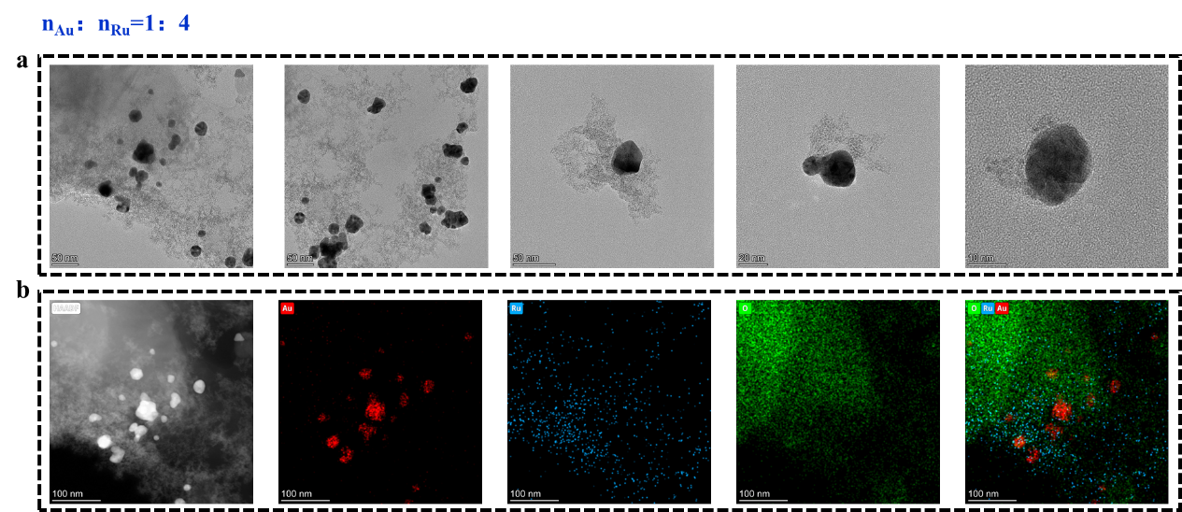
Fig. S1. TEM image (a) and EDS mapping image (b) of the Au(Ru) nanocomposite prepared with a n_{Au}:n_{Ru} ratio of 1:4.

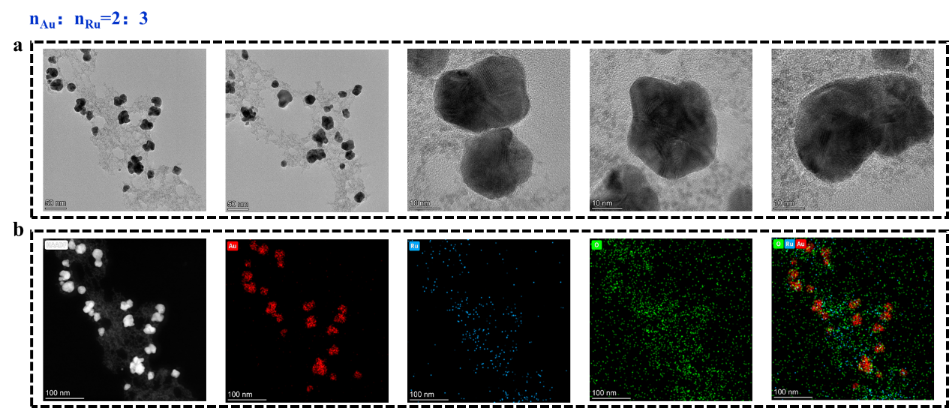
Fig. S2. TEM image (a) and EDS mapping image (b) of the Au(Ru) nanocomposite prepared with a n_{Au}:n_{Ru} ratio of 2:3.

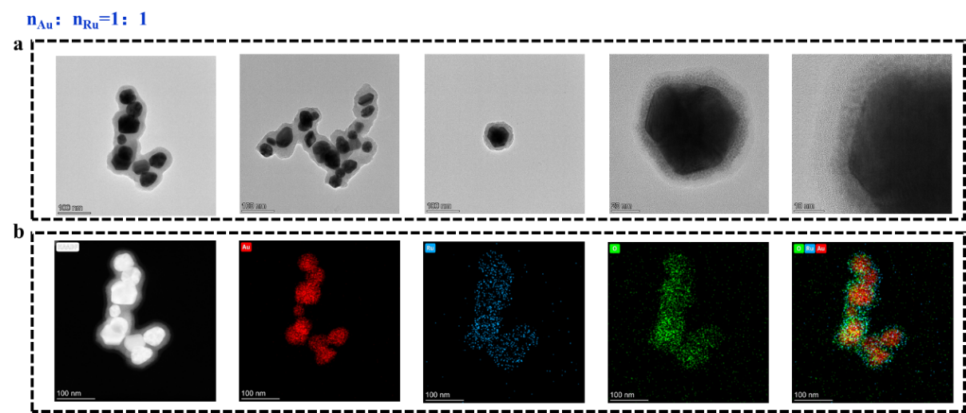
Fig. S3. TEM image (a) and EDS mapping image (b) of the Au(Ru) nanocomposite prepared with a n_{Au}:n_{Ru} ratio of 1:1.

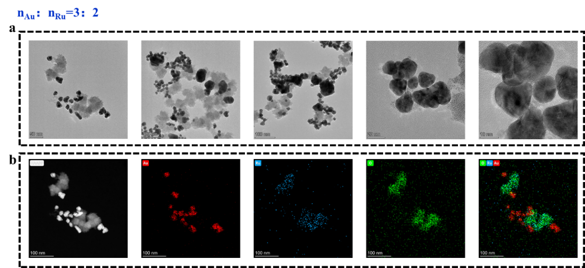
Fig. S4. TEM image (a) and EDS mapping image (b) of the Au(Ru) nanocomposite prepared with a n_{Au}:n_{Ru} ratio of 3:2.

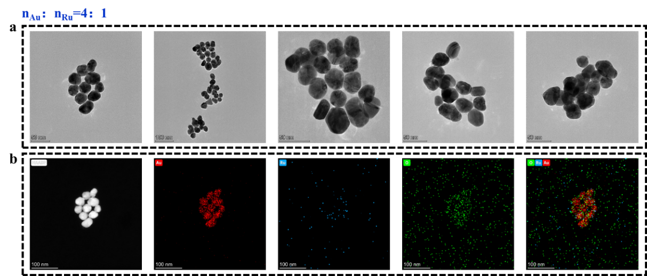
Fig. S5. TEM image (a) and EDS mapping image (b) of the Au(Ru) nanocomposite prepared with a n_{Au}:n_{Ru} ratio of 4:1.

When the n_{Au}:n_{Ru} ratio is 1:4 (with the amount of Au precursor much lower than that of Ru precursor), the TEM image (Fig. S1a) clearly shows two distinct phases: one consists of darker, well-dispersed nanoparticles, and the other appears as lighter, continuous agglomerated structures. Combined with the EDS mapping image (Fig. S1b), it is evident that the dark dispersed particles are mainly enriched in Au, while the light flaky agglomerated regions are dominated by a large amount of O and a small amount of Ru.
At an n_{Au}:n_{Ru} ratio of 2:3 (Au precursor slightly less than Ru precursor), the products still contain distinguishable dark Au-rich particles and light Ru, O-rich agglomerates. However, compared to the 1:4 group, the light Ru, O-rich agglomerates are no longer distributed as large independent areas but are mainly aggregated around the dark Au-rich particles (Fig. S2).
When the n_{Au} : n_{Ru} ratio is increased to 3:2 (Au precursor slightly more than Ru precursor), the TEM and EDS mapping results (Fig. S4) reveal two mutually independent types of nanoparticles in the system: dark particles are Au NPs, and light particles are RuO_{x} NPs with highly overlapping Ru and O elements. However, these two types do not effectively combine to form a core-shell structure.
When the ratio reaches 4:1 (excess Au precursor), the TEM image (Fig. S5a) shows only a single dark particle phase, and the EDS mapping image (Fig. S5b) exhibits that the elemental distribution is dominated by Au, with a very low content of Ru.

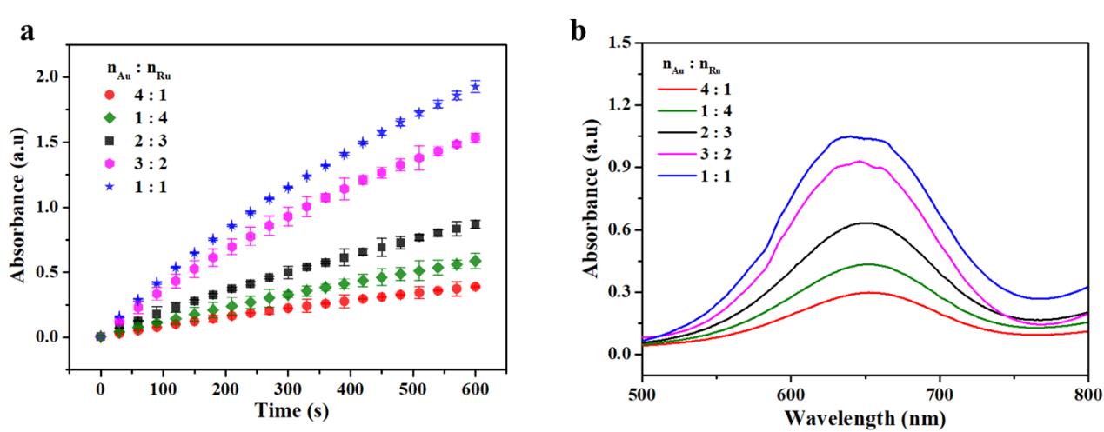
Fig. S6. Comparison of the peroxidase-like activities of Au(Ru) nanocomposites prepared with different n_{Au}:n_{Ru} ratios. (a) Time-dependent curves, (b) UV-Vis absorption spectra (500~800 nm).

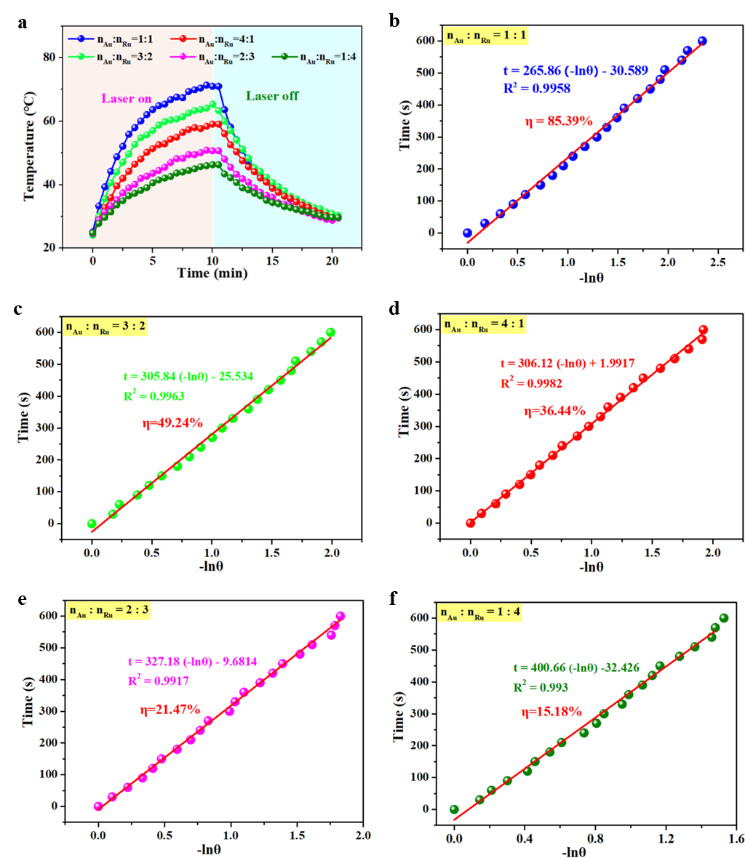
Fig. S7. Photothermal performance of Au(Ru) nanocomposites prepared with different n_{Au}:n_{Ru} ratios. (a) Heating-cooling curves of these Au(Ru) nanocomposites under 808 nm (1.0 W/cm²) irradiation; (b-f) Linear relationship plots of -ln(θ) versus time obtained from the cooling stage in (a), and the photothermal conversion efficiencies of these Au(Ru) nanocomposites.
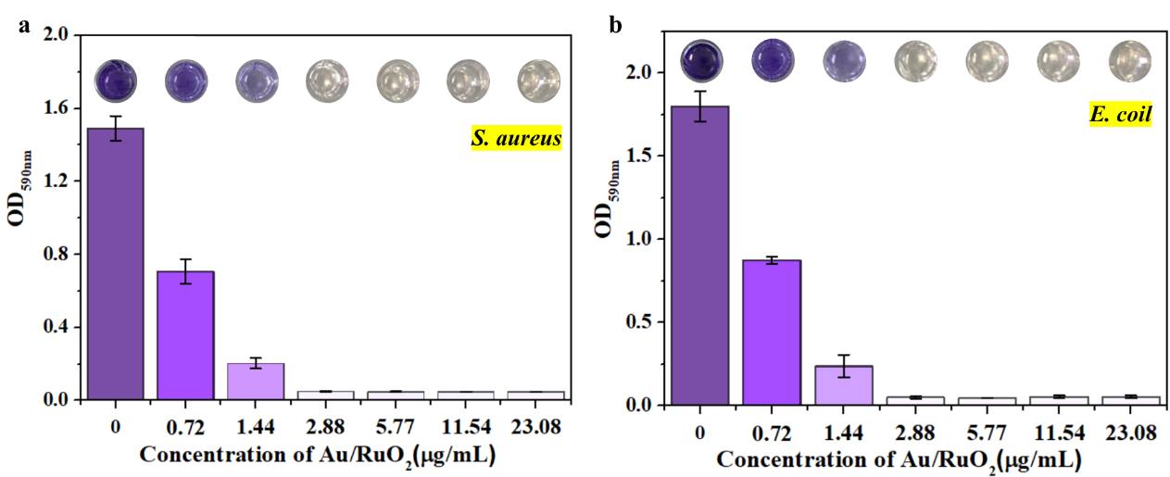
Fig. S8. Photographs and absorbance values at 590 nm of 0.1% CV-stained biofilms dissolved by 33% acetic acid. (a) S. aureus, (b) E. coli.

Reference
- Rodriguez‐Abetxuko A, Muñumer P, Okuda M, Calvo J, Knez M, Beloqui A (2020) Nanoconfined (bio) catalysts as efficient glucose-responsive nanoreactors. Adv Funct Mater 30: 2002990.
- Zhong Y, Chen H, Wu P, Zhang B, Yang Y, Zhu Q, Zhang C, Zhao S (2019) Synthesis and biological evaluation of novel oleanolic acid analogues as potential α-glucosidase inhibitors. Eur J Med Chem 164: 706-716.

