Supplementary Information (SI)

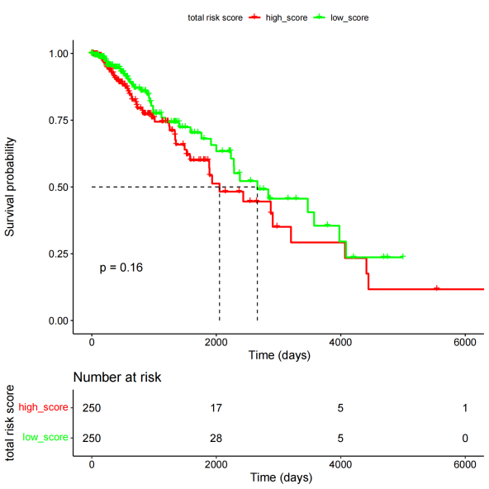
(A)

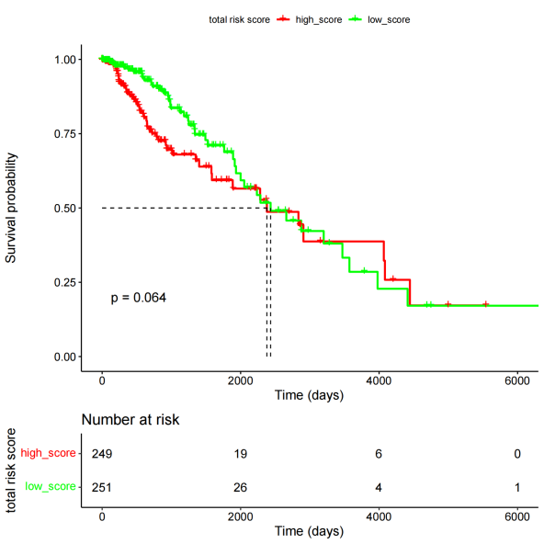
(B)
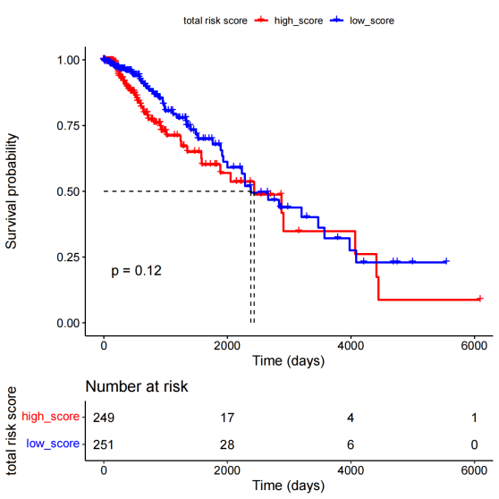
(C)
Supplementary Figure S1: Survival curves of the TCGA-LGG dataset (expression expressed as TPM number), none of (A) MGMT; (B) TERT; (C) MGMT+TERT, showed significant differences.

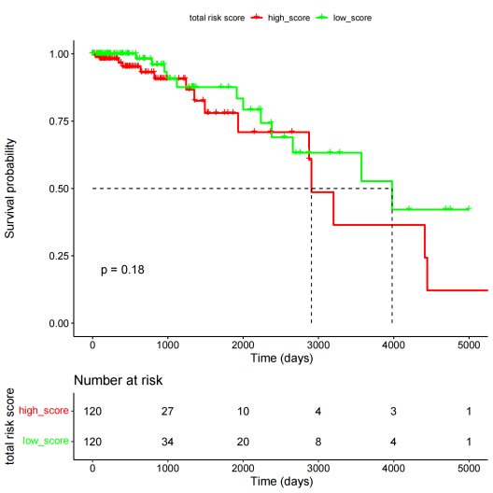
(A)
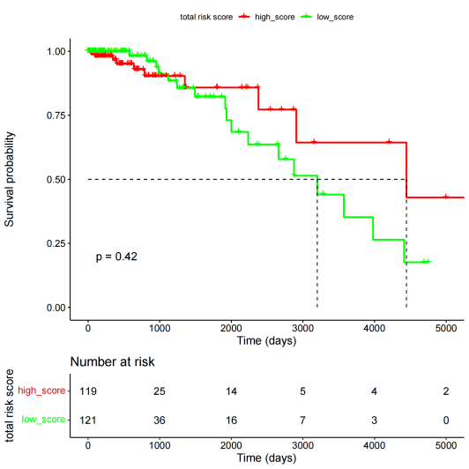
(B)
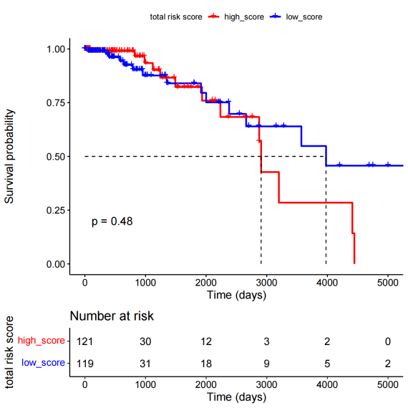
(C)
Supplementary Figure S2: Survival curves of grade II in the TCGA-LGG dataset (expression expressed as TPM number), (A) MGMT; (B) TERT; (C) MGMT+TERT, none of which showed significant differences.

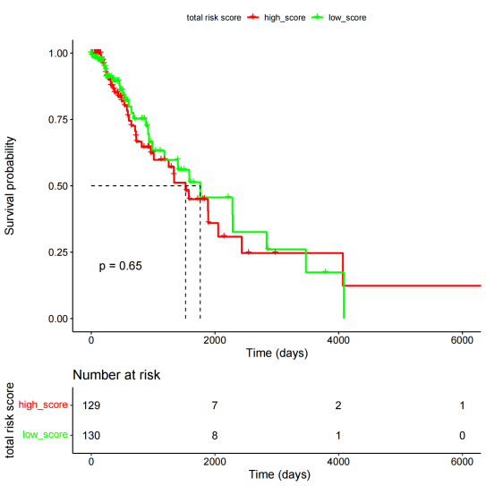
(A)
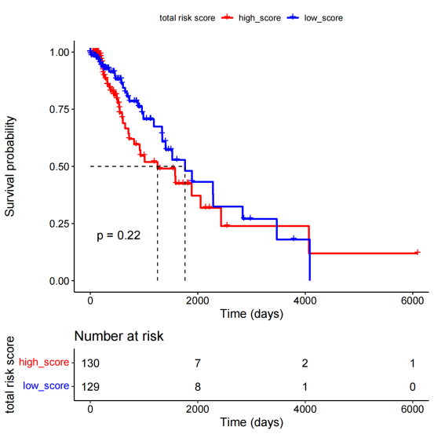
(B)
Supplementary Figure S3: Survival curves of TCGA-LGG dataset grade III (expression expressed as TPM number) (A) MGMT; (B) MGMT+TERT, neither of them shows significant difference.

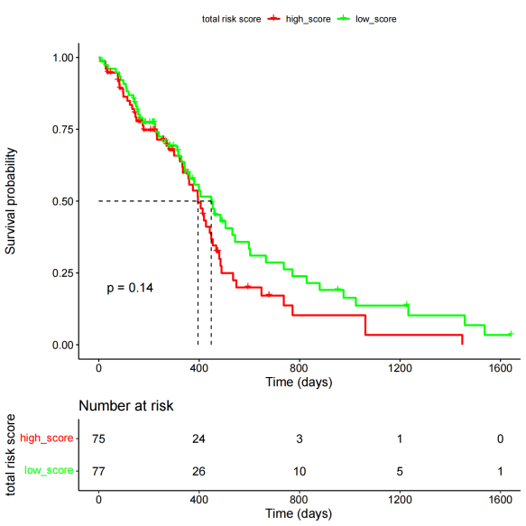
(A)
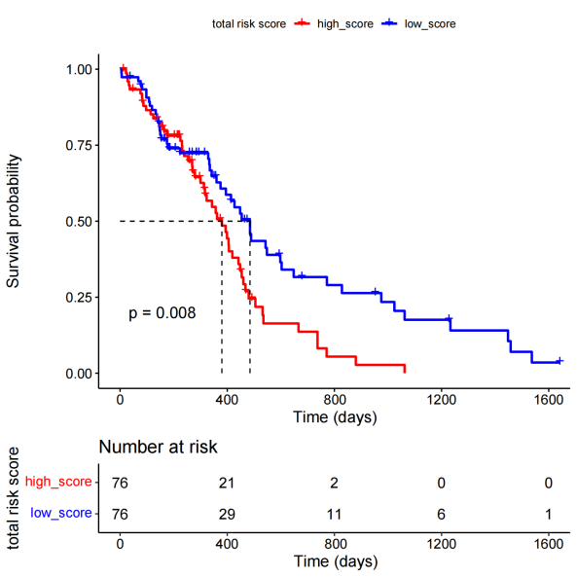
(B)
Supplementary Figure S4: Survival curves of the TCGA-GBM dataset (expression expressed as TPM number), (A) TERT not significant differences; (B)MGMT+TERT, both show significant differences, (expanded sample size). High MGMT expression was associated with shorter OS (Logrank p=0.00088, HR=1.5).
(A)
(B)
Supplementary Figure S5. Functional effects of MGMT and TERT on glioma cell phenotypes.(A) Representative images of wound healing assay at 0 h and 24 h post-scratch (B) Quantification of cell invasion assessed by Transwell assay.

