Appendix -1

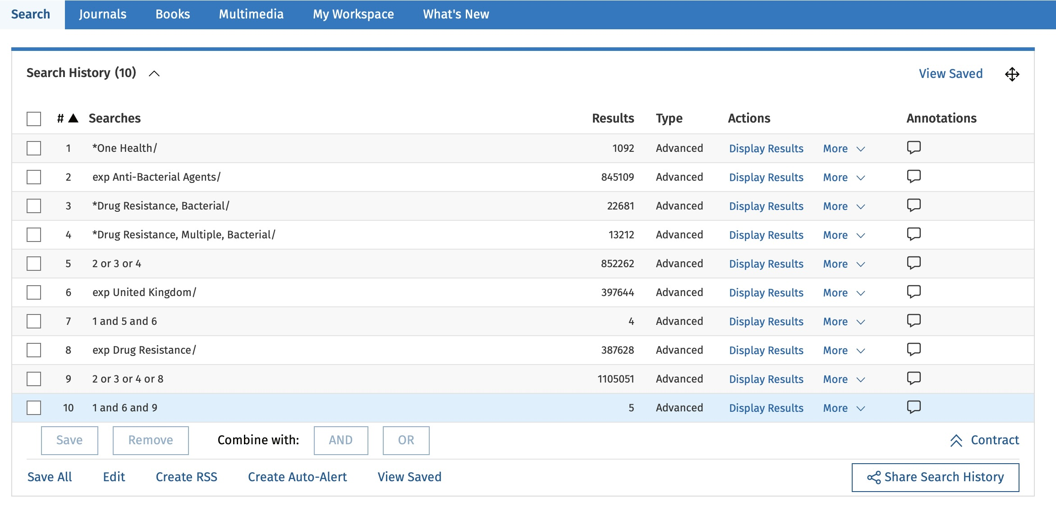
The Ovid search strategy for this CLR.

Appendix -2

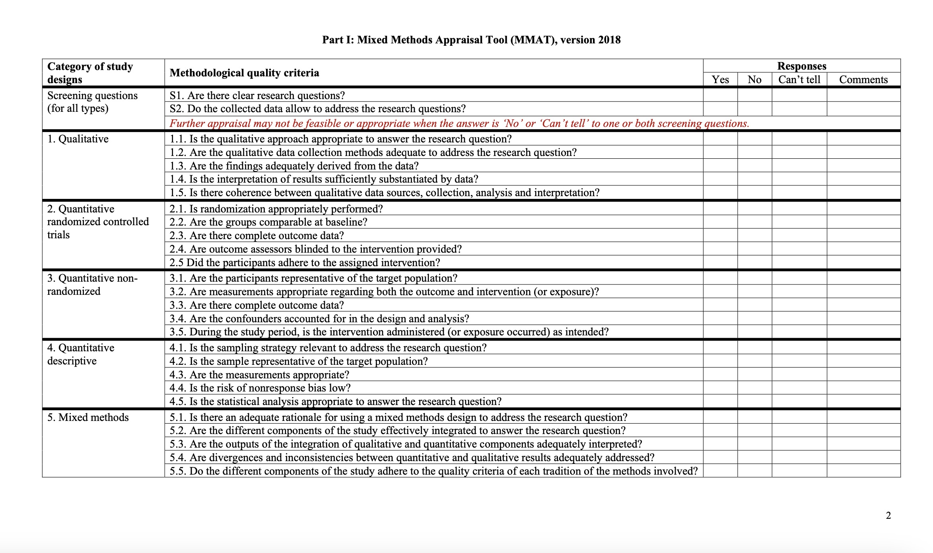
The MMAT tool used for this CLR is given below.
Source- http://mixedmethodsappraisaltoolpublic.pbworks.com/w/file/fetch/127916259/MMAT_2018_criteria-manual_2018-08-01_ENG.pdf

The PRISMA checklist and Cochrane bias assessment tool for this CLR have been provided in the supporting documents.

Appendix - 3
Table-4 Strengths and weaknesses of the selected studies in the CLR-
Name of the study | Year of Publication | Type of study | Population | Strengths of the study | Weaknesses of the study
Comparative meta-analysis of antimicrobial resistance from different food sources  along with one health approach in the UK and Egypt. | 2023 | Meta analysis | United Kingdom and Egypt | The study's strength lies in its comprehensive approach, analysing a significant dataset and its use of the One Health framework, which is increasingly recognised as vital in addressing AMR. It resulted in the presence of AMR against tetracycline and β-lactam antibiotics.  The study identifies chicken as the most prevalent source of AMR bacteria. The paper concludes with a call for urgent global action to combat AMR. The study's findings suggest that both countries need to improve their AMR surveillance and stewardship programs. For Egypt, there is a call for stricter regulations and better enforcement, while the UK needs to continue its efforts in monitoring and reducing antibiotic use in agriculture. | The study could have benefited from a more detailed analysis of the socio-economic factors influencing AMR in both countries. Additionally, the paper could have explored the effectiveness of specific interventions in reducing AMR, particularly in the context of the One Health approach in more detail.
A One Health Study of the Genetic Relatedness of Klebsiella pneumoniae and Their Mobile Elements in the East of England | 2019 | Cross sectional study | England (UK) | Comprehensive Sampling: The study's strength lies in its comprehensive sampling across multiple reservoirs, including human, environmental, and animal sources, which provides a holistic view.  Use of WGS: WGS is a robust tool for identifying genetic similarities and differences, providing high-resolution data on the relatedness of bacterial isolates.  Clear Presentation of Results: The results were presented clearly, with appropriate use of genomic analysis to support conclusions to support cconclusions.  Identification of Contamination Events: The study successfully identified environmental contamination events in the hospital, highlighting areas for infection control. | Limited Temporal Scope: The study was conducted over a relatively short period, which might not capture long-term trends or rare transmission events.  Potential Bias in Sample Collection: The study might have selection bias, as it focused on specific hospital wards and may not represent all potential reservoirs of K. pneumoniae.
Antibiotic antagonist: the curious career of René Dubos | 2016 | Systematic review | United Kingdom | Historical Contextualization: The article excels in providing a detailed historical context, tracing the evolution of antibiotics from the discovery of sulfa drugs to the later developments in the field. By highlighting Dubos’s work on gramicidin, the author sheds light on a crucial yet often overlooked topic.  Ecological Perspective: Honigsbaum effectively underscores the significance of Dubos’s ecological approach to microbiology. Dubos’s belief that microbial ecology could be harnessed to combat bacterial infections, and his foresight regarding the adaptive nature of bacteria, are presented as prescient insights that predated the modern understanding of antibiotic resistance.  Critical Reflection: The article offers a critical reflection on the dominant narratives in the history of antibiotics. By presenting Dubos as a paradoxical figure—both a pioneer and a critic of antibiotics—the author challenges the simplistic narrative of antibiotics as a purely triumphant scientific achievement. | Limited Exploration of Broader Impact: While the article focuses on Dubos’s contributions and warnings, it could have delved deeper into the broader impact of his work on subsequent research in microbiology and public health. The article mentions Lederberg’s revival of Dubos’s warnings but does not explore how Dubos’s ecological approach has influenced modern scientific practices or policy-making in detail.  Biographical Details: The article touches on some personal aspects of Dubos’s life, such as his wife's death, which influenced his shift away from antibiotic research. However, these biographical details are somewhat underdeveloped and could have been integrated more fully to provide a richer understanding of Dubos as a person and a scientist.  Narrative Structure: The narrative occasionally shifts focus abruptly, moving from Dubos's scientific achievements to broader reflections on the history of antibiotics. While these shifts are not detrimental, a more cohesive narrative structure might have enhanced the flow of the article.
COVID-19, antibiotics and One Health: a UK environmental risk assessment | 2020 | Systematic review | United Kingdom | The paper successfully brings attention to an under-explored issue, providing quantitative evidence of the environmental risks associated with pandemic-related antibiotic use. The identification of amoxicillin as a high-risk antibiotic is particularly valuable for guiding future research and policy. | The findings are based on models and assumptions that may not fully capture the complexities of real-world scenarios. For instance, the study does not account for potential variations in wastewater treatment efficiency across different regions or the cumulative impact of multiple antibiotics. Moreover, the reliance on a single case study limits the generalisability of the conclusions.
One Health Genomic Surveillance of Escherichia coli Demonstrates Distinct Lineages and Mobile Genetic Elements in Isolates from Humans versus Livestock | 2019 | Cross sectional study | United Kingdom | One Health Approach:- The study adopts a comprehensive One Health approach, which is essential in understanding the transmission dynamics of E. coli between humans, animals, and the environment.  Large Sample Size and Diversity:- The study includes a significant number of isolates (431 from livestock and 1,517 from human bloodstream infections), which enhances the robustness of the findings. The inclusion of multiple animal species (cattle, pigs, poultry) and retail meat products adds diversity to the sample, making the findings more generalizable.  Advanced Genomic Techniques:- The use of whole-genome sequencing (WGS) and phylogenetic analysis allows for a detailed comparison of core genomes and accessory genes, including those responsible for antibiotic resistance. This provides a high view of the genetic differences between human and livestock isolates.  Clear Findings on Transmission - The study's conclusion that livestock-associated E. coli are genetically distinct from those causing serious infections in humans. | Sampling Bias:The sampling framework, while extensive, might still be subject to bias. For instance, the study acknowledges that the human isolates may overrepresent hospital-acquired infections, which might not be fully comparable to community-acquired infections that could have different sources, including livestock.  Focus on ESBL-Producing Isolates: The emphasis on extended-spectrum β-lactamase (ESBL)-producing E. coli is appropriate given their clinical significance, but it may overlook other important resistance mechanisms. Additionally, the study’s findings are less relevant to non-ESBL E. coli strains, which could have different transmission dynamics.  Limited Data on Environmental Factors: The study focuses on direct transmission between livestock and humans but does not extensively explore environmental reservoirs or indirect transmission routes, such as through water or soil. These factors could play a significant role in the dissemination of AMR. The practical implications for livestock management and antimicrobial usage policies are not fully explored.
Comparing public attitudes, knowledge, beliefs and behaviours towards antibiotics and antimicrobial resistance in Australia, United Kingdom, and Sweden (2010-2021): A systematic review, meta-analysis, and comparative policy analysis | 2022 | Meta analysis | UK, Australia, Sweden | Comprehensive Approach: The study employs a systematic review and meta-analysis, offering a robust methodological approach. This ensures that the findings are based on a broad spectrum of existing research.  Comparative Analysis: By comparing three countries—Australia, the UK, and Sweden—with varying rates of antibiotic consumption and different policy approaches, the study provides valuable insights into how national policies and public education efforts influence antibiotic use and public awareness of AMR.  Policy and Practice Implications: The study’s focus on the impact of public knowledge, attitudes, and practices (KAP) on antibiotic use, and how these factors interact with national policies, offers practical implications. For instance, it highlights the effectiveness of Sweden's stringent control measures compared to the more education-focused approaches in Australia and the UK.  Meta-Analysis Inclusion: The inclusion of a meta-analysis adds a quantitative dimension to the study, allowing for a more nuanced understanding of public perception. | Heterogeneity of Included Studies: The study acknowledges the complexity and diversity of the included KAP surveys. The differences in survey design, population demographics, and the specific questions asked across studies may introduce variability in the results of findings.  Potential Bias in Policy Evaluation: The study’s evaluation of the success of policies in Sweden might be influenced by the generally positive global perception of Sweden's healthcare system. While Sweden’s approach to reducing antibiotic consumption is praised, the study may not fully account for other socio-economic and cultural factors that could contribute to its success, leading to an overly favorable assessment.  Limited Focus on Implementation Challenges: The study identifies the importance of policy and practice changes but does not deeply delve into the practical challenges of implementing these changes, especially in diverse healthcare settings like those in Australia and the UK. Understanding these challenges is crucial for translating policy in real-world practice.
Developing a local antimicrobial resistance action plan: the Cornwall One Health Antimicrobial Resistance Group | 2017 | Systematic review | UK population | The study’s strengths lie in its comprehensive One Health approach, which integrates human, veterinary, and environmental health sectors, enabling a holistic response to AMR. The alignment of local initiatives with the UK’s national AMR strategy, combined with measurable outcomes like reduced antibiotic usage, showcases effective implementation. The project also emphasizes public and professional engagement, using media campaigns and educational programs to raise awareness and improve practices across sectors. Additionally, the group's flexible, iterative planning allows for adaptive responses based on stakeholder input and emerging needs, enhancing the initiative's relevance and sustainability. | The study's limitations include its narrow focus, excluding key aspects like new diagnostics and international collaboration, which are critical to comprehensive AMR management. The heavy reliance on stakeholder participation creates vulnerability if engagement wanes, and the use of unpublished data raises concerns about transparency and reliability. Moreover, the environmental dimension of AMR is underdeveloped despite the One Health framing, reducing the initiative's overall impact. Lastly, potential bias due to the study’s authorship by those involved in the project might result in an overemphasis on successes while downplaying challenges.

