Figure1. Schematic of Target Delineation in Bronchiectasis Regions
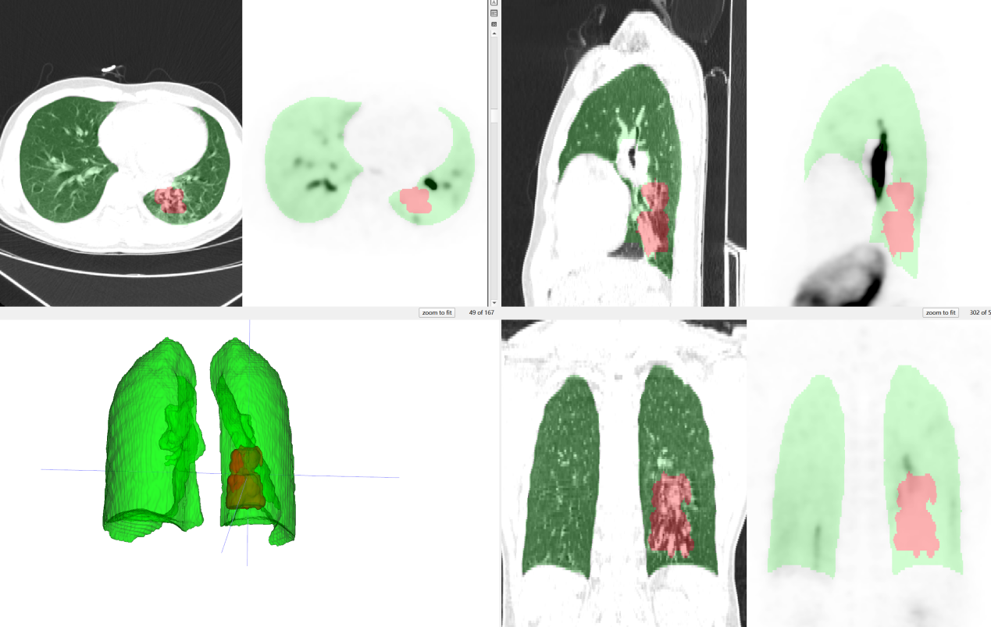

Table1. Inter-reader concordance for qualitative identification of bronchiectatic regions on aerosolized [¹⁸F]NaF PET/CT
Reader A/Reader B | Yes | No | Total
Yes | 70 | 5 | 75
No | 0 | 2 | 2
Total | 70 | 7 | 77

