Supplementary Figures:

RAcolony: A Multimodal Platform Integrating Raman Spectroscopy and Automated Imaging for Efficient Construction of Personalized Gut Microbiome Biobanks
Yang Yan†¹, He Jiang†¹, Jian-Bo Ma⁵, Min-Zhi Jiang¹, Chen Chen¹, Zi-Nuo An¹, Xin-Yao Li¹, Guozhong Chen¹, Xiao-Yang Zhu¹, Tian-Yu Li³, Yulin Wang¹, Chang Liu¹, An-Qi Zhao¹, Xiao-Jia Han¹, Dalei Wu*^{,1}, Bei Li*^{,3,4}, Shuang-Jiang Liu*^{,1,2}
¹State Key Laboratory of Microbial Technology, Shandong University, 72 Binhai Road, Jimo, Qingdao 266237, P.R. China
²State Key Laboratory of Microbial Diversity and Innovative Utilization, Institute of Microbiology, Chinese Academy of Sciences, No.1 Beichenxi Road, Chaoyang District, Beijing, P.R. China
³HOOKE Instruments Ltd., Changchun 130033, P.R. China
⁴State Key Laboratory of Advanced Manufacturing for Optical Systems, Changchun Institute of Optics, Fine Mechanics and Physics, Chinese Academy of Sciences, Changchun 130033, P. R. China
⁵Haining high-tech research institute, Jiaxing, Zhejiang 314408, P.R. China
*Corresponding authors:
Shuang-Jiang Liu (liusj @sdu.edu.cn)
Address: State Key Laboratory of Microbial technology, Shandong University, 72 Binhai Road, Jimo, Qingdao, P.R. China
Phone number: 0532-58630001
Bei Li (beili@ciomp.ac.cn)
Address: State Key Laboratory of Advanced Manufacturing for Optical Systems, Changchun Institute of Optics, Fine Mechanics and Physics, Chinese Academy of Sciences, Changchun 130033, P. R. China;
Phone number: 0431-81077008
Dalei Wu (dlwu@sdu.edu.cn)
Address: State Key Laboratory of Microbial technology, Shandong University, 72 Binhai Road, Jimo, Qingdao, P.R. China
Phone number: 0532-58631508

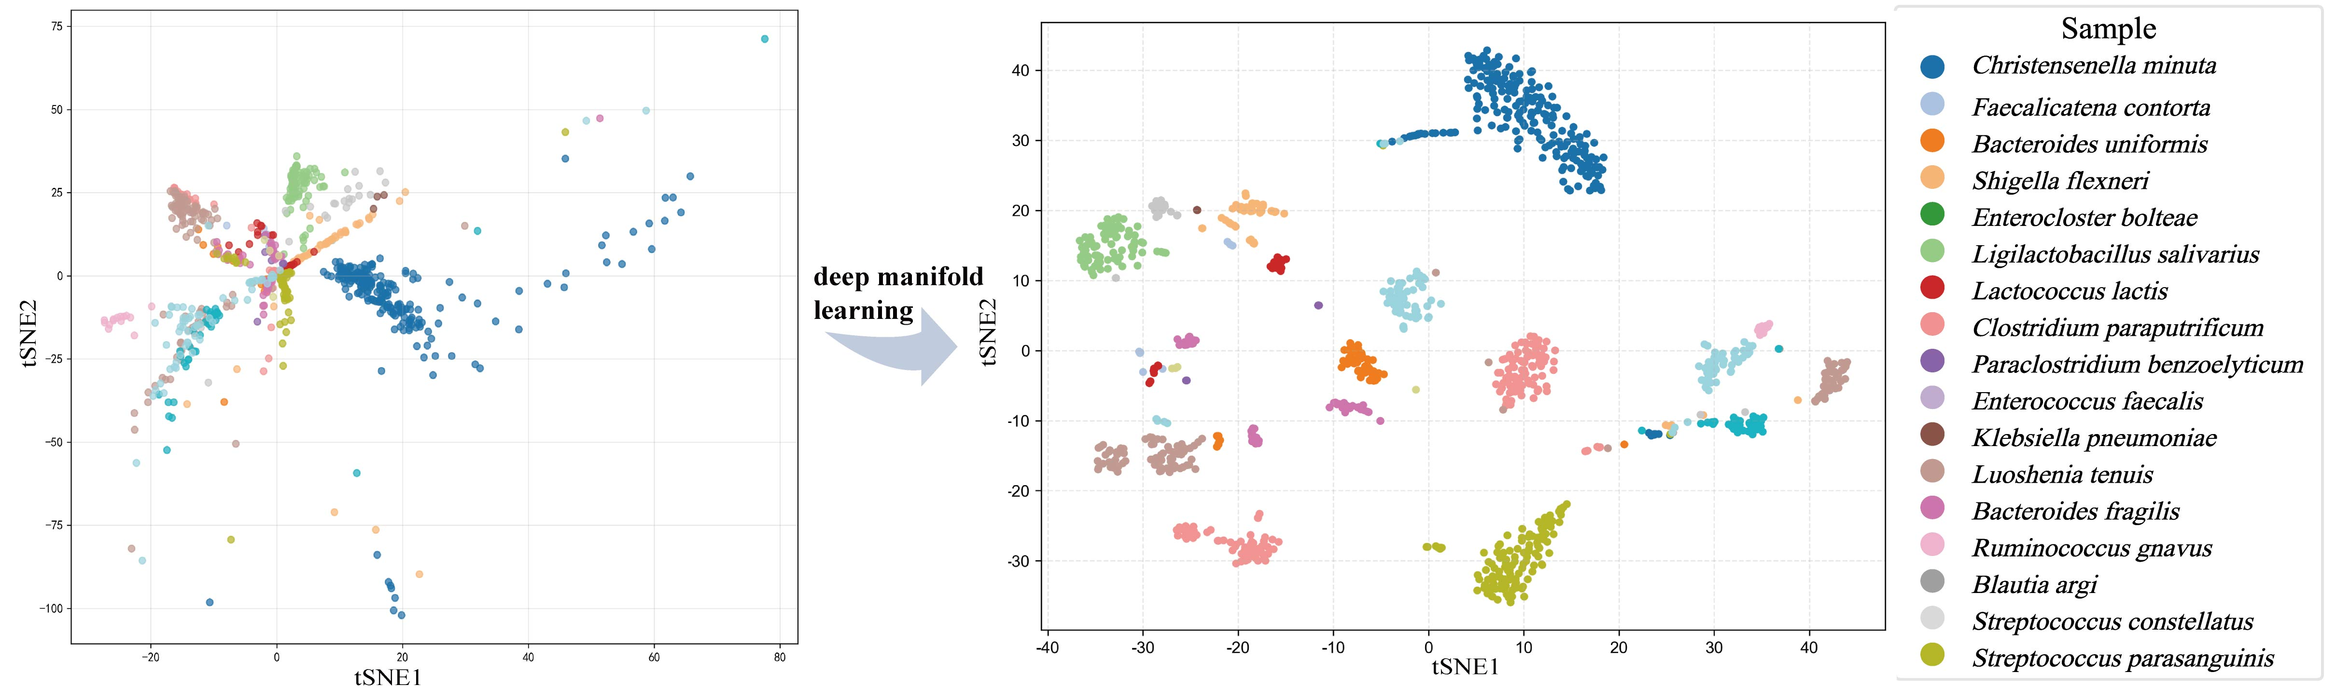
Fig. S1 Comparison of clustering performance of bacterial colony Raman spectra before and after deep manifold learning.

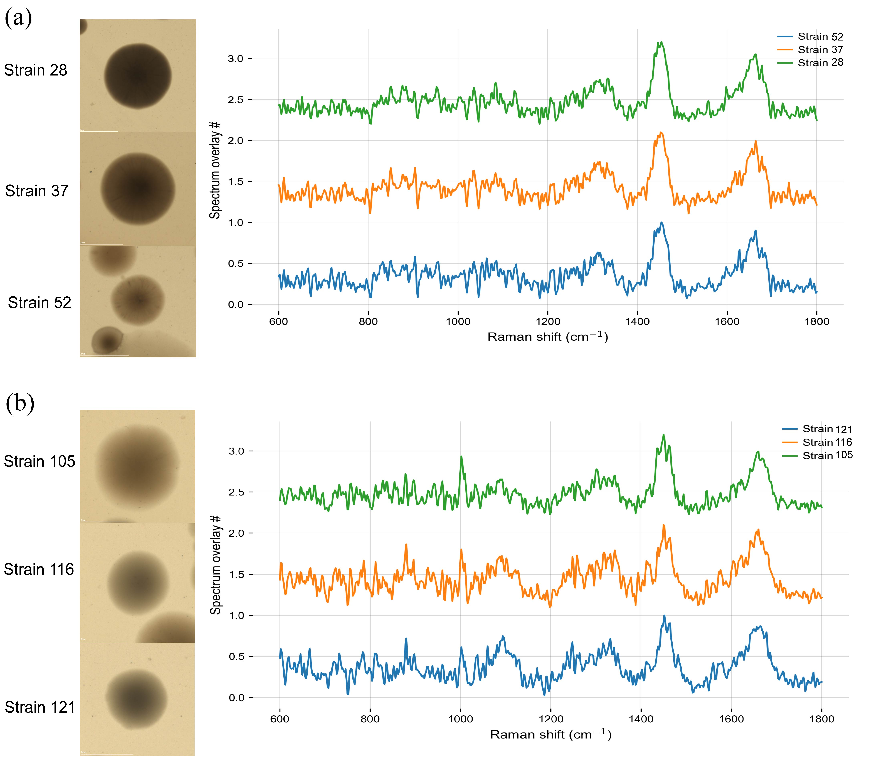
Fig. S2 Strains within the same species exhibiting significant phenotypic differences from the same fecal sample. a shows Bacteroides stercoris, b shows Bacteroides fragilis.

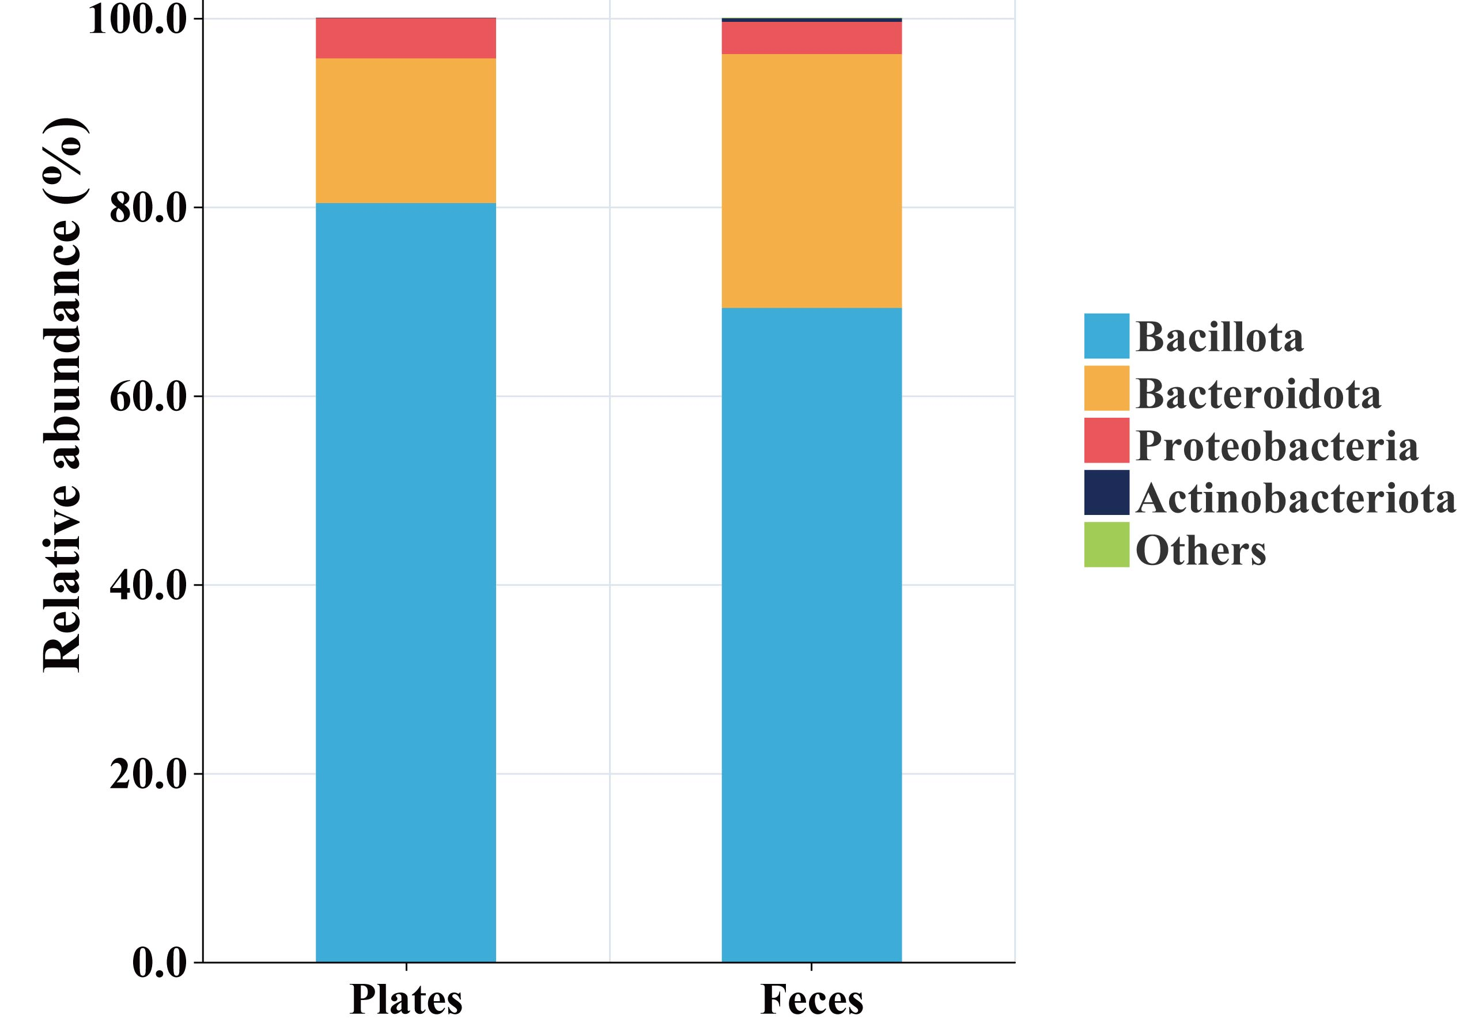
Fig. S3 Bar chart of the Phylum by relative abundance.

Fig. S4 Distribution of lost Species colonies during dimensionality reduction for five samples in Table S4. (a-e) t-SNE projections showing the distribution of colonies from samples with incomplete coverage (samples 3, 5, 6, 7, 8). For each sample, the left panel shows the projection based on colony image features, and the right panel shows the projection based on Raman spectral features. Colonies of species that were not successfully isolated are highlighted.

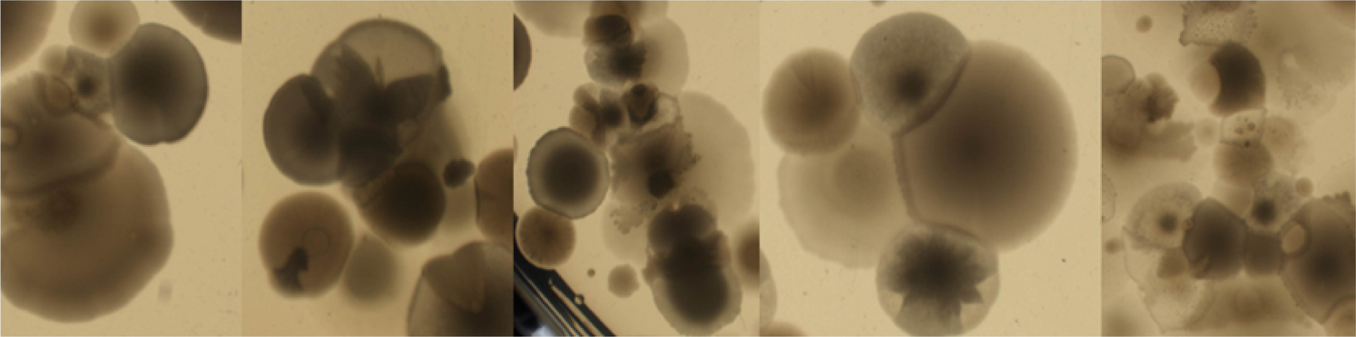
Fig. S5 Adherent colonies within plates.

