Supplementary data:

RAcolony: A Multimodal Platform Integrating Raman Spectroscopy and Automated Imaging for Efficient Construction of Personalized Gut Microbiome Biobanks
Yang Yan†¹, He Jiang†¹, Jian-Bo Ma⁵, Min-Zhi Jiang¹, Chen Chen¹, Zi-Nuo An¹, Xin-Yao Li¹, Guozhong Chen¹, Xiao-Yang Zhu¹, Tian-Yu Li³, Yulin Wang¹, Chang Liu¹, An-Qi Zhao¹, Xiao-Jia Han¹, Dalei Wu*^{,1}, Bei Li*^{,3,4}, Shuang-Jiang Liu*^{,1,2}
¹State Key Laboratory of Microbial Technology, Shandong University, 72 Binhai Road, Jimo, Qingdao 266237, P.R. China
²State Key Laboratory of Microbial Diversity and Innovative Utilization, Institute of Microbiology, Chinese Academy of Sciences, No.1 Beichenxi Road, Chaoyang District, Beijing, P.R. China
³HOOKE Instruments Ltd., Changchun 130033, P.R. China
⁴State Key Laboratory of Advanced Manufacturing for Optical Systems, Changchun Institute of Optics, Fine Mechanics and Physics, Chinese Academy of Sciences, Changchun 130033, P. R. China
⁵Haining high-tech research institute, Jiaxing, Zhejiang 314408, P.R. China
*Corresponding authors:
Shuang-Jiang Liu (liusj @sdu.edu.cn)
Address: State Key Laboratory of Microbial technology, Shandong University, 72 Binhai Road, Jimo, Qingdao, P.R. China
Phone number: 0532-58630001
Bei Li (beili@ciomp.ac.cn)
Address: State Key Laboratory of Advanced Manufacturing for Optical Systems, Changchun Institute of Optics, Fine Mechanics and Physics, Chinese Academy of Sciences, Changchun 130033, P. R. China;
Phone number: 0431-81077008
Dalei Wu (dlwu@sdu.edu.cn)
Address: State Key Laboratory of Microbial technology, Shandong University, 72 Binhai Road, Jimo, Qingdao, P.R. China
Phone number: 0532-58631508

Eubacterium kunpengii sp. nov.
Description of Eubacterium kunpengii (kun.peng.i’i. N.L. gen. masc. n. kunpengii, of Kunpeng, referring to the Kunpeng, a giant creature in Chinese mythology that can transform between a massive fish (Kun) and a giant bird (Peng), symbolizing vastness and transformation)
The closest phylogenetic neighbor of strain NSJ-201^{T} is Eubacterium ventriosum ATCC 27560^{T}. E. ventriosum and strain NSJ-201^{T} (16S rRNA sequence accession number in NCBI (National Center for Biotechnology Information is PZ194098) has a 16S rRNA gene identity of 97.25%. The phylogenetic tree shows that strain NSJ-201^{T} clusters with other members of the genus Eubacterium (Figure SD-1a), suggesting strain NSJ-201^{T} is a member of the genus Eubacterium. According to the phylogenominc tree (Figure SD-1b), the ANIs and dDDH values of genomes between strain NSJ-201^{T} and phylogenomically neighbored genomes were calculated, and the highest ANI and dDDH values are 76.74 and 26.00%, respectively, between the query genome of Eubacterium ventriosum (GCA_000153885.1); and difference in % G+C between genomes of strain NSJ-201^{T} and Eubacterium ventriosum (GCA_000153885.1) is 1.26; OrthoANI heatmap (Figure SD-1c) shows the phylogenomic status of the corresponding neighbor species based on OrthoANI values. Based on these results, we concluded that the strain NSJ-201^{T} represents of new species of the genus Eubacterium, and the name Eubacterium kunpengii sp. nov. is proposed. The type strain NSJ-201^{T} (=CGMCC 1.58803^{T}) was isolated from the faeces of a healthy adult.

Figure 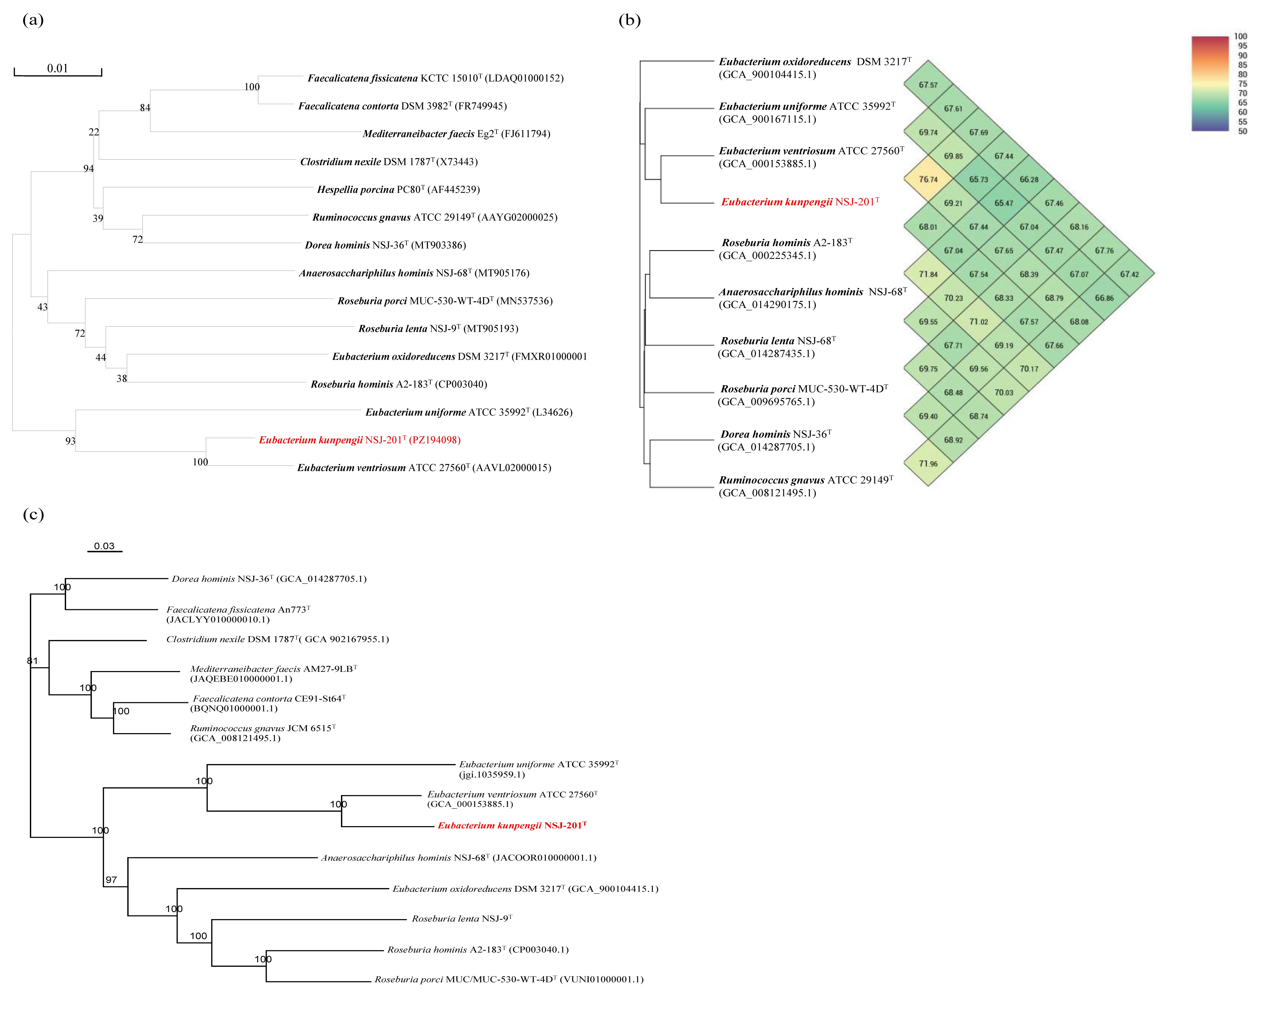SD-1 (a) The Neighbour-joining phylogenetic tree based on 16S rRNA gene sequences of strain NSJ-201^{T}. GenBank accession numbers are given in parentheses. Percentages of bootstrap support are shown at branch nodes. Bootstrap value was 1000. Bar: 0.01 substitutions per nucleotide position. The phylogenominc tree based on gemome-sequence-alignment (b) and OrthoANI heatmap (c) of strain NSJ-201^{T} and its neighbor species. Refseq ID of representative genomes are given in parentheses. Percentages of bootstrap support are shown at branch nodes. Bar: 0.03 substitutions per nucleotide position.
Mediterraneibacter segnis sp. nov.
Description of Mediterraneibacter segnis sp. nov. (se’gnis. L. masc. adj. segnis, slow, indicating the slow growth of the type strain)
Strain NSJ-207^{T} (16S rRNA sequence accession number in NCBI is PZ194104) is phylogenetically closest to Mediterraneibacter torques, with 16S rRNA gene identity of 95.83%. Phylogenetic tree shows that strain NSJ-207^{T} clusters with other members of the genus Mediterraneibacter (Figure SD-2a), suggesting strain NSJ-207^{T} is a member of the genus Mediterraneibacter. The genome of strain NSJ-207^{T} was sequenced and the NCBI accession number is JBWBFL000000000. According to the phylogenominc tree (Figure SD-2b), the ANIs and dDDH values of genomes between strain NSJ-207^{T} (NCBI accession number is JBWBFL000000000) and phylogenomically neighbored genomes were calculated, and the highest ANI and dDDH values are 74.30 and 22.40%, respectively, between the query genome of Mediterraneibacter torques (GCA_044591705.1); and difference in % G+C between genomes of strain NSJ-207^{T} and Mediterraneibacter torques (GCA_044591705.1) is 4.30; OrthoANI heatmap (Figure SD-2c) shows the phylogenomic status of the corresponding neighbor species based on OrthoANI values. Based on these results, we concluded that the strain NSJ-207^{T} represents of new species of the genus Mediterraneibacter, and the name Mediterraneibacter segnis sp. nov. is proposed. The type strain NSJ-207^{T} (=CGMCC 1.58809^{T}) was isolated from the faeces of a healthy adult.
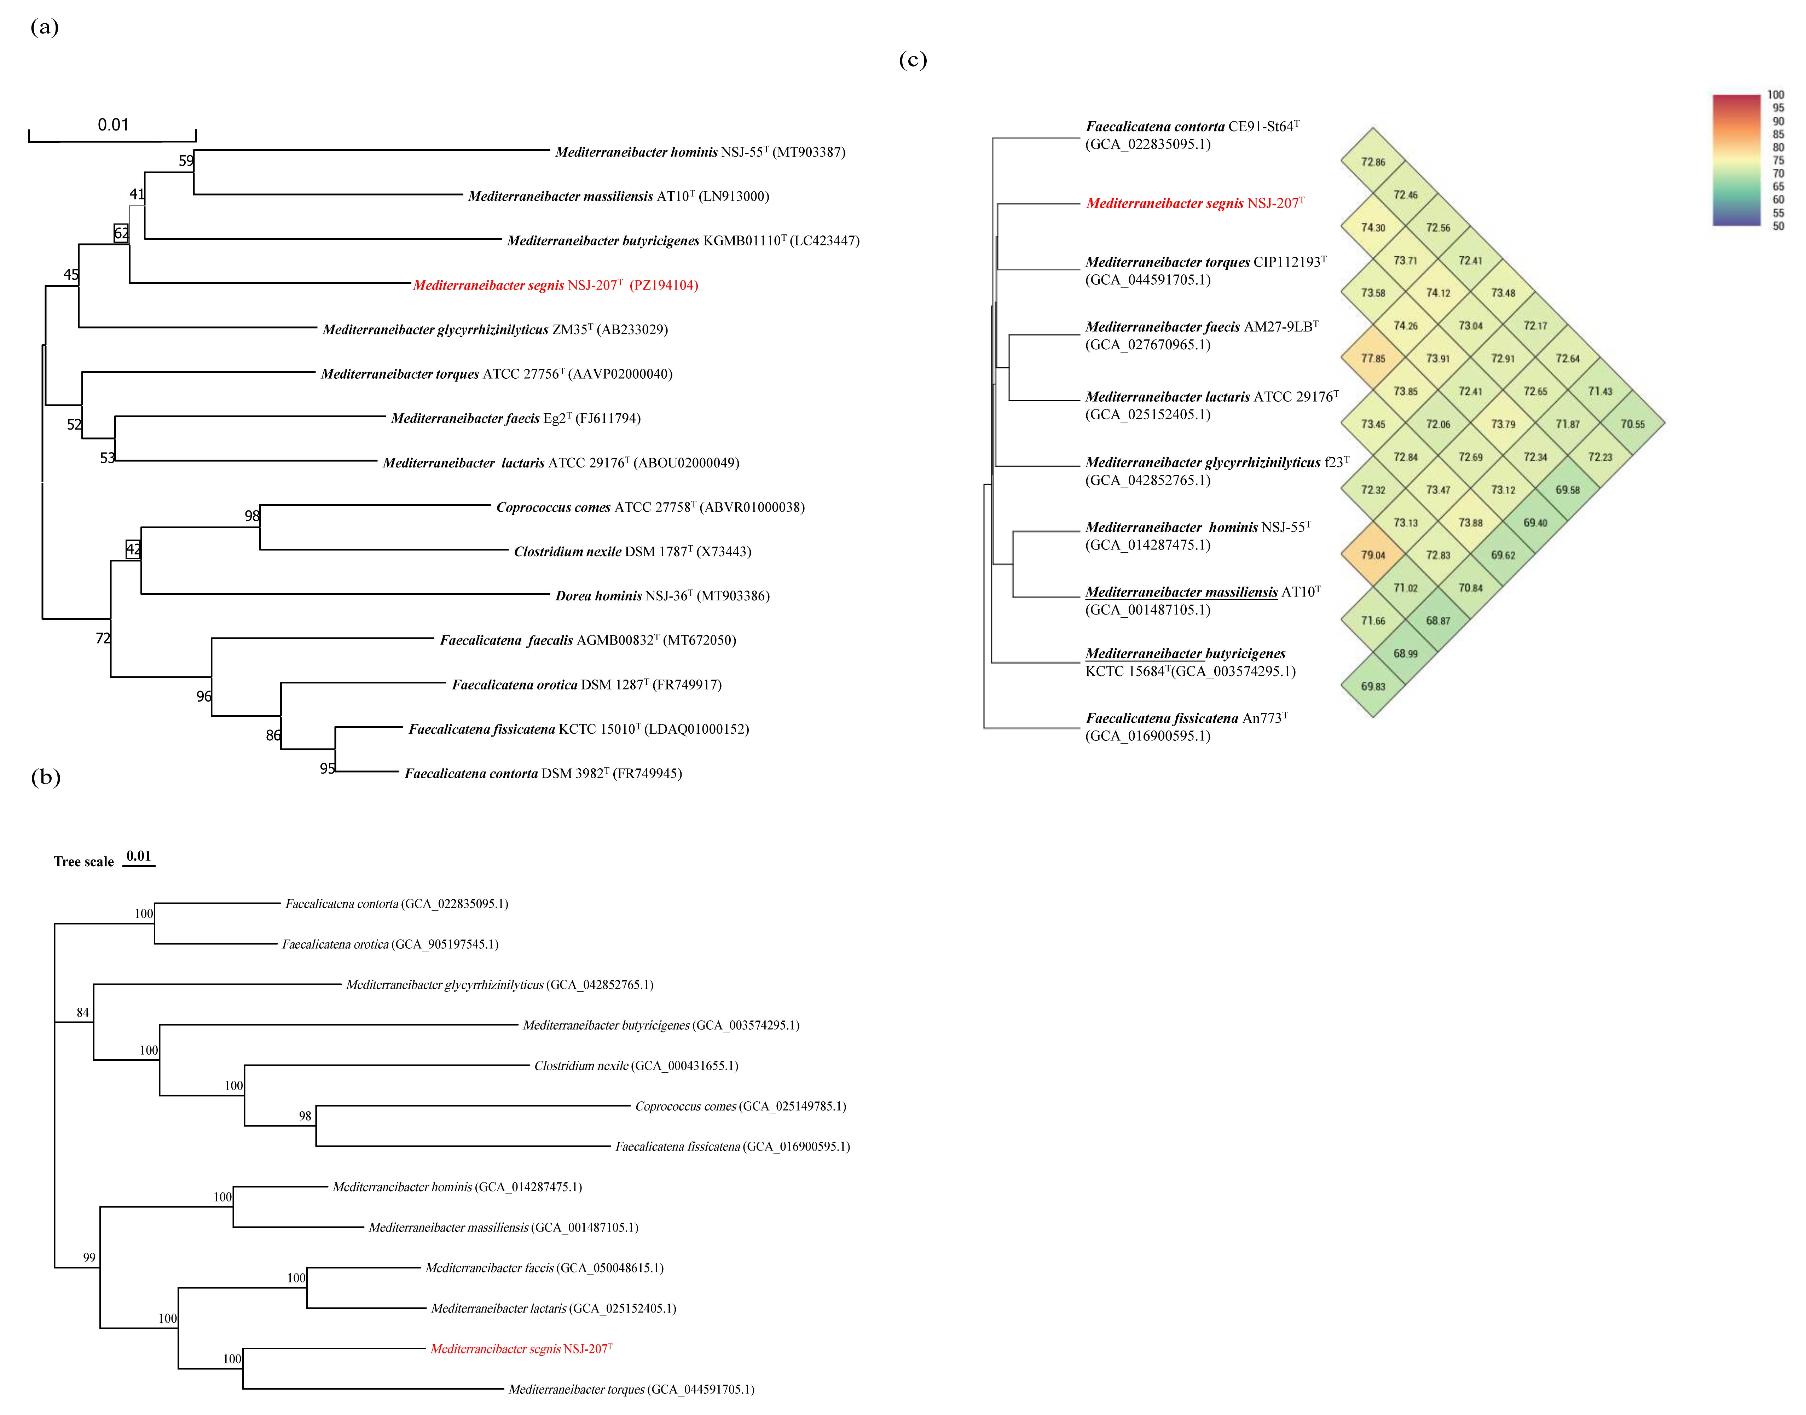
Figure SD-2 (a) The Neighbour-joining phylogenetic tree based on 16S rRNA gene sequences of strain NSJ-207^{T}. GenBank accession numbers are given in parentheses. Percentages of bootstrap support are shown at branch nodes. Bootstrap value was 1000. Bar: 0.01 substitutions per nucleotide position. The phylogenominc tree based on gemome-sequence-alignment (b) and OrthoANI heatmap (c) of strain NSJ-207^{T} and its neighbor species. Refseq ID of representative genomes are given in parentheses. Percentages of bootstrap support are shown at branch nodes. Bar: 0.01 substitutions per nucleotide position.
Faecalimonas qinglongii sp. nov.
Description of Faecalimonas qinglongii sp. nov. (qing.long.i’i. N.L. gen. masc. n. qinglongii, of Qinglong, referring to the Azure Dragon, the guardian of the East in Chinese mythology)
Strain NSJ-200^{T} (16S rRNA sequence accession number in NMDC is PZ194097) is phylogenetically closest to Faecalimonas nexile, with 16S rRNA gene identity of 95.83%. Phylogenetic tree shows that strain NSJ-200^{T} clusters with other members of the genus Faecalimonas (Figure SD-3a), suggesting strain NSJ-200^{T} is a member of the genus Faecalimonas. The genome of strain NSJ-200^{T} was sequenced and the NCBI accession number is JBXEKU000000000. According to the phylogenominc tree (Figure SD-3b), the ANIs and dDDH values of genomes between strain NSJ-200^{T} (NCBI accession number is JBXEKU000000000) and phylogenomically neighbored genomes were calculated, and the highest ANI and dDDH values are 73.46 and 33.10%, respectively, between the query genome of Faecalimonas nexile DSM 1787^{T} (GCA_000431655.1); and difference in % G+C between genomes of strain NSJ-200^{T} and Faecalimonas nexile DSM 1787^{T} (GCA_000431655.1) is 8.80; OrthoANI heatmap (Figure SD-3c) shows the phylogenomic status of the corresponding neighbor species based on OrthoANI values. Based on these results, we concluded that the strain NSJ-200^{T} represents of new species of the genus Faecalimonas, and the name Faecalimonas qinglongii sp. nov. is proposed. The type strain NSJ-200^{T} (=CGMCC 1.58802^{T}) was isolated from the faeces of a healthy adult.
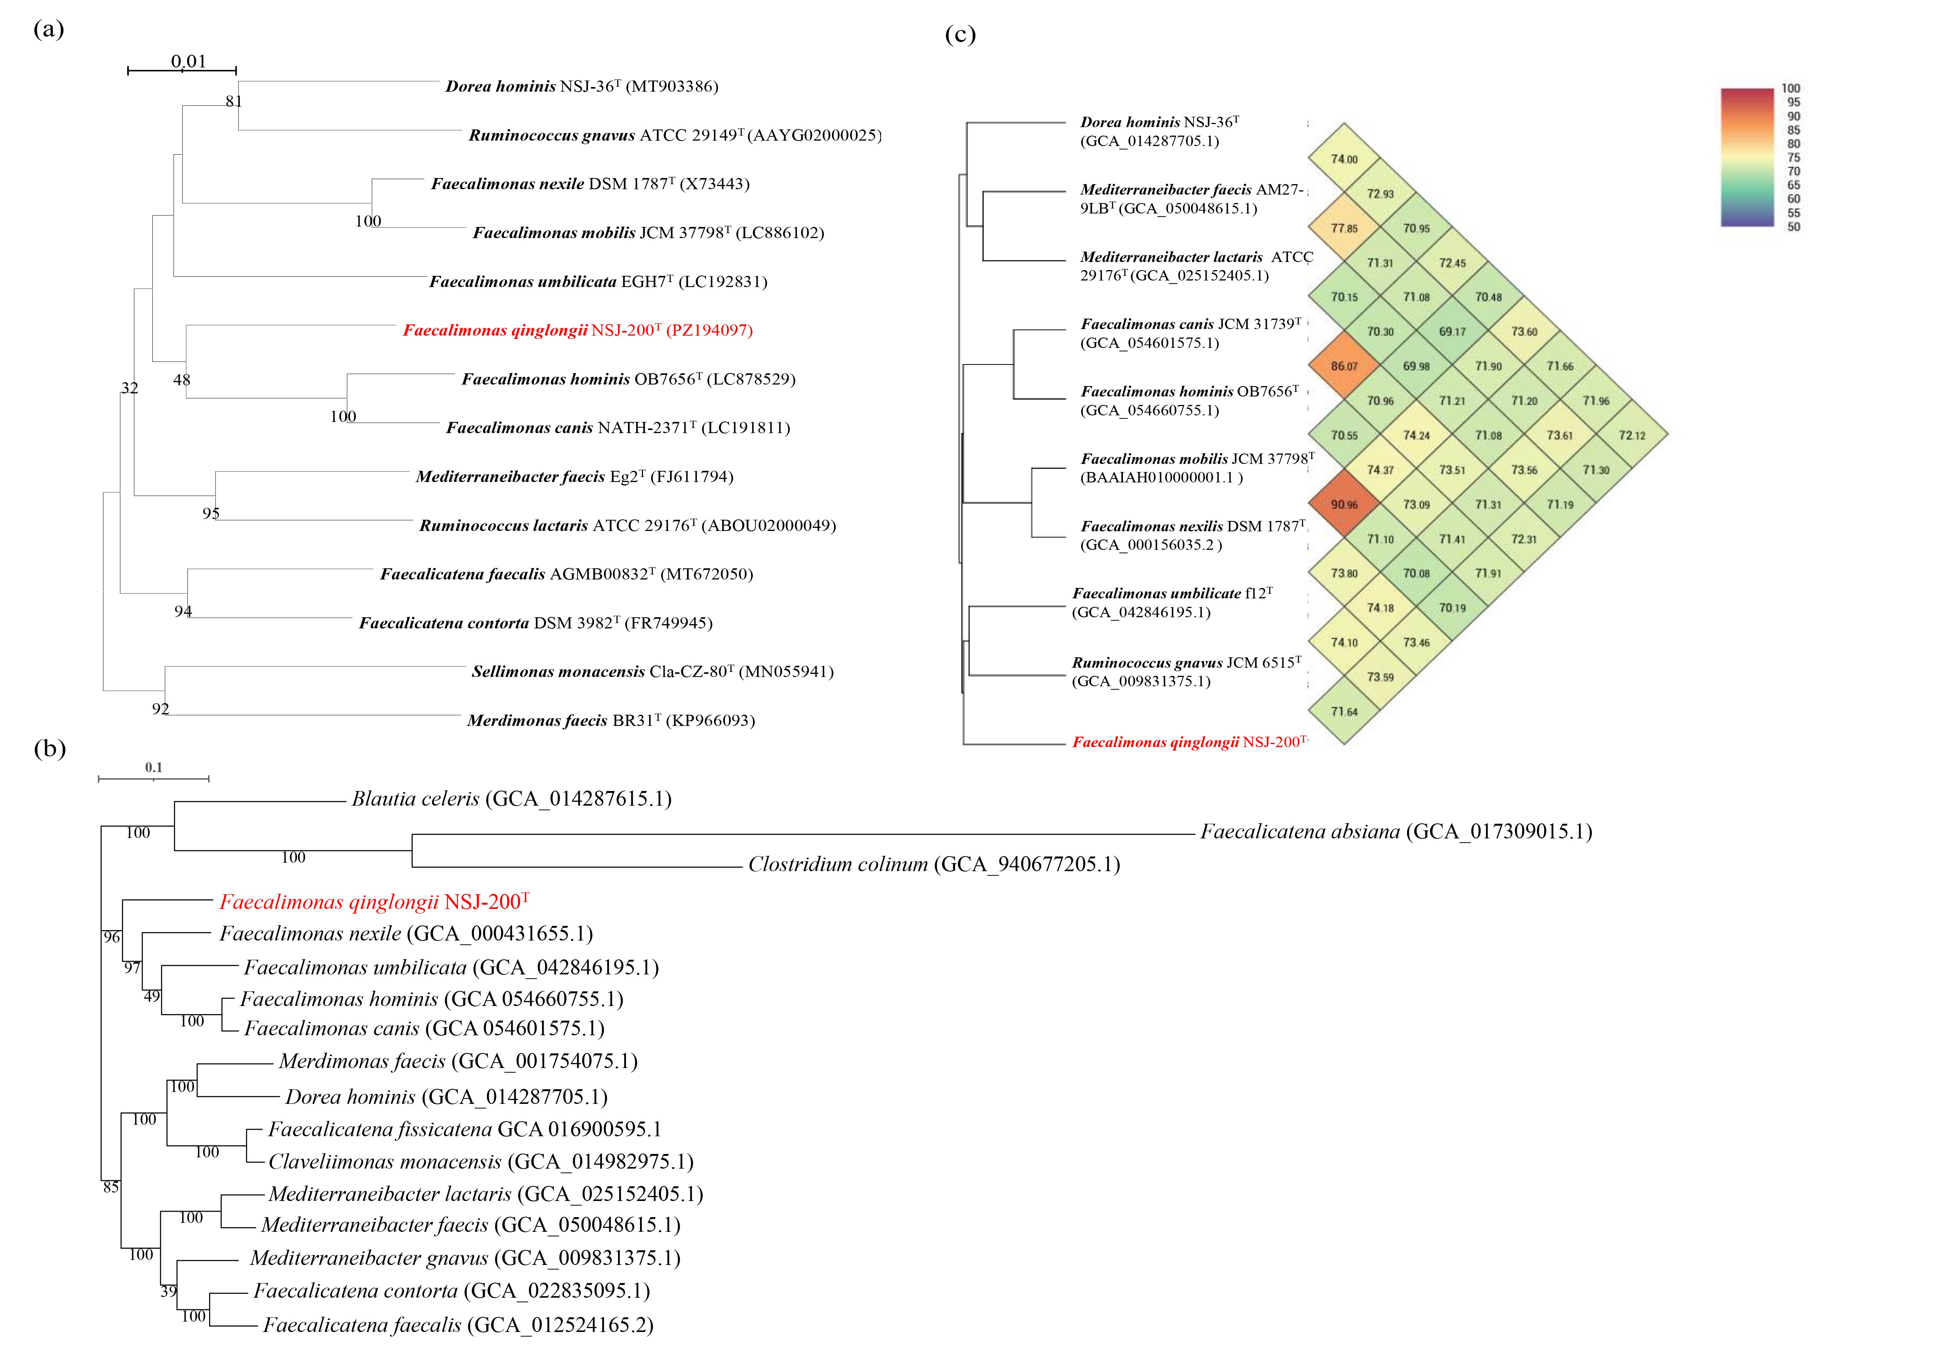
Figure SD-3 (a) The Neighbour-joining phylogenetic tree based on 16S rRNA gene sequences of strain NSJ-200^{T}. GenBank accession numbers are given in parentheses. Percentages of bootstrap support are shown at branch nodes. Bootstrap value was 1000. Bar: 0.01 substitutions per nucleotide position. The phylogenominc tree based on gemome-sequence-alignment (b) and OrthoANI heatmap (c) of strain NSJ-200^{T} and its neighbor species. Refseq ID of representative genomes are given in parentheses. Percentages of bootstrap support are shown at branch nodes. Bar: 0.1 substitutions per nucleotide position.
Fusicatenibacter xuanwui sp. nov.
Description of Fusicatenibacter xuanwui sp. nov. (xu.an.wu’i. N.L. gen. masc. n. xuanwui, of Xuanwu, referring to Xuanwu, the guardian of the North in Chinese mythology)
Strain NSJ-204^{T} (16S rRNA sequence accession number in NCBI is PZ194101) is phylogenetically closest to Fusicatenibacter faecihominis, with 16S rRNA gene identity of 97.79%. Phylogenetic tree shows that strain NSJ-204^{T} clusters with other members of the genus Fusicatenibacter (Figure SD-4a), suggesting strain NSJ-204^{T} is a member of the genus Fusicatenibacter. According to the phylogenominc tree (Figure SD-4c), the ANIs and dDDH values of genomes between strain NSJ-204^{T} and phylogenomically neighbored genomes were calculated, and the highest ANI and dDDH values are 86.49 and 33.20%, respectively, between the query genome of Fusicatenibacter faecihominis CLA-AA-H277^{T} (GCA_020686945.1); and difference in % G+C between genomes of strain NSJ-204^{T} and Fusicatenibacter faecihominis CLA-AA-H277^{T} (GCA_020686945.1) is 2.24; OrthoANI heatmap (Figure SD-4d) shows the phylogenomic status of the corresponding neighbor species based on OrthoANI values. Based on these results, we concluded that the strain NSJ-204^{T} represents of new species of the genus Fusicatenibacter, and the name Fusicatenibacter xuanwui sp. nov. is proposed. The type strain NSJ-204^{T} (=CGMCC 1.58806^{T}) was isolated from the faeces of a healthy adult.
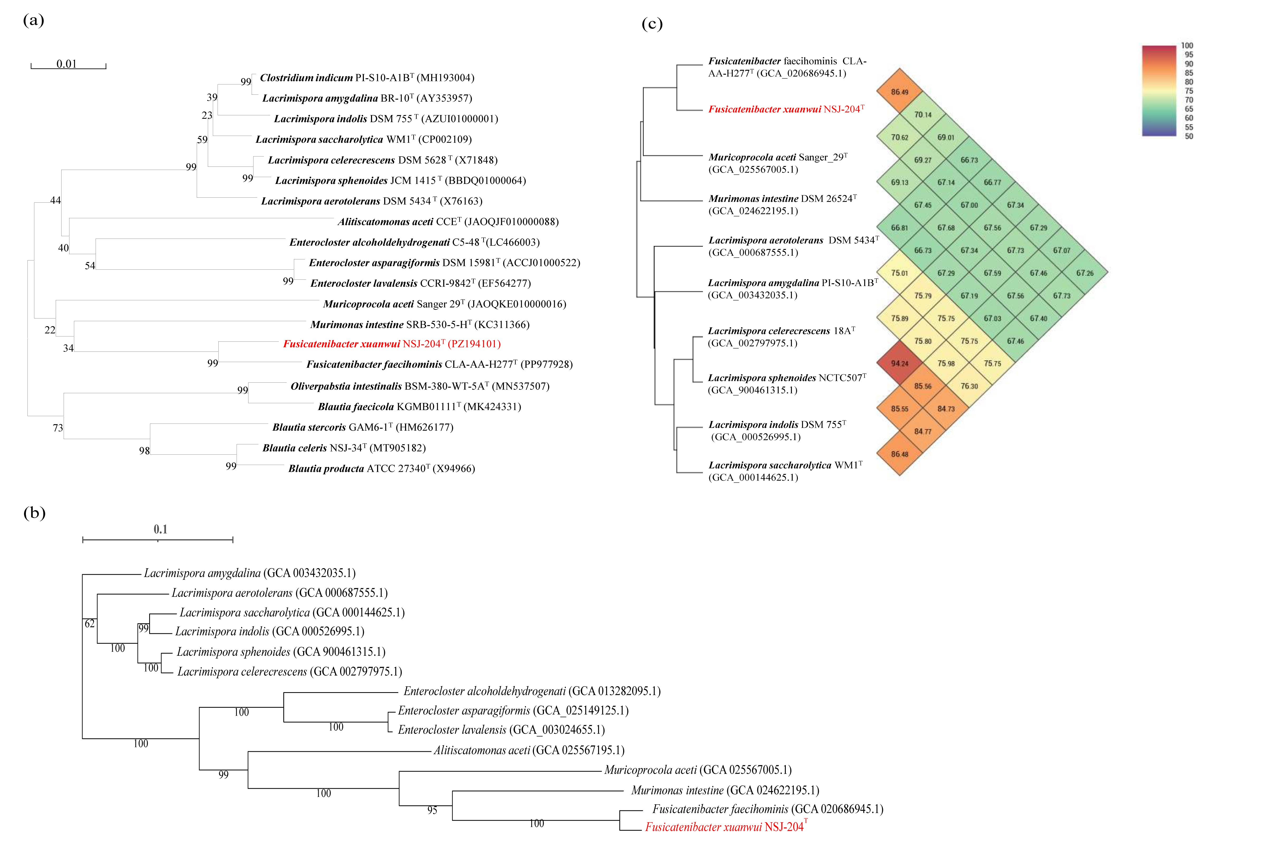
Figure SD-4 (a) The Neighbour-joining phylogenetic tree based on 16S rRNA gene sequences of strain NSJ-204^{T}. GenBank accession numbers are given in parentheses. Percentages of bootstrap support are shown at branch nodes. Bootstrap value was 1000. Bar: 0.01 substitutions per nucleotide position. The phylogenominc tree based on gemome-sequence-alignment (b) and OrthoANI heatmap (c) of strain NSJ-204^{T} and its neighbor species. Refseq ID of representative genomes are given in parentheses. Percentages of bootstrap support are shown at branch nodes. Bar: 0.1 substitutions per nucleotide position.
Faecalibacterium baihui sp. nov.
Description of Faecalibacterium baihui (bai.hu’i. N.L. gen. masc. n. baihui, of Baihu, referring to the White Tiger, the guardian of the West in Chinese mythology)
Strain NSJ-208^{T} (16S rRNA sequence accession number in NCBI is PZ194105) is phylogenetically closest to Faecalibacterium hattorii, with 16S rRNA gene identity of 96.69%. Phylogenetic tree shows that strain NSJ-208^{T} clusters with other members of the genus Faecalibacterium (Figure SD-5a), suggesting strain NSJ-208^{T} is a member of the genus Faecalibacterium. According to the phylogenominc tree (Figure SD-5b), the ANIs and dDDH values of genomes between strain NSJ-208^{T} and phylogenomically neighbored genomes were calculated, and the highest ANI and dDDH values are 79.24 and 24.20%, respectively, between the query genome of Faecalibacterium hattorii APC922/41-1^{T} (GCA_003287455.1); and difference in % G+C between genomes of strain NSJ-208^{T} and Faecalibacterium hattorii APC922/41-1^{T} (GCA_003287455.1) is 0.10; OrthoANI heatmap (Figure SD-5c) shows the phylogenomic status of the corresponding neighbor species based on OrthoANI values. Based on these results, we concluded that the strain NSJ-208^{T} represents of new species of the genus Faecalibacterium, and the name Faecalibacterium baihui sp. nov. is proposed. The type strain NSJ-208^{T} (=CGMCC 1.58810^{T}) was isolated from the faeces of a healthy adult.
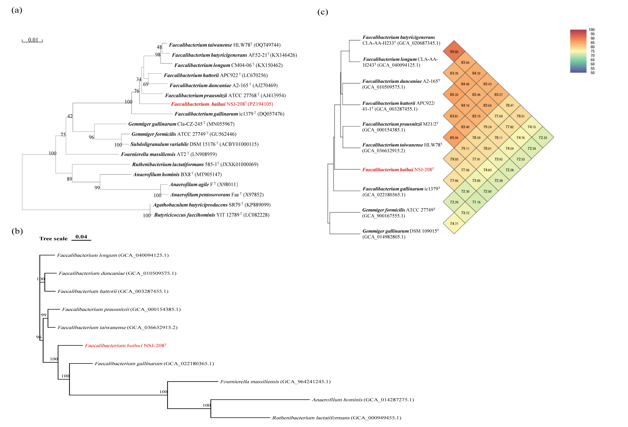
Figure SD-5 (a) The Neighbour-joining phylogenetic tree based on 16S rRNA gene sequences of strain NSJ-208^{T}. GenBank accession numbers are given in parentheses. Percentages of bootstrap support are shown at branch nodes. Bootstrap value was 1000. Bar: 0.01 substitutions per nucleotide position. The phylogenominc tree based on gemome-sequence-alignment (b) and OrthoANI heatmap (c) of strain NSJ-208^{T} and its neighbor species. Refseq ID of representative genomes are given in parentheses. Percentages of bootstrap support are shown at branch nodes. Bar: 0.04 substitutions per nucleotide position.
Blautia qilinii sp. nov.
Description of Blautia qilinii sp. nov. (qi.lin’i.i. N.L. gen. masc. n. qilinii, of Qilin, referring to Qilin, a prominent auspicious beast in Chinese mythology characterized by its benevolence and kindness)
Strain NSJ-202^{T} (16S rRNA sequence accession number in NCBI is PZ194099) is phylogenetically closest to Blautia obeum, with 16S rRNA gene identity of 97.83%. Phylogenetic tree shows that strain NSJ-202^{T} clusters with other members of the genus Blautia (Figure SD-6a), suggesting strain NSJ-202^{T} is a member of the genus Blautia. According to the phylogenominc tree (Figure SD-6b), the ANIs and dDDH values of genomes between strain NSJ-202^{T} and phylogenomically neighbored genomes were calculated, and the highest ANI and dDDH values are 82.65 and 28.40%, respectively, between the query genome of Blautia obeum ATCC 29174^{T} (GCA_000153905.1); and difference in % G+C between genomes of strain NSJ-202^{T} and Blautia obeum (GCA_000153905.1) is 2.30; OrthoANI heatmap (Figure SD-6c) shows the phylogenomic status of the corresponding neighbor species based on OrthoANI values. Based on these results, we concluded that the strain NSJ-202^{T} represents of new species of the genus Blautia, and the name Blautia qilinii sp. nov. is proposed. The type strain NSJ-202^{T} (=CGMCC 1.58804^{T}) was isolated from the faeces of a healthy adult.
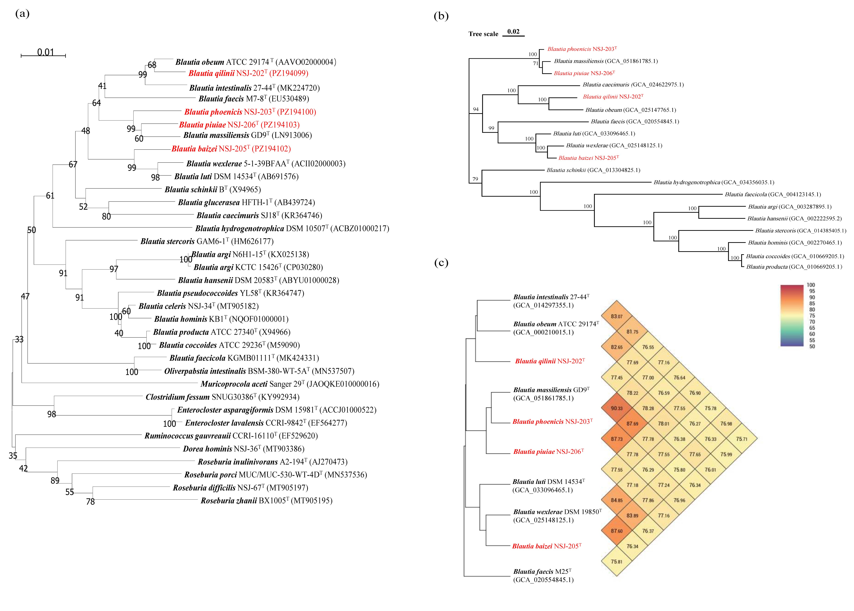
Figure SD-6 (a) The Neighbour-joining phylogenetic tree based on 16S rRNA gene sequences of strain NSJ-202^{T}, NSJ-203^{T}, NSJ-205^{T} and NSJ-206^{T}. GenBank accession numbers are given in parentheses. Percentages of bootstrap support are shown at branch nodes. Bootstrap value was 1000. Bar: 0.01 substitutions per nucleotide position. The phylogenominc tree based on gemome-sequence-alignment (b) and OrthoANI heatmap (c) of strain NSJ-202^{T}, NSJ-203^{T}, NSJ-205^{T}, NSJ-206^{T} and its neighbor species. Refseq ID of representative genomes are given in parentheses. Percentages of bootstrap support are shown at branch nodes. Bar: 0.02 substitutions per nucleotide position.
Blautia baizei sp. nov.
Description of Blautia baizei sp. nov. (bai.ze’i. N.L. gen. masc. n. baizei, of Baize, referring to the Baize, a wise mythical beast in Chinese mythology capable of speaking and knowing the secrets of all creatures)
Strain NSJ-205^{T} (16S rRNA sequence accession number in NCBI is PZ194102) is phylogenetically closest to Blautia wexlerae, with 16S rRNA gene identity of 97.93%. Phylogenetic tree shows that strain NSJ-205^{T} clusters with other members of the genus Blautia (Figure SD-6a), suggesting strain NSJ-205^{T} is a member of the genus Blautia. The genome of strain NSJ-205^{T} was sequenced and the NCBI accession number is JBWLUT000000000. According to the phylogenominc tree (Figure SD-6b), the ANIs and dDDH values of genomes between strain NSJ-205^{T} (NCBI accession number is JBWLUT000000000) and phylogenomically neighbored genomes were calculated, and the highest ANI and dDDH values are 87.60 and 38.50%, respectively, between the query genome of Blautia wexlerae DSM 19850^{T} (GCA_000484655.1); and difference in % G+C between genomes of strain NSJ-205^{T} and Blautia obeum (GCA_000484655.1) is 0.35; OrthoANI heatmap (Figure SD-6c) shows the phylogenomic status of the corresponding neighbor species based on OrthoANI values. Based on these results, we concluded that the strain NSJ-205^{T} represents of new species of the genus Blautia, and the name Blautia baizei sp. nov. is proposed. The type strain NSJ-205^{T} (=CGMCC 1.58807^{T}) was isolated from the faeces of a healthy adult.
Blautia phoenicis sp. nov.
Description of Blautia phoenicis sp. nov. (phoe.ni’cis. L. gen. masc. n. phoenicis, of Phoenix, referring to Phoenix, the name of the Chinese mythical bird Phoenix)
Strain NSJ-203^{T} (16S rRNA sequence accession number in NCBI is PZ194100) is phylogenetically closest to Blautia massiliensis with 16S rRNA gene identity of 97.52%. Phylogenetic tree shows that strain NSJ-203^{T} clusters with other members of the genus Blautia (Figure SD-6a), suggesting strain NSJ-203^{T} is a member of the genus Blautia. The genome of strain NSJ-203^{T} was sequenced and the NCBI accession number is JBWJVO000000000. According to the phylogenominc tree (Figure SD-6b), the ANIs and dDDH values of genomes between strain NSJ-203^{T} (NCBI accession number is JBWJVO000000000) and phylogenomically neighbored genomes were calculated, and the highest ANI and dDDH values are 90.33 and 41.30%, respectively, between the query genome of Blautia massiliensis GD9^{T} (GCA_001487165.1); and difference in % G+C between genomes of strain NSJ-203^{T} and Blautia massiliensis (GCA_001487165.1) is 0.02; OrthoANI heatmap (Figure SD-6c) shows the phylogenomic status of the corresponding neighbor species based on OrthoANI values. Based on these results, we concluded that the strain NSJ-203^{T} represents of new species of the genus Blautia, and the name Blautia phoenicis sp. nov. is proposed. The type strain NSJ-203^{T} (=CGMCC 1.58805^{T}) was isolated from the faeces of a healthy adult.

Blautia pixuiae sp. nov.
Description of Blautia pixuiae sp. nov. (pi.xu.i’ae. N.L. gen. masc. n. pixuiae, of Pixiu, referring to Pixiu, a mythical auspicious creature in Chinese mythology, believed to bring wealth and good fortune)
Strain NSJ-206^{T} (16S rRNA sequence accession number in NCBI is PZ194103) is phylogenetically closest to Blautia massiliensis with 16S rRNA gene identity of 97.52%. Phylogenetic tree shows that strain NSJ-206^{T} clusters with other members of the genus Blautia (Figure SD-6a), suggesting strain NSJ-206^{T} is a member of the genus Blautia. The genome of strain NSJ-206^{T} was sequenced and the NCBI accession number is JBWJVN000000000. According to the phylogenominc tree (Figure SD-6b), the ANIs and dDDH values of genomes between strain NSJ-206^{T} (NCBI accession number is JBWJVN000000000) and phylogenomically neighbored genomes were calculated, and the highest ANI and dDDH values are 87.69 and 36.00%, respectively, between the query genome of Blautia massiliensis GD9^{T} (GCA_001487165.1); and difference in % G+C between genomes of strain NSJ-206^{T} and Blautia massiliensis GD9^{T} (GCA_001487165.1) is 0.43; OrthoANI heatmap (Figure SD-6c) shows the phylogenomic status of the corresponding neighbor species based on OrthoANI values.Based on these results, we concluded that the strain NSJ-206^{T} represents of new species of the genus Blautia, and the name Blautia pixiui sp. nov. is proposed. The type strain NSJ-206^{T} (=CGMCC 1.58808^{T}) was isolated from the faeces of a healthy adult.

