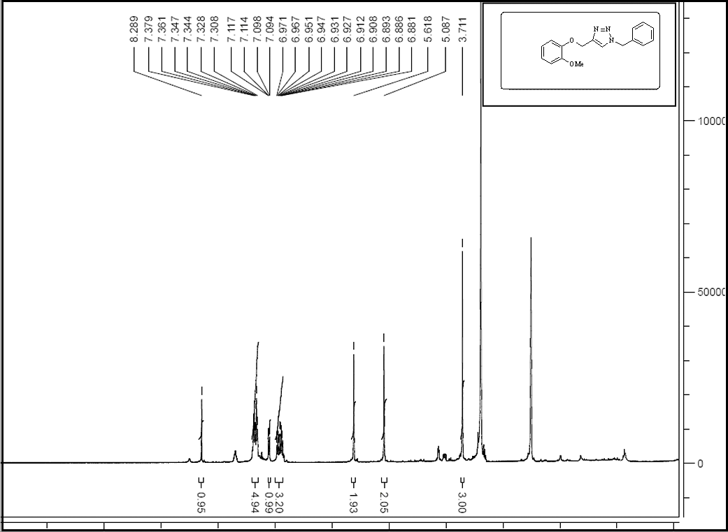
The ¹H NMR spectrum of 1-Benzyl-4-((2-methoxyphenoxy)methyl)-1H-1,2,3-triazole

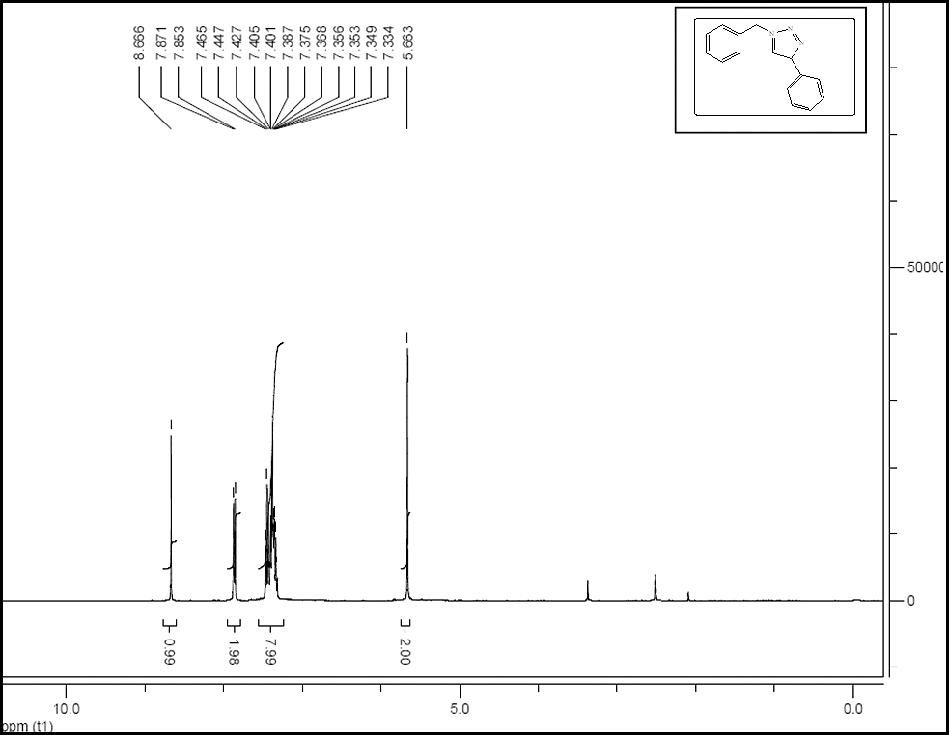
The ¹H NMR spectrum of 1-benzyl-4-phenyl-1H-1,2,3-triazole

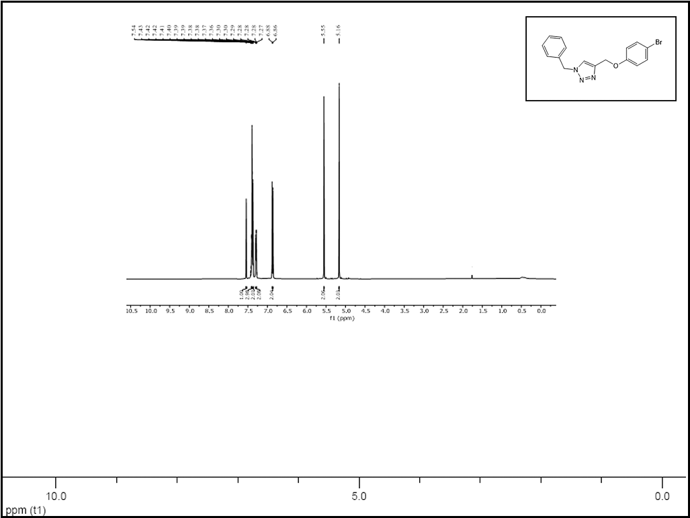
The ¹H NMR spectrum of 1-Benzyl-4-((4-bromophenoxy)methyl)-1H-1,2,3-triazole

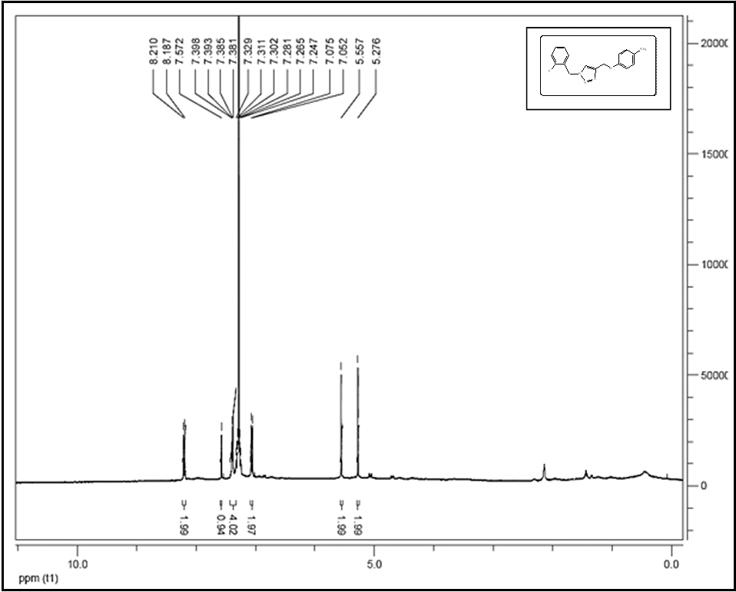
The ¹H NMR spectrum of 1-[(2-fluorophenyl) methyl]-4-phenyl-1H-1,2,3-triazol

The ¹H NMR spectrum of 1-(2,4-dichlorobenzyl)-4-phenyl-1H-1,2,3-triazole

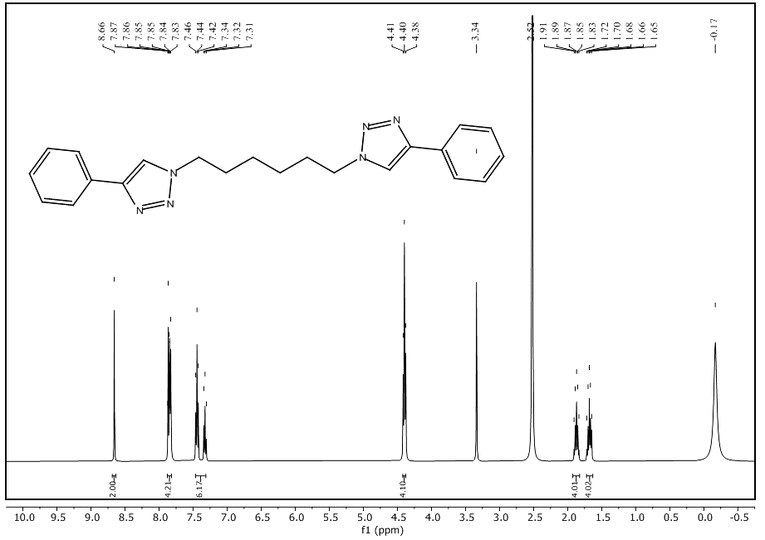
The ¹H NMR spectrum of 1,6-bis(4-phenyl-1H-1,2,3-triazol-1-yl)hexane.

