Immune-related liver injury : Distinct Clinical and Histological Subtyping Enables Personalized Treatment Strategies

Ryo Izai¹, Sae Yumita¹, Sadahisa Ogasawara¹, Midori Sawada¹, Kazuo Tubura¹,
Taro Watabe¹, Haruka Anzai¹, Keiichi Katayama¹, Makoto Fujiya¹, Ryohei Yoshino¹,
Takahiro Tsuchiya¹, Teppei Akatsuka¹, Chihiro Miwa¹, Takuya Yonemoto¹,
Hiroaki Kanzaki¹, Keisuke Koroki¹, Masanori Inoue¹, Masato Nakamura¹,
Naoya Kanogawa¹, Shingo Nakamoto¹, Jun Kato¹, Mina Komuta²,

¹Department of Gastroenterology, Graduate School of Medicine, Chiba University, Chiba, Japan
²Department of Pathology, International University of Health and Welfare Narita Hospital, Chiba, Japan

Inventory of supplementary data
- Supplementary Figure………………...Page 2
- Supplementary Tables………………....................... Page 3 - 6

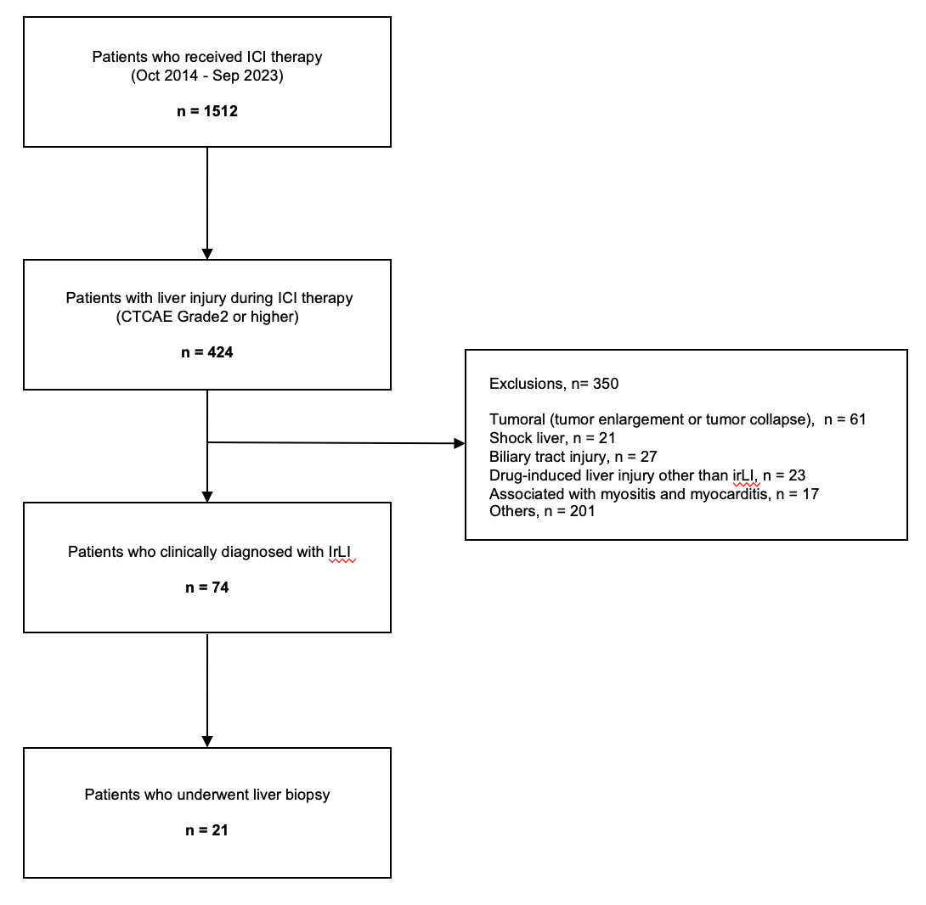
Fig. S1. Patient selection flowchart. This retrospective study included all 1,512 patients who received immune checkpoint inhibitors (ICIs) at Chiba University Hospital between October 2014 and September 2023. Among them, 74 patients (4.86%) were clinically diagnosed with immune-related liver injury (irLI), defined as CTCAE Grade ≥2 elevations in liver enzymes, based on expert panel assessment. The flowchart illustrates the selection process of patients included in the analysis and highlights those diagnosed with irLI.
Supplementary Table 1. Baseline characteristics of patients treated with immune checkpoint inhibitors
Variable | n = 1512
Demographics (n [%])
Age, ≥ 75 | 487 (32.2)
Sex, male | 1088 (72.0)
Metabolic factors (n [%])
Metabolic comorbidities (per AASLD) | 1212 (80.2)
Background liver disease (n [%])
MASLD | 142 (9.40)
Alcohol-related liver disease | 51 (3.37)
Hepatitis B | 52 (3.44)
Hepatitis C | 98 (6.48)
Others | 5 (0.33)
No underlying liver disease | 1168 (77.2)
Laboratory data (n [%])
AST, >upper normal limitation | 373 (24.7)
ALT, >upper normal limitation | 194 (12.8)
ALP, >upper normal limitation | 475 (31.4)
T-Bil, >upper normal limitation | 53 (3.50)
Fibrosis-4 index, ≥1.3 | 1004 (66.4)
Cancer type (n [%])
Lung cancer | 349 (23.1)
HCC | 260 (17.2)
Kidney Cancer | 159 (10.5)
Esophageal cancer | 143 (9.46)
Melanoma | 131 (8.66)
Gastric cancer | 109 (7.21)
Others | 361 (23.9)
Tumor status of intrahepatic lesion (n [%])
Presence of intrahepatic lesions | 394 (26.1)
Intrahepatic tumor volume ≥50% | 50 (3.31)
ICI Regimen (n [%])
Anti PD-1/PD-L1 monotherapy | 846 (56.0)
Anti PD-1/PD-L1+Anti VEGF | 287 (19.0)
Anti PD-1/PD-L1+Anticancer drug other than anti VEGF | 266 (17.6)
Including anti CTLA-4 | 113 (7.47)

Abbreviations: AASLD, American Association for the Study of Liver Diseases; MASLD, Metabolic Dysfunction-Associated Steatotic Liver Disease; PD-1, Programmed cell death protein 1; PD-L1, Programmed cell death ligand 1; irAE, immune-related adverse event; irLI, immune-related liver injury.

Supplementary Table 2. Comparison of Peak Liver Enzyme Levels and Liver Injury Patterns Between Transient and Persistent irLI

Parameter | irLI All | Transient irLI type | Persistent irLI type | P value  (Transient vs Persistent)
Parameter | n = 74 | n = 48 | n = 26 | P value  (Transient vs Persistent)
Peak ALT (IU/L), median (IQR) | 242 (159-421) | 297 (188-559) | 213 (148-273) | 0.019†
Peak AST (IU/L), median (IQR) | 189 (133-360) | 198 (147-404) | 143 (120-269) | 0.033†
Peak ALP (IU/L), median (IQR) | 180 (122-381) | 163 (120-355) | 190 (151-475) | 0.147†
Peak T-Bil (mg/dL), median (IQR) | 1.0 (0.7-1.6) | 0.95 (0.68-1.43) | 1.3 (0.9-1.68) | 0.039 †
Liver injury type, n (%)
Hepatocellular | 13 (17.6) | 11 (22.9) | 2 (7.69) | 0.122 ³⁾
Cholestatic | 35 (47.3) | 19 (39.6) | 16 (61.5) | 0.118 ‡
Mixed | 26 (35.1) | 18 (37.5) | 8 (30.8) | 0.746 §

Abbreviations: AST, aspartate aminotransferase; ALT, alanine aminotransferase; ALP, alkaline phosphatase; T-Bil, total bilirubin.

† Mann–Whitney U test was used to compare continuous variables between the two groups.

‡ Chi-squared test was used to compare categorical variables.

§ Fisher’s exact test was used to compare categorical variables.

Supplementary Table 3. Univariate cox proportional hazards analysis for risk factors of transient and persistent irLI
Variable | Transient irLI type |  | Persistent irLI type
Variable | Hazard ratio (95% CI) | P value | Hazard ratio (95% CI) | P value
Demographics (n [%])
Age, ≥ 75 | 0.33  (0.15-0.74) | 0.008 | 2.02  (0.93-4.35) | 0.087
Sex, male | 1.22  (0.62-2.40) | 0.572 | 0.70  (0.31-1.57) | 0.390
Metabolic factors (n [%])
Metabolic comorbidities (per AASLD) | 0.62  (0.32-1.19) | 0.161 | 2.71  (0.64-11.5) | 0.183
Visceral fat area, ≥100cm² | 0.94  (0.52-1.70) | 0.826 | 0.64  (0.27-1.53) | 0.322
Hypertension | 1.05  (0.60-1.85) | 0.812 | 2.45  (1.06-5.62) | 0.035
Diabetes | 0.54  (0.25-1.15) | 0.109 | 0.85  (0.34-2.13) | 0.716
Dyslipidemia | 1.11  (0.55-2.23) | 0.745 | 1.28  (0.51-3.19) | 0.588
MASLD | 1.57  (0.70-3.51) | 0.267 | 0.76  (0.18-3.22) | 0.726
Any metabolic factor with ALT,  >upper normal limitation | 1.32  (0.56-3.12) | 0.468 | 3.32  (1.40-7.92) | 0.007
MASLD with ALT,  >upper normal limitation | 2.02  (0.72-5.62) | 0.157 | 1.90  (0.45-8.04) | 0.367
Laboratory data (n [%])
AST, >upper normal limitation | 0.87  (0.44-1.76) | 0.739 | 2.02  (0.91-4.44) | 0.087
ALT, >upper normal limitation | 1.10  (0.47-2.60) | 0.763 | 3.26  (1.41-7.50) | 0.006
ALP, >upper normal limitation | 0.79  (0.40-1.55) | 0.541 | 2.48  (1.15-5.37) | 0.023
T-Bil, >upper normal limitation | 0 (0-inf) | 0.995 | 1.17  (0.16-8.65) | 0.904
Fibrosis-4 index, ≥1.3 | 0.59  (0.33-1.04) | 0.065 | 0.76  (0.35-1.68) | 0.481
Cancer type (n [%])
Lung cancer | 1.26  (0.67-2.39) | 0.501 | 0.28  (0.07-1.20) | 0.090
HCC | 0.77  (0.35-1.73) | 0.563 | 1.66  (0.70-3.96) | 0.254
Kidney Cancer | 1.51  (0.71-3.23) | 0.288 | 1.04  (0.31-3.45) | 0.929
Esophageal cancer | 1.47  (0.62-3.46) | 0.369 | 1.79  (0.62-5.19) | 0.275
Melanoma | 1.07  (0.42-2.71) | 0.873 | 1.29  (0.39-4.29) | 0.668
Gastric cancer | 1.39  (0.50-3.86) | 0.531 | 0.57  (0.08-4.24) | 0.585
Others | 0.40  (0.16-1.00) | 0.049 | 1.01  (0.40-2.50) | 0.957
Tumour status (n [%])
Presence of intrahepatic lesions | 0.93  (0.47-1.84) | 0.863 | 1.31  (0.57-3.02) | 0.531
Intrahepatic tumor volume ≥50% | 2.71  (0.84-8.75) | 0.078 | 2.93  (0.69-12.5) | 0.134
Regimen (n [%])
Anti PD-1/PD-L1 monotherapy | 0.62  (0.35-1.11) | 0.096 | 0.60  (0.27-1.30) | 0.178
Anti PD-1/PD-L1+Anti VEGF | 0.99  (0.49-2.00) | 0.998 | 1.15  (0.46-2.87) | 0.753
Anti PD-1/PD-L1+Anticancer drug other than anti VEGF | 1.31  (0.65-2.63) | 0.459 | 0.87  (0.30-2.53) | 0.814
Including anti CTLA-4 | 1.94  (0.83-4.58) | 0.114 | 2.41  (0.83-7.00) | 0.092

Abbreviations: AASLD, American Association for the Study of Liver Diseases; MASLD, Metabolic Dysfunction-Associated Steatotic Liver Disease; AST, aspartate aminotransferase; ALT, alanine aminotransferase; ALP, alkaline phosphatase; T-Bil, total bilirubin; HCC, hepatocellular carcinoma; PD-1, Programmed cell death protein 1; PD-L1, Programmed cell death ligand 1; VEGF, Vascular Endothelial Growth Factor; CTLA-4, Cytotoxic T-lymphocyte Antigen-4.
Supplementary Table 4. Multivariate cox proportional hazards analysis for risk factors of transient and persistent irLI
Variable | Transient irLI type |  | Persistent irLI type
Variable | Hazard ratio (95% CI) | P value | Hazard ratio (95% CI) | P value
Age, ≥ 75 | 0.37  (0.16-0.83) | 0.019 | 2.47  (1.07-5.70) | 0.039
Sex, male | 1.37  (0.69-2.71) | 0.387 | 0.77  (0.33-1.75) | 0.523
Any metabolic factor with ALT, >upper normal limitation | 1.49  (0.60-3.68) | 0.371 | 3.09  (1.18-8.07) | 0.021
Fibrosis-4 index, ≥1.3 | 0.73  (0.39-1.36) | 0.299 | 0.49  (0.19-1.22) | 0.117
HCC | 0.90  (0.37-2.20) | 0.863 | 1.33  (0.47-3.76) | 0.580
Including anti CTLA-4 | 1.76  (0.74-4.15) | 0.177 | 2.23  (0.76-6.54) | 0.137

Abbreviations: ALT, alanine aminotransferase; HCC, hepatocellular carcinoma; CTLA-4, Cytotoxic T-lymphocyte Antigen-4.

