Supplementary Tables
Supplementary Table S1. Full Cox model coefficients for the combined model at the 6-month landmark.
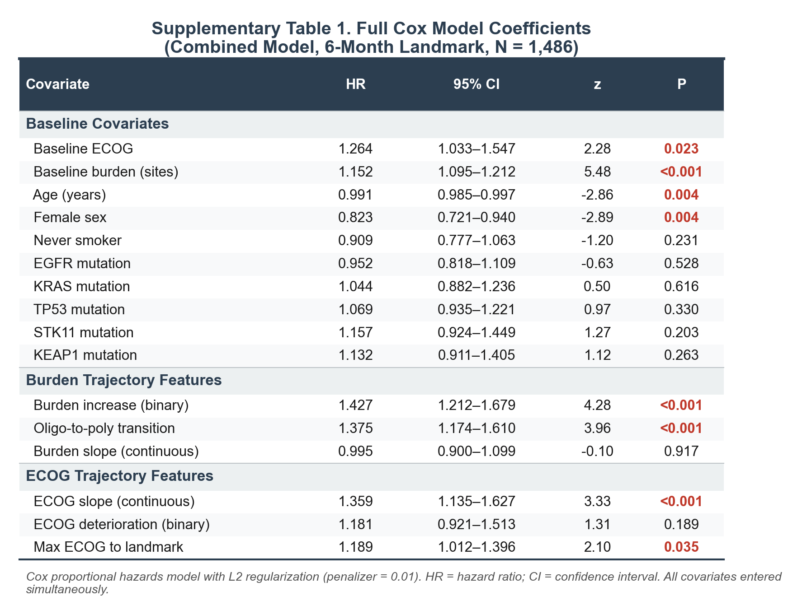

Supplementary Figures

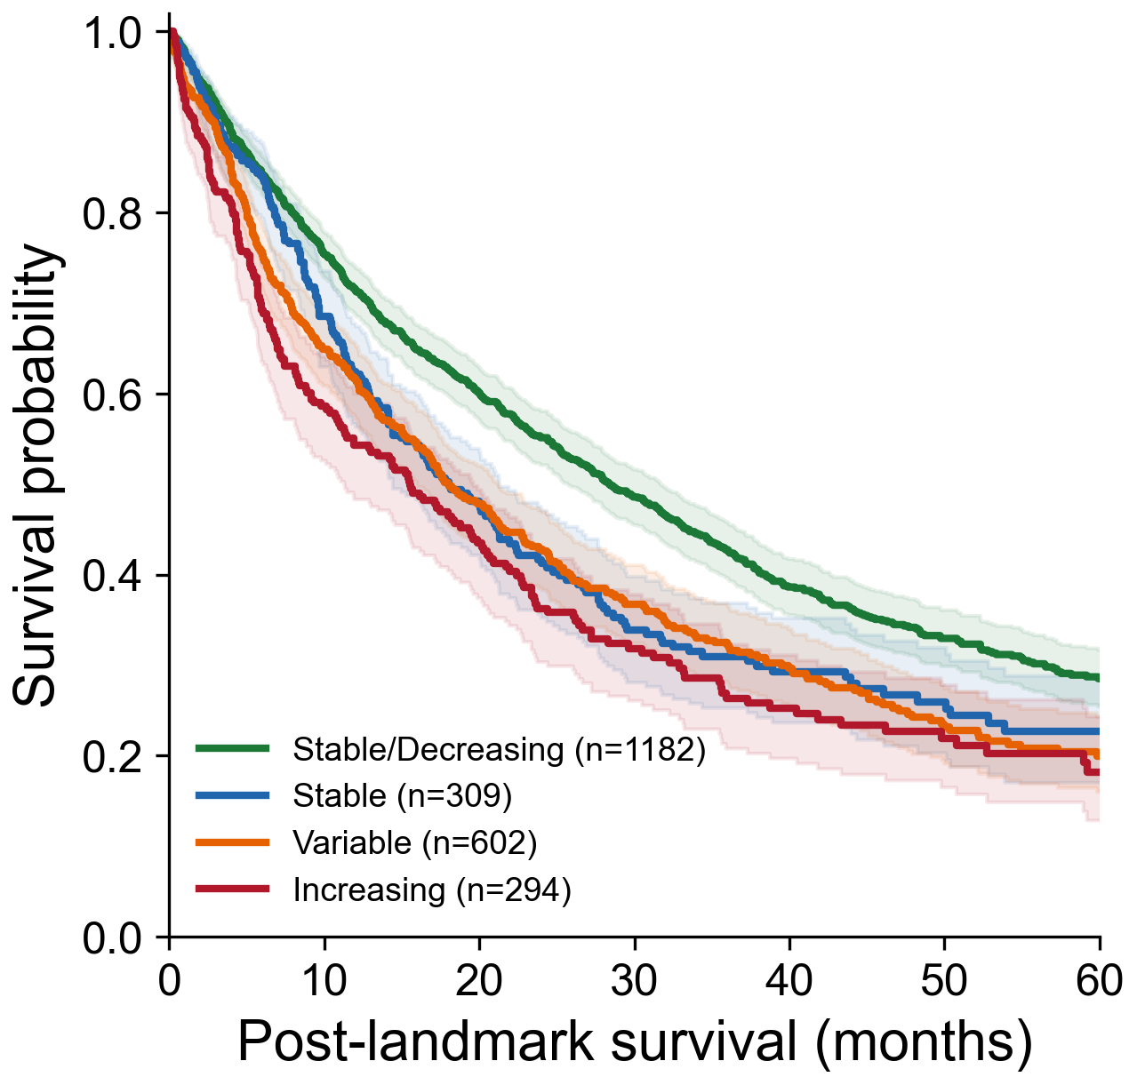
Supplementary Figure S1. Kaplan-Meier curves for burden trajectory classification at 6-month landmark (Stable/Decreasing, Stable, Variable, Increasing).

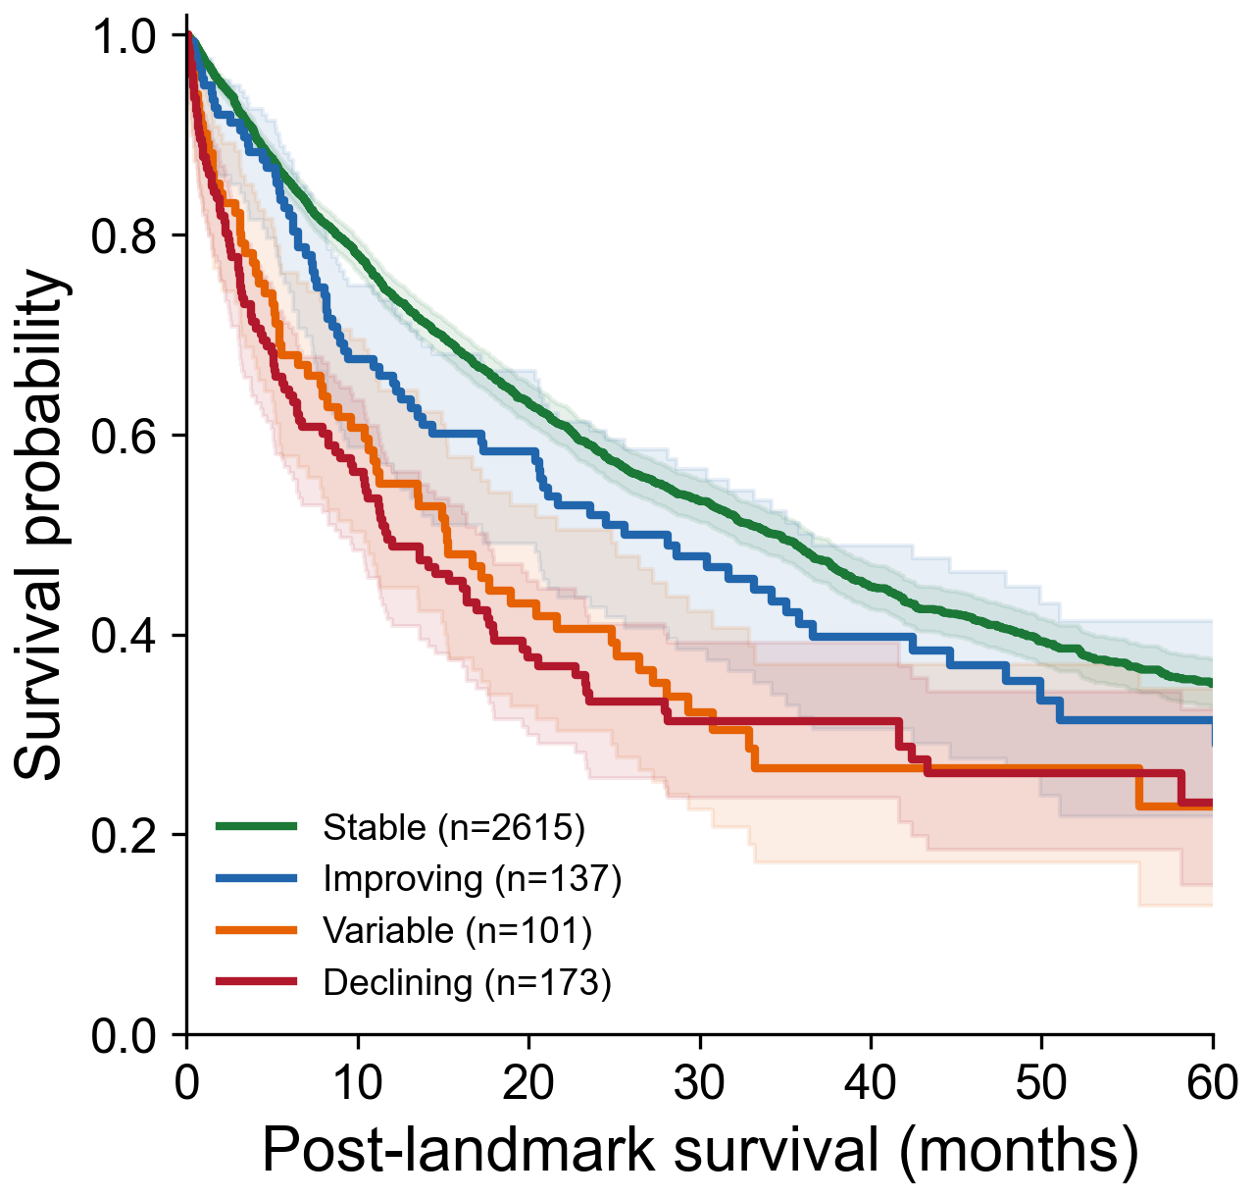
Supplementary Figure S2. Kaplan-Meier curves for ECOG trajectory classification at 6-month landmark (Stable, Improving, Variable, Declining).

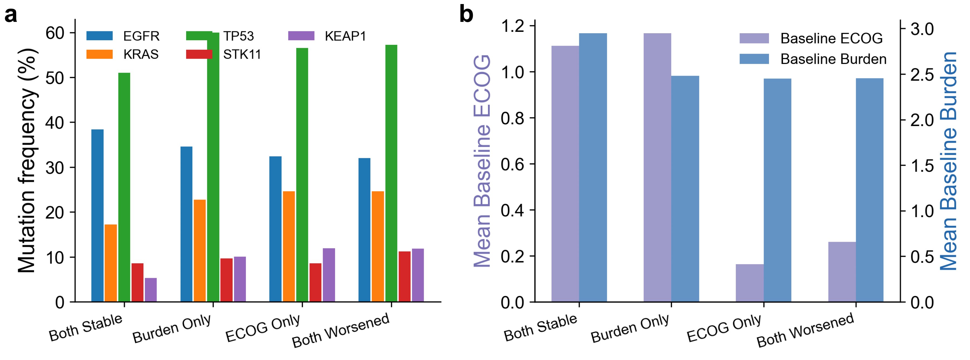
Supplementary Figure S3. Risk group characterization: (a) driver mutation frequencies, (b) baseline clinical features

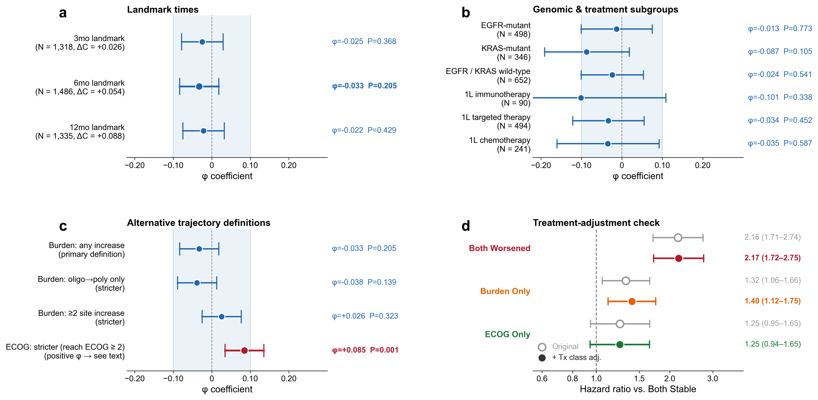
Supplementary Figure S4. Robustness of trajectory independence. Forest plots of the burden × ECOG independence φ coefficient (panels a–c) and paired hazard ratios (panel d) across pre-specified sensitivity dimensions. (a) φ at the 3-, 6-, and 12-month landmarks. (b) φ within genomic subgroups and first-line treatment subgroups (immunotherapy, targeted therapy, chemotherapy). (c) φ under alternative trajectory definitions: three burden thresholds (any increase, oligo→poly transition only, ≥2-site increase) and a stricter ECOG definition (reaching ECOG ≥ 2, bolded). (d) Paired hazard ratios vs. Both Stable for the three discordance groups, from the main full Cox model (open circles) and the same model with additional adjustment for first-line treatment class (filled, color-coded; chemo-immunotherapy reference). For panels a–c, shaded band marks the |φ| < 0.10 equivalence region (TOST margin); blue indicates non-significant independence (χ² P ≥ 0.05), red indicates a significant departure. Point estimates with 95% confidence intervals; CIs for φ computed via Fisher's z transform. All analyses use the 6-month landmark cohort (N = 1,486) except panel a, which spans landmarks as labelled.

