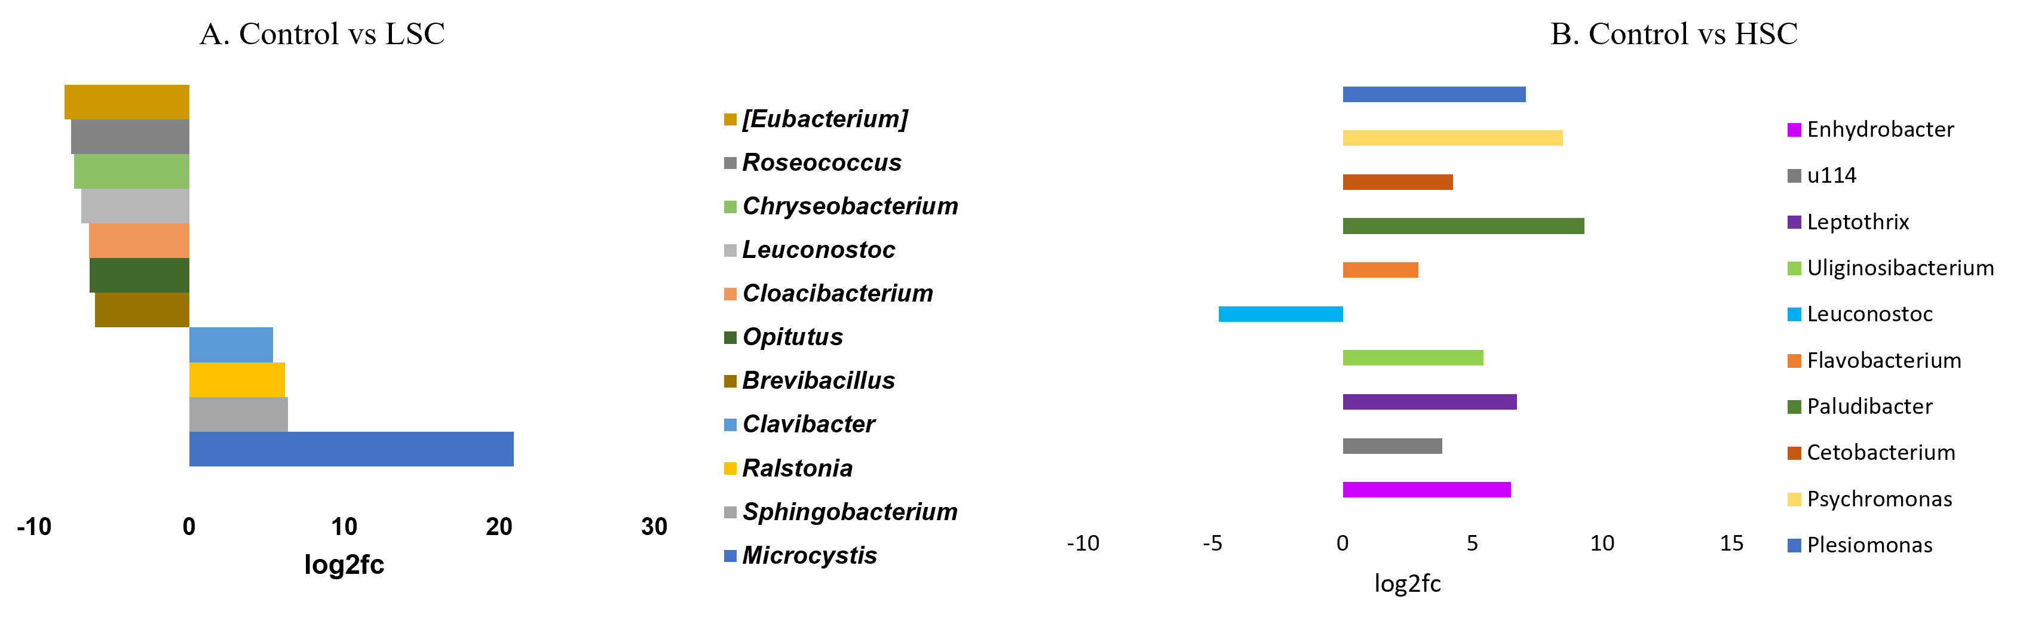
Fig. 1: The bar plot illustrates the log2fold change in the relative abundance of significantly altered bacterial genera between control and LSC (A); control and HSC (B). Positive values indicate enrichment in control, while negative values indicate enrichment in treatment. Taxa are color-coded according to the legend.
Fig_ 2: CCA biplot displaying correlation between rohu gut microbiota treated with TFM and host enzymatic activity.

Table 1: Topological description of the cooccurrence network
Description | Control | LSC | HSC
Nodes | 20 | 19 | 20
Edges | 83 | 59 | 190
Average degree | 8.3 | 6.211 | 19
Density | 0.437 | 0.345 | 1
Modularity | 0.28 | 0.383 | 0
Clustering coefficient | 0.858 | 0.868 | 1
Average path length | 1.162 | 1.52 | 1
% of Positive interaction | 50.6 | 89.83 | 73.16
% of negative interaction | 49.4 | 10.17 | 26.84

