Metagenomic Analysis of Bacterial Communities during Estrous cycle in Bos indicus
Purva Gohil¹, Kajal Patel¹, Kishan Purohit¹, Dhruvil Chavda¹, Apurva Puvar¹, Vishal. S. Suthar^{2*}, Deepak. B. Patil², Madhavi Joshi¹, Chaitanya. G. Joshi¹
¹ Gujarat Biotechnology Research Centre, Gandhinagar, Gujarat- 302010
² Directorate of Research, Kamdhenu University Gandhinagar, Gujarat, India-38201

*Corresponding author: Vishal Suthar. Email: vsuthar28@gmail.com
M: +919824491049
Assistant Professor
Directorate of Research, Kamdhenu University Gandhinagar, Gujarat, India-382010

Table S1. ION Torrent 16S Fusion Primers Barcode details
Table S2: Difference between Alpha diversity of two stages of estrous cycle using Kruskal-Wallis (pairwise) statistics using faith phylogenetic diversity group significance.
Table S3: Difference between Alpha diversity of two farms where animals were selected for the study using Kruskal-Wallis (pairwise) statistics using faith phylogenetic diversity group significance

Table S1
Primer Name | Nucleotide Sequence
ION-16S-F-B1 | CCATCTCATCCCTGCGTGTCTCCGACTCAGCTAAGGTAACGATACTGGCGGACGGGTGAGTAA
ION-16S-F-B2 | CCATCTCATCCCTGCGTGTCTCCGACTCAGTAAGGAGAACGATACTGGCGGACGGGTGAGTAA
ION-16S-F-B3 | CCATCTCATCCCTGCGTGTCTCCGACTCAGAAGAGGATTCGATACTGGCGGACGGGTGAGTAA
ION-16S-F-B4 | CCATCTCATCCCTGCGTGTCTCCGACTCAGTACCAAGATCGATACTGGCGGACGGGTGAGTAA
ION-16S-F-B5 | CCATCTCATCCCTGCGTGTCTCCGACTCAGCAGAAGGAACGATACTGGCGGACGGGTGAGTAA
ION-16S-F-B6 | CCATCTCATCCCTGCGTGTCTCCGACTCAGCTGCAAGTTCGATACTGGCGGACGGGTGAGTAA
ION-16S-F-B7 | CCATCTCATCCCTGCGTGTCTCCGACTCAGTTCGTGATTCGATACTGGCGGACGGGTGAGTAA
ION-16S-F-B8 | CCATCTCATCCCTGCGTGTCTCCGACTCAGTTCCGATAACGATACTGGCGGACGGGTGAGTAA
ION-16S-F-B9 | CCATCTCATCCCTGCGTGTCTCCGACTCAGTGAGCGGAACGATACTGGCGGACGGGTGAGTAA
ION-16S-F-B10 | CCATCTCATCCCTGCGTGTCTCCGACTCAGCTGACCGAACGATACTGGCGGACGGGTGAGTAA
ION-16S-F-B11 | CCATCTCATCCCTGCGTGTCTCCGACTCAGTCCTCGAATCGATACTGGCGGACGGGTGAGTAA
ION-16S-F-B12 | CCATCTCATCCCTGCGTGTCTCCGACTCAGTAGGTGGTTCGATACTGGCGGACGGGTGAGTAA
ION-16S-F-B13 | CCATCTCATCCCTGCGTGTCTCCGACTCAGTCTAACGGACGATACTGGCGGACGGGTGAGTAA
ION-16S-F-B14 | CCATCTCATCCCTGCGTGTCTCCGACTCAGTTGGAGTGTCGATACTGGCGGACGGGTGAGTAA
ION-16S-F-B15 | CCATCTCATCCCTGCGTGTCTCCGACTCAGTCTAGAGGTCGATACTGGCGGACGGGTGAGTAA
ION-16S-F-B16 | CCATCTCATCCCTGCGTGTCTCCGACTCAGTCTGGATGACGATACTGGCGGACGGGTGAGTAA
ION-16S-F-B17 | CCATCTCATCCCTGCGTGTCTCCGACTCAGTCTATTCGTCGATACTGGCGGACGGGTGAGTAA
ION-16S-F-B18 | CCATCTCATCCCTGCGTGTCTCCGACTCAGAGGCAATTGCGATACTGGCGGACGGGTGAGTAA
ION-16S-F-B19 | CCATCTCATCCCTGCGTGTCTCCGACTCAGTTAGTCGGACGATACTGGCGGACGGGTGAGTAA
ION-16S-F-B20 | CCATCTCATCCCTGCGTGTCTCCGACTCAGCAGATCCATCGATACTGGCGGACGGGTGAGTAA
ION-16S-F-B21 | CCATCTCATCCCTGCGTGTCTCCGACTCAGTCGCAATTACGATACTGGCGGACGGGTGAGTAA
ON-16S-F-B22 | CCATCTCATCCCTGCGTGTCTCCGACTCAGTTCGAGACGCGATACTGGCGGACGGGTGAGTAA
ION-16S-F-B23 | CCATCTCATCCCTGCGTGTCTCCGACTCAGTGCCACGAACGATACTGGCGGACGGGTGAGTAA
ION-16S-F-B24 | CCATCTCATCCCTGCGTGTCTCCGACTCAGAACCTCATTCGATACTGGCGGACGGGTGAGTAA
ION-16S-F-B25 | CCATCTCATCCCTGCGTGTCTCCGACTCAGCCTGAGATACGATACTGGCGGACGGGTGAGTAA
ION-16S-F-B26 | CCATCTCATCCCTGCGTGTCTCCGACTCAGTTACAACCTCGATACTGGCGGACGGGTGAGTAA
ION-16S-F-B27 | CCATCTCATCCCTGCGTGTCTCCGACTCAGAACCATCCGCGATACTGGCGGACGGGTGAGTAA
ION-16S-F-B28 | CCATCTCATCCCTGCGTGTCTCCGACTCAGATCCGGAATCGATACTGGCGGACGGGTGAGTAA
ION-16S-F-B29 | CCATCTCATCCCTGCGTGTCTCCGACTCAGTCGACCACTCGATACTGGCGGACGGGTGAGTAA
ION-16S-F-B30 | CCATCTCATCCCTGCGTGTCTCCGACTCAGCGAGGTTATCGATACTGGCGGACGGGTGAGTAA
ION-16S-F-B31 | CCATCTCATCCCTGCGTGTCTCCGACTCAGTCCAAGCTGCGATACTGGCGGACGGGTGAGTAA
ION-16S-F-B32 | CCATCTCATCCCTGCGTGTCTCCGACTCAGTCTTACACACGATACTGGCGGACGGGTGAGTAA
ION-16S-F-B33 | CCATCTCATCCCTGCGTGTCTCCGACTCAGTTCTCATTGAACGATACTGGCGGACGGGTGAGTAA
ION-16S-F-B34 | CCATCTCATCCCTGCGTGTCTCCGACTCAGTCGCATCGTTCGATACTGGCGGACGGGTGAGTAA
ION-16S-F-B35 | CCATCTCATCCCTGCGTGTCTCCGACTCAGTAAGCCATTGTCGATACTGGCGGACGGGTGAGTAA
ION_16S_Reverse | CCTCTCTATGGGCAGTCGGTGATCGTATTACCGCGGCTGCTGG

Table S2
Group 1 | Group 2 | H | p-value | q-value
Follicular | Luteal | 2.440 | 0.118 | 0.118

Table S3
Group 1 | Group 2 | H | p-value | q-value
Farm 1 | Farm 2 | 0.862 | 0.353 | 0.353

Figure S1: Abundance of lactobacillaceae families across the four phases of estrous cycle.
Figure S2: Alpha Rarefaction Curve of all the samples with two different estrous stages at the depth of 1000
Figure S2B: Alpha Rarefaction Curve of all the samples with four different estrous phases at the depth of 1000
Figure S4A. Beta Diversity of four phases of estrous cycle at family level in cows.
Figure S4B. Beta Diversity of four phases of estrous cycle at species level in cows.
Figure S3A: Beta diversity analysis, Principle coordinate analysis based on unweighted Unifrac distance matrix, the samples were compared at the four phases of the estrous cycle using a beta diversity analysis
Figure S3B: Beta diversity analysis, Principle coordinate analysis based on weighted Unifrac distance matrix, the samples were compared at the follicular and luteal stages of the estrous cycle using a beta diversity analysis
Figure S3C: Beta diversity analysis, Principle coordinate analysis based on unweighted Unifrac distance matrix, the samples were compared at the follicular and luteal stages of the estrous cycle using a beta diversity analysis

Figure S1
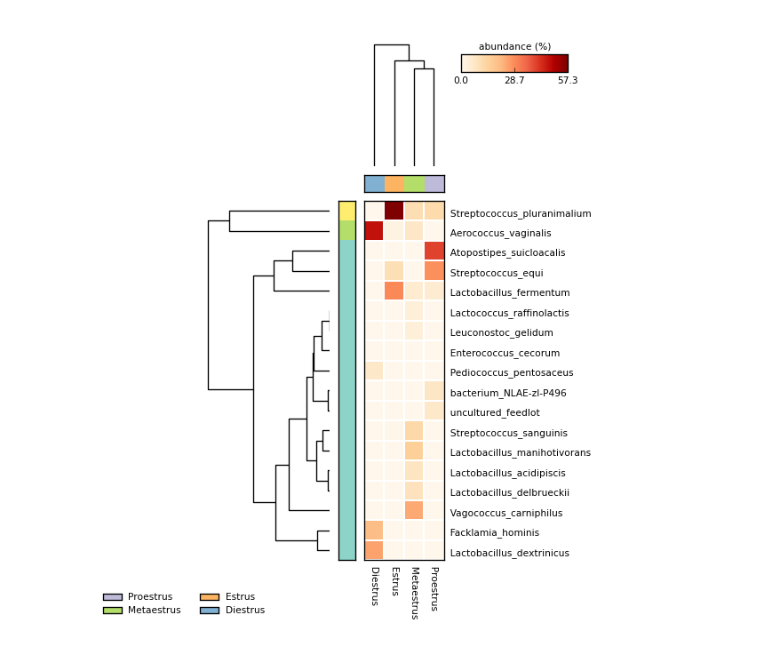

Figure S2A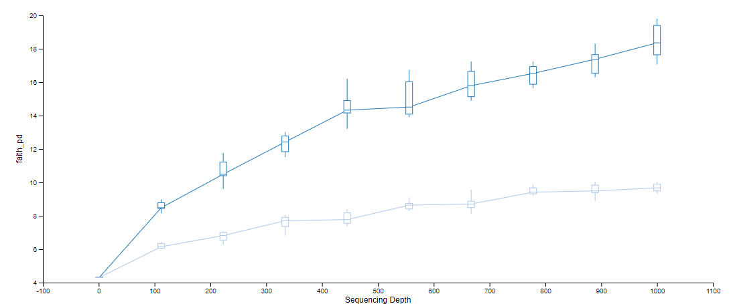 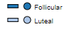

Figure S2B
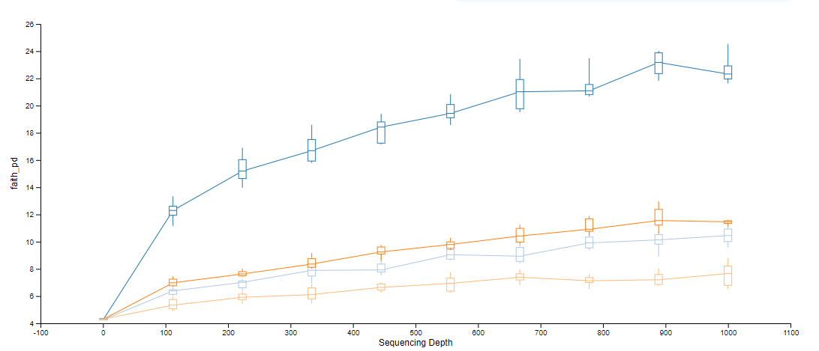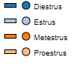

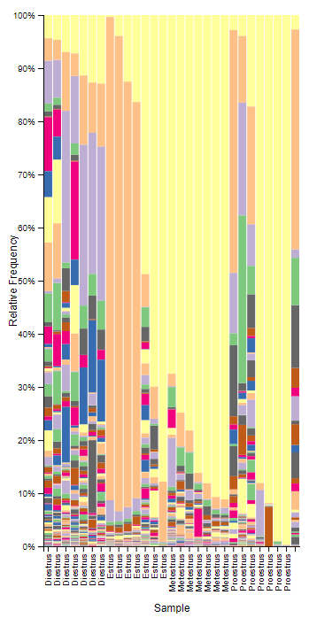
Figure S4A
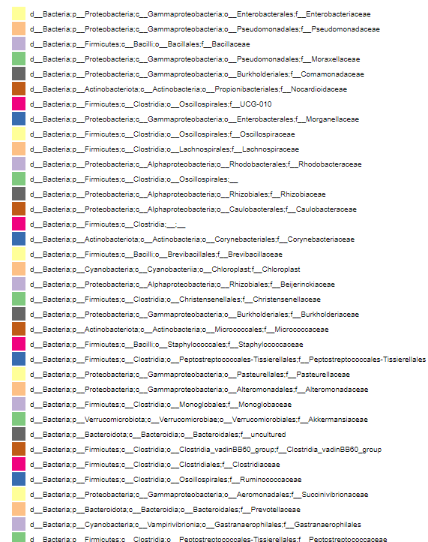

Figure S4B
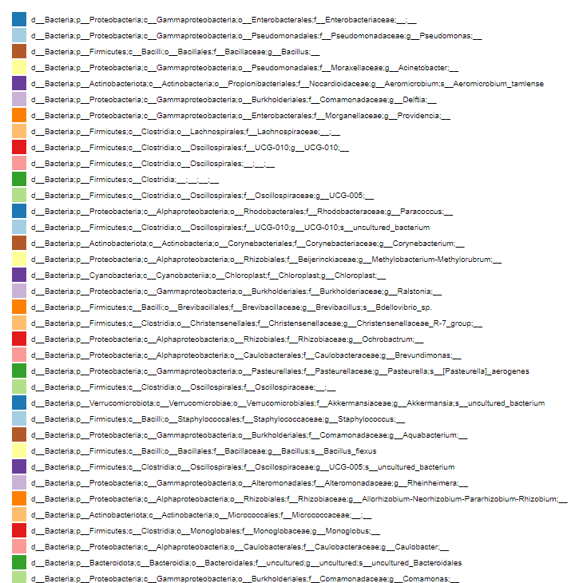
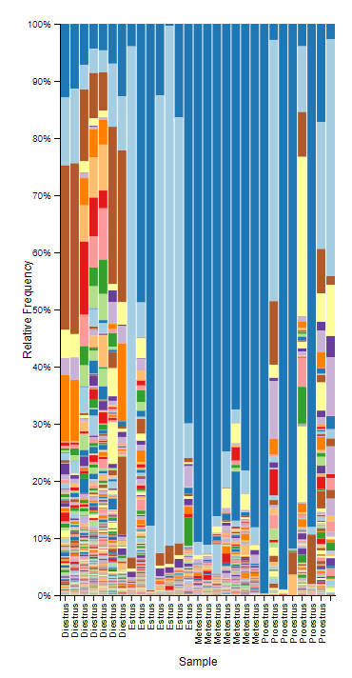

Figure S3A
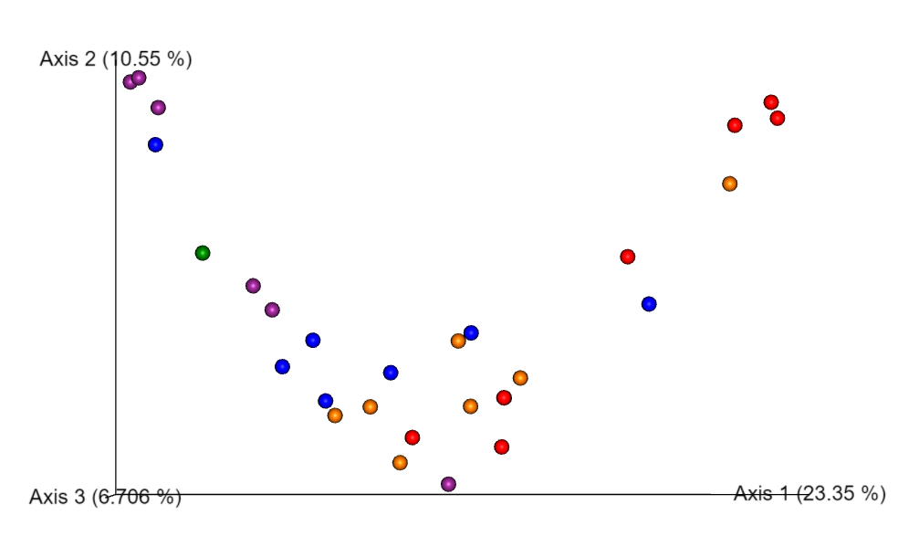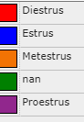

Figure S3B
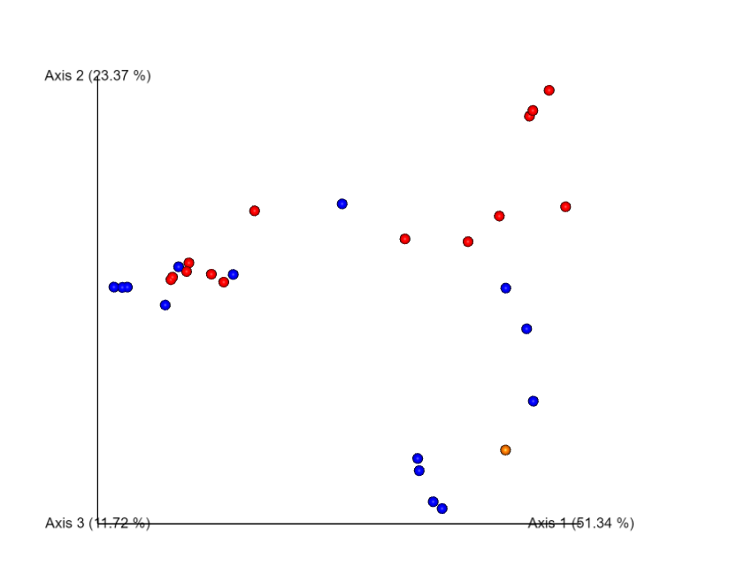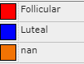

Figure S3C
