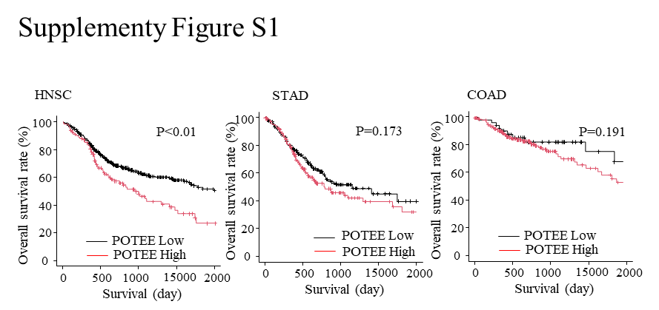
Supplementary Figure 1.
Prognostic significance of POTEE mRNA expression in public datasets.
Kaplan–Meier curves showing overall survival according to POTEE mRNA expression levels in HNSC, STAD, and COAD. High POTEE expression was significantly associated with poor prognosis in HNSC, while non-significant trends toward poorer prognosis were observed in STAD and COAD.

Supplement table I. List of 226 genes highly expressed in the testis, ovary, or placenta based on the Human Protein Atlas RNA tissue expression consensus dataset.
AGEC2 | SPO11 | PAGE1 | FKBP6 | LRRC74A | SEL1L2 | H2BW2 | LUZP4
CCDC70 | ESX1 | ATXN3L | MAGEA10 | BANF2 | SSX1 | QRICH2 | VCY1B
USP26 | PIWIL4 | GH2 | C4orf17 | PLCZ1 | SYCP3 | ADAM21 | DMRTC2
ALLC | SLC25A31 | CATSPER3 | TEKT5 | FAM81B | TEX29 | TRIM42 | MAGEA8
TEX47 | LRRC18 | RPL10L | NOXRED1 | SSX3 | PASD1 | TBATA | SUN5
GARIN2 | CBY2 | C9orf131 | ARL13A | GOLGA6L2 | TEX36 | CATSPER1 | CCDC197
BEND2 | C12orf54 | SPATA31E1 | PRM3 | ZNF716 | SPDYE4 | REC114 | TFDP3
FAM47A | NPAP1 | SLC36A3 | CCDC73 | H2AP | NANOS3 | DNAH17 | FAM205C
HBG2 | TEX43 | OR8G1 | CLEC9A | FAM24A | DPPA5 | C1orf146 | SPANXN1
C16orf96 | C18orf63 | CTAGE1 | TSGA13 | MAGEB1 | DCDC2C | PNMA6E | C16orf90
SPANXB1 | TEX46 | C2orf92 | TSPY8 | IQCF3 | TEX50 | PAGE2 | CCDC188
TEX49 | ENSG00000259060 | GFY | SSX4 | SSX2B | CT45A1 | MEI4 | TMEM275
ADAM2 | THEG | SPAM1 | SLC25A2 | TEX11 | LYZL1 | RGSL1 | IQCM
ZSCAN10 | CDX4 | RHOXF2 | LIN28A | FTHL17 | LARGE1 | ADAM30 | TEX52
ZAN | GCNA | ANKRD30A | OOSP2 | SPATA25 | CCDC83 | LYZL2 | MEIOSIN
LYZL4 | HIPK4 | DPPA2 | DNAJC5G | C4orf45 | PRDM9 | SPATA48 | LITAFD
C16orf92 | GOT1L1 | USP50 | XAGE3 | XAGE5 | KLF17 | TEX37 | ZNF722
TMEM270 | ENTHD1 | FOXR1 | DCAF4L2 | CNBD1 | TRIM60 | FMR1NB | THSD8
PP2D1 | NUTM1 | PRSS55 | DDX53 | C5orf47 | ZNF479 | TEX33 | ERVW-1
TMEM202 | POTEE | NANOS2 | POTEA | DUSP21 | DCAF8L2 | OTUD6A | ENSG00000284526
TXNDC8 | SPANXN5 | CBY3 | FAM221B | MS4A13 | FAM205A | IZUMO3 | GMCL2
KCNU1 | CDC14C | MAGEA3 | POM121L12 | SUPT20HL2 | C8orf90 | MROH5 | SMIM42
TERB1 | ARMS2
These genes showed significantly higher expression in the testis, ovary, or placenta than in other tissues (t-test P<0.05 and fold change >20), with no detectable expression in 95% of the remaining tissues.

Supplement table II. Fifteen genes with high commonality in tumor tissues of HNSC, STAD, READ, and COAD.
Gene name | HNSC(%) | STAD(%) | READ(%) | COAD(%)
C20orf144 | 99.2 | 99.7 | 100 | 98.2
DYNLT2 | 100 | 99.7 | 100 | 99.5
TMEM262 | 100 | 99.7 | 100 | 99.8
ACTL8 | 86.8 | 88.2 | 97.5 | 96.8
AKNAD1 | 97.6 | 95.2 | 96.9 | 93.6
ERICH6B | 92.8 | 97.7 | 96.9 | 95.4
C11orf94 | 96.4 | 94.1 | 88.1 | 82.7
PPP1R2B | 85.4 | 99.4 | 84.3 | 77.4
C1orf100 | 86.8 | 93.2 | 82.4 | 76.1
CAGE1 | 99.4 | 85.6 | 82.4 | 75.9
CSTL1 | 82.8 | 81.4 | 81.1 | 82.2
POTEE | 90.8 | 99.7 | 79.2 | 69
TEX19 | 80 | 77.2 | 76.7 | 77.7
MMP20 | 70.5 | 74.9 | 75.5 | 70.8
CCDC168 | 91.4 | 97.2 | 69.8 | 71.8
The table lists 15 genes showing high commonality in tumor tissues of HNSC, STAD, READ, and COAD, defined as expression in tumor tissues in more than 60% of cases for each cancer type. HNSC, head and neck squamous cell carcinoma; STAD, stomach adenocarcinoma; READ, rectal adenocarcinoma; COAD, colon adenocarcinoma.

