Supplementary Information
Supplementary Figure 1: Importance of H&E Alignment with MxIF for Quality Control in Spatial-Omics Data, including A) Positive, B) Negative and C) Mixed examples.
Supplementary Figure 2: Overview of ovarian TMA dataset, including MxIF and H&E-stained sections.
Supplementary Figure 3: Example of manually annotated landmarks in TMA cores for establishing ground truth transformations.
Supplementary Figure 4: Examples of segmentation discrepancies between H&E and MxIF.
Supplementary Figure 5: Results of CPD-based alignment extended with "super-cell" clustering for whole-slide images.

Supplementary Figures:

Supplementary Figure 1: Importance of H&E Alignment with MxIF for Quality Control in Spatial-Omics Data, including A) Positive, B) Negative and C) Mixed examples.
A. Positive Example. A tissue microarray (TMA) core of high-grade ovarian serous carcinoma is shown in Figure A1 (H&E, 2X magnification). Figure A2 represents an immediate serial section of the same area stained with MxIF (including 40 markers). This study particularly attempts to evaluate tumor infiltrating plasma cells within the tumor immune microenvironment. As shown in figure A2, CD38 (green), a plasma cell marker, demonstrates a prominent staining pattern the tumor stroma and surrounding tumor nests but shows minimal infiltration into tumor nests themselves. Alignment of the H&E (A1) and MxIF with CD38 (A2) confirms all CD38 positive cells are plasma cells. To further illustrate this observation, high-magnification view of this section(A3, 40X) demonstrates nearly perfect correlation between plasma cells identified on H&E and CD38-positive cells on MxIF (A4), while other cell types, including tumor cells, lymphocytes, endothelial cells, and fibroblasts, remain completely negative.
Footnote in A3: T-tumor; P-plasma cells; F-fibroblast; L-lymphocyte
B. Negative Example. A TMA core of high-grade ovarian serous carcinoma is shown in Figure B1 (H&E, 2X magnification), with Figure B2 depicting an immediate serial section stained with MxIF (including 40 markers). Similarly, this study also particularly attempts to evaluate tumor infiltrating plasma cells within the tumor immune microenvironment by CD38 staining (green, B2), which appears in patchy regions, particularly in the lower portion of the section. However, upon alignment of H&E (B1) and MxIF with CD38 (B2), the presumed plasama cell infiltration pattern is invalidated, as nearly no plasma cells are present on H&E. High-magnification images (B3, 40X) further clarify cell composition, showing tumor cells, lymphocytes, fibroblasts, and vascular endothelial cells without plasma cells on H&E (representative cell types marked on B3, see footnote), while CD38-positive staining (B4) is distributed in a random pattern, highlighting these non-plasma cell types (tumor cells, fibroblasts and lymphocytes). This suggests non-specific staining, which would have gone undetected without H&E alignment, underscoring the importance of this quality control step.
Footnote in B3: T-tumor; V-vessel (endothelial); F-fibroblast; L-lymphocyte
C. Mixed Example. This example demonstrates a mixed scenario, emphasizing the need for H&E alignment in MxIF analysis. A TMA core of tumor stroma containing vessels, fibroblasts, immune cells and rare tumor cells is shown in Figure C1 (H&E, 20X magnification) with representative cell types marked (see footnote). Figure C2 depicts an immediate serial section stained with MxIF (including 40 markers). CD31 (green, Figure C2), a vascular marker, highlights three vessels (red single arrow) that correspond to those seen on H&E (C1), confirming accurate staining. However, additional focal CD31-positive signals (yellow double arrows) are observed in fibroblasts and lymphocytes, indicating potential background or non-specific staining. Proper analysis requires H&E alignment to ensure that only CD31-positive cells corresponding to vessels on H&E are included in the final interpretation.
Footnote in C2: T-tumor; V-vessel; F-fibroblast; L-lymphocyte
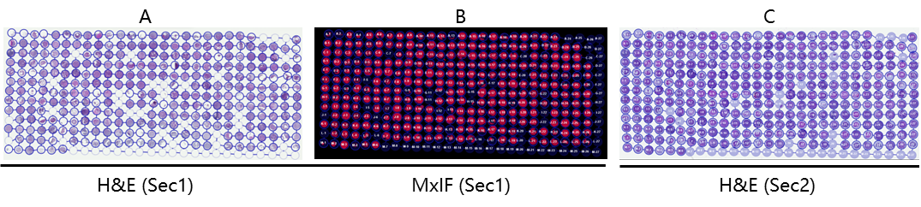
Supplementary Figure 2. Ovarian TMA dataset used in this study. A) and B) were a tissue section (Section 1) stained with MxIF protocol and then restained with H&E. C) was H&E stain of a serial section (Section 2) 5 µm apart from section 1.

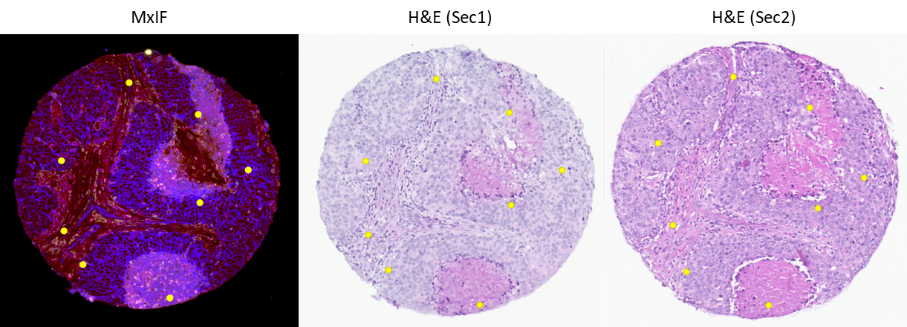
Supplementary Figure 3. TMA core with manually labeled landmarks (eight points annotations). Each yellow dot was a landmark manually label for establishing ground truth transformation. The size of the landmarks was enlarged for better visualization. The actual resolution of landmarks equals to the pixel size of the image.

Supplementary Figure 4. A) Example of cell sampling results from a pair of aligned images: MxIF (top) and H&E (bottom). B) Visualization of alignment results. Tissue structures were delineated on the H&E image and subsequently transferred to the MxIF image based-on the MxIF-H&E alignment. These transferred annotations serve as references for identifying biomarkers across different tissue types.

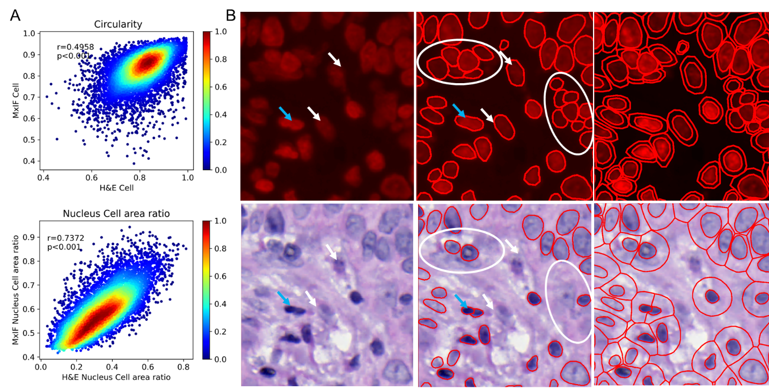
Supplementary Figure 5. Cell morphology differences caused by segmentation discrepancies. A) concordance of cell morphology features; B) segmentation differences within MxIF and H&E.

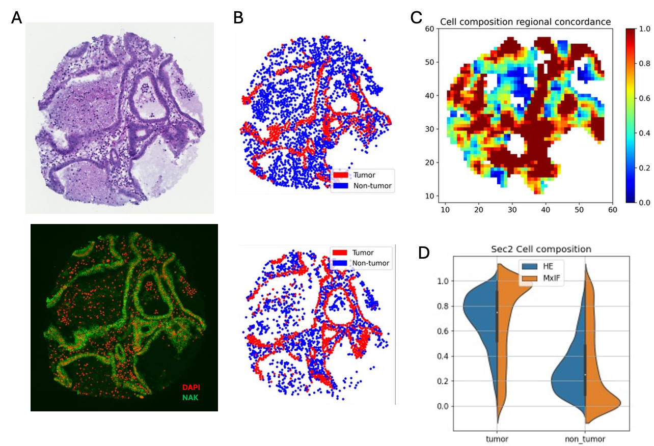

Supplementary Figure 6. A) An example of H&E and MxIF. B) Cells were labeled with red (tumor) and blue (non-tumor). C) Regional cell composition similarity was illustrated with heatmap (warm color denotes high concordance). D) The comparison of cell composition within H&E and MxIF for all serial tissue cores.

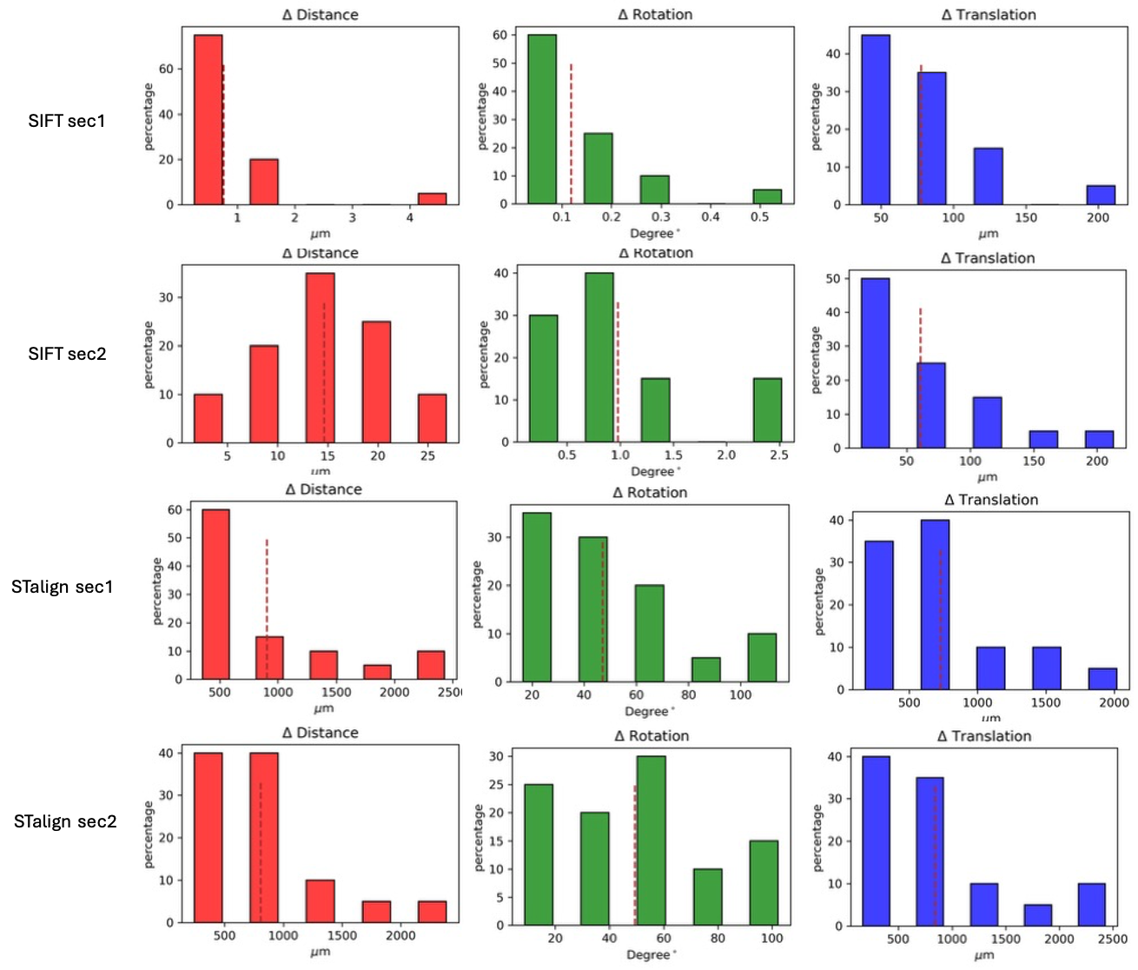
Supplementary Figure 7. Alignment accuracy comparison on restained and serial TMA sections. A) SIFT; B) STalign.

