SUPLEMENTAL MATERIAL
Despite the high number of ASVs in both sites, there were only 144 ASVs shared between them (Fig. 1), which represent 32.6% of the ASVs in Diabasodden and 33.2% of Longyearbyens ASVs. Even though there are a high number of species in Longyearbyen, it is lower than Diabasodden, an environment with less human disturbances.
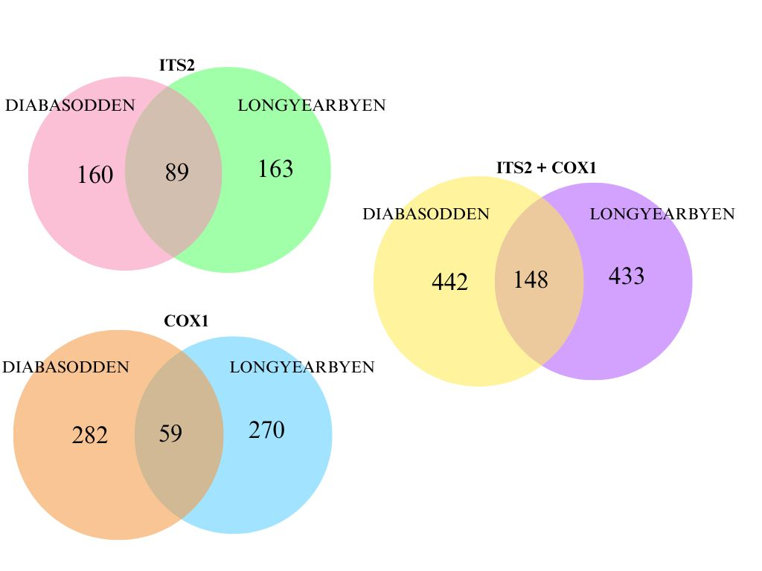
Supl. Figure 1. Venn diagrams of all ASVs found in the two sites.

Chromista
Non-native species
There were 11 non-native Chromista species in our samples, some with less than 100 reads, which means that the chance of false positives is high (Fig. 5). Consequently, the chances of the organism's presence increase as the number of reads increase, even though it is not possible to know in fact if there are living organisms in the samples.
There were 3 species belonging to genus Phytophthora. This genus is known to cause a large number of plant diseases that cause extreme damage or even death of the plant (BRASIER et al., 1995; AKROFI, 2015; TRZEWIK et al., 2015; BREGANT et al., 2023). Another important characteristic of the genus is its capacity for hybridization, which allows them to adapt to new environments and conditions when in contact with local species (AKROFI, 2015).
The first species, Phytophthora amnicola T.I.Burgess & T.Jung (51 reads), has registers of occurrence in the GBIF database only in the Australian region, mostly in New Zealand. However, there are registers of P. amnicola hybrids occurring in South Africa and Europe (NAGEL et al., 2013; AGHIGHI et al., 2016; BREGANT et al., 2023). In Europe, the species is causing great loss of Alnus glutinosa (L.) Gaertn., the symptoms involving canopy dieback, stem bleeding cankers, necrotic bark lesions at the collar and root rot (BREGANT et al., 2023). Some hybrids also seem to affect blackberries (Rubus anglocandicans A. Newton), serving as a potential control to this invasive species in Australia (AGHIGHI et al., 2016).
The species Phytophthora insolita Ann & W.H.Ko (543 reads) is natural to the oriental region. There are no records of P. insolita natural hosts, but its pathogenicity was tested several times. The results shows that it cannot affect unwounded fruits, but causes water soaked dark brown lesion when inoculated in wounded fruits, having this effect on apple, avocado, cucumber, eggplant, mango, green pepper and tomato (HO et al., 2002; DAS et al., 2012; BAWAGE et al., 2013)
The second species was Phytophthora megakarya Brasier & Griffin (14 reads), common in the African continent. This species is highly pathogenic, and one of the biggest threats to the cocoa (Theobroma cacao L.) culture in the continent (AKROFI, 2015). The symptoms of the P. megakarya infection includes root rot, pod rot and canker. Even though the plant may be affected by other Phytophthora species, P. megakarya is the most virulent, and causes great impact on the economy of West and Central Africa (AKROFI, 2015).
There were also 2 species of the genus Pythium, Pythium biforme Uzuhashi & G. Okada (40 reads) and Pythium brachiatum Uzuhashi & G. Okada (4285 reads), both of them found in the Nagano Lake, Japan (UZUHASHI et al., 2015). The genus species are usually pathogenic, causing diseases in algae species (HERRERO et al., 2020). However, there is still no register of the found species causing diseases, and it is possible that they have saprophytic habits (UZUHASHI et al., 2015). Nevertheless, P. brachiatum was the most abundant species in the Phylum Oomycota, counting with 31% of the reads.
We found three other Oomycete species, from three different genus. The first species is Aphanomyces invadans David & Kirk (151 reads). A. invadans is known to cause Epizootic Ulcerative Syndrome (EUS) in fishes, infecting damaged skin tissue, resulting in inflammation, ulceration, tissue necrosis and death (IBERAHIM et al., 2018). The species is common in the oriental and ethiopian region, but there are also records of EUS outbreaks in Canada, USA and Australia (OIDTMANN, 2011). So far, there are records of A. invadans affecting 87 different fish genera, representing a great threat to the aquaculture industry (OIDTMANN, 2011; IBERAHIM et al., 2018).
The second species was Globisporangium spinosum (Sawada) Uzuhashi (612 reads), Tojo & Kakish, with reports from Australian and oriental regions. According to Huo et al. (2023), G. spinosum causes diseases in a lot of plants around the world, leading to great loss in cultivated species. Root rot is a consistent symptom, and the period that takes until the symptoms can be observed varies according to the infected species (HUO et al., 2023; FENG et al., 2024). In the last reports, G. spinosum was causing root rot disease in kiwifruit (Actinidia chinensis Planch.) and ginseng (Panax ginseng C.A.Mey.) cultures in China, resulting in 30-70% of product loss (HUO et al., 2023; FENG et al., 2024).
Lastly, Phytopythium litorale (Nechw.) Abad, de Cock, Bala, Robideau, A.M.Lodhi & Lévesque (21 reads), is natural to warmer climates, with occurrences in Australian, Ethiopian and oriental regions. It also causes plant diseases, causing a variety of symptoms, even ultimately leading to the death of the plant (DERVIŞ et al., 2020). There are recent reports of P. litorale affecting kiwifruit, Rhododendron pulchellum Salisb., Cornus kousa Bürger and Platanus orientalis L. (DERVIŞ et al., 2020; LI et al., 2021; POLAT et al., 2023; OKSEL et al., 2024).
There were three non-native Ochrophyta species found in our samples. The first was Haramonas dimorpha Horiguchi (1845 reads), a marine raphidophyte, from Australia (HORIGUCHI, 1996). Second was Lessonia flavicans Bory (299 reads), a macroalgae natural from sub-Antarctic region, and lastly Schizocladia ischiensis Henry, Okuda et Kawai (1090 reads), a filamentous alga from Greece (KAWAI et al., 2003; MANSILLA et al., 2013).
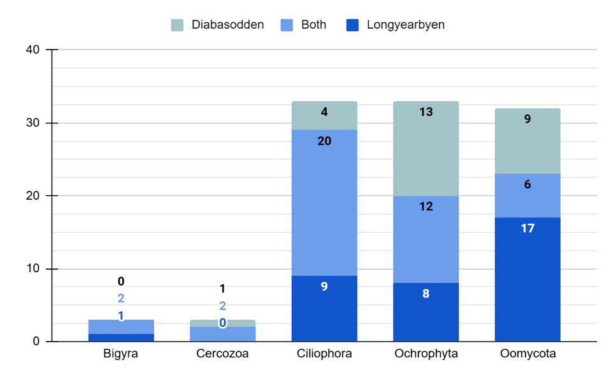
Supl. Figure 2. Number of ASVs of each Phylum within the Chromista Kingdom in each site.
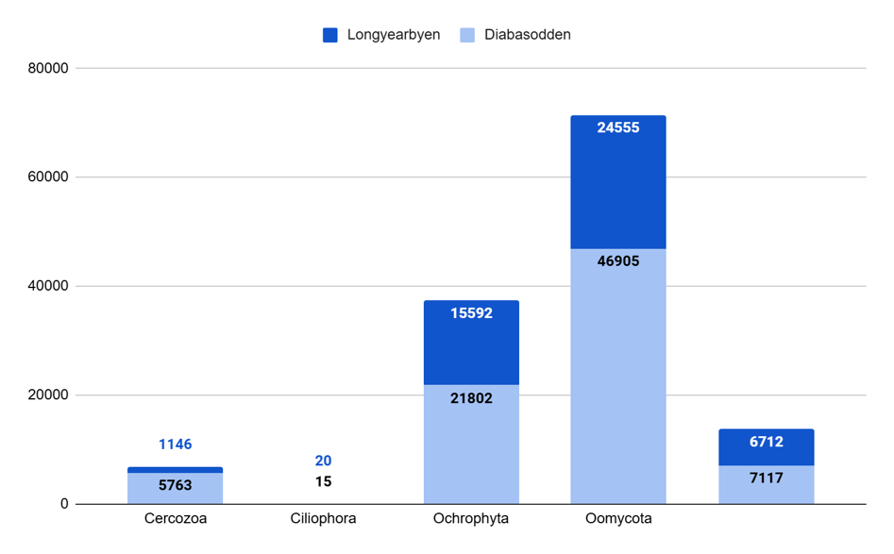
Supl. Figure 3. Number of reads of each Chromista Phylum.

In Diabasodden exclusively, 26 ASVs were found, only 3 of the ASVs only identified at genus level. These species were distributed in 4 Phyla, 8 Classes, 22 Orders and 34 Families. There were also 2 ASVs that could only be identified at higher taxonomic levels. Ochrophyta was both the richest and most abundant Phylum, with 25 ASVs and 57.5% of the reads (Fig. 2 and 3). The most abundant Order in Diabasodden was Ectocarpales, with 74.1% of the reads, followed by Peronosporales with 10.2%. The richest Orders were Peronosporales and Pythiales, with 4 species each.
In Longyearbyen, 36 ASVs occur exclusively, with 8 of the ASVs only identified at genus level and 1 at Order level. There were 5 Phylum, with 7 Classes, 20 Orders and 34 Families. The most abundant Phylum was Ochrophyta, with 51.1% of the number of reads, while the richest was Ciliophora, with 29 ASVs (Fig. 2 and 3). The most abundant Orders were Ectocarpales with 52.4% of reads, and Pythiales 21.2%. The richest Orders were 10 species of Peronosporales and 6 of Pythiales.
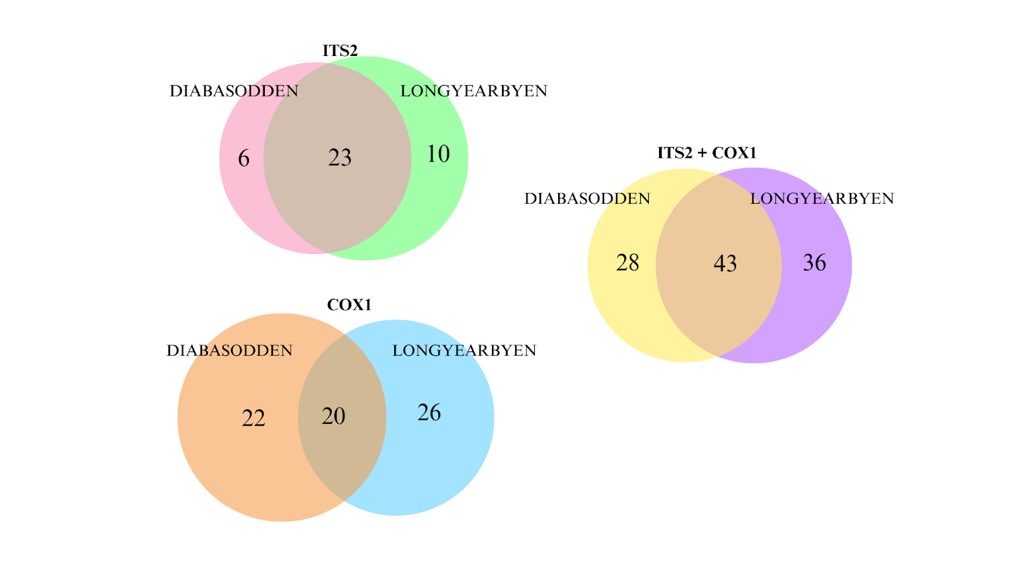
Supl. Figure 4. Venn diagram of Chromista ASVs in both sites.

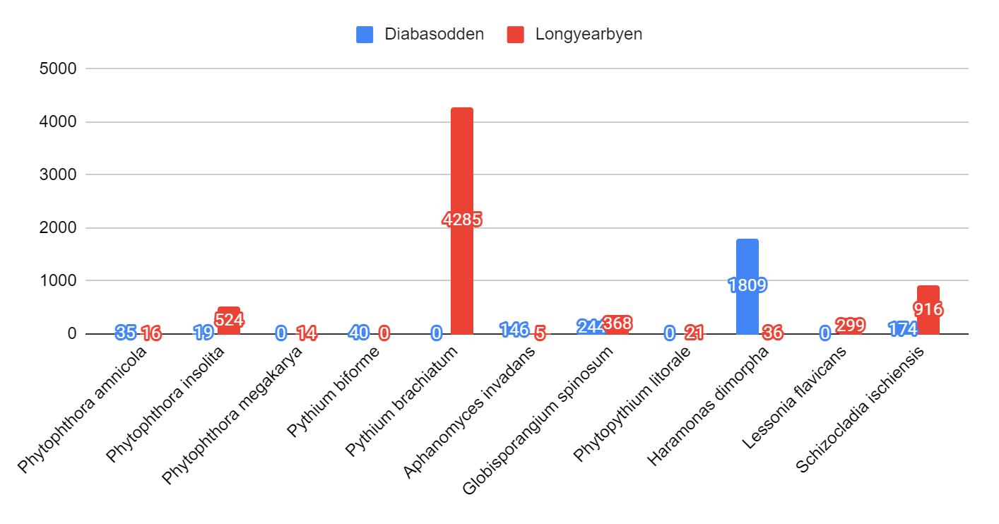
Supl. Figure 5. Number of reads and location of each non-native Chromista species.

Metazoa:
Non-native species
All the next species had <1000 number of reads, thus less trustful diagnostic. There were 26 Arthropoda, 4 Chordata, 2 Cnidaria, 16 Mollusca, and each of Onychophora, Platyhelminthes, Porifera, Rotifera and Tardigrada had 1 ASV (Fig. 10). The Classes Insecta and Gastropoda had the highest number of ASVs, with 18 and 13, respectively. Because of the high number of species, this section will be written in sections, divided by Phylum.
Phylum Arthropoda
The species Leptonetela hangzhouensis (Chen, Shen & Gao, 1984) is a small spider from the Leptonetidae Family, native from the Zhejiang province, in China (WANG et al., 2011). There is little information about this species in the literature, all found studies focusing on taxonomic description.
Syedra oii (Saito, 1983) is a spider from the Family Linyphiidae, native from South Korea and nearby nations. Is described as a common species in the region, and there is little information about it other than distribution and taxonomic traits (KWON et al., 2023).
The last spider was Phintella arenicolor (Grube, 1861), from the Family Salticidae. It has records from Korea, China, Japan, Russia (JUNG et al., 2007). No further information besides taxonomic description was found.
The last species from the Arachnida Class was Tropilaelaps mercedesae (D.L.Anderson & M.J.Morgan, 2007), a mite from the Oriental region. It is a vector of the honeybee (Apis mellifera L.) virus DWV (DAINAT et al., 2008). When infected, the honeybees exhibit symptoms of crippled wings, which could lead to a colony collapse, being a major threat to A. mellifera, thus honey production (FORSGREN et al., 2008). None of the four genus had no records of other species in Svalbard.
There was only one Collembola species, Gomphiocephalus hodgsoni (Carpenter, 1908). The springtail is considered endemic to the Antarctic region, therefore having a high tolerance to cold and dry conditions, similar to the Arctic (SINCLAIR and SJURSEN, 2001; STEVENS and HOGG, 2003). There are no previous records of the genus Gomphiocephalus in Svalbard, and further investigation is necessary to identify a possible bipolar distribution.
The Class Diplopoda had also only one species, Trachyjulus phylloides (Golovatch, Geoffroy, Mauriès & VandenSpiegel, 2012). The millipede was only found in Thailand, living specifically in karst caves (LIKHITRAKARN et al., 2020). There are no previous records of the genus Trachyjulus in Svalbard.
The beetle Phlogistomorpha croesus (Blackburn) is a Cleridae native from the Australian region. No further information was found besides the anatomical description of the species (OPITZ, 2003).
The second beetle species was Pteroptyx tener (E.Olivier, 1907), a Lampyridae native from the oriental region. The firefly depends on its natural environment to survive, having a straight relation with the tropical plants of their habitat (KIRTON et al., 2006; KHOO et al., 2012; CHENG et al., 2017).
The last beetle was Gonocephalum pubens (Marseul), a Tenebrionidae with records in China, South Korea, Japan, and Taiwan. It was one of the most abundant species in a previous study in the coastal sand dunes in South Korea, and is often found in warmer tropical regions (MIN et al., 2018; HEDGE, 2019).
We only found one mosquito in our study, Culex sitiens (Wiedemann) from the family Culicidae. It has reports from Oriental, Australian and Ethiopian regions and feeds mostly of birds and pigs blood (VYTHILINGAM et al., 1994). However, it can also feed of human blood, and the great concern about this species is that it is a potential vector of the Japanese encephalitis (JE) virus, a flavivirus related to dengue, yellow fever and West Nile viruses (VYTHILINGAM et al., 2003; World Health Organization, who.int). The disease is usually asymptomatic, but can cause permanent neurologic, cognitive and behavioural sequelae and, in some cases, death ( World Health Organization, who.int).
The Hemiptera Gaeana maculata (Drury, 1773) is a cicada with Oriental distribution. Most of the studies found in the literature discurred about its ultrastructure, cytochemistry and morphology (CHEUNG and MARSHALL, 1973; RUSCHEL et al., 2019). Also from the Order Hemiptera, Deraeocoris claspericapilatus (Kulik, 1965) is a plant-bug from Japan and Korea area, that belongs to the Miridae Family (JUNG and LEE, 2011; KIM et al., 2023).
There were 3 Hymenoptera species, the first being Wiebesia pumilae (Hill, 1967) is a wasp, with records from China, Japan and Taiwan. It is known by its obligate mutualism with Ficus pumila L., working as their pollinators, showing a classic co-evolutionary system (CHEN et al., 2015; LO et al., 2021).
The second Hymenoptera species was Euglossa rufipes (Rasmussen & Skov, 2006), native from the Neotropical region. The genus Euglossa is known for its orchid bees (FERRARi et al., 2017; KHADEMI, 2017). Being natural to tropical climate, there are no orchids in Svalbard (Svalbard Flora, svalbardflora.no).
The last Hymenoptera species was Smithagathis davidsmithi (Sharkey). It is a parasitic wasp, endemic to the Colombian Andes, and we found no further information in the literature about the species (SHARKEY and CHAPMAN, 2017; SHARKEY, 2024).
There were 6 Lepidoptera species. The first was Cyana pratti (Elwes, 1890), a moth from the Oriental region. It is usually found in China, although there was a record in Indonesia (VOLYNKIN et al., 2023; DAAWIA et al., 2024). Also from the Oriental region, there was Mycalesis visala (Moore, 1857), a butterfly usually found in India (DEEPIKA et al., 2014; PONMANICKAM et al., 2022).
The third Lepidoptera species from the same region was Archaeoattacus edwardsii (White, 1859), a silk moth usually found in India. Since it inhabits mountainous environments, such as Khasi Hills and Arunachal Pradesh, with colder winters, it is likely that this species already have adaptations that could help them survive in Svalbard (NARANG and GRUPTA, 1982; GOGOI et al., 2014).
Still in Lepidoptera Order, there was Larentioides cacothemon (Prout, 1917), another moth, from Ethiopian region (SIHVONEN et al., 2017). It is a cycad-moth, that are one of the main pollinator of the cycad plants, mostly because of its ability to resist to the plants toxins (SCHNEIDER et al., 2002; SIHVONEN et al., 2017).
Moschoneura pinthous (L.) is a species of butterfly, natural to South America. Moschoneura is a small genus, all species having Neotropical distribution (LAMAS, 2004; NEILD et al., 2021). The last Lepidoptera was Manduca blackburni (Butler, 1880), an endemic moth from Hawaii islands. Before human contact, the moth is thought to depend on endemic solanaceous trees, nowadays feeding on tobacco weed (RUBINOFF and JOSE, 2010).
Gryposmylus pennyi (Winterton & Y.-j.Wang, 2016) is a Neuroptera, distributed in northern Vietnam and adjoining southern China. There is not much information in the literature about the species other than its description and distribution (WINTERTON and WANG, 2016).
The dragonfly Epiophlebia superstes (Selys, 1889) is endemic to Japan. It is part of the clade Anisozygoptera and have similar features to the other suborders Zygoptera and the Anisoptera (RÜPPEL and HILFERT, 1993; APPEL and GORB, 2011; WANG et al., 2015).
The last member of the Class Insecta was Dolichopoda kiriakii (Rampini & Di Russo, 2008), is a cricket endemic to Greece. The genus Dolichopoda is composed by cave crickets, and D. kiriakii was only found in the Kiriaki Cave, in the district of Preveza (RAMPINI et al., 2008; ALLEGRUCCI et al., 2009) None of the Insecta species had any species of the same genus recorded in Svalbard.
There were only two species in the Class Malacostraca: Scopelocheirus schellenbergi (Birstein & Vinogradov, 1958) and Caridina typus (H.Milne Edwards, 1837). The first species, S. schellenbergi is an amphipod, usually found in deep sea, with two records in the Kermadec Trenches and one register in the New Hebrides Trench, being most abundant at ~6500–7500m (BLANKENSHIP et al., 2006; LACEY et al., 2017).
The second species, C. typus is a freshwater shrimp, common in the tropical regions. Although it is widely spread, present in Neotropical, Oriental and Ethiopian regions, it has no records Northward, indicating that it needs warmer climates (SOOMRO et al., 2011; BERNARDES et al., 2017). Again, no species of similar genus have records in Svalbard in the Class Malacostraca.
There were four species from the Phylum Chordata, all with neotropical distribution. The first was Apogon binotatus (Poey, 1867), a fish from Central America. It lives associated with coastal reefs, hiding in cracks and crevices during the day (Fishbase, fishbase.se). The genus is cosmopolitan, although there is no register up the Arctic Circle parallel.
The second species was Pithys albifrons (L.), a bird from the South America rainforest getting close to the Andes. Common in the amazon forest, they feed mostly on ants, therefore landing close to the ground (eBird.org). Its genus is also endemic to South America, with no species in any other region.
The third species was Oxyrhopus guibei (Hoge & Romano, 1977), also known as false coral snake, native to South America, most common in southeastern Brazil. It is a non-venomous snake, having a constrictor behavior and feeding mostly on rodents (ANDRADE and SILVANO, 1996). The false coral is known to present mimicry as a defensive mechanism, having similar color pattern as the coral snakes, highly venomous snakes of the genera Leptomicrurus, Micrurus and Micruroides (BUCARETCHI et al., 2016). All species of the genus Oxyrhopus have neotropical distribution.
The last Chordata species was Sapajus nigritus (Goldfuss, 1809), a monkey species endemic to the Atlantic Forest in Brazil and the Argentinean provinces of Iguazú and Missiones (MARTINS et al., 2019). It is insecto-frugivorous, and usually live in groups of about 20 animals (MARTINS et al., 2019).
Since all Chordata species are from South America, mostly Brazil, it is possible a contamination of the collected samples. However, if it is not the case, it is important to investigate if the DNA of these animals came to Svalbard via tourism or other means.
The Phylum Cnidaria had two species, Acropora palmata (Lamarck, 1816) and Cyanea nozakii (Kishinouye, 1891). The first species, A. palmata, is a coral that was usually found in the Caribbean, Bahamas and Florida. Its population, however, is facing a massive decline due to climate and environmental changes (WILLIANS et al., 2007). The genus Acropora had no species in Svalbard, most of them distributed among warmer regions.
The second species was C. nozakii, also known as ghost jellyfish, with oriental distribution. Its blossoms caused a serious impact in the Chinese marine ecosystem and in the fishery economy (DONG et al., 2008). It prefers warmer waters, with a high salinity level (DONG et al., 2008). C. nozakii is also venomous, presenting cytotoxicity and hemolytic activity, although is yet to understand the full mechanism of its venom (YANG et al., 2020). The genus Cyanea had one species with records in Svalbard, Cyanea capillata (Linnaeus, 1758), and one species with holarctic distribution, Cyanea lamarckii (Péron & Lesueur, 1810), therefore it is possible a misidentification.
Phylum Mollusca
There were three species from the Class Bivalvia, Leukoma jedoensis (Lischke, 1874), Periglypta puerpera (L). and Saxidomus purpurata (G.B.Sowerby II, 1852). None of the three genus have any other species recorded in Svalbard.
The first Bivalvia, L. jedoensis, is common in Japan and Korea sea coasts. It is produced for human consumption, being an important source of dietary-essential amino acids, lipids, vitamins, minerals and other bioactive nutrients (RISTIVOJEVIĆ et al., 2019; XIN et al., 2024). Its shell is also used in traditional Chinese medicine to treat ecthyma (AHMAD et al., 2017). The culture of these important Bivalves is threatened by various factors, including pollution driven saturation states in sediments, hydrodynamics, temperature and parasitic copepods (GREEN et al., 2007; XIN et al, 2024).
The second species, P. puerpera has a Oriental distribution. No understandable information other than taxonomic description was found about this species. Lastly, S. purpurata is also common in the Japanese, Korean and Chinese coasts. It inhabits shallow sea waters and is also a common fishery for those nations' diets (SELIN, 2014). It has i-type lysozymes of high bacteriolytic activities, that might be interesting for future studies, while still a rich nutrient source (MIYAUCHI et al., 2006; LIU et al., 2018).
There were 13 species of Gastropoda in our samples. Only the genus Turris was already recorded in Svalbard, although there is no identification at species level.
The first species was Salinator rosaceous (Golding, Ponder & Byrne, 2007) is an amphiboloidean, only recorded in Australia. It was found on mud between mangroves (GOLDING et al., 2007). No further information was found in the literature. The Lamellomphalus manusensis (S.-Q.Zhang & S.-P.Zhang, 2017) is a neomphalid also from the Australian region. It is an extremophile, found in deep sea-waters, with records of it at 1,603m deep (ZHONG et al., 2022).
Then there was Nerita japonica (Dunker, 1860), with records from Japan and Korea. The genus is known to have internal fertilization and producing egg capsules (PARUNTU and TOKESHI, 2003). It lives by the sea, usually found on boulder shores (TAKADA, 2008). Also from Japan, there was Nipponacmea nigrans (Kira, 1961), a limpet found in Japanese seashores and an important part of the community on rocks and boulders in Japan coast (TAKADA, 1997).
Iberozospeum biscaiense (Gómez & Prieto, 1983) is a snail endemic to Spain. All species of its genus are from Spain or nearby nations, mostly found in caves (KNEUBÜHLER et al., 2022).
There were two species of the Conus genus: Conus laterculatus (G.B.Sowerby II, 1870), Conus miles (L.). The genus is widely studied by its venom, the conotoxins, that have potential for the production of new drugs, promising therapeutic resources for the treatment of chronic pain, among other diseases (HEMAMI et al., 2018; JERGOVA et al., 2021; MARGIOTTA et al., 2022). An already known medication produced with its venom is Ziconotide (Prialt®), a non-opioid used to treat severe chronic pain. The species used to produce the drug (Conus geographus (L.) and Conus magus (L.)) were not found in our work.
The cone snail C. miles is widely spread among Indian and Pacific Oceans, with 1,330 georeferenced records in the GBIF database. The second species, C. laterculatus, from australian and oriental regions, also produces insulin as a part of its venom, having a high potential to improve diabetes treatment in humans (XIONG et al., 2022).
In the genus Turris we found the species Turris babylonia (L.), a shallow-water marine cone snail natural to the Australian region (KILBURN et al., 2012). Its genus also produces venom and the toxins, although still not used, also have the potential to be used in new therapeutic medicine (HEMAMI et al., 2018).
The freshwater snail Bulinus globosus (Morelet, 1866) is natural from the Ethiopian region. It is host and vector of the platyhelminth Schistosoma haematobium ((Bilharz, 1852) Weinland, 1858), thus capable of transmitting the urogenital schistosomiasis disease (DAVIES et al., 1998; KALINDA et al., 2017; PENNANCE et al., 2022). According to the World Health Organization (https://www.who.int/) the symptoms include haematuria, kidney damage and fibrosis of the bladder and ureter, genital lesions, vaginal bleeding, pain during sexual intercourse, nodules in the vulva, pathology of the seminal vesicles, prostate and other organs, infertility and bladder cancer. There are records of the disease in the African continent, the Middle East, Corsica (France) (WHO, https://www.who.int/, 2024).
The species Mesodontrachia fitzroyana (Solem, 1985) is an Australian endemic land snail. It was found in the Victoria River District, belonging to a small genus, all species of the genus being endemic (CRISCIONE and KOHLER, 2013). Mysticarion hyalinus (L.Pfeiffer, 1855) is another land snail native from Australia. These species, as long as a lot of Australian terrestrial vertebrates, were deeply impacted by the 2019–2020 Bushfires on New South Wales, and are still recovering (HYMAN et al., 2020).
Lastly, the genus Helminthoglypta had two species: Helminthoglypta hertleini (G.D.Hanna & A.G.Smith, 1937) and Helminthoglypta talmadgei (B.Roth, 1988). Both species are native from the USA, endemic to the States of Washington, Oregon and California (ROTH and SADEGHIAN, 2006). Their common names are Oregon shoulderband and Trinity shoulderband and its natural environment are the coniferous forests (DUNK et al., 2002).
Phylum Onychophora
There was only one species of the Phylum Onychophora: Kumbadjena shannonensis (Reid, 2002), native from Australia. The species of this Phylum are commonly called velvet worms, they usually are restricted to temperate and tropical regions, due to its incapacity in retaining water, and are usually endemic (BLAXTER and SUNNUCKS, 2011). Currently, there are only 216 valid species described in this Phylum spread worlwide (OLIVEIRA, 2023).
Platyhelmintha
There was one species of Platyhelminthes: Obama carinata ((Riester, 1938) Carbayo et al., 2013). Its genus is composed by Neotropical land planarians, with the only records located in Brazilian rainforests (CSEH et al., 2017; ITURRALDI et al., 2021). They feed on a wide range of organisms, including snails, slugs, acari, insects, earthworms and others (CSEH et al., 2017).
Phylum Porifera
Stellettinopsis megastylifera (Wintermann-Kilian & Kilian, 1984) is a sea sponge, with neotropical distribution, being an important component of the region's coastal community (SANDES et al., 2019). No further information was found other than taxonomic description and phylogeny.
Rotifera
Bradyscela clauda (Bryce, 1893) is a bdelloid native from Korea and China. It is able to survive in environmental extremes, thus are widely spread (SONG and MIN, 2015).
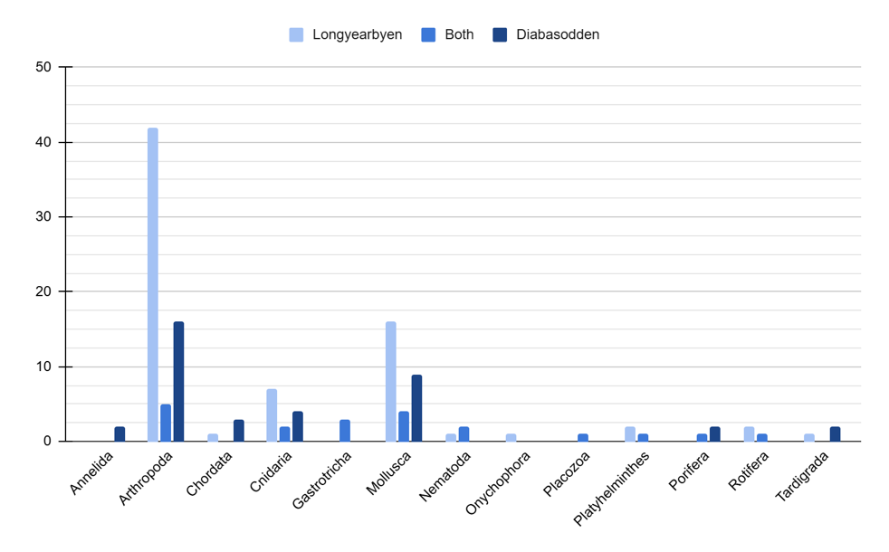
Supl. Figure 6. Number of ASVs (b) of each Metazoa Phylum in each site.
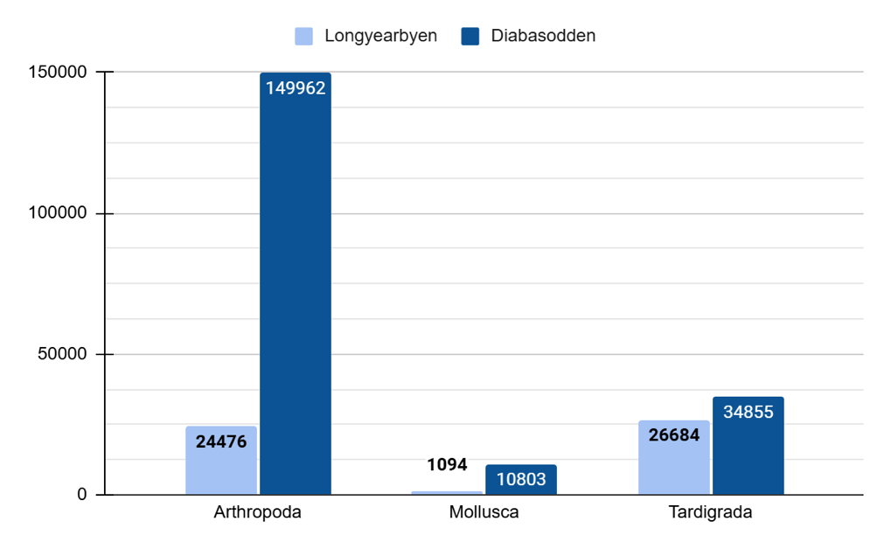
Supl. Figure 7. Number of reads of the most abundant Metazoa Phylum.
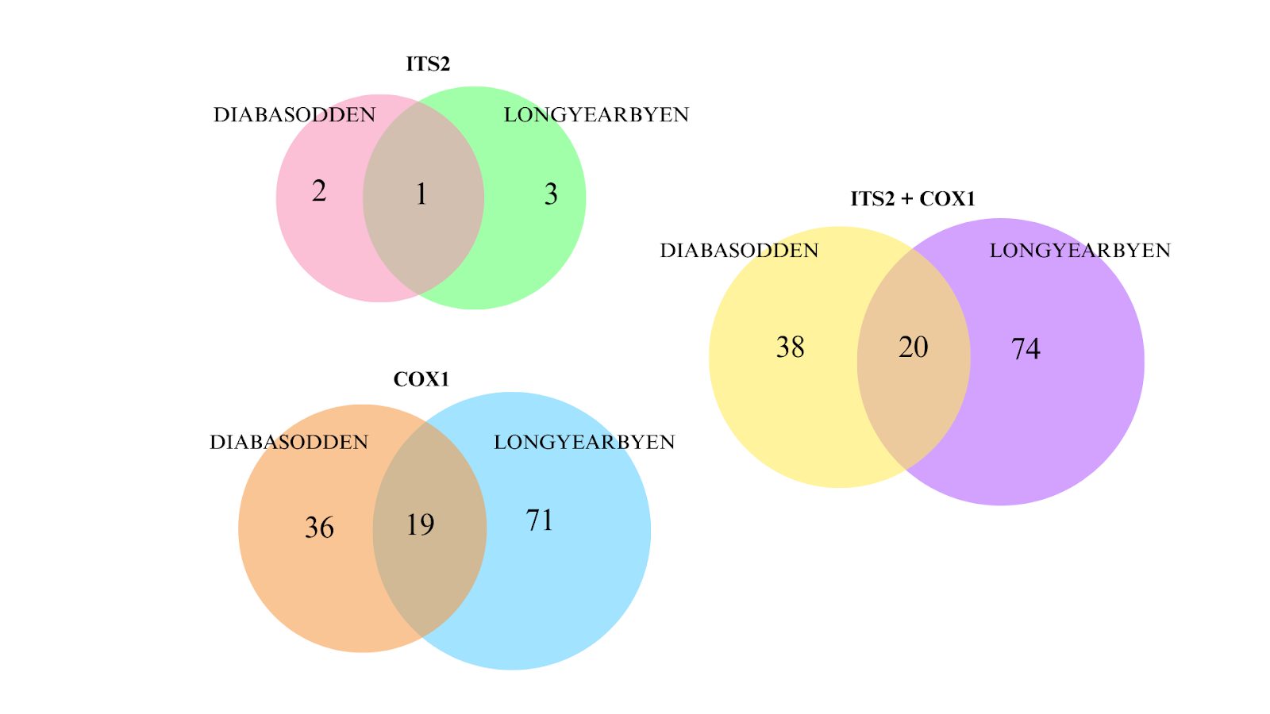
Supl. Figure 8. Venn diagram of Metazoa ASvs in both sites.

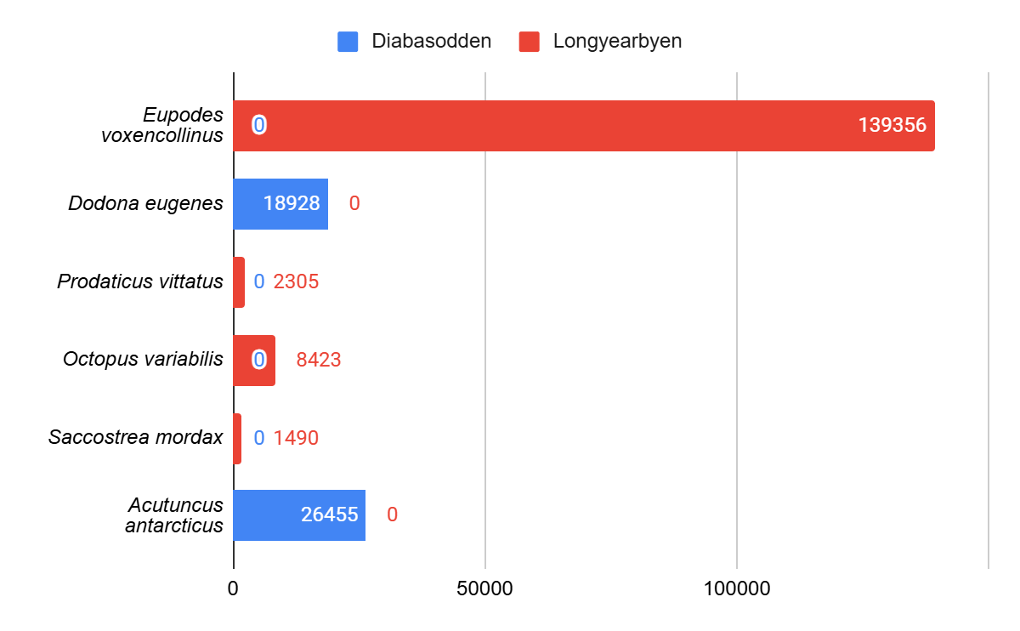
Supl. Figure 9. Number of reads and location of the Metazoa non-native species with >1000 reads.

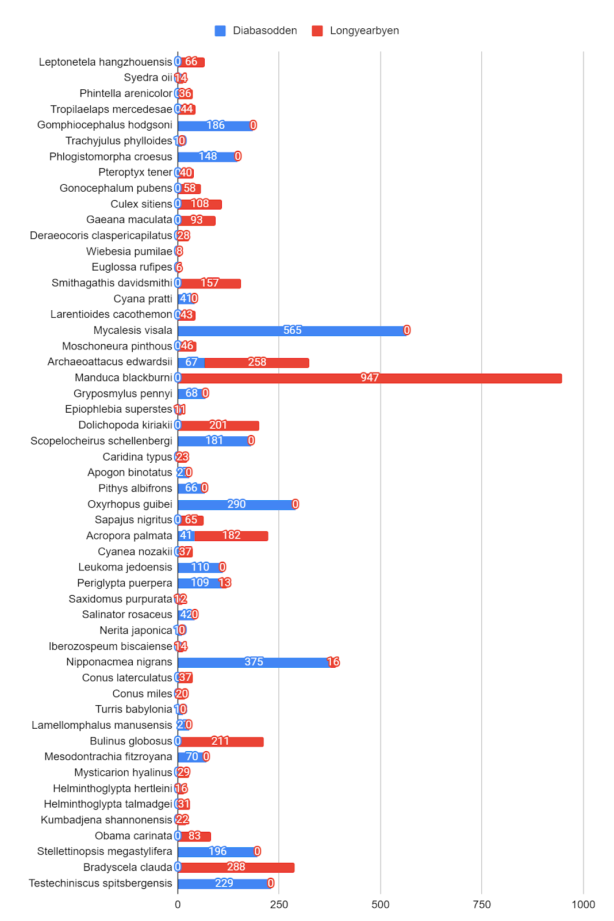
Supl. Figure 10. Number of reads and location of the Metazoa non-native species with <1000 reads.

Protozoa:
Acanthamoeba tubiashi (Lewis & Sawyer, 1979) was the only non-native species in our samples. It is usually found in Oriental and Australian regions, living in freshwater environments (PUTAPORNTIP et al., 2021). The genus Acanthamoeba is known as an opportunistic pathogen, causing keratitis, sinusitis and encephalitis, although there is no records of A. tubiashi causing any disease (RAYAMAJHEE et al., 2022; HALIM et al., 2023).
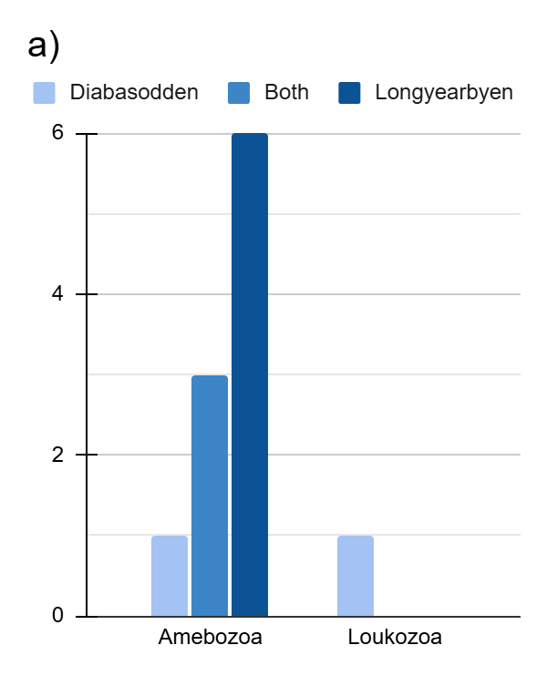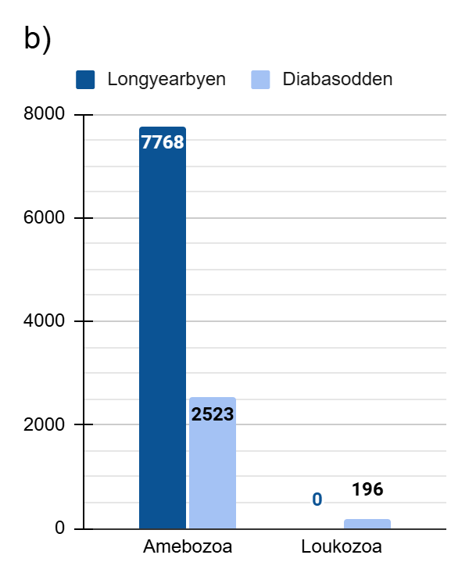
Supl. Figure 11. Number of ASVs of each Protista Phylum in each site (a) and number of reads (b).

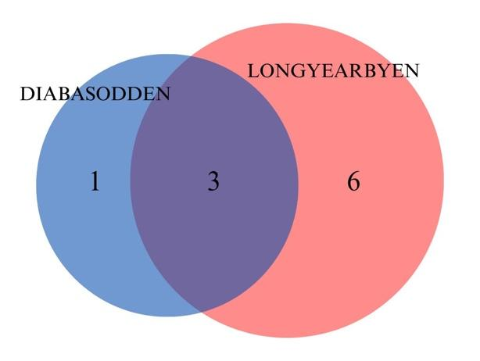
Supl. Figure 12. Venn diagram of Protista ASVs in both sites.

Viridiplantae:
Non-native species
There were 8 non-native Viridiplantae species in our samples. Only one had >100 reads, therefore this data being possibly a methodological issue. From these, 4 species belonged to the Phylum Rhodophyta, 3 from Bryophyta and 1 from Chlorophyta. The number of reads of all Viridiplantae non-native species is shown in figure 16/.
The only non-native Chlorophyta found in our samples was Trebouxia brindabellae (A.Beck 2002), native from the Australian region. It is known to form association with Fungi, in a lichen symbiosis (SADOVSKA-DEŚ et al., 2013; SINGH et al., 2016).
There were 4 Rhodophyta non-native species, all found with COX1 marker, none of them with previous records of the genus in Svalbard. The first species was Ptilophora malagasya (G.H.Boo, L.Le Gall, I.K.Hwang, K.A.Miller & S.M.Boo 2018), a small agar-producing red algae, endemic to Madagascar (BOO et al., 2018). No further information besides taxonomic description was found. The second was Gloiopeltis compressa (Harvey) H.Kawai, K.Yamamura & T.Hanyuda 2019, a red algae from Japan and Korea region. It was previously called Caulacanthus compressus, the name changing after phylogenetic analysis (HANYUDA et al., 2019).
The third was Hydropuntia rangiferina (Kützing) Gurgel & Fredericq 2004, with records from Oriental, Ethiopian and Neotropical regions. It was first collected in Brazil and its taxonomy still not fully resolved (GURGEL et al., 2020). The last Rhodophyta was Cephalocystis furcellata (J.Agardh) A.J.K.Millar, G.W.Saunders, I.M.Strachan & Kraft 1996, native from Australian region. It usually grows in rocks either in deep intertidal pools or subtidally at 2-20 m depths (MILLAR et al., 1995).
From the Bryophyte Phylum there were 3 species, from which 2 (Tayloria longiseta and Steereobryon subulirostrum) were found with ITS2 marker and 1 (Treubia lacunosa)was found with COX1 marker. The first species was Tayloria longiseta E.B. Bartram, a moss endemic to Papua New Guinea and Indonesia. It seems to be a rare species, having only 14 occurrences in the Consortium of Bryophyte Herbaria website (https://bryophyteportal.org/) and 17 occurrences in the GBIF (https://www.gbif.org/) database. There are 3 species of the Tayloria genus recorded in Svalbard: T. froelichiana (Hedw.) Mitt. ex Broth., T. lingulata (Dicks.) Lindb. and T. acuminata Hornsch., which could mean a potential misidentification of the found species.
The second Bryophyte was Treubia lacunosa (Colenso) Prosk., a liverwort from the Australian region, as long as all species in the Treubia genus. Because its Class, Haplomitriopsida, is considered an ancient clade, it is studied to understand plant evolution (LIU et al., 2011). It also was investigated by forming mutualistic partnerships with Mucoromycotina fungi, opening space to research on evolution of land plant–fungus symbioses and their role in the colonization of terrestrial environments by plants (FIELD et al., 2015).
The last non-native species was Steereobryon subulirostrum (Schimp. ex Besch.) G.L.Sm., with Neotropical distribution, mostly in Central America, being the only species in this genus. It is from the Class Polytrichopsida, a separate lineage commonly called “hair-cap mosses”, with about 200 species, easily distinguished from the Bryopsida mosses by its relatively large size, the gametophyte able to reach 65cm high and usually have greatest degree gametophyte and sporophyte complexity (BELL et al., 2021, BIPPUS et al., 2017).
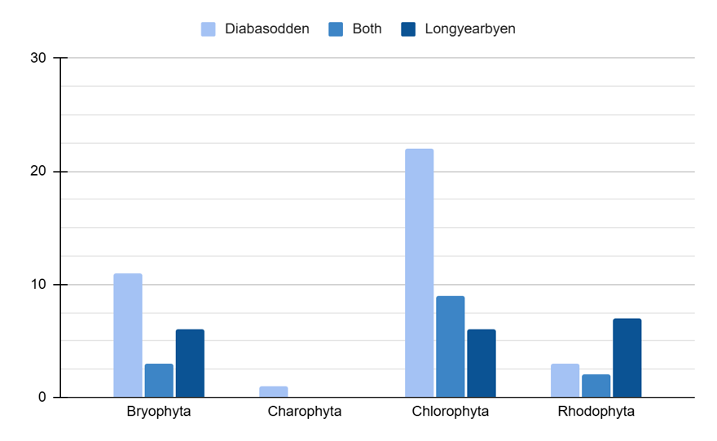
Supl. Figure 13. Number os ASVs of each Viridiplantae Phylum in each site.
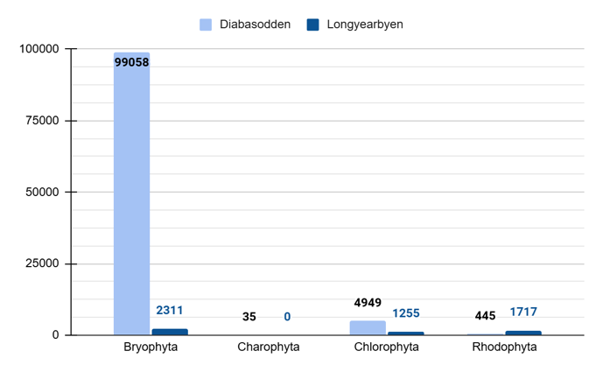
Supl. Figure 14. Number of reads of each Viridiplantae Phylum in each site. As Sanionia uncinata was the collected subtract, its reads were disconsidered for this figure.
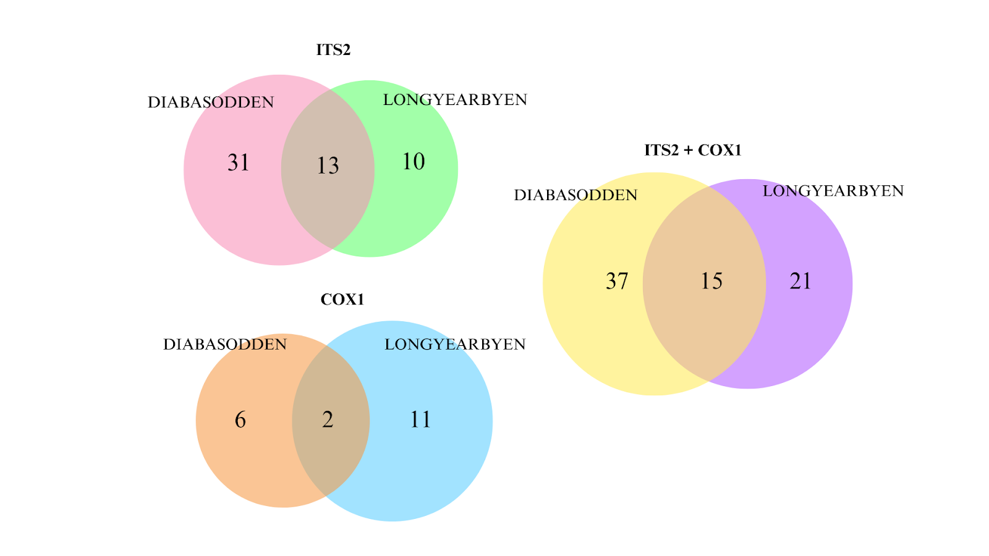
Supl. Figure 15. Venn diagram of Viridiplantae ASVs in both sites.

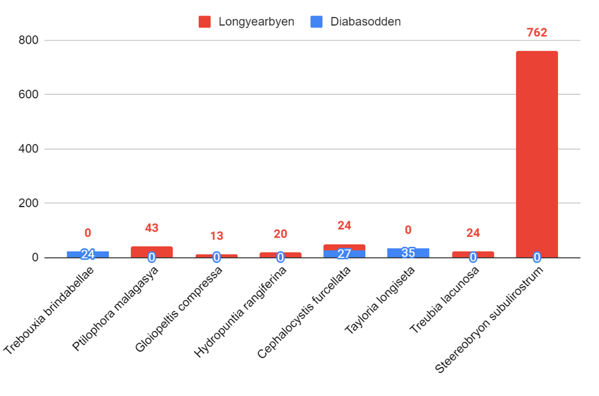
Supl. Figure 16. Number of reads and location of each non-native Viridiplantae ASV.

REFERENCES:
Aghighi, S., Burgess, T. I., Scott, J. K., Calver, M., & Hardy, G. E. St. J. (2016). Isolation and pathogenicity of Phytophthora species from declining Rubus anglocandicans. Plant Pathology, 65(3), 451–461. https://doi.org/10.1111/ppa.12436

Ahmad, T. B., Liu, L., Kotiw, M., & Benkendorff, K. (2018). Review of anti-inflammatory, immune-modulatory and wound healing properties of molluscs. Journal of Ethnopharmacology, 210, 156–178. https://doi.org/10.1016/j.jep.2017.08.008

Allegrucci, G., Rampini, M., Gratton, P., Todisco, V., & Sbordoni, V. (2009). Testing phylogenetic hypotheses for reconstructing the evolutionary history of Dolichopoda cave crickets in the eastern Mediterranean. Journal of Biogeography, 36(9), 1785–1797. https://doi.org/10.1111/j.1365-2699.2009.02130.x

Andrade, R. D. O., & Silvano, R. A. M. (1996). Comportamento alimentar e dieta da “falsa-coral” Oxyrhopus guibei Hoge & Romano (Serpentes, Colubridae). Revista Brasileira de Zoologia, 13(1), 143–150. https://doi.org/10.1590/s0101-81751996000100014

Appel, E., & Gorb, S. N. (2011). Resilin-bearing wing vein joints in the dragonfly Epiophlebia superstes. Bioinspiration & Biomimetics, 6(4), 046006. https://doi.org/10.1088/1748-3182/6/4/046006

Bawage, S., Nerkar, S., Kumar, A., & Das, A. (2013). Morphological and Molecular Description of Phytophthora insolita Isolated from Citrus Orchard in India. Journal of Mycology, 2013(1), 247951. https://doi.org/10.1155/2013/247951

Bell, N., Kariyawasam, I., Flores, J., & Hyvönen, J. (2021). <p><strong>The diversity of the Polytrichopsida—A review</strong></p>. Bryophyte Diversity and Evolution, 43(1), Artigo 1. https://doi.org/10.11646/bde.43.1.8

Bernardes, S. C., Pepato, A. R., von Rintelen, T., von Rintelen, K., Page, T. J., Freitag, H., & de Bruyn, M. (2017). The complex evolutionary history and phylogeography of Caridina typus (Crustacea: Decapoda): long-distance dispersal and cryptic allopatric species. Scientific Reports, 7(1), 9044. https://doi.org/10.1038/s41598-017-08494-w

Bippus, A. C., Escapa, I. E., & Tomescu, A. M. F. (2018). Wanted dead or alive (probably dead): Stem group Polytrichaceae. American Journal of Botany, 105(8), 1243–1263. https://doi.org/10.1002/ajb2.1096

Blankenship, L. E., Yayanos, A. A., Cadien, D. B., & Levin, L. A. (2006). Vertical zonation patterns of scavenging amphipods from the Hadal zone of the Tonga and Kermadec Trenches. Deep Sea Research Part I: Oceanographic Research Papers, 53(1), 48–61. https://doi.org/10.1016/j.dsr.2005.09.006

Blaxter, M., & Sunnucks, P. (2011). Velvet worms. Current Biology, 21(7), R238–R240. https://doi.org/10.1016/j.cub.2011.02.017

Brasier, C. M., Rose, J., & Gibbs, J. N. (1995). An unusual Phytophthora associated with widespread alder mortality in Britain. Plant Pathology, 44(6), 999–1007. https://doi.org/10.1111/j.1365-3059.1995.tb02658.x

Bregant, C., Batista, E., Hilário, S., Linaldeddu, B. T., & Alves, A. (2023). Phytophthora Species Involved in Alnus glutinosa Decline in Portugal. Pathogens, 12(2), 276. https://doi.org/10.3390/pathogens12020276

Bucaretchi, F., De Capitani, E. M., Vieira, R. J., Rodrigues, C. K., Zannin, M., Da Silva, N. J., Casais-e-Silva, L. L., & Hyslop, S. (2016). Coral snake bites (Micrurus spp.) in Brazil: A review of literature reports. Clinical Toxicology, 54(3), 222–234. https://doi.org/10.3109/15563650.2015.1135337

Chen, Y., Huang, M., Wu, W., Wang, A., Bao, T., Zheng, C., Chou, L., Tzeng, H., & Tu, S. (2016). The floral scent of Ficus pumila var. Pumila and its effect on the choosing behavior of pollinating wasps of Wiebesia pumilae. Acta Ecologica Sinica, 36(5), 321–326. https://doi.org/10.1016/j.chnaes.2016.06.008

Cheng, S., Chan, K.-M., Ishak, S.-F., Khoo, V., & Chew, M. Y. (2017). Elucidating food plants of the aggregative, synchronously flashing Southeast Asian firefly, Pteroptyx tener Olivier (Coleoptera, Lampyridae). BioRisk, 12, 25–39. https://doi.org/10.3897/biorisk.12.14061

Cheung, W. W. K., & Marshall, A. T. (1973). Studies on water and ion transport in homopteran insects: Ultrastructure and cytochemistry of the cicadoid and cercopoid midgut. Tissue and Cell, 5(4), 651–669. https://doi.org/10.1016/S0040-8166(73)80051-5

Criscione, F., & Köhler, F. (2013). Conserved shell disguises diversity in Mesodontrachia land snails from the Australian Monsoon Tropics (Gastropoda: Camaenidae). Zoologica Scripta, 42(4), 389–405. https://doi.org/10.1111/zsc.12011

Cseh, A., Carbayo, F., & Froehlich, E. M. (2017). Observations on food preference of Neotropical land planarians (Platyhelminthes), with emphasis on Obama anthropophila, and their phylogenetic diversification. Zoologia, 34, 1–8. https://doi.org/10.3897/zoologia.34.e12622

Daawia, Rahareng, E. F., Ramandey, E., Morib, G., Yando, H., de Vos, R., Sinnema, S., Sinnema-Bloemen, J., Cruz, M. G., Zumkehr, P., & de Vries, P. J. (2024, janeiro 1). A faunistic overview of the moth species recorded from Yapen Island, Papua, Indonesia (Lepidoptera). | EBSCOhost. https://doi.org/10.19269/sugapa2024.15(2).01

Daawia, Rahareng, E. F., Ramandey, E., Morib, G., Yando, H., de Vos, R., Sinnema, S., Sinnema-Bloemen, J., Cruz, M. G., Zumkehr, P., & de Vries, P. J. (2024, janeiro 1). A faunistic overview of the moth species recorded from Yapen Island, Papua, Indonesia (Lepidoptera). | EBSCOhost. https://doi.org/10.19269/sugapa2024.15(2).01

Das, A. K., Kumar, A., Nerkar, S., & Bawage, S. (2012). First report of Phytophthora insolita in India. Australasian Plant Disease Notes, 7(1), 131–132. https://doi.org/10.1007/s13314-012-0066-6

Davies, C. M., Webster, J. P., Krüger, O., Munatsi, A., Ndamba, J., & Woolhouse, M. E. J. (1999). Host–parasite population genetics: A cross-sectional comparison of Bulinus globosus and Schistosoma haematobium. Parasitology, 119(3), 295–302. https://doi.org/10.1017/S0031182099004722

Deepika,D. S. and Atluri,J. B. and Sowmya,K. L., 20143221375, English, Journal article, India, 0976-593X 0973-1547, 9, (1), Muzaffarnagar, International Journal of Plant Sciences (Muzaffarnagar), (72–78), Hind Agri-Horticultural Society, Nectar host plants of butterflies, their flowering period and flower colour at Visakhapatnam., (2014)

Derviş, S., Türkölmez, Ş., Çiftçi, O., Özer, G., Ulubaş Serçe, Ç., & Dikilitas, M. (2020). Phytopythium litorale: A Novel Killer Pathogen of Plane ( Platanus orientalis ) Causing Canker Stain and Root and Collar Rot. Plant Disease, 104(10), 2642–2648. https://doi.org/10.1094/PDIS-01-20-0141-RE

Dong, X., Armstrong, S. D., Xia, D., Makepeace, B. L., Darby, A. C., & Kadowaki, T. (2017). Draft genome of the honey bee ectoparasitic mite, Tropilaelaps mercedesae, is shaped by the parasitic life history. GigaScience, 6(3). https://doi.org/10.1093/gigascience/gix008

Feng, X., Ye, W., Liu, X., Lu, Y., Gao, M., Lai, R., & Chen, Y. (2024). First Report of Kiwifruit Root Rot Caused by Globisporangium spinosum in China. Plant Disease, PDIS-12-23-2773-PDN. https://doi.org/10.1094/PDIS-12-23-2773-PDN

Ferrari, R. R., Nemésio, A., & Silveira, F. A. (2017). Phylogeny of the orchid-bee genus Euglossa Latreille (Hymenoptera: Apidae), with emphasis on the subgenera E. (Glossura) Cockerell and E. (Glossuropoda) Moure. Zoologischer Anzeiger, 267, 82–100. https://doi.org/10.1016/j.jcz.2017.02.005

Field, K. J., Rimington, W. R., Bidartondo, M. I., Allinson, K. E., Beerling, D. J., Cameron, D. D., Duckett, J. G., Leake, J. R., & Pressel, S. (2015). First evidence of mutualism between ancient plant lineages (Haplomitriopsida liverworts) and Mucoromycotina fungi and its response to simulated Palaeozoic changes in atmospheric CO2. New Phytologist, 205(2), 743–756. https://doi.org/10.1111/nph.13024

Forsgren, E., De Miranda, J. R., Isaksson, M., Wei, S., & Fries, I. (2009). Deformed wing virus associated with Tropilaelaps mercedesae infesting European honey bees (Apis mellifera). Experimental and Applied Acarology, 47(2), 87–97. https://doi.org/10.1007/s10493-008-9204-4

Gogoi, H., Borah, G., Habung, T., & Wangsa, K. (2014). A Field Survey Of The Silk Moths (Lepidoptera: Saturniidae) In West Siang District, Arunachal Pradesh And Threats To Their Population. 1, 16–24.

Golding, R. E., Ponder, W. F., & Byrne, M. (2007). Taxonomy and anatomy of Amphiboloidea (Gastropoda: Heterobranchia: Archaeopulmonata). Zootaxa, 1476(1). https://doi.org/10.11646/zootaxa.1476.1.1

Green, M. A., Waldbusser, G. G., Reilly, S. L., Emerson, K., & O’Donnell, S. (2009). Death by dissolution: Sediment saturation state as a mortality factor for juvenile bivalves. Limnology and Oceanography, 54(4), 1037–1047. https://doi.org/10.4319/lo.2009.54.4.1037

Gurgel, C. F. D., Soares, L. P., Norris, J. N., Fujii, M. T., Schmidt, W. E., & Fredericq, S. (2021). Molecular systematics of Crassiphycus and Hydropuntia (Gracilariales, Rhodophyta) with the description of poorly known taxa in the Western Atlantic Ocean. European Journal of Phycology, 56(2), 216–229. https://doi.org/10.1080/09670262.2020.1814424

Halim, A. R., Mohd Hussain, R. H., Aazmi, S., Halim, H., Ahmed Khan, N., Siddiqui, R., & Shahrul Anuar, T. (2023). Molecular characterisation and potential pathogenicity analysis of Acanthamoeba isolated from recreational lakes in Peninsular Malaysia. Journal of Water and Health, 21(9), 1342–1356. https://doi.org/10.2166/wh.2023.186

Hanyuda, T., Yamamura, K., & Kawai, H. (2020). Molecular studies of Gloiopeltis (Endocladiaceae, Gigartinales), with recognition of G. compressus comb. Nov. From Japan. Phycologia, 59(1), 1–5. https://doi.org/10.1080/00318884.2019.1663476

Hegde, V. D. (2019). Checklist of darkling beetles (Coleoptera: Tenebrionidae) of Arunachal Pradesh, India. Records of the Zoological Survey of India, 69–77. https://doi.org/10.26515/rzsi/v119/i1/2019/119498

Hemami, H. S., Brogan, S. E., & Olivera, B. M. (2019). Pain therapeutics from cone snail venoms: From Ziconotide to novel non-opioid pathways. Journal of Proteomics, 190, 12–20. https://doi.org/10.1016/j.jprot.2018.05.009

Herrero, M.-L., Brurberg, M. B., Ojeda, D. I., & Roleda, M. Y. (2020). Occurrence and pathogenicity of Pythium (Oomycota) on Ulva species (Chlorophyta) at different salinities. ALGAE, 35(1), 79–89. https://doi.org/10.4490/algae.2020.35.2.25

Ho, H. & Zeng, H.C. & Zheng, F.C.. (2002). Phytophthora insolita on Hainan Island. Botanical Bulletin- Academia Sinica Taipei. 43. 227-230.
Horiguchi, T. (1996). Haramonas dimorpha gen. Et sp. Nov. (Raphidophyceae), a new marine raphidophyte from Australian mangrove*. Phycological Research, 44(3), 143–150. https://doi.org/10.1111/j.1440-1835.1996.tb00043.x

Huo, C., Cao, J., Wu, K., Chen, Y., & Zhao, Z. (2023). First Report of Globisporangium spinosum Causing Root Rot of Panax notoginseng in China. Plant Disease, 107(9), 2891. https://doi.org/10.1094/PDIS-05-22-1216-PDN

Hyman, I. T., Ahyong, S. T., Köhler, F., McEvey, S. F., Milledge, G. A., Reid, C. A. M., & Rowley, J. J. L. (2020). Impacts of the 2019–2020 bushfires on New South Wales biodiversity: A rapid assessment of distribution data for selected invertebrate taxa. Technical Reports of the Australian Museum Online, 32, 1–17. https://doi.org/10.3853/j.1835-4211.32.2020.1768

Iberahim, N. A., Trusch, F., & van West, P. (2018). Aphanomyces invadans, the causal agent of Epizootic Ulcerative Syndrome, is a global threat to wild and farmed fish. Fungal Biology Reviews, 32(3), 118–130. https://doi.org/10.1016/j.fbr.2018.05.002

Iturralde, G. G., Allgayer, H., Valiati, V. H., & Leal-Zanchet, A. M. (2021). Seeing the true colours: Three new species of. Invertebrate Systematics, 35(3), 312–331. https://doi.org/10.1071/is20043

Jergova, S., Perez, C., Imperial, J. S., Gajavelli, S., Jain, A., Abin, A., Olivera, B. M., & Sagen, J. (2021). Cannabinoid receptor agonists from Conus venoms alleviate pain-related behavior in rats. Pharmacology Biochemistry and Behavior, 205, 173182. https://doi.org/10.1016/j.pbb.2021.173182

Jung, M.-P., Kim, S.-T., Kim, H., & Lee, J.-H. (2008). Biodiversity and community structure of ground-dwelling spiders in four different field margin types of agricultural landscapes in Korea. Applied Soil Ecology, 38(2), 185–195. https://doi.org/10.1016/j.apsoil.2007.10.010

Jung, S., & Lee, S. (2012). Molecular phylogeny of the plant bugs (Heteroptera: Miridae) and the evolution of feeding habits. Cladistics, 28(1), 50–79. https://doi.org/10.1111/j.1096-0031.2011.00365.x

Kalinda, C., Chimbari, M. J., & Mukaratirwa, S. (2017). Effect of temperature on the Bulinus globosus—Schistosoma haematobium system. Infectious Diseases of Poverty, 6(1), 57. https://doi.org/10.1186/s40249-017-0260-z

Kawai, H. (2003). A New Filamentous Marine Chromophyte Belonging to a New Class, Schizocladiophyceae. Protist, 154(2), 211–228. https://doi.org/10.1078/143446103322166518

Khademi, T. G. (2018). New insight into the phylogeny of the orchid bees (Apidae: Euglossini). Journal of Wildlife and Biodiversity, 2(1), Artigo 1. https://doi.org/10.22120/jwb.2018.30117

Khoo, V., Nada, B., Kirton, L. G., & Chooi-Khim, P. (2009). Monitoring the population of the firefly Pteroptyx tener along the Selangor River, Malaysia for conservation and sustainable ecotourism. Lampyrid, 2, 162–173.

Kilburn, R. N., Fedosov, A. E., & Olivera, B. M. (2012). Revision of the genus Turris (Gastropoda: Conoidea: Turridae) with the description of six new species. Zootaxa, 3244(1), 1–58.

Kim, J., Cassis, G., & Jung, S. (2023). Phylogenetic analysis of the predatory plant bug subfamily Deraeocorinae (Hemiptera: Heteroptera: Miridae) based on molecular and morphological data. Zoological Journal of the Linnean Society, 197(1), 246–266. https://doi.org/10.1093/zoolinnean/zlac061

Kirton, L., Nada, B., Tan, S., Ang, L., Tang, L. K., Hui, T., & Ho, W. M. ([s.d.]). The Kampung Kuantan Firefly Project: A Preliminary Assessment of the Habitat Requirements of Pteroptyx tener (Coleoptera: Lampyridae).

Kneubühler, J., Jochum, A., Prieto, C. E., & Neubert, E. (2022). Molecular investigation and description of Iberozospeum n. Gen., including the description of one new species (Eupulmonata, Ellobioidea, Carychiidae). Organisms Diversity & Evolution, 22(1), 61–92. https://doi.org/10.1007/s13127-021-00517-9

Kwon, T.-S., Kim, S.-S., Choi, W. I., & Nam, Y. (2023). Two-Dimensional Projection of Distribution and Abundance of Common Species of Spiders and Beetles in South Korea Caused by Climate Change. Diversity, 15(3), Artigo 3. https://doi.org/10.3390/d15030335

Lacey, N. C., Mayor, D. J., Linley, T. D., & Jamieson, A. J. (2018). Population structure of the hadal amphipod Bathycallisoma (Scopelocheirus) schellenbergi in the Kermadec Trench and New Hebrides Trench, SW Pacific. Deep Sea Research Part II: Topical Studies in Oceanography, 155, 50–60. https://doi.org/10.1016/j.dsr2.2017.05.001

Lamas, G. 2004. Checklist: Part 4A. Hesperioidea – Papilionoidea. In Atlas of Neotropical Lepidoptera (J.B. Heppner, ed). Scientific Publishers, Gainesville 439 p.

Li, Y., Feng, Y., Wu, C., Xue, J., Jiao, B., Li, B., & Dai, T. (2021). First Report of Phytopythium litorale Causing Crown and Root Rot on Rhododendron pulchrum in China. Plant Disease, 105(12), 4173. https://doi.org/10.1094/PDIS-04-21-0830-PDN

Likhitrakarn, N., Golovatch, S. I., Jeratthitikul, E., Srisonchai, R., Sutcharit, C., & Panha, S. (2020). A remarkable new species of the millipede genus Trachyjulus Peters, 1864 (Diplopoda, Spirostreptida, Cambalopsidae) from Thailand, based both on morphological and molecular evidence. ZooKeys, 925, 55–72. https://doi.org/10.3897/zookeys.925.49953

Liu, Y., Xue, J.-Y., Wang, B., Li, L., & Qiu, Y.-L. (2011). The Mitochondrial Genomes of the Early Land Plants Treubia lacunosa and Anomodon rugelii: Dynamic and Conservative Evolution. PLOS ONE, 6(10), e25836. https://doi.org/10.1371/journal.pone.0025836

Liu, Z.-Y., Zhou, D.-Y., Wu, Z.-X., Yin, F.-W., Zhao, Q., Xie, H.-K., Zhang, J.-R., Qin, L., & Shahidi, F. (2018). Extraction and detailed characterization of phospholipid-enriched oils from six species of edible clams. Food Chemistry, 239, 1175–1181. https://doi.org/10.1016/j.foodchem.2017.07.035

Lo, B.-W., & Wang, H.-Y. (2021). Genetic data revealed co-diversification and host switching in the Wiebesia pumilae species complex, pollinators of Ficus pumila. https://kops.uni-konstanz.de/handle/123456789/55686

Mansilla, A., Rosenfeld, S., Rendoll, J., Murcia, S., Werlinger, C., Yokoya, N. S., & Terrados, J. (2014). Tolerance response of Lessonia flavicans from the sub-Antarctic ecoregion of Magallanes under controlled environmental conditions. Journal of Applied Phycology, 26(5), 1971–1977. https://doi.org/10.1007/s10811-014-0294-6

Margiotta, F., Micheli, L., Ciampi, C., Ghelardini, C., McIntosh, J. M., & Di Cesare Mannelli, L. (2022). Conus regius-Derived Conotoxins: Novel Therapeutic Opportunities from a Marine Organism. Marine Drugs, 20(12), Artigo 12. https://doi.org/10.3390/md20120773

Martins, J.N., dos Santos, M., Lynch Alfaro, J., Martins, W.P., Ludwig, G., Melo, F., Miranda, J., Alonso, A.C. & Rímoli, J. 2019. Sapajus nigritus. The IUCN Red List of Threatened Species 2019: e.T136717A70614508. http://dx.doi.org/10.2305/IUCN.UK.2019-3.RLTS.T136717A70614508.en

Millar, A. J. K., Saunders, G. W., Strachan, I. M., & Kraft, G. T. (1996). The morphology, reproduction and small-subunit rRNA gene sequence of Cephalocystis (Rhodymeniaceae, Rhodophyta), a new genus based on Cordylecladia furcellata J. Agardh from Australia. Phycologia, 35(1), 48–60. https://doi.org/10.2216/i0031-8884-35-1-48.1

Min, H.-K., Kim, D. S., & Cho, Y.-B. (2018). The monitoring of sand dune insects using pitfall trap in Goraebul beach, Yeongdeok-gun, South Korea. Journal of Asia-Pacific Biodiversity, 11(1), 32–38. https://doi.org/10.1016/j.japb.2017.11.001

Miyauchi, K., Matsumiya, M., & Mochizuki, A. (2006). Purification and characterization of lysozyme from purple washington clam Saxidomus purpurata. Fisheries Science, 72(6), 1300–1305. https://doi.org/10.1111/j.1444-2906.2006.01289.x

Nagel, J. H., Gryzenhout, M., Slippers, B., Wingfield, M. J., Hardy, G. E. St. J., Stukely, M. J. C., & Burgess, T. I. (2013). Characterization of Phytophthora hybrids from ITS clade 6 associated with riparian ecosystems in South Africa and Australia. Fungal Biology, 117(5), 329–347. https://doi.org/10.1016/j.funbio.2013.03.004

Naranc, R., & Gupta, L. (1982). The Chromosomes of a Wild Silkmoth, Archaeoattacus Edwardsii, with a Record High Chromosome number Forsaturniidae. Journal of the Lepidopterists' Society, 36(2), 112-118.

Neild, A. F. E., Losada, M. E., & Willmott, K. R. (2021). A distinctive new subspecies of Moschoneura pinthous (Linnaeus, 1758) (Lepidoptera: Pieridae: Dismorphiinae) from the Orinoco Delta, Venezuela, with comments on the species-level taxonomy. Tropical Lepidoptera Research, 60–67.

Oidtmann, B. (2012). Review of Biological Factors Relevant to Import Risk Assessments for Epizootic Ulcerative Syndrome ( Aphanomyces invadans ). Transboundary and Emerging Diseases, 59(1), 26–39. https://doi.org/10.1111/j.1865-1682.2011.01241.x

Oksel, C., Ghimire, B., Avin, F. A., Liyanapathiranage, P., Simmons, T., Subedi, P., Scott, M., & Baysal-Gurel, F. (2024). First Report of Phytopythium litorale Causing Root Rot on Kousa Dogwood in Tennessee and the United States. Plant Disease, PDIS-03-24-0616-PDN. https://doi.org/10.1094/PDIS-03-24-0616-PDN

Oliveira, I. de S. (2023). An updated world checklist of velvet worms (Onychophora) with notes on nomenclature and status of names. ZooKeys, 1184, 133–260. https://doi.org/10.3897/zookeys.1184.107286

Paruntu, C. P., & Tokeshi, M. (2003). Variability in the Reproductive Characteristics of Local Populations of an Intertidal Gastropod, Nerita japonica(Dunker). Benthos Research, 58(1), 7–14. https://doi.org/10.5179/benthos1996.58.1_7

Pennance, T., Ame, S. M., Amour, A. K., Suleiman, K. R., Muhsin, M. A., Kabole, F., Ali, S. M., Archer, J., Allan, F., Emery, A., Rabone, M., Knopp, S., Rollinson, D., Cable, J., & Webster, B. L. (2022). Transmission and diversity of Schistosoma haematobium and S. bovis and their freshwater intermediate snail hosts Bulinus globosus and B. nasutus in the Zanzibar Archipelago, United Republic of Tanzania. PLOS Neglected Tropical Diseases, 16(7), e0010585. https://doi.org/10.1371/journal.pntd.0010585

Ponmanickam, P., Gowsalya, K., Rajagopal, T., Muniasamy, S., & Sundaram, K. K. M. (2022). Biodiversity of butterflies in Ayya Nadar Janaki Ammal College Campus, Sivakasi, Tamil Nadu, India. International Journal of Entomology Research, 7(5), 175-182.

Polat, Z., Kaymak, S., Gültekin, M. A., Bayraktar, H., & Özer, G. (2023). First report of Phytopythium litorale associated with dieback disease of kiwifruit in Turkey. Journal of Plant Pathology, 105(4), 1761–1762. https://doi.org/10.1007/s42161-023-01510-1

Putaporntip, C., Kuamsab, N., Nuprasert, W., Rojrung, R., Pattanawong, U., Tia, T., Yanmanee, S., & Jongwutiwes, S. (2021). Analysis of Acanthamoeba genotypes from public freshwater sources in Thailand reveals a new genotype, T23 Acanthamoeba bangkokensis sp. Nov. Scientific Reports, 11(1), 17290. https://doi.org/10.1038/s41598-021-96690-0

Rampini, M., Russo, C. D., Pavesi, F., & Cobolli, M. (2008). The genus Dolichopoda in Greece. A description of new species from the Ionian Regions and Peloponnisos (Orthoptera, Rhaphidophoridae). Zootaxa, 1923(1). https://doi.org/10.11646/zootaxa.1923.1.1

Rayamajhee, B., Willcox, M. D. P., Henriquez, F. L., Petsoglou, C., Subedi, D., & Carnt, N. (2022). Acanthamoeba, an environmental phagocyte enhancing survival and transmission of human pathogens. Trends in Parasitology, 38(11), 975–990. https://doi.org/10.1016/j.pt.2022.08.007

Ristivojević, K. M., Jovanović, V. B., Ristivojević, P., & Ćirković Veličković, T. (2019). Fatty acids composition of the most common bivalves in Korean diet. In Book of Abstracts of the XX EuroFoodChem Congress. Portugal: Sociedade Portuguesa de Química.

Roth, B., & Sadeghian, P. (2006). Checklist of the Land Snails and Slugs of California. Second Edition.
Rubinoff, D., & San Hose, M. (2010). Life History and Host Range of Hawaii’s Endangered Blackburn’s Sphinx Moth (Manduca blackburni Butler). http://hdl.handle.net/10125/19918

Rüppell, G., & Hilfert, D. (1993). The flight of the relict dragonfly Epiophlebia superstes (Selys) in comparison with that of the modern Odonata (Anisozygoptera: Epiophlebiidae). Odonatologica, 22(3), 295–309.

Ruschel, T. P., Bianchi, F. M., & Campos, L. A. (2019). Genital coupling, morphology and evolution of male holding structures in Cicadinae (Hemiptera: Cicadidae). Biological Journal of the Linnean Society, 128(4), 838–853. https://doi.org/10.1093/biolinnean/blz151

Sadowska-Deś, A. D., Bálint, M., Otte, J., & Schmitt, I. (2013). Assessing intraspecific diversity in a lichen-forming fungus and its green algal symbiont: Evaluation of eight molecular markers. Fungal Ecology, 6(2), 141–151. https://doi.org/10.1016/j.funeco.2012.12.001

Sandes, J., Lira, J., Pinheiro, U., & Muricy, G. (2020). Taxonomy of Melophlus Thiele, 1899 and Stellettinopsis Carter, 1879, with description of two new species from Brazil (Demospongiae: Astrophorina). Marine Biodiversity, 50(2), 22. https://doi.org/10.1007/s12526-019-01037-8

Schneider, D., Wink, M., Sporer, F., & Lounibos, P. (2002). Cycads: Their evolution, toxins, herbivores and insect pollinators. Naturwissenschaften, 89(7), 281–294. https://doi.org/10.1007/s00114-002-0330-2

Selin, N. I. (2014). The distribution, size, and age composition, and growth of Saxidomus purpurata (Sowerby, 1852) (Bivalvia: Veneridae) in Vostok Bay, the Sea of Japan. Russian Journal of Marine Biology, 40(5), 375–382. https://doi.org/10.1134/S106307401405006X

Sharkey, M. J., & Chapman, E. G. (2017). Phylogeny of the Agathidinae (Hymenoptera: Braconidae) with a Revised Tribal Classification and the Description of a New Genus. Proceedings of the Entomological Society of Washington, 119(sp1), 823–842. https://doi.org/10.4289/0013-8797.119.SpecialIssue.823

Sharkey, M. J., Janzen, D. H., Hallwachs, W., Chapman, E. G., Smith, M. A., Dapkey, T., Brown, A., Ratnasingham, S., Naik, S., Manjunath, R., Perez, K., Milton, M., Hebert, P., Shaw, S. R., Kittel, R. N., Solis, M. A., Metz, M. A., Goldstein, P. Z., Brown, J. W., … Burns, J. M. (2021). Minimalist revision and description of 403 new species in 11 subfamilies of Costa Rican braconid parasitoid wasps, including host records for 219 species. ZooKeys, 1013, 1–665. https://doi.org/10.3897/zookeys.1013.55600

Sinclair, B. J., & Sjursen, H. (2001). Cold tolerance of the Antarctic springtail Gomphiocephalus hodgsoni (Collembola, Hypogastruridae). Antarctic Science, 13(3), 271–279. https://doi.org/10.1017/S0954102001000384

Singh, G., Dal Grande, F., Divakar, P. K., Otte, J., Crespo, A., & Schmitt, I. (2017). Fungal–algal association patterns in lichen symbiosis linked to macroclimate. New Phytologist, 214(1), 317–329. https://doi.org/10.1111/nph.14366

Sihvonen, P., Staude, H. S., & Mutanen, M. (2015). Systematic position of the enigmatic African cycad moths: An integrative approach to a nearly century old problem (Lepidoptera: Geometridae, Diptychini). Systematic Entomology, 40(3), 606–627. https://doi.org/10.1111/syen.12125

Song, M. O., & Min, G.-S. (2015). <strong>A new species and ten new records of bdelloid rotifers from Korea</strong>. Zootaxa, 3964(2), Artigo 2. https://doi.org/10.11646/zootaxa.3964.2.3

Soomro, A. N., Suzuki, H., Kitazaki, M., & Yamamoto, T. (2011). Reproductive Aspects of Two Atyid Shrimp Caridina Sakishimensis and Caridina Typus in Head Water Streams of Kikai-Jima Island, Japan. Journal of Crustacean Biology, 31(1), 41–49. https://doi.org/10.1651/10-3329.1

Stevens, M. I., & Hogg, I. D. (2003). Long-term isolation and recent range expansion from glacial refugia revealed for the endemic springtail Gomphiocephalus hodgsoni from Victoria Land, Antarctica. Molecular Ecology, 12(9), 2357–2369. https://doi.org/10.1046/j.1365-294X.2003.01907.x

Takada, Y. (2008). Contrasting characteristics in increasing and decreasing phases of the Nerita japonica (Mollusca: Gastropoda) population on a boulder shore. Population Ecology, 50(4), 391–403. https://doi.org/10.1007/s10144-008-0091-7

Trzewik, A., Oszako, T., Nowakowska, J. A., Orlikowska, T., & Orlikowski, L. B. (2015). The Characterization of Phytophthora Isolates Obtained from Diseased Alnus glutinosa in Poland. Baltic Forestry, 21(1), 44–50.

Uzuhashi, S., Okada, G., & Ohkuma, M. (2015). Four new Pythium species from aquatic environments in Japan. Antonie van Leeuwenhoek, 107(2), 375–391. https://doi.org/10.1007/s10482-014-0336-8

Volynkin, A., ČERNÝ, K., Si-yao, H., & Saldaitis, A. (2023). Taxonomic review of the Cyana adelina (Staudinger) species-group (Lepidoptera: Erebidae: Arctiinae) with descriptions of three new species and one new subspecies from Laos, Thailand and China. Zootaxa, 5323, 477–498. https://doi.org/10.11646/zootaxa.5323.4.2

Vythilingam, I., Oda, K., Tsuchie, H., Mahadevan, S., & Vijayamalar, B. (1994). Isolation of Japanese encephalitis virus from Culex sitiens mosquitoes in Selangor, Malaysia. Journal of the American Mosquito Control Association, 10(2 Pt 1), 228–229.

Vythilingam, I., Tan, S. B., & Krishnasamy, M. (2002). Short communication: Susceptibility of Culex sitiens to Japanese encephalitis virus in peninsular Malaysia. Tropical Medicine & International Health, 7(6), 539–540. https://doi.org/10.1046/j.1365-3156.2002.00896.x

Wang, C., & Li, S. (2011). A further study on the species of the spider genus Leptonetela (Araneae: Leptonetidae). Zootaxa, 2841(1), Artigo 1. https://doi.org/10.11646/zootaxa.2841.1.1

Winterton, S. L., & Wang, Y. (2016). Revision of the genus Gryposmylus Krüger, 1913 (Neuroptera, Osmylidae) with a remarkable example of convergence in wing disruptive patterning. ZooKeys, 617, 31–45. https://doi.org/10.3897/zookeys.617.10165

Xin, D. (2024). Molecular Identification of Parasitic Copepods Using Cytochrome c Oxidase Subunit 1 from Chinese Marine Waters. Pakistan Journal of Zoology. https://doi.org/10.17582/journal.pjz/20230906072422

Xiong, X., Blakely, A., Kim, J. H., Menting, J. G., Schäfer, I. B., Schubert, H. L., Agrawal, R., Gutmann, T., Delaine, C., Zhang, Y. W., Artik, G. O., Merriman, A., Eckert, D., Lawrence, M. C., Coskun, Ü., Fisher, S. J., Forbes, B. E., Safavi-Hemami, H., Hill, C. P., & Chou, D. H.-C. (2022). Symmetric and asymmetric receptor conformation continuum induced by a new insulin. Nature Chemical Biology, 18(5), 511–519. https://doi.org/10.1038/s41589-022-00981-0

Yang, H., Huang, Y., Li, Z., Guo, Y., Li, S., Huang, H., Yang, X., Li, G., & Chen, H. (2022). Effects of Dietary Supplementation with Aurantiochytrium sp. On Zebrafish Growth as Determined by Transcriptomics. Animals : an Open Access Journal from MDPI, 12(20), 2794. https://doi.org/10.3390/ani12202794

Zhong, Z., Lan, Y., Chen, C., Zhou, Y., Linse, K., Li, R., & Sun, J. (2022). New mitogenomes in deep-water endemic Cocculinida and Neomphalida shed light on lineage-specific gene orders in major gastropod clades. Frontiers in Ecology and Evolution, 10. https://doi.org/10.3389/fevo.2022.973485

Wang, J.-F., Chen, M.-Y., Chaw, S.-M., Morii, Y., Yoshimura, M., Sota, T., & Lin, C.-P. (2015). Complete mitochondrial genome of an enigmatic dragonfly, Epiophlebia superstes (Odonata, Epiophlebiidae). Mitochondrial DNA, 26(5), 718–719. https://doi.org/10.3109/19401736.2013.845756

Williams, D. E., Miller, M. W., & Kramer, K. L. (2008). Recruitment failure in Florida Keys Acropora palmata, a threatened Caribbean coral. Coral Reefs, 27(3), 697–705. https://doi.org/10.1007/s00338-008-0386-3

