Supporting Information

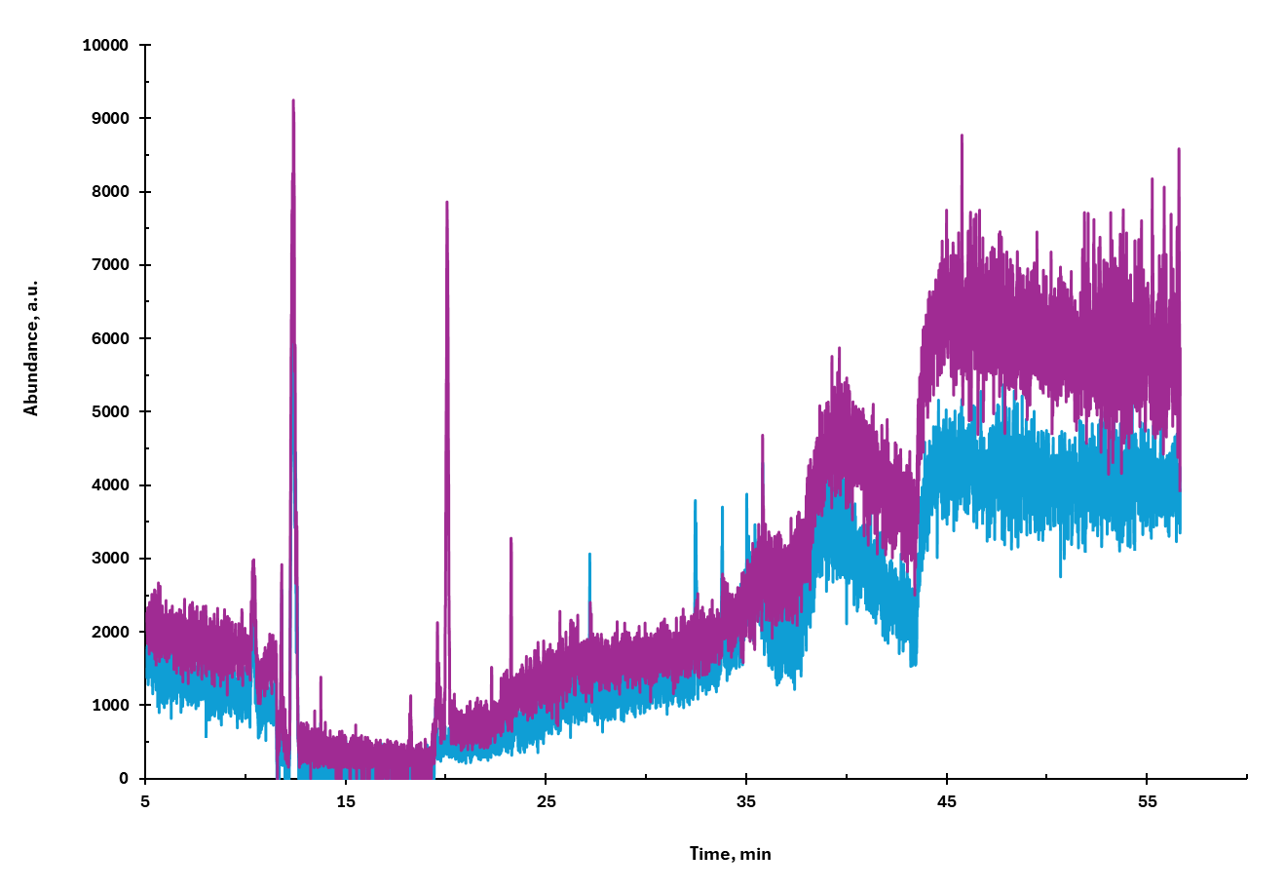

Fig. S1: GC chromatogram for blank preconditioned TD-tubes along with glass wool plugs

Standard Mix-1 | Correlation Coefficient
C12 | 0.999
C13 | 0.9986
C14 | 0.9985
C15 | 0.9728
C16 | 0.9537
C17 | 0.9826
C18 | 0.9971
C19 | 0.9969
C20 Eicosane | 0.9948
C21 Heneicosane | 0.9955
C22 Docosane | 0.9969
C23 Tricosane | 0.9965
C24 Tetracosane | 0.9958
Naphthalene (NP) | 0.9991
Methyl naphthalene (MN) | 0.9996
Dimethyl naphthalene (DMN) | 0.9258
Pyrene (PY) | 0.9981
Fluoranthene (FT) | 0.9923
Phenanthrene (PNT) | 0.9966
Acenaphthene (ACNP) | 0.9899
2,2,4,4,6,8,8-Heptamethyl nonane (HMN) | 0.9987
Standard Mix-2
Dimethyl phthalate (DMPh) | 0.9525
Diethyl phthalate (DEPh) | 0.9831
Diisobutyl adipate (DIBA) | 0.9972
Dibutyl adipate (DBA) | 0.9954
Di-n-butyl phthalate (DnBPh) | 0.9856
Di-n-pentyl phthalate (DnPPh)  (Synonym: Diamyl phthalate) | 0.9947
Di-n-hexyl phthalate (DnHPh) | 0.9951
Butyl benzyl phthalate (BBPh) | 0.9765
Bis(2-ethylhexyl) adipate (BEHA) | 0.9919
Di-(2-ethylhexyl) phthalate (DEHPh) | 0.9763
Di-n-octyl phthalate (DnOPh) | 0.9962
Diisononyl cyclohexane-1,2 dicaroxylate (DINCH) | 0.9915
*Tributyl Phosphate (TBP) | 0.9931

Table S1: Correlation Coefficients of analytes in two standard mixtures analyzed by TD-GC/MS. Concentration ranges for Standard Mix-1: 2.5 to 50 ng; Standard Mix-2: 5 to 100 ng (*except for TBP, which was between 10 to 100 ng)

