Contents
Supplementary Appendix 1: Detailed Search Strategy 2
Supplementary Table S1: Risk of bias assessment (RoB 2) 5
Supplementary Table S2: Detailed characteristics of included studies 7
Supplementary Figure S1: Summary risk of bias plot 8
Supplementary Figure S2: Traffic light risk of bias plot 9
Supplementary Figure S3: Forest plot for preterm birth 10
Supplementary Figure S4: Forest plot for neonatal hypoglycemia 10
Supplementary Figure S5 —Forest plot for Caesarean delivery 11
Supplementary Figure S6: Funnel plot for large-for-gestational-age (LGA) outcome 12
Supplementary Figure S7: Leave-one-out sensitivity analysis for LGA outcome 13
Supplementary Figure S8: Subgroup analysis of large-for-gestational-age (LGA) outcome according to CGM modality (rtCGM vs isCGM). 13
Supplementary Figure S9. Subgroup analysis of large-for-gestational-age (LGA) outcome according to CGM exposure pattern (continuous, short-term, and intermittent use). 14

Supplementary Appendix 1: Detailed Search Strategy
A systematic search was conducted in PubMed/MEDLINE, Embase, the Cochrane Central Register of Controlled Trials (CENTRAL), and Web of Science from database inception to 1 March 2026. Both controlled vocabulary and free‑text terms related to gestational diabetes and continuous glucose monitoring were used.
PubMed (MEDLINE)
Search date: 1 March 2026
Step | Search Query
1 | "Diabetes, Gestational"[Mesh]
2 | gestational diabetes[tiab]
3 | gestational diabetic*[tiab]
4 | GDM[tiab]
5 | diabetes in pregnancy[tiab]
6 | 1 OR 2 OR 3 OR 4 OR 5
7 | "Continuous Glucose Monitoring"[Mesh]
8 | continuous glucose monitor*[tiab]
9 | CGM[tiab]
10 | real-time continuous glucose monitoring[tiab]
11 | rt-CGM[tiab]
12 | flash glucose monitor*[tiab]
13 | intermittently scanned glucose monitor*[tiab]
14 | sensor glucose monitoring[tiab]
15 | glucose sensor*[tiab]
16 | 7 OR 8 OR 9 OR 10 OR 11 OR 12 OR 13 OR 14 OR 15
17 | randomized controlled trial[pt]
18 | controlled clinical trial[pt]
19 | randomized[tiab]
20 | randomised[tiab]
21 | trial[ti]
22 | 17 OR 18 OR 19 OR 20 OR 21
23 | 6 AND 16 AND 22
Embase (Elsevier)
Search date: 1 March 2026
Step | Search Query
1 | 'gestational diabetes mellitus'/exp
2 | 'gestational diabetes':ti,ab
3 | 'diabetes in pregnancy':ti,ab
4 | 'gestational diabetic*':ti,ab
5 | GDM:ti,ab
6 | 1 OR 2 OR 3 OR 4 OR 5
7 | 'continuous glucose monitoring'/exp
8 | 'continuous glucose monitor*':ti,ab
9 | CGM:ti,ab
10 | 'real time continuous glucose monitoring':ti,ab
11 | 'rt-CGM':ti,ab
12 | 'flash glucose monitoring':ti,ab
13 | 'intermittently scanned glucose monitoring':ti,ab
14 | 'sensor glucose monitoring':ti,ab
15 | 'glucose sensor*':ti,ab
16 | 7 OR 8 OR 9 OR 10 OR 11 OR 12 OR 13 OR 14 OR 15
17 | 6 AND 16
Cochrane CENTRAL
Search date: 1 March 2026
Step | Search Query
1 | gestational diabetes
2 | diabetes in pregnancy
3 | gestational diabetic*
4 | GDM
5 | 1 OR 2 OR 3 OR 4
6 | continuous glucose monitoring
7 | CGM
8 | real-time continuous glucose monitoring
9 | rt-CGM
10 | flash glucose monitoring
11 | intermittently scanned glucose monitoring
12 | sensor glucose monitoring
13 | 6 OR 7 OR 8 OR 9 OR 10 OR 11 OR 12
14 | 5 AND 13
Web of Science
Search date: 1 March 2026
TS=((gestational diabetes OR diabetes in pregnancy OR gestational diabetic* OR GDM) AND (continuous glucose monitoring OR CGM OR real time continuous glucose monitoring OR rt-CGM OR flash glucose monitoring OR intermittently scanned glucose monitoring OR sensor glucose monitoring))
Additional Search Methods
Reference lists of included studies and relevant systematic reviews were manually screened to identify additional eligible studies. No language restrictions were applied.

Supplementary Table S1: Risk of bias assessment (RoB 2)

Study | Design | D1: Randomization process | Justification | D2: Deviations from intended interventions | Justification | D3: Missing outcome data | Justification | D4: Measurement of outcome | Justification | D5: Selection of reported result | Justification | Overall risk of bias | Justification
GRACE 2026 | Randomized controlled trial | Low risk | Random allocation with baseline comparability reported | Some concerns | Open-label monitoring; participants and clinicians aware of CGM vs SMBG | Low risk | Outcome data available for most participants with minimal attrition | Low risk | Objective neonatal outcomes (birthweight, complications) | Low risk | Outcomes prespecified in protocol | Low risk | Well-conducted RCT with minimal bias
Steady Sugar 2026 | Randomized controlled trial | Some concerns | Randomisation mentioned but allocation concealment unclear | Some concerns | Open-label design may influence behaviour | Low risk | Missing data minimal and balanced | Low risk | Outcomes measured objectively | Some concerns | Protocol/statistical plan not clearly reported | Some concerns | Minor reporting limitations without major bias
DipGluMo 2025 | Randomized controlled trial | Low risk | Computer-generated randomisation using REDCap system | Some concerns | Lack of blinding (rtCGM vs SMBG) | Low risk | Outcome data available for ~99% participants | Low risk | Objective neonatal outcomes | Low risk | Trial registered with prespecified outcomes | Low risk | Strong methodology with minimal bias
FLAMINGO 2023 | Randomized controlled trial | Low risk | Randomisation with comparable baseline characteristics | Some concerns | Device-based intervention not blinded | Low risk | Low and balanced attrition | Low risk | Objective clinical outcomes | Some concerns | Limited protocol details | Some concerns | Minor concerns due to blinding/reporting
Mengyu Lai 2023 | Randomized controlled trial | Some concerns | Allocation concealment unclear | Some concerns | Open-label intervention may influence behaviour | Low risk | Low attrition with adequate data | Low risk | Objective neonatal and clinical outcomes | Some concerns | Protocol not clearly referenced | Some concerns | Some methodological concerns
Valent et al. 2025 | Randomized controlled trial | Low risk | Computer-generated randomisation with balanced baseline | Some concerns | Lack of blinding due to device use | Low risk | Minimal missing data | Low risk | Outcomes measured objectively | Low risk | Outcomes prespecified | Low risk | Robust trial with minimal bias

Supplementary Table S1. Risk of bias assessment of included randomized controlled trials using the Cochrane Risk of Bias 2 tool, with domain-wise judgments and justification

Supplementary Table S2: Detailed characteristics of included studies
Study | Country / Setting | Study design | Sample size (CGM / SMBG) | CGM modality | Exposure pattern | Gestational age at enrolment | Comparator | Trial primary outcome | Neonatal outcomes reported
GRACE (2026) | Austria, Germany, Switzerland | Open-label randomized controlled trial | 190 / 185 | Real-time CGM (Dexcom G6) | Continuous until delivery | ~28 weeks | SMBG; control also used short blinded CGM periods | Large-for-gestational-age birth | LGA, SGA, NICU admission, neonatal hypoglycaemia, preterm birth, caesarean delivery, birthweight
Steady Sugar (2026) | USA | Randomized controlled trial (2:1 allocation) | 80 / 40 | Real-time CGM (Dexcom G6) | Continuous until delivery | 8–26 weeks | SMBG with intermittent blinded CGM | Percent time-in-range | LGA, NICU admission, neonatal hypoglycaemia, preterm birth, caesarean delivery, birthweight
DipGluMo (2025) | Switzerland | Open-label randomized controlled trial | 156 / 143 | Real-time CGM (Dexcom G6) | Continuous throughout pregnancy | 24–28 weeks | SMBG with blinded CGM assessments | Composite perinatal outcome | LGA, NICU admission, neonatal hypoglycaemia, preterm birth, caesarean delivery
FLAMINGO (2023) | Poland | Randomized controlled trial | 50 / 50 | Flash CGM (FreeStyle Libre) | Short-term (4 weeks after diagnosis) | 24–28 weeks | SMBG | Maternal glycaemic control | LGA, SGA, neonatal hypoglycaemia, caesarean delivery, birthweight
Lai et al. (2023) | China | Randomized controlled trial | 77 / 77 | Intermittent CGM plus SMBG | Periodic (3 days every 4 weeks) | 24–28 weeks | SMBG alone | Time-in-range | LGA, SGA, NICU admission, neonatal hypoglycaemia, preterm birth, caesarean delivery
Valent et al. (2025) | USA | Open-label randomized controlled trial (2:1 allocation) | 74 / 37 | Real-time CGM (Dexcom G6) | Continuous until delivery | ≥20 weeks | SMBG with periodic blinded CGM | Percent time-in-range | LGA, SGA, NICU admission, neonatal hypoglycaemia, preterm birth, caesarean delivery, birthweight

Supplementary Table S2. Detailed characteristics of included randomized controlled trials evaluating continuous glucose monitoring versus self-monitoring of blood glucose in gestational diabetes mellitus

Supplementary Figure S1: Summary risk of bias plot

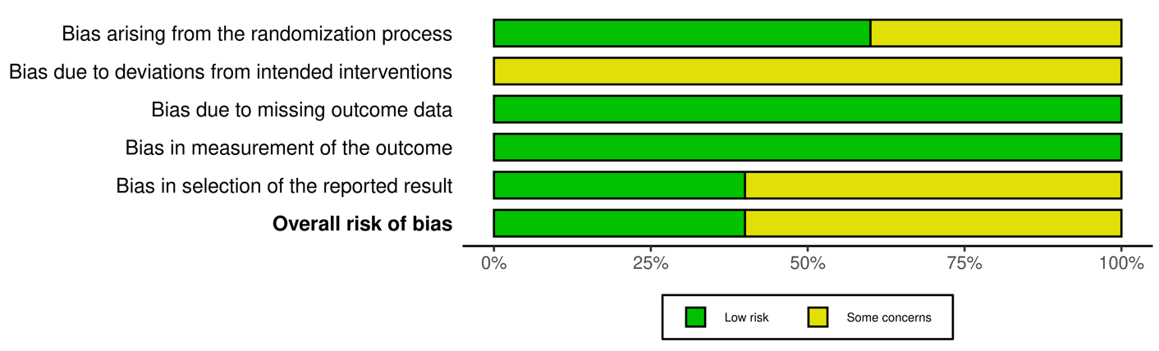
Supplementary Figure S1. Summary of risk of bias across domains for included randomized controlled trials assessed using the Cochrane Risk of Bias 2 tool.
The figure presents the proportion of studies rated as low risk or having some concerns for each bias domain, including bias arising from the randomization process, deviations from intended interventions, missing outcome data, measurement of the outcome, and selection of the reported result. The overall risk-of-bias judgment across studies is also shown.

Supplementary Figure S2: Traffic light risk of bias plot
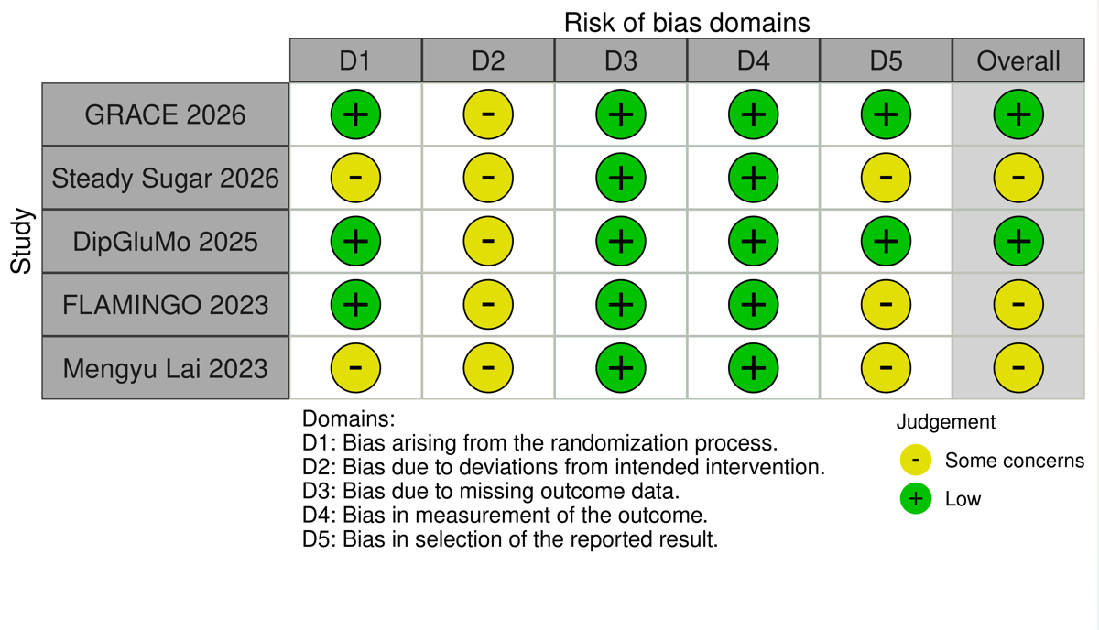
Supplementary Figure S2. Study-level risk of bias assessment across domains for included randomized controlled trials using the Cochrane Risk of Bias 2 tool.
Each row represents an individual study and each column corresponds to a bias domain, including bias arising from the randomization process (D1), deviations from intended interventions (D2), missing outcome data (D3), measurement of the outcome (D4), and selection of the reported result (D5). Symbols indicate the judgment for each domain, with green representing low risk of bias and yellow representing some concerns. The overall risk-of-bias judgment for each study is also presented.

Supplementary Figure S3: Forest plot for preterm birth

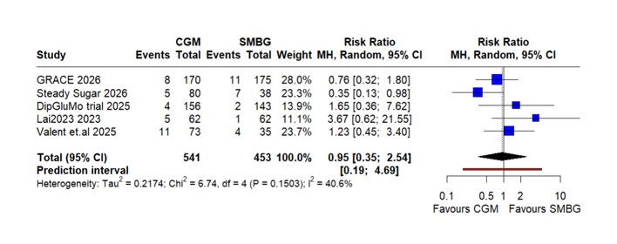
Supplementary Figure S3. Forest plot of randomized trials comparing continuous glucose monitoring (CGM) with self-monitoring of blood glucose (SMBG) for the outcome of preterm birth using a random-effects model

Supplementary Figure S4: Forest plot for neonatal hypoglycemia
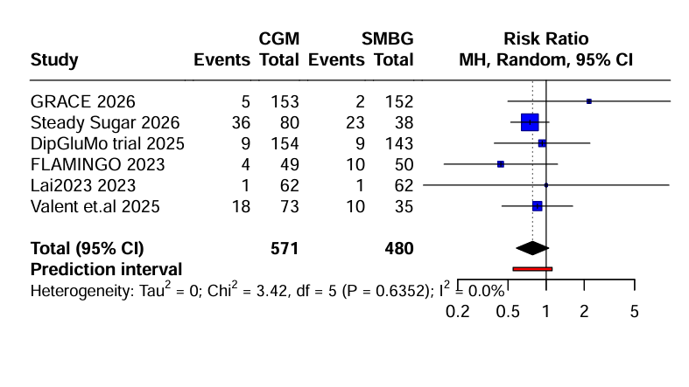 Supplementary Figure S4. Forest plot comparing continuous glucose monitoring (CGM) with self-monitoring of blood glucose (SMBG) for neonatal hypoglycaemia.

Supplementary Figure S5 —Forest plot for Caesarean delivery

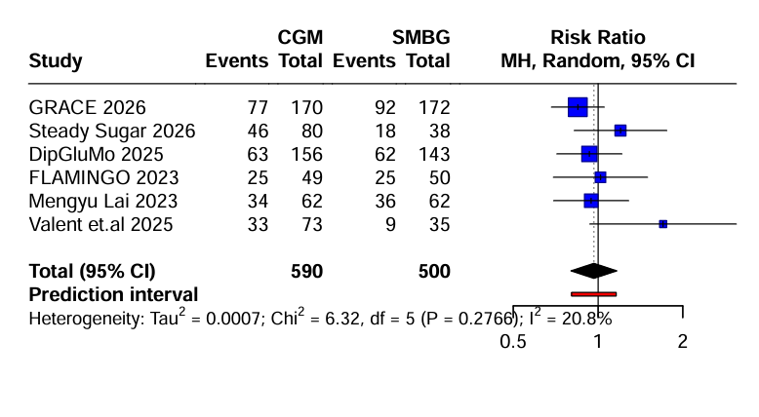
Supplementary Figure S5. Forest plot comparing continuous glucose monitoring (CGM) with self-monitoring of blood glucose (SMBG) for caesarean delivery.

Supplementary Figure S6: Funnel plot for large-for-gestational-age (LGA) outcome

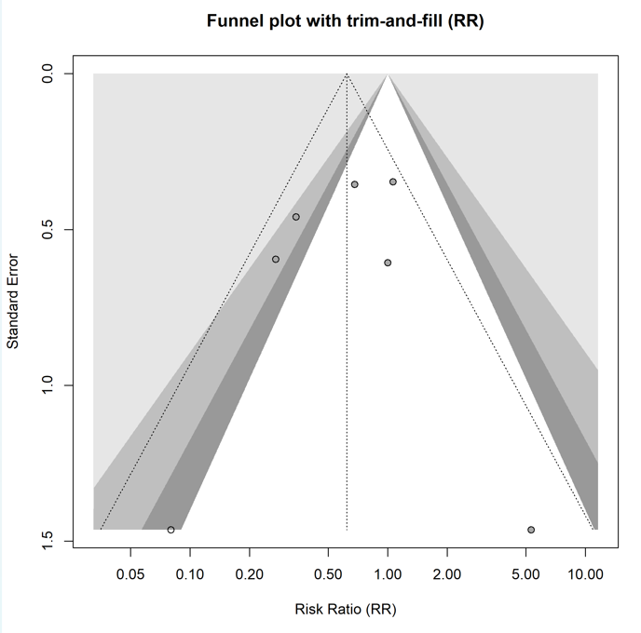
Supplementary Figure S6. Contour-enhanced funnel plot with trim-and-fill analysis for the large-for-gestational-age (LGA) outcome.
Each point represents an individual study. The vertical line indicates the pooled effect estimate. The shaded regions represent areas of statistical significance. The trim-and-fill method was used to explore potential small-study effects and publication bias.

Supplementary Figure S7: Leave-one-out sensitivity analysis for LGA outcome

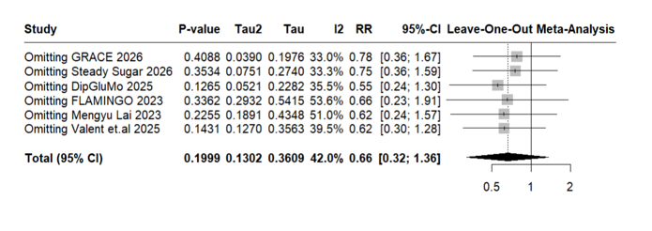
Supplementary Figure S7. Leave-one-out influence analysis for large-for-gestational-age (LGA) outcome.

Supplementary Figure S8: Subgroup analysis of large-for-gestational-age (LGA) outcome according to CGM modality (rtCGM vs isCGM).
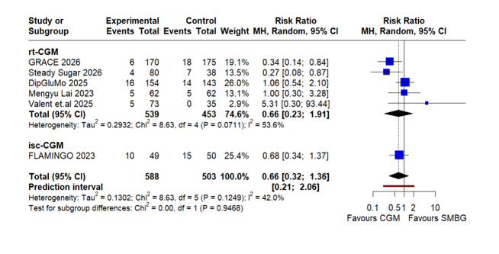 Supplementary Figure S8. Subgroup analysis of large-for-gestational-age (LGA) outcome according to CGM modality (real-time versus intermittently scanned CGM).
Abbreviations: CGM, continuous glucose monitoring; rt-CGM, real-time continuous glucose monitoring; isCGM, intermittently scanned continuous glucose monitoring; SMBG, self-monitoring of blood glucose; LGA, large-for-gestational-age; RR, risk ratio.

Supplementary Figure S9. Subgroup analysis of large-for-gestational-age (LGA) outcome according to CGM exposure pattern (continuous, short-term, and intermittent use).

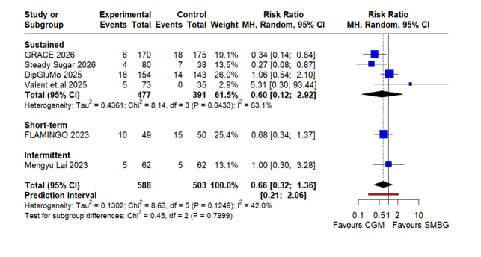
Supplementary Figure S9. Subgroup analysis of large-for-gestational-age (LGA) outcome according to CGM exposure pattern (continuous, short-term, and intermittent use).

Figure S10: Bayesian analysis of LGA (posterior, probability, predictive)
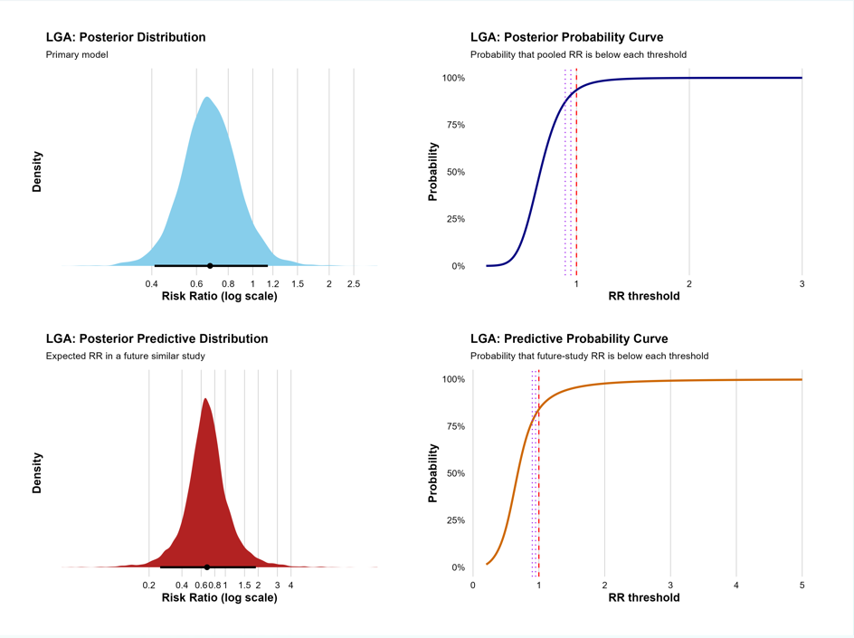
Supplementary Figure S10. Bayesian analysis of the effect of continuous glucose monitoring (CGM) on large-for-gestational-age (LGA). The posterior distribution shows the pooled risk ratio (RR), the posterior probability curve shows the probability that RR is below specified thresholds, and the posterior predictive distribution reflects the expected effect in a future similar study. The vertical line indicates RR = 1 (no effect).

Figure S11: Bayesian analysis of SGA (posterior, probability, and predictive estimates)

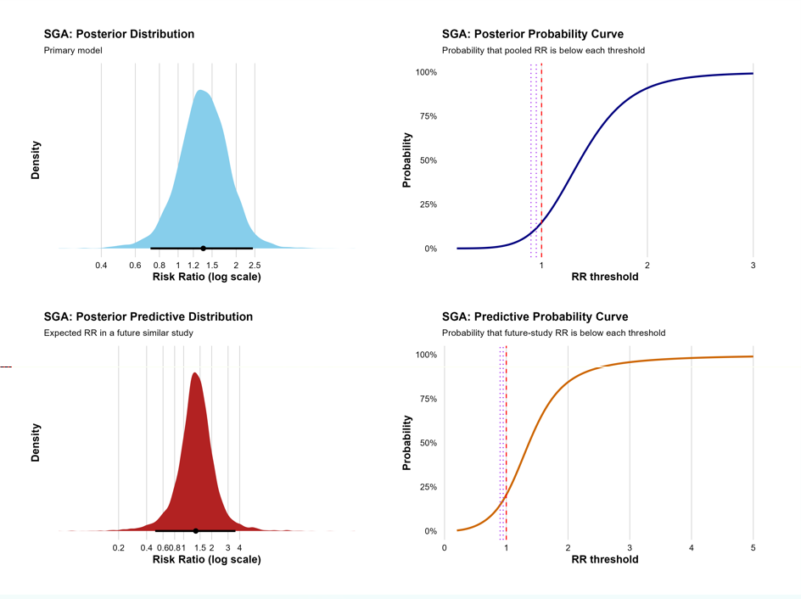
Supplementary Figure S11. Bayesian analysis of the effect of continuous glucose monitoring (CGM) on small-for-gestational-age (SGA). The posterior distribution shows the pooled risk ratio (RR), the posterior probability curve shows the probability that RR is below specified thresholds, and the posterior predictive distribution reflects the expected effect in a future similar study. The vertical line indicates RR = 1 (no effect).

Figure S12: Bayesian analysis of NICU admission (posterior, probability, and predictive estimates)
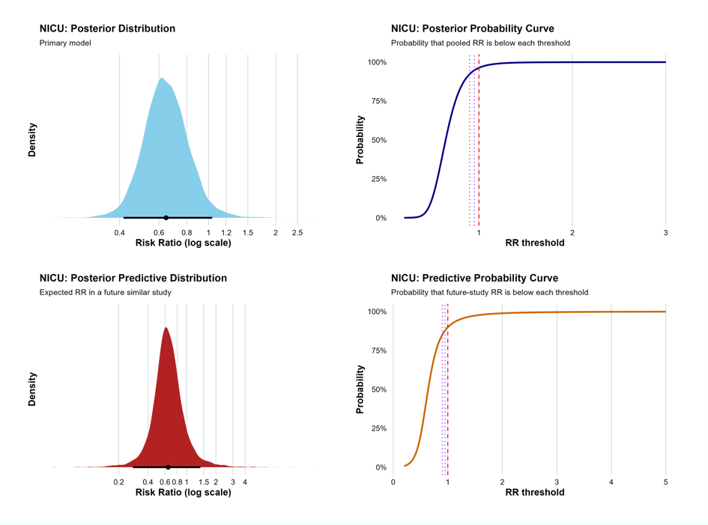
Supplementary Figure S12. Bayesian analysis of the effect of continuous glucose monitoring (CGM) on neonatal intensive care unit (NICU) admission. The posterior distribution shows the pooled risk ratio (RR), the posterior probability curve shows the probability that RR is below specified thresholds, and the posterior predictive distribution reflects the expected effect in a future similar study. The vertical line indicates RR = 1 (no effect).

