Supplementary material
Cellulose-Based Superabsorbent Hydrogels for Hygiene Applications: A Study of Absorbency Properties
Mirela A. Artner¹, Alfonso J. Dominguez¹, Richard A. Venditti¹, Joel J. Pawlak¹
¹Department of Forest Biomaterials, North Carolina State University, 2820 Faucette Drive, Raleigh, NC 27695, USA.
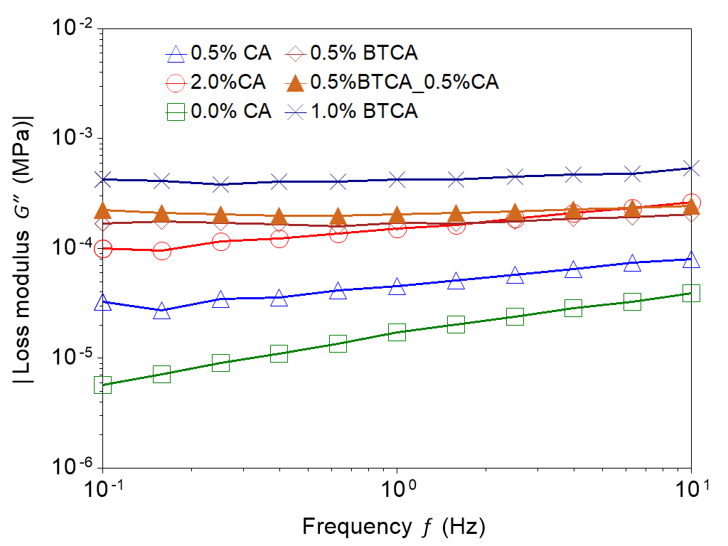
S1. Loss modulus of CMC–HEC hydrogels crosslinked with citric acid (CA) and BTCA at different concentrations
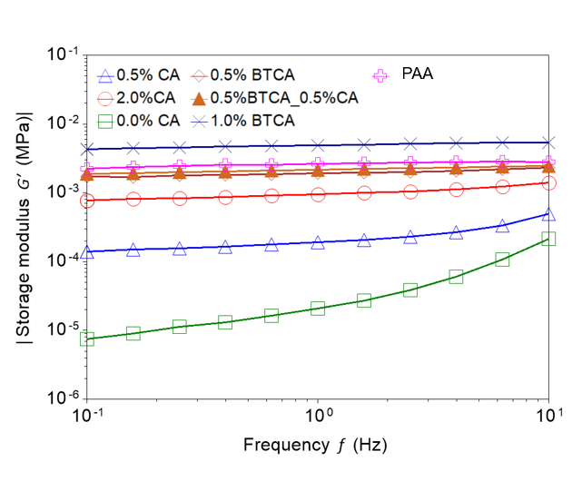
S2. Loss modulus of CMC–HEC hydrogels crosslinked with citric acid (CA) and BTCA at different concentrations and Polyacrylate SAP.

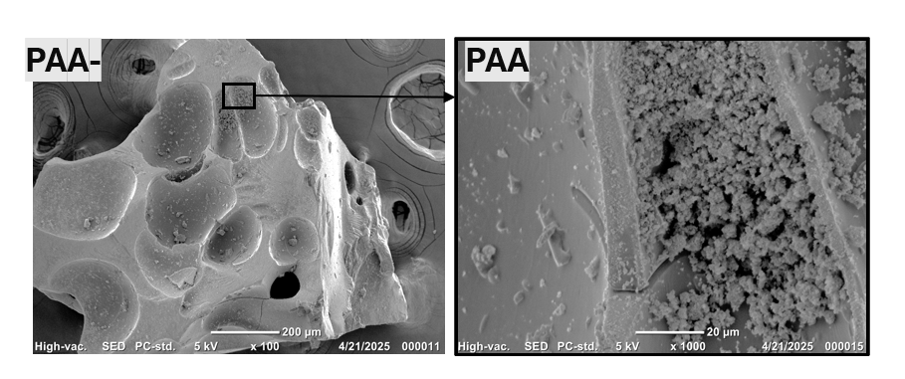
S3. Morphology of Polyacrylate SAP.

