Supplementary Information
Electrochemistry of Polyaniline: Insights into Structural Processes, Charge, Energy and Reactive Sensing Capabilities Studied through Coulovoltammetry
Madari P. Sidheekha#, Lijin Rajan#, Sivakrishna Prakash#, Aranhikundan Shabeeba#, Yahya A. Ismail#*
#Advanced Materials Research Center, Department of Chemistry, University of Calicut, Thenhipalam, Kerala, 673635, India
Corresponding Author
Yahya A. Ismail
Email: E-mail: aiyahya@uoc.ac.in; aiyahya123@gmail.com

  - General characterizations of synthesized PANI

- Structural characterization (FTIR spectra)
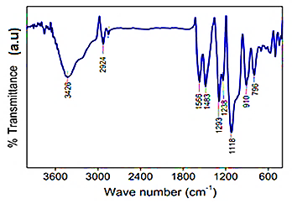
Figure S1 FTIR spectra of PANI
The FTIR spectrum of polyaniline recorded in the frequency range of 4000–400 cm⁻¹ is shown in Figure S1. The broad band at 3426 cm⁻¹ corresponds to the stretching vibration of N–H bonds. The peak at 2924 cm⁻¹ is attributed to the stretching vibration of C–H in the aromatic ring. The two characteristic peaks of 1566 cm⁻¹ and 1483 cm⁻¹ correspond to the quinonoid and benzenoid ring C=C vibrations of PANI respectively. Since the intensities of these peaks are almost the same almost equal number of oxidized and reduced rings are present in the synthesized PANI [32]. The peak at 1293 cm⁻¹ is due to C-N stretching vibrations, while the band at 1238 cm⁻¹ is ascribed to the C-N⁺ stretching vibration in the polaron structure [33]. The peak at 1118 cm⁻¹ is due to the in-plane bending of C-H and the bands at 796 cm⁻¹ are assigned to the out-of-plane bending vibration of C-H bonds [34].
- Thermal characterization
The thermal stability of as prepared PANI is analyzed by thermogravimetry and the obtained thermogram is presented in Figure S2. The PANI presents three stages of mass loss. The first stage of mass loss up to 105 °C with a weight loss of 15 % corresponds to the loss of water molecules; the second stage, between 180 °C and 270 °C with a weight loss of 12 % is ascribed to the release of low molecular weight oligomers and dopant ions [35]; the third stage, from 450 °C to 580 °C with 18 % of weight loss, is attributed to the degradation of the polymer chains of PANI through the rupture of the benzene rings and 47 % residue is left at 700 °C. The degradation temperature of PANI is 525 °C [36].
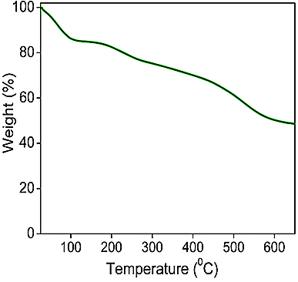
Figure S2 TG curve of PANI
- Electrical characterization
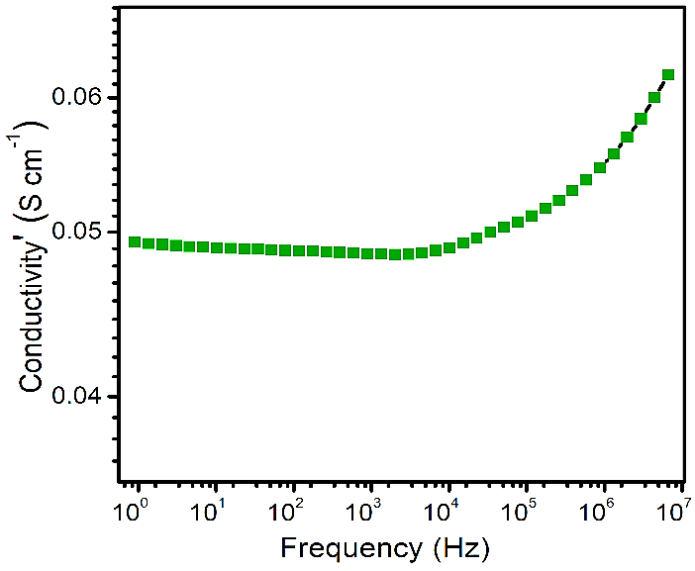
Figure S3 Frequency dependent conductivity of PANI

The electrical conductivity of pelletized PANI was measured using a broad-band dielectric spectrometer, and the frequency-dependent conductivity is illustrated in Figure S3. The electrical conductivity values were obtained by fitting the curve with Jonscher's power law. The conductivity is 4.9 x 10⁻² S cm⁻¹, which indicates the semiconducting nature of PANI.
- Morphological characterization
The morphology of synthesized PANI was investigated by FESEM analysis. Figure S4 is the FESEM image and it revealed that polyaniline grown with coral-like nanowire structures during the chemical polymerization of aniline. The figure demonstrates the presence of substantial porosity in PANI, which facilitates the diffusion of ions and solvent molecules for efficient electrochemical reactions.
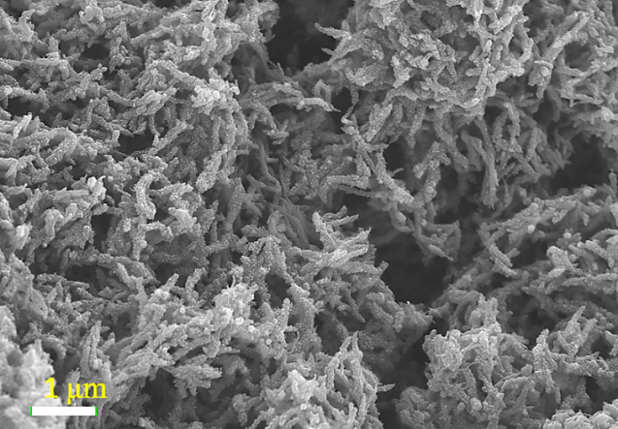
Figure S4 FESEM image of PANI
2.2. Energy asymmetry with respect to scan rate
At a particular scan rate the energy consumed to reduce a PANI is greater than that consumed to oxidize it. This fact is related to the hysteresis of the coulovoltammetric responses. This energetic asymmetry decreases with the increasing of scan rate in the case of polyaniline when the potential is cycled between -0.25 V to 0.7 V. This energy asymmetry has a semilogarithmic linear dependence to scan rate as shown in Fig. S5.
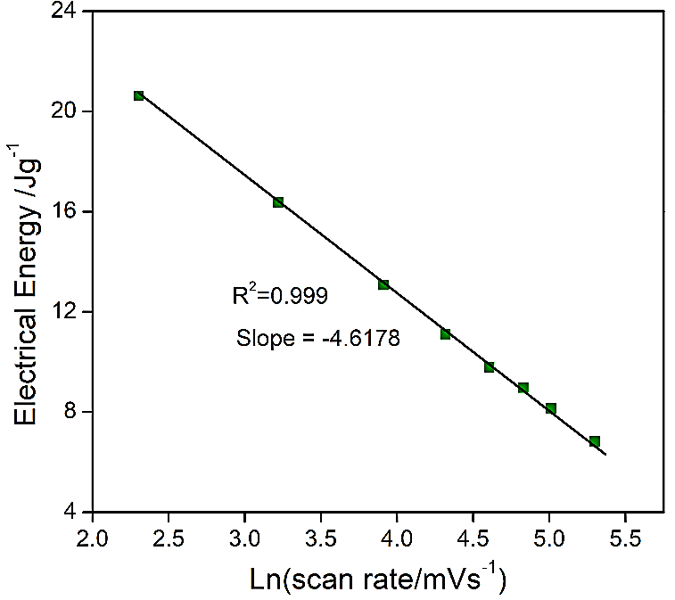
Figure S5 Energy asymmetry with respect to scan rate when CV recorded in between -0.25 V to 0.7 V from 1 M HCl electrolyte at room temperature
2.3. Energy asymmetry with respect to electrolyte concentration
At a particular concentration the energy consumed to reduce a PANI is greater than that consumed to oxidize it. This energetic asymmetry decreases with the decreasing of electrolyte concentration in the case of polyaniline when the potential is cycled between -0.25 V to 0.7 V. This energy asymmetry has a semilogarithmic linear dependence to electrolyte concentration as shown in Fig. S6.
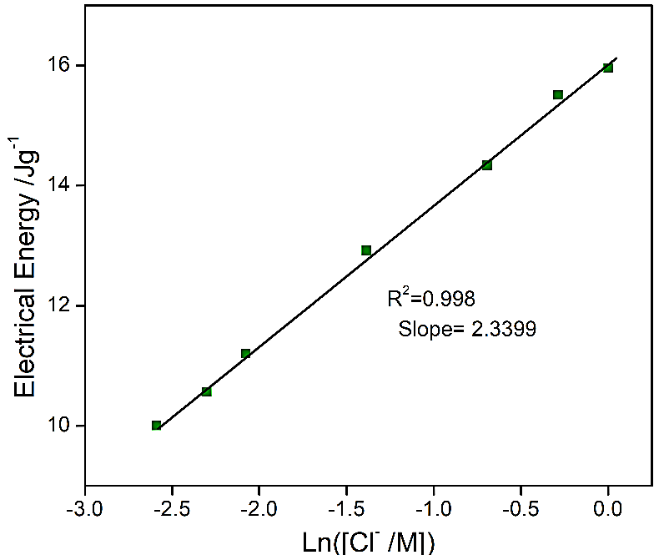
Figure S6 Energy asymmetry with respect to electrolyte concentration when CV recorded in between -0.25 V to 0.7 V from 1 M HCl electrolyte at a scan rate of 25 mV/s
2.4. Energy asymmetry with respect to temperature
At a particular temperature the energy consumed to reduce a PANI is greater than that consumed to oxidize it. This energetic asymmetry increases with the increasing of working temperature in the case of polyaniline when the potential is cycled between -0.25 V to 0.7 V. This energy asymmetry has a linear dependence to temperatre as shown in Fig. S7.
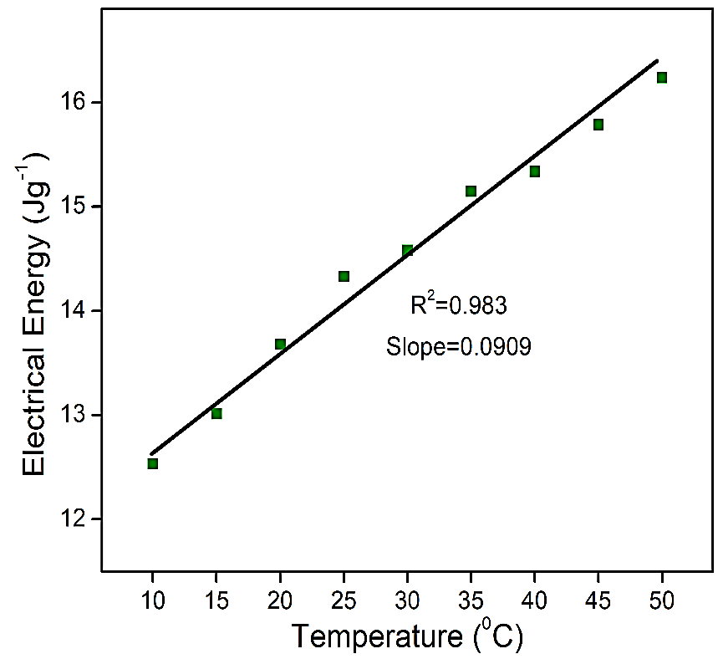
Figure S7 Energy asymmetry with respect to temperature when CV recorded in between -0.25 V to 0.7 V from 1 M HCl electrolyte at a scan rate of 25 mV/s

