Additional File 1 to manuscript ‘Effect of an intensive weight-loss lifestyle intervention on kidney function: a randomized controlled trial’ (Díaz-López et al., 2020)
This appendix has been provided by the authors to give readers additional information about their work.
Table of Contents

 | Page
1. List of PREDIMED-Plus study Investigators. | 2
2. Supplementary Figure 1. Study flow diagram. | 6
3. Supplementary Table 1. Baseline and 1-year changes in adiposity-related parameters, 17-point Mediterranean diet score, sedentary behaviors and energy expenditure in leisure-time physical activity by group assignment: completers-only. | 7
4. Supplementary Table 2. Participants (%) using drugs at baseline and changes during the intervention by group assignment: completers-only. | 8
5. Supplementary Table 3. Baseline and 1-year changes in kidney function markers in specific subgroups by group assignment: completers-only. | 9
6. Supplementary Table 4. Baseline and multivariable-adjusted 1-year changes* in kidney function markers by categories of change of weight, Mediterranean diet score and TV- viewing: completers-only. | 11
7. Supplementary Figure 2. Interaction between intervention and categories of weight change (left upper graph) and adherence to the Mediterranean diet score (right upper graph) on 1-year changes in eGFR (ml/min/1.73 m²); or weight change categories (left lower graph) and TV watching (right lower graph) on 1-year changes in UACR (mg/g). | 12

1. List of PREDIMED-Plus study investigators

Steering Committee:
J. Salas-Salvadó (Coordinator), M.A. Martínez-González, M. Fitó. E. Ros, FJ. Tinahones, D. Corella and R. Estruch.

Executive Committee:
J. Salas-Salvadó, M.A. Martínez-González, D. Corella, M. Fitó, J. Vioque, D. Romaguera, J.A Martínez, J. Wärnberg, J. Lopez-Miranda, R. Estruch, A. Bueno-Cavanillas, Á.M. Alonso-Gómez, J.A. Tur, FJ. Tinahones, L. Serra-Majem, V. Martin, J. Lapetra, C. Vázquez, X. Pinto, J. Vidal, L. Daimiel, M. Delgado-Rodríguez, M.A. Rubio and E. Ros.

Dietary and Lifestyle Intervention Committee:
J. Salas-Salvadó (Chair), M.A. Martínez-González, M. Fitó and R. Estruch;
Dietary Intervention: J. Salas-Salvadó (Chair), N. Babio, E. Ros, A. Sánchez-Tainta;
Physical Exercise: M. Fitó (Chair), H. Schröder, A. Marcos, D. Corella, J. Warnberg;
Behavioural support: R. Estruch (Chair), F. Fernández-Aranda, C. Botella and J. Salas-Salvadó.

Clinical Event Ascertainment Committee:
F. Arós (Chair), M. Aldamiz, A. Alonso-Gómez, L. Forga, A. García-Layana, J. Portu, J. Timiraos, A. González-Pinto, I. Zorrilla, M. Martínez-Kareaga, P. Seoane.
Chair: Dr. Fernando Arós
Cardiology: Dr. Angel Alonso-Gómez; Dr. Fernando Arós
Neurology: Dr. Juan Timiraos
Internal Medicine: Dr. Mikel Aldamiz; Dr. Joseba Portu
Endocrinology: Dr. Lluis Forga
Ophthalmology: Dr. Alfredo García-Layana
Psychiatry: Dr. Ana González Pinto; Dr. Iñaki Zorrilla
Oncology: Dr. Mireia Martínez; Dr. Patricia Seoane

Rovira i Virgili University, Department of Biochemistry and Biotechnology, Human Nutrition Unit, University Hospital of Sant Joan de Reus, Pere Virgili Institute for Health Research, Reus, Spain: R. Pedret Llaberia, R. Gonzalez, R. Sagarra Álamo, F. París Palleja, J. Balsells, J.M. Roca, T. Basora Gallisa, J. Vizcaino, P. Llobet Alpizarte, C. Anguera Perpiñá, M. Llauradó Vernet, C. Caballero, M. Garcia Barco, M.D. Morán Martínez, J. García Rosselló, A. Del Pozo, C. Poblet Calaf, P. Arcelin Zabal, X. Floresví, M. Ciutat Benet, A. Palau Galindo, J.J. Cabré Vila, F. Dolz Andrés, M. Soler, M. Gracia Vidal, J. Vilalta J. Boj Casajuana, M. Ricard, F. Saiz, A. Isach, M. Sanchez Marin Martinez, E. Granado Font, C, Lucena Luque, C. Mestres Sola, M. Bulló, N. Babio, N. Becerra-Tomás, G. Mestres, J. Basora, G. Mena-Sánchez, L. Barrubés Piñol, M. Gil Segura, C. Papandreou, N. Rosique-Esteban, S. Chig, I. Abellán Cano, C. Mestres Sola, V. Ruiz García, A. Salas-Huetos, I. Paz-Graniel, L. Sánchez Niembro, P. Hernandez-Alonso, S. Canudas, L. Camacho-Barcia, J. García-Gavilán, A. Díaz-López, A. Martínez-Vea.
Department of Preventive Medicine and Public Health, University of Navarra-Navarra Institute for Health Research (IdiSNA), Pamplona, Spain: M. Ruiz-Canela, E. Toledo, P. Buil-Cosiales, Z. Vázquez, C. Razquin, M. Bes-Rastrollo, A. Gea, A. Sanchez Tainta, B. SanJulian Aranguren, E. Goñi, L. Goñi, M.J. Cobo, A. Rico-Campa, F.J. Basterra Gortari, A. Garcia Arellano, J. Diez-Espino, O. Lecea-Juarez, J. Carlos Cenoz-Osinaga, I. Alvarez-Alvarez, M.C. Sayon-Orea, C.I. Fernandez-Lázaro, L. Ruiz-Estigarribia, J. Bartolome-Resano, A. Sola-Larraza (†), E. Lozano-Oloriz, B. Cano-Valles, S. Eguaras, E. Pascual Roquet-Jalmar, I. Galilea-Zabalza, H. Lancova, R. Ramallal, M.L. Garcia-Perez, V. Estremera-Urabayen, M.J. Ariz-Arnedo, C. Hijos-Larraz, C. Fernandez-Alfaro, B. Iñigo-Martinez, R. Villanueva Moreno, S. Martin-Almendros, L. Barandiaran-Bengoetxea, C. Fuertes-Goñi, A. Lezaun-Indurain, M.J. Guruchaga-Arcelus, O. Olmedo-Cruz, L. Escriche-Erviti, R. Ansorena-Ros, R. Sanmatin-Zabaleta, J. Apalategi-Lasa, J. Villanueva-Telleria, M.M. Hernández-Espinosa, L. Herrera-Valdez, L. Dorronsoro-Dorronsoro, L. Echeverria-Lizarraga, J.A. Cabeza-Beunza, P. Fernández-Urretavizcaya, P. Gascó-García, C. Royo-Jimenez, J. Moran-Pí, F. Salazar-Fernández, F.J. Chasco-Ros, F. Cortés-Ugalde, J.J. Jurio-Burgui, P. Pascual-Pascual, A.I. Rodríguez-Ezpeleta, M. Esparza-Cáceres, C. Arroyo-Azpa, M. Rodríguez-Sanz de Galdeano, T. Forcen-Alonso, M. Armendariz-Marcotegui, A. Brugos-Larumbe, A. Arillo, B. López-Aisa.
Department of Preventive Medicine, University of Valencia, University Jaume I, Conselleria de Sanitat de la Generalitat Valenciana, Valencia, Spain: J.I. González, J.V. Sorlí, O. Portolés, R. Fernández-Carrión, C. Ortega-Azorín, R. Barragán, E.M. Asensio, O. Coltell, R. Martínez-Lacruz, I. Giménez‐Alba, C. Sáiz, R. Osma, E. Férriz, I. González-Monje, P. Guillém-Sáiz, F. Giménez-Fernández, L. Quiles, P. Carrasco, A. Carratalá-Calvo, C. Valero-Barceló, C. Mir, S. Sánchez-Navarro, J. Navas, I. González-Gallego, L. Bort-Llorca, L. Pérez-Ollero, M. Giner-Valero, R. Monfort-Sáez, J. Nadal-Sayol, V. Pascual-Fuster, M. Martínez-Pérez, C. Riera, M.V. Belda, A. Medina, E. Miralles, M.J. Ramírez-Esplugues, M. Rojo-Furió, G. Mattingley, M.A. Delgado, M.A. Pages, Y Riofrío, L. Abuomar, N. Blasco-Lafarga, R. Tosca, L. Lizán, A.M Valcarce, M.D. Medina, S. de Valcárcel, N. Tormo, O. Felipe-Román, S. Lafuente, E.I. Navío, G. Aldana, J.V. Crespo, J.L. Llosa, L. González-García, R. Raga-Marí.
Cardiovascular Risk and Nutrition Research Group, Endocrinology Service, Neurosciences Programme, Clinical Research Unit at the Hospital del Mar Medical Research Institute (IMIM), Barcelona. Medicine Departament, Universitat Autònoma de Barcelona, Barcelona, Spain: M. Fitó, O. Castañer, M.A. Muñoz, M.D. Zomeño, A. Hernaéz, L. Torres, M. Quifer, R. Llimona, G Freixer, KA. Pérez-Vega, M. Farràs, R. Elosua, J. Vila, I. Subirana, S. Pérez, A. Goday, J.J. Chillaron Jordan, J.A. Flores Lerroux, D. Benaiges Boix, G. Llauradó, M. Farré, E. Menoyo, A. Aldea-Perona, M. Pérez-Otero, D. Muñoz-Aguayo, S. Gaixas, G. Blanchart, A. Sanllorente, M. Soria, J. Valussi, A. Cuenca, L. Forcano, A. Pastor, A. Boronat, S. Tello, M. Cabañero, L. Franco, H. Schröder, R. De la Torre, C. Medrano, J. Bayó, M.T. García, V. Robledo, P. Babi, E. Canals, N. Soldevila, L. Carrés, C. Roca, M.S. Comas, G. Gasulla, X. Herraiz, A. Martínez, E. Vinyoles, J.M. Verdú, M. Masague Aguade, E. Baltasar Massip, M. López Grau, M. Mengual, V. Moldon, M. Vila Vergaz, R. Cabanes Gómez, Ciurana, M. Gili Riu, A. Palomeras Vidal, F Peñas F, A Raya, M.A. Sebastian, M. Valls, J. Guerrero, M. Marne, E. Minguella, M. Montenegro, A. Sala, M.R. Senan, N. Talens, N. Vera.
Nutritional Epidemiology Unit, Miguel Hernandez University, ISABIAL-FISABIO, Alicante, Spain: J. Vioque, M. García-de-la-Hera, E.M. Navarrete-Muñoz, S. Gonzalez-Palacios, L. Torres-Collado, L. Compañ-Gabucio, A. Oncina-Canovas, L. Notario-Barandiaran, D. Orozco-Beltran, S. Pertusa Martínez, A. Asensio, I. Candela-García, J.M. Zazo, C. Gisbert Sellés, N. Fernándis-Brufal, J. Román Maciá, C. Sánchez Botella, M. García Muñoz, C. Barceló, M.C. Altozano-Rodado, N. Iranzo García, M.C. Martínez Vergara, M.A. Sempere Pascual, S.J. Miralles Gisbert, A. González Botella, C.M. López García, R. Valls Enguix, N. Gómez Bellvert, I. López Aguilera, R. Lloret Macián, A. Pastor Morell, E. Alonso Bartolomé, J.J. Ballester Baixauli, M.T. Cano Sánchez, B.E. Ayús Rojo, E.P. Cases Pérez, C. Tercero Maciá, L.A. Mira Castejón, I.A. García García, M. Jordá Ballesta, C. Pastor Polo, E. Puig Agulló.
Hospital Son Espases (HUSE) and Institute for Health Research Illes Balears (IdISBa), Palma de Mallorca, Spain: M. Fiol, M. Moñino, A. Colom, J. Konieczna, M. Morey, R. Zamanillo, A.M. Galmés-Panadés, V. Pereira, M.A. Martín, A. Yáñez, J. Llobera, J. Ripoll, R. Prieto, F. Grases, A. Costa, C. Fernández-Palomeque, E. Fortuny, M. Noris, S. Munuera, F. Tomás, F. Fiol, A. Jover, J.M. Janer, C. Vallespir, I. Mattei, N. Feuerbach, M. del Mar Sureda, S. Vega, L. Quintana, A. Fiol, M. Amador, S. González, J. Coll, A. Moyá, T. Piqué Sistac, M.D. Sanmartín Fernández, M.C. Piña Valls, M.A. Llorente San Martín, J. Pou Bordoy.
Department of Nutrition, Food Sciences, and Physiology, Center for Nutrition Research, University of Navarra, Pamplona, Spain: I. Abete, I. Cantero, C. Cristobo, I. Ibero-Baraibar, M. Zulet, J. Ágreda-Peiró, M.D. Lezáun-Burgui, N. Goñi-Ruiz, R. Bartolomé-Resano, E. Cano-Cáceres, T. Elcarte-López, E. Echarte-Osacain, B. Pérez-Sanz, I. Blanco-Platero, A. Andueza- Azcárate, A. Gimeno-Aznar, E. Ursúa-Sesma, B. Ojeda-Bilbao, J. Martinez-Jarauta, L. Ugalde-Sarasa, B. Rípodas-Echarte, M.V. Güeto-Rubio, C. Napal-Lecumberri, MD Martínez-Mazo, E Arina-Vergara, A. Parra-Osés, F. Artal-Moneva, F. Bárcena-Amigo, F. Calle-Irastoza, J. Abad-Vicente, J.I. Armendáriz-Artola, P. Iñigo-Cibrian, J. Escribano-Jarauta, J. Ulibarri-delportillo, B. Churio-Beraza, Y. Monzón-Martínez, E. Madoz-Zubillaga, C. Arroniz.
University of Málaga and Institute of Biomedical Research in Malaga (IBIMA), Málaga, Spain: F.J. Barón-López, J.C. Fernández García, N. Pérez-Farinós, N. Moreno-Morales, M. del C. Rodríguez-Martínez, J. Pérez-López, J.C. Benavente-Marín, E. Crespo Oliva, E. Contreras Fernández, F.J. Carmona González, R. Carabaño Moral, S. Torres Moreno, M.V. Martín Ruíz, M. Alcalá Cornide, V. Fuentes Gómez.
Lipids and Atherosclerosis Unit, Department of Internal Medicine, Maimonides Biomedical Research Institute of Cordoba (IMIBIC), Reina Sofia University Hospital, University of Cordoba, Cordoba, Spain: J. López-Miranda, A. Garcia-Rios, J. Criado García, A.I. Jiménez Morales, A. Ortiz Morales, J.D. Torres Peña, F.J. Gómez Delgado, J.F. Alcalá, A. León Acuña, A.P. Arenas Larriva, F. Rodríguez Cantalejo, J. Caballero Villaraso, I. Nieto Eugenio, P. Coronado Carvajal, M.C del Campo Molina, P.J. Peña Orihuela, I. Perez Corral, G. Quintana Navarro.
Department of Internal Medicine, Institut d’Investigacions Biomèdiques August Pi i Sunyer (IDIBAPS), Hospital Clínic, University of Barcelona, Barcelona, Spain: R. Casas, M. Domenech, C. Viñas, S. Castro-Barquero, A.M. Ruiz-León, R. Losno, L. Tarés, A. Jordán, R. Soriano, M. Camafort, C. Sierra, E. Sacanella, A. Sala-Vila, J. M. Cots, I. Sarroca, M. García, N. Bermúdez, A. Pérez, I. Duaso, A. de la Arada, R. Hernández, C. Simón, M.A. de la Poza, I. Gil, M. Vila, C. Iglesias, N. Assens, M. Amatller, LL. Rams, T. Benet, G. Fernández, J. Teruel, A. Azorin, M. Cubells, D. López, J.M. Llovet, M.L. Gómez, P. Climente, L. de Paula, J. Soto, C. Carbonell, C. Llor, X. Abat, A. Cama, M. Fortuny, C. Domingo, A. I. Liberal, T. Martínez, E. Yañez, M. J. Nieto, A. Pérez, E. Lloret, C. Carrazoni, A. M. Belles, C. Olmos, M. Ramentol, M. J. Capell, R. Casas, I. Giner, A. Muñoz, R. Martín, E. Moron, A. Bonillo, G. Sánchez, C. Calbó, J. Pous, M. Massip, Y. García, M.C. Massagué, R. Ibañez, J. Llaona, T. Vidal, N. Vizcay, E. Segura, C. Galindo, M. Moreno, M. Caubet, J. Altirriba, G. Fluxà, P. Toribio, E. Torrent, J. J. Anton, A. Viaplana, G. Vieytes, N. Duch, A. Pereira, M. A. Moreno, A. Pérez, E. Sant, J. Gené, H. Calvillo, F. Pont, M. Puig, M. Casasayas, A. Garrich, E. Senar, A. Martínez, I. Boix, E. Sequeira, V. Aragunde, S. Riera, M. Salgado, M. Fuentes, E. Martín, A. Ubieto, F. Pallarés, C. Sala, A. Abilla, S. Moreno, E. Mayor, T. Colom, A. Gaspar, A. Gómez, L. Palacios, R. Garrigosa.
Departament of Preventive Medicine and Public Health, University of Granada, Granada, Spain: L. García Molina, B. Riquelme Gallego, N. Cano Ibañez, A. Maldonado Calvo, A. López Maldonado, E.M. Garrido, A. Baena Dominguez, F. García Jiménez, E. Thomas Carazo, A. Jesús Turnes González, F. González Jiménez, F. Padilla Ruiz, J. Machado Santiago, M.D. Martínez Bellón, A. Pueyos Sánchez, L. Arribas Mir, R. Rodríguez Tapioles, F. Dorador Atienza, L. Baena Camus, C. Osorio Martos, D. Rueda Lozano, M. López Alcázar, F. Ramos Díaz, M. Cruz Rosales Sierra, P. Alguacil Cubero, A. López Rodriguez, F. Guerrero García, J. Tormo Molina, F. Ruiz Rodríguez.
OSI ARABA, University Hospital Araba, Vitoria, Spain: I. Salaverria, A. Alonso-Gómez, M.C. Belló, L. Tojal, L. Goicolea, C. Sorto, A Goikoetxea, A. Casi Casanellas, M.L. Arnal Otero, J. Ortueta Martínez De Arbulo, J. Vinagre Morgado, J. Romeo Ollora, J. Urraca, M.I. Sarriegui Carrera, F.J. Toribio, E. Magán, A. Rodríguez, S. Castro Madrid, M.T. Gómez Merino, M. Rodríguez Jiménez, M. Gutiérrez Jodra, B. López Alonso, J. Iturralde Iriso, C. Pascual Romero, A. Izquierdo De La Guerra.
Research Group on Community Nutrition & Oxidative Stress, University of Balearic Islands, Palma de Mallorca, Spain: M. Abbate, E. Angullo, E. Argelich, M.M. Bibiloni, C. Bouzas, X. Capó, S. Carreres, L. Gallardo, J.M. Gámez, B. García, C. García, A. Julibert, C. Gómez, I. Llompart, A. Martorell, C.M. Mascaró, D. Mateos, M, Monserrat, S. Montemayor, A. Pons, A. Pouso, J. Ramos, V. Ramos, T. Ripoll, T. Rodríguez, L. Sanz, A. Sureda, S. Tejada, L. Ugarriza.
Virgen de la Victoria Hospital, University of Málaga, Málaga, Spain: M.R. Bernal López, M. Macías González, J. Ruiz Nava, J.C. Fernández García, A. Muñoz Garach, A. Vilches Pérez, A. González Banderas, A.V. Alarcón-Martín, M. García Ruiz de Mier, J. Alcaide Torres, A. Vargas Candela, M. León Fernández, R. Hernández Robles, S. Santamaría Fernández, J.M. Marín.
University of Las Palmas de Gran Canaria, Las Palmas, Spain: J. Álvarez-Pérez, E.M. Díaz Benítez, F. Díaz-Collado, A. Sánchez-Villegas, J. Pérez-Cabrera, L.T. Casañas-Quintana, R.B. García-Guerra, I. Bautista-Castaño, C. Ruano-Rodríguez, F. Sarmiento de la Fe, J.A. García-Pastor, B. Macías-Gutiérrez, I. Falcón-Sanabria, C. Simón-García, A.J. Santana-Santana, J.B. Álvarez-Álvarez, B.V. Díaz-González, J.M. Castillo Anzalas, R.E. Sosa-Also, J. Medina-Ponce.
Biomedicine Institute (IBIOMED); University of León, and Primary Health Care Management of León (Sacyl), León, Spain: Biomedicine Institute (IBIOMED); University of León, and Primary Health Care Management of León (Sacyl), León, Spain: S. Abajo Olea, L. Álvarez-Álvarez, M. Rubín García, A. Torres, P. Farias, N. Cubelos, A. Adlbi Sibai, M. Ajenjo, E. Carriedo Ule, M. Escobar Fernández, J.I. Ferradal García, J.P. Fernández Vázquez, C. González Quintana, F. González Rivero, M. Lavinia Popescu, J.I. López Gil, J. López de la Iglesia, A. Marcos Delgado, C. Merino Acevedo, S. Reguero Celada, M. Rodríguez Bul, E. Fernández Mielgo.
Department of Endocrinology and Nutrition, Hospital Fundación Jimenez Díaz. Instituto de Investigaciones Biomédicas IISFJD. University Autonoma, Madrid, Spain: A.I. de Cos, S. Gutierrez, S. Artola, A. Galdon, I. Gonzalo.
Lipids and Vascular Risk Unit, Internal Medicine, University Hospital of Bellvitge-IDIBELL, Hospitalet de Llobregat, Barcelona, Spain: X. Pintó, A. Galera, M. Gimenez-Gracia, E. de la Cruz, R. Figueras, M. Poch, R. Freixedas, F. Trias, I. Sarasa, M. Fanlo-Maresma, H. Lafuente, M. Liceran, A. Rodriguez-Sanchez, C. Pallarols, E. Gómez-Sanchez, V. Esteve-Luque, J. Monedero, X. Corbella, E. Corbella.
Department of Endocrinology, IDIBAPS, Hospital Clinic, University of Barcelona, Barcelona, Spain: A. Altés, I. Vinagre, C. Mestre, J. Viaplana, M. Serra, J. Vera, T. Freitas, E. Ortega, I. Pla, R. Olbeyra.
Nutritional Genomics and Epigenomics Group, Institute IMDEA-Food, CEI UAM+CSIC, Madrid, Spain: J.M. Ordovás, V. Micó, L. Berninches, M.J. Concejo, J. Muñoz, M. Adrián, Y. de la Fuente, C. Albertos, E. Villahoz, M.L. Cornejo, C. Cuesta. Montero A., Valdés, MC.
Division of Preventive Medicine, University of Jaén, Jaén, Spain: J.J. Gaforio, S. Moraleda, N. Liétor, J.I. Peis, T. Ureña, M. Rueda, M.I. Ballesta.
Department of Endocrinology and Nutrition, Hospital Clínico San Carlos, Instituto de Investigación Sanitaria del Hospital Clínico San Carlos (IdISSC), Madrid, España (Spain): C. Moreno Lopera, C. Aragoneses Isabel, M.A. Sirur Flores, M. Ceballos de Diego, T. Bescos Cáceres, Y. Peña Cereceda, M. Martínez Abad, R. Cabrera Vélez, M. González Cerrajero, M.A. Rubio Herrera, M. Torrego Ellacuría, A. Barabash Bustelo, M. Ortiz Ramos, A. Larrad Sainz.

2. Figure S1. Study flow diagram
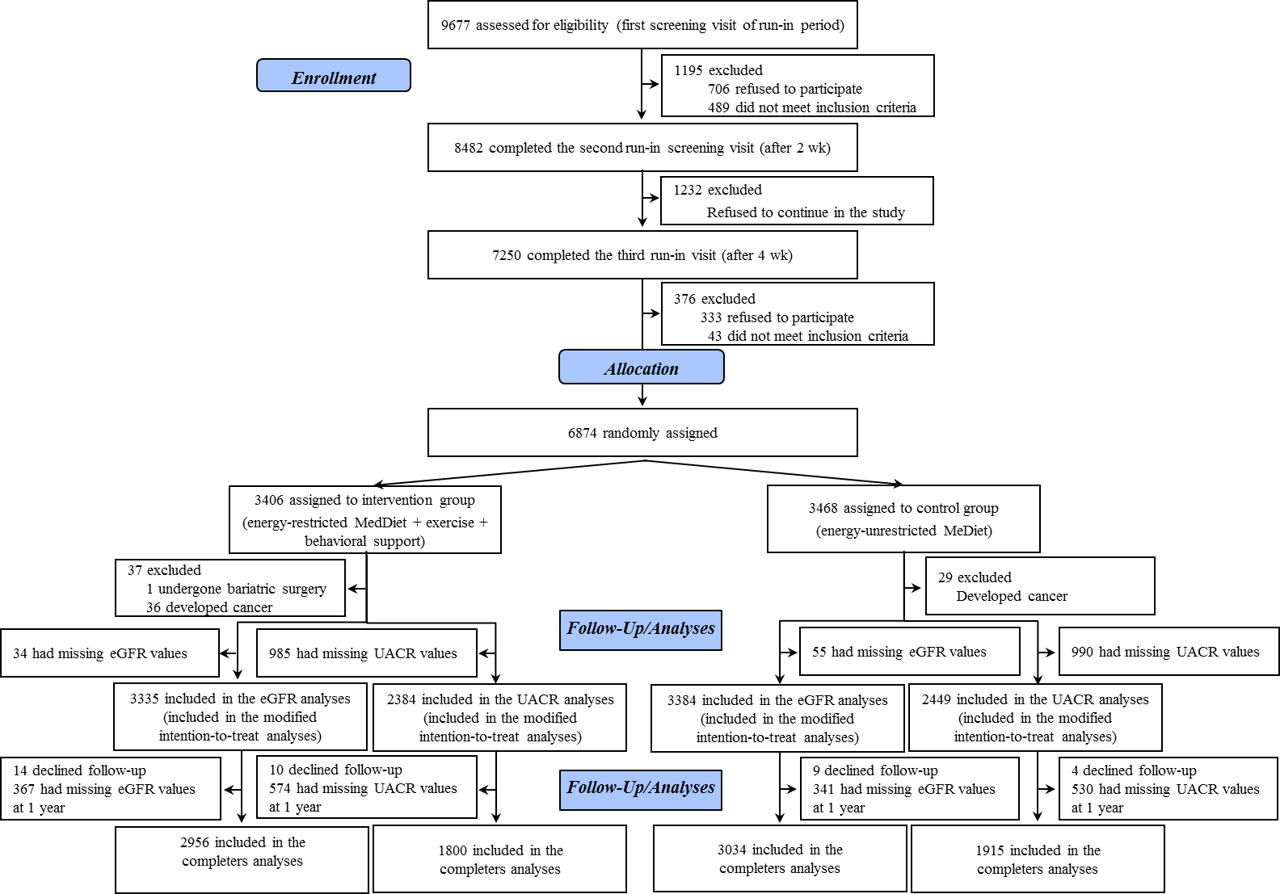

3. Table S1. Baseline and 1-year changes in adiposity-related parameters, 17-point Mediterranean diet score, sedentary behaviors and energy expenditure in leisure-time physical activity by group assignment: completers-only
 |  |  |  | Intervention vs Control
Variable |  | Intervention Group | Control Group | Between-group difference | p value
Body weight, kg |  | n=2915 | n=3011
 | Baseline | 86.6 (86.1 to 87.1) | 86.4 (85.9 to 86.8)
 | 1-year change | -3.7 (-3.8 to -3.5) | -0.7 (-0.9 to -0.6) | -2.9 (-3.1 to -2.7) | <0.001
 | 1-year change in body weight, % | -4.2 (-4.4 to -4.0) | -0.9 (-1.0 to -0.7) | -3.3 (-3.6 to -3.1) | <0.001
BMI, kg/m² |  | n=2915 | n=3011
 | Baseline | 32.5 (32.4 to 32.7) | 32.5 (32.4 to 32.6)
 | 1-year change | -1.4 (-1.4 to -1.3) | -0.3 (-0.3 to -0.2) | -1.1 (-1.2 to -1.0) | <0.001
Waist circumference, cm |  | n=2876 | n=2987
 | Baseline | 107.4 (107.1 to 107.7) | 107.5 (107.2 to 107.9)
 | 1-year change | -4.3 (-4.5 to -4.1) | -1.0 (-1.2 to -0.9) | -3.3 (-3.5 to -3.0) | <0.001
erMedDiet, 0 to 17-items |  | n=2874 | n=2983
 | Baseline | 8.4 (8.3 to 8.5) | 8.5 (8.4 to 8.6)
 | 1-year change | 4.5 (4.4 to 4.6) | 2.2 (2.0 to 2.3) | 2.3 (2.2 to 2.5) | <0.001
Sedentary time, hours/d* |  | n=2868 | n=2976
 | Baseline | 4.9 (4.8 to 5.0) | 4.9 (4.8 to 5.0)
 | 1-year change | -0.5 (-0.6 to -0.4) | -0.2 (-0.3 to -0.2) | -0.3 (-0.4 to -0.2) | <0.001
TV-viewing time, hours/d |  | n=2868 | n=2976
 | Baseline | 3.3 (3.2 to 3.3) | 3.3 (3.2 to 3.3)
 | 1-year change | -0.3 (-0.3 to -0.2) | -0.1 (-0.1 to -0.0) | -0.2 (-0.3 to -0.1) | <0.001
Total leisure-time physical activity, METs-min/d |  | n=2891 | n=2999
 | Baseline | 350.1 (338.3 to 361.9) | 374.7 (362.3 to 387.2)
 | 1-year change | 133.4 (119.1 to 147.7) | 20.5 (8.3 to 32.6) | 112.9 (94.2 to 131.7) | <0.001
Data are mean (95% CI). BMI= body mass index. erMedDiet= energy restricted Mediterranean diet. *Sedentary time include the sum of hours/d spent in TV-viewing, sitting while using computer, sitting on journeys (for work purposes or leisure time, as driver or passenger car, subway, bus, etc.) and total sitting. P values for between-groups differences were calculated using linear regression models with robust standard errors to account for intra-cluster correlations.

4. Table S2. Participants (%) using drugs at baseline and changes during the intervention by group assignment: completers-only
 |  |  |  | Intervention vs Control
 |  | Intervention Group | Control Group | Between-group differences | p value
Drugs |  | (n=2956) | (n=3034)
Oral hypoglycemic agents
 | Baseline | 782 (26.5%) | 755 (24.9%)
 | 1-year change | 0.5% (-0.1 to 1.1) | 1.9% (1.1 to 2.6) | -1.4% (-0.4 to -2.3) | 0.006
Insulin treatment
 | Baseline | 115 (3.9%) | 125 (4.1%)
 | 1-year change | 0.5% (0.2 to 0.8) | 0.3% (-0.1 to 0.6) | 0.2% (-0.2 to 0.7) | 0.27
Lipid-lowering drugs
 | Baseline | 1551 (52.5%) | 1520 (50.1%)
 | 1-year change | -1.5 (-2.6 to -0.4) | 0.8 (-0.2 to 2.0) | -2.4% (-4.0 to -0.8) | 0.003
Antihypertensive agents
 | Baseline | 2313 (78.3%) | 2395 (78.9%)
 | 1-year change | -0.6 (-1.4 to 0.3) | -0.1 (-0.9 to 0.7) | -0.5% (-1.6 to 0.7) | 0.43
ARBs
 | Baseline | 1064 (36.0%) | 1099 (36.2%)
 | 1-year change | 0.2 (-0.6 to 0.9) | 0.4 (-0.4 to 1.2) | -0.2% (-1.3 to 0.9) | 0.69
ACEis
 | Baseline | 859 (29.1%) | 944 (31.1%)
 | 1-year change | 0.2 (-0.6 to 1.0) | -0.5 (-1.4 to 0.2) | 0.7% (-0.4 to 1.9) | 0.20
Data are n (%) or percentage of change (95% CI). ARBs= angiotensin-type 2 receptor blocker. ACEis= angiotensin converting enzyme inhibitors. P values for differences between groups by Chi-square tests.

5. Table S3. Baseline and 1-year changes in kidney function markers in specific subgroups by group assignment: completers-only
 |  |  |  |  |  | Intervention vs Control
Variable and Subgroups |  |  |  | Intervention Group | Control Group | Between-group differences | p value | p for interaction*
eGFG, ml/min/1.73 m²
 |  | Men |  | n=1527 | n=1566 |  |  | 0.38
 |  |  | Baseline | 84.88 (84.17 to 85.60) | 84.69 (83.97 to 85.42) |  |  | 0.38
 |  |  | 1-year change | -0.47 (-0.90 to -0.05) | -1.24 (-1.65 to -0.83) | 0.77 (0.17 to 1.36) | 0.011 | 0.38
 |  | Women |  | n=1429 | n=1468 |  |  | 0.38
 |  |  | Baseline | 83.64 (82.95 to 84.33) | 83.58 (82.89 to 84.27) |  |  | 0.38
 |  |  | 1-year change | -0.88 (-1.32 to -0.42) | -1.25 (-1.73 to -0.76) | 0.37 (-0.29 to 1.03) | 0.26 | 0.38
 |  | Age < 65 years |  | n=1390 | n=1379 |  |  | 0.136
 |  |  | Baseline | 87.90 (87.19 to 88.60) | 88.17 (87.50 to 88.83) |  |  | 0.136
 |  |  | 1-year change | -0.41 (-0.83 to 0.01) | -1.32 (-1.77 to -0.87) | 0.91 (0.28 to 1.53) | 0.004 | 0.136
 |  | Age ≥ 65 years |  | n=1566 | n=1655 |  |  | 0.136
 |  |  | Baseline | 81.07 (80.41 to 81.73) | 80.81 (80.11 to 81.51) |  |  | 0.136
 |  |  | 1-year change | -0.91 (-1.33 to -0.49) | -1.17 (-1.58 to -0.74) | 0.26 (-0.34 to 0.85) | 0.40 | 0.136
 |  | BMI < 30 kg/m² |  | n=795 | n=815 |  |  | 0.77
 |  |  | Baseline | 83.83 (82.91 to 84.75) | 84.02 (83.06 to 84.97) |  |  | 0.77
 |  |  | 1-year change | -0.72 (-1.29 to -0.14) | -1.40 (-1.97 to -0.84) | 0.69 (-0.12 to 1.49) | 0.096 | 0.77
 |  | BMI ≥ 30 kg/m² |  | n=2161 | n=2219 |  |  | 0.77
 |  |  | Baseline | 84.45 (83.86 to 85.04) | 84.20 (83.61 to 84.80) |  |  | 0.77
 |  |  | 1-year change | -0.64 (-0.99 to -0.29) | -1.19 (-1.56 to -0.82) | 0.54 (0.03 to 1.06) | 0.037 | 0.77
 |  | Type 2 diabetes (Yes)† |  | n=901 | n=912 |  |  | 0.153
 |  |  | Baseline | 84.25 (83.29 to 85.22) | 83.36 (82.34 to 84.38) |  |  | 0.153
 |  |  | 1-year change | -1.96 (-2.54 to -1.38) | -2.03 (-2.63 to -1.44) | 0.07 (-0.76 to 0.90) | 0.86 | 0.153
 |  | Type 2 diabetes (No) |  | n=2055 | n=2122 |  |  | 0.153
 |  |  | Baseline | 84.29 (83.71 to 84.87) | 84.49 (83.92 to 85.06) |  |  | 0.153
 |  |  | 1-year change | -0.11 (-0.44 to 0.24) | -0.90 (-1.25 to -0.54) | 0.79 (0.29 to 1.29) | 0.002 | 0.153
 | Hypertension (Yes) |  |  | n=2544 | n=2605 |  |  | 0.135
 |  |  | Baseline | 83.70 (83.17 to 84.26) | 83.40 (82.84 to 83.95) |  |  | 0.135
 |  |  | 1-year change | -0.58 (-0.91 to -0.25) | -1.29 (-1.64 to -0.95) | 0.72 (0.24 to 1.19) | 0.003 | 0.135
 | Hypertension (No) |  |  | n=412 | n=429 |  |  | 0.135
 |  |  | Baseline | 87.80 (86.65 to 88.94) | 88.76 (87.76 to 89.77) |  |  | 0.135
 |  |  | 1-year change | -1.18 (-1.92 to -0.45) | -0.92 (-1.63 to -0.21) | -0.26 (-1.29 to 0.75) | 0.61 | 0.135
UACR, mg/g |  |  |  |  |  |  |  | 0.135
 |  | Men |  | n=1009 | n=1068 |  |  | 0.98
 |  |  | Baseline | 17.91 (14.92 to 20.90) | 21.69 (17.12 to 25.26) |  |  | 0.98
 |  |  | 1-year change | 2.82 (0.25 to 5.40) | 3.50 (1.14 to 5.86) | -0.67 (-4.16 to 2.81) | 0.70 | 0.98
 |  | Women |  | n=791 | n=847 |  |  | 0.98
 |  |  | Baseline | 12.01 (9.56 to 14.45) | 13.89 (10.98 to 16.81) |  |  | 0.98
 |  |  | 1-year change | 1.55 (-0.31 to 3.42) | 2.40 (-0.05 to 4.75) | -0.85 (-3.81 to 2.12) | 0.57 | 0.98
 |  | Age < 65 years |  | n=845 | n=886 |  |  | 0.164
 |  |  | Baseline | 16.44 (13.28 to 19.59) | 15.32 (12.34 to 18.30) |  |  | 0.164
 |  |  | 1-year change | 1.36 (-0.86 to 3.58) | 4.01 (1.96 to 6.05) | -2.64 (-5.63 to 0.36) | 0.084 | 0.164
 |  | Age ≥ 65 years |  | n=955 | n=1,029 |  |  | 0.164
 |  |  | Baseline | 14.33 (11.81 to 16.85) | 20.76 (17.15 to 24.36) |  |  | 0.164
 |  |  | 1-year change | 2.82 (0.35 to 5.29) | 2.38 (-0.57 to 4.82) | 0.44 (-2.95 to 3.83) | 0.79 | 0.164
 |  | BMI < 30 kg/m² |  | n=474 | n=513 |  |  | 0.191
 |  |  | Baseline | 12.14 (9.15 to 15.14) | 14.59 (11.33 to 17.85) |  |  | 0.191
 |  |  | 1-year change | 3.62 (0.66 to 6.58) | 1.41 (-1.10 to 3.91) | 2.21 (-1.72 to 6.16) | 0.27 | 0.191
 |  | BMI ≥ 30 kg/m² |  | n=1326 | n=1402 |  |  | 0.191
 |  |  | Baseline | 16.45 (13.97 to 18.94) | 19.58 (16.56 to 22.60) |  |  | 0.191
 |  |  | 1-year change | 1.80 (-0.17 to 3.78) | 3.58 (1.46 to 5.69) | -1.77 (-4.63 to 1.09) | 0.22 | 0.191
 |  | Type 2 diabetes (Yes) |  | n=524 | n=546 |  |  | 0.20
 |  |  | Baseline | 21.99 (17.45 to 26.53) | 29.71 (23.40 to 36.03) |  |  | 0.20
 |  |  | 1-year change | 5.12 (0.81 to 9.43) | 3.67 (-0.35 to 7.69) | 1.44 (-4.39 to 7.29) | 0.62 | 0.20
 |  | Type 2 diabetes (No)† |  | n=1276 | n=1369 |  |  | 0.20
 |  |  | Baseline | 12.58 (10.49 to 14.67) | 13.67 (11.54 to 15.80) |  |  | 0.20
 |  |  | 1-year change | 1.06 (-0.47 to 2.59) | 2.79 (1.08 to 4.49) | -1.73 (-4.02 to 0.56) | 0.140 | 0.20
 | Hypertension (Yes) |  |  | n=1537 | n=1645 |  |  | 0.47
 |  |  | Baseline | 16.37 (14.05 to 18.64) | 19.50 (16.80 to 22.20) |  |  | 0.47
 |  |  | 1-year change | 2.57 (0.67 to 4.47) | 2.98 (1.06 to 4.89) | -0.41 (-3.09 to 2.27) | 0.767 | 0.47
 | Hypertension (No) |  |  | n=263 | n=270 |  |  | 0.47
 |  |  | Baseline | 9.33 (6.80 to 11.86) | 10.58 (6.88 to 14.27) |  |  | 0.47
 |  |  | 1-year change | 0.54 (-2.11 to 3.19) | 3.17 (0.82 to 5.50) | -2.62 (-6.14 to 0.88) | 0.143 | 0.47
Values expressed as mean (95% CI). Abbreviations: BMI, body mass index; eGFR, estimated glomerular filtration rate; UACR, urinary albumin–creatinine ratio. p values for between-groups differences were calculated using linear regression models adjusting for corresponding baseline value with robust standard errors to account for intra-cluster correlations. †Current diabetes was defined as previous diagnosis of diabetes, glycated haemoglobin (HbA1c) ≥6.5%, use of antidiabetic medication, or having fasting glucose >126 mg/dl in both the screening visit and baseline visit.*P value for the tests of interaction between the subgroups and the intervention group. To test for these interactions, we compared the model with and without the interaction term using the likelihood ratio test.

6. Table S4. Baseline and multivariable-adjusted 1-year changes* in kidney function markers by categories of change of weight, Mediterranean diet score and TV-viewing: completers-only
kidney function markers |  |  |  | Categories of change in weight from baseline to 1-year (percentage)
 |  |  |  | Gain/Stable (<1% loss) | Small Loss (1 to 5%) | Medium Loss (5 to 10%) | Large Loss (≥10%) | p for trend | p for interaction†
No. |  |  |  | 2246 | 2039 | 1106 | 375
Δ in weight, % |  |  |  | 1.63 (1.52 to 1.72) | -2.83 (-2.87 to -2.78) | -7.00 (-7.07 to -6.91) | -13.11 (-13.42 to -12.80)
Serum creatinine, µmol/L
 | Baseline |  |  | 74.081 (73.33 to 74.84) | 74.37 (73.60 to 75.15) | 75.65 (74.55 to 76.76) | 74.84 (73.13 to 76.56)
 | 1-year change |  |  | 0.90 (0.46 to 1.34) | 0.50 (0.07 to 0.94) | 0.03 (-0.54 to 0.61) | -1.08 (-2.13 to -0.03)
 |  | vs. Gain/Stable (<1% loss) |  | 0 (ref.) | -0.40 (-1.02 to 0.22) | -0.87 (-1.64 to -0.10) | -1.99 (-3.17 to -0.80) | 0.003 | 0.38
eGFR, ml/min/1.73 m²
 | Baseline |  |  | 84.81 (84.24 to 85.38) | 84.14 (83.54 to 84.74) | 83.06 (82.21 to 83.91) | 84.33 (82.91 to 85.76)
 | 1-year change |  |  | -1.33 (-1.71 to -0.96) | -1.01 (-1.38 to -0.63) | -0.65 (-1.15 to -0.15) | 0.12 (-0.76 to 1.01)
 |  |  | vs. Gain/Stable (<1% loss) | 0 (ref.) | 0.33 (-0.20 to 0.85) | 0.68 (0.02 to 1.35) | 1.46 (0.46 to 2.45) | 0.004 | 0.124
No. |  |  |  | 1459 | 1267 | 656 | 205
Δ in weight, % |  |  |  | 1.62 (1.50 to 1.74) | -2.82 (-2.88 to -2.76) | -6.96 (-7.07 to -6.86) | -13.08 (-13.48 to -12.69)
UACR, mg/g
 | Baseline |  |  | 18.14 (15.41 to 20.87) | 16.28 (13.77 to 18.78) | 15.64 (12.39 to 18.88) | 15.71 (8.82 to 22.61)
 | 1-year change |  |  | 5.88 (3.63 to 8.15) | 1.60 (-0.44 to 3.65) | -0.62 (-2.82 to 1.62) | -3.29 (-7.09 to 0.49)
 |  |  | vs. Gain/Stable (<1% loss) | 0 (ref.) | -3.34 (-6.43 to -0.24) | -5.75 (-9.11 to -2.40) | -7.91 (-12.79 to -3.03) | 0.006 | 0.51
 |  |  |  | Categories of Mediterranean diet score change
 |  |  |  | Decrease/maintenance | 1 to 2-point increase | 3 to 6-point increase | ≥7-point increase
No. |  |  |  | 1142 | 1945 | 1753 | 926
Δ in Mediterranean diet score, items |  |  |  | -1.20 (-1.29 to -1.11) | 2.07 (2.03 to 2.10) | 4.91 (4.88 to 4.95) | 8.32 (8.23 to 8.40)
eGFR, ml/min/1.73 m²
 | Baseline |  |  | 83.44 (82.60 to 84.29) | 84.15 (83.53 to 84.77) | 84.73 (84.08 to 85.39) | 84.29 (83.42 to 85.16)
 | 1-year change |  |  | -1.49 (-2.00 to -0.97) | -1.05 (-1.42 to -0.67) | -0.94 (-1.33 to -0.57) | -0.37 (-0.95 to 0.21)
 |  |  | vs. decrease/maintenance | 0 (ref.) | 0.44 (-0.19 to 1.07) | 0.55 (-0.11 to 1.20) | 1.12 (0.31 to 1.93) | 0.011 | 0.66
 |  |  |  | Categories of TV-viewing time change
 |  |  |  | Decreased (< -0.5h/day) | No change (0±0.5h/day) | Increased (>0.5 to 1h/day) | Increased (> 1h/day)
No. |  |  |  | 1365 | 1250 | 512 | 460
TV-viewing time, hours/d |  |  |  | -1.60 (-1.65 to -1.54) | 0.00 (-0.01 to 0.01) | 0.84 (0.82 to 0.86) | 2.07 (1.98 to 2.16)
UACR, mg/g^{b}
 | Baseline |  |  | 17.82 (15.06 to 20.58) | 14.60 (12.38 to 16.83) | 19.65 (14.85 to 24.44) | 17.21 (12.65 to 21.77)
 | 1-year change |  |  | 1.30 (-0.65 to 3.25) | 1.64 (-0.01 to 3.30) | 6.42 (2.44 to 10.40) | 5.57 (1.95 to 9.35)
 |  |  | vs. decreased (> -0.5h/day) | 0 (ref.) | 0.34 (-2.17 to 2.85) | 5.13 (0.63 to 9.62) | 4.35 (0.14 to 8.56) | 0.48 | 0.47
Data are means (95% CI). Abbreviations: UACR, urinary albumin–creatinine ratio; eGFR, estimated glomerular filtration rate. *Adjusted for baseline eGFR or UACR, treatment group (intervention/control group), sex (men/women), age (< 65/≥65 years), baseline BMI (continuous), diabetes (yes/no), systolic and diastolic blood pressure (continuous), smoking (never, current, or former smoker), educational level (primary/secondary education or academic/graduate), oral glucose-lowering agents (yes/no), lipid-lowering drugs (yes/no), antihypertensive use (yes/no), center (categorized into quartiles by number of participants), changes in systolic and diastolic blood pressure, and 1-year changes in body weight, Mediterranean diet score, TV-viewing time, and physical activity mutually adjusted for each other (all, continuous). Robust standard errors to account for intracluster correlations were used. †P-value for interaction between categories and intervention group. To test for these interactions, we compared the multivariable model with and without the interaction term using the likelihood ratio test.

7. Figure S2. Interaction between intervention and categories of weight change (left upper graph) and adherence to the Mediterranean diet score (right upper graph) on 1-year changes in eGFR (ml/min/1.73 m²); or weight change categories (left lower graph) and TV watching (right lower graph) on 1-year changes in UACR (mg/g)

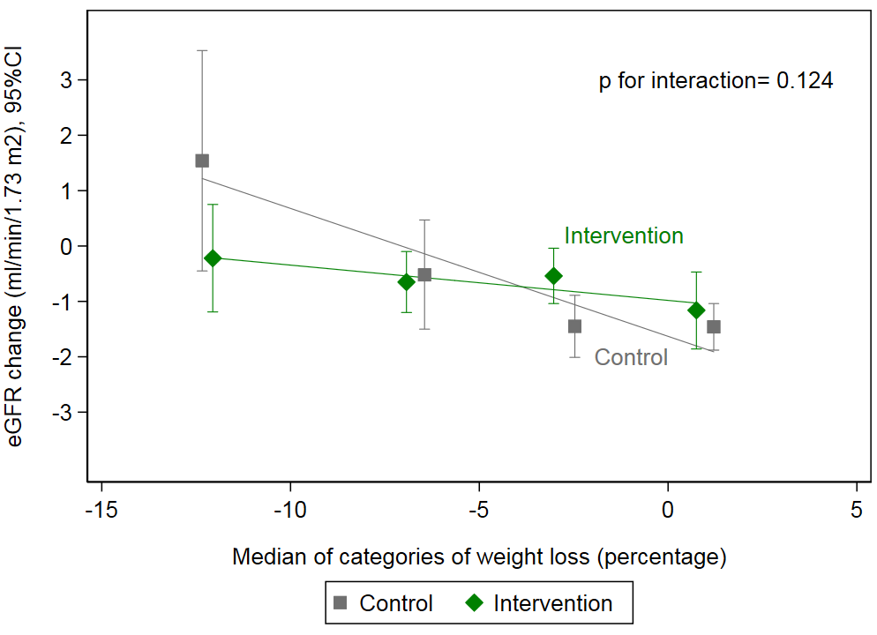 | 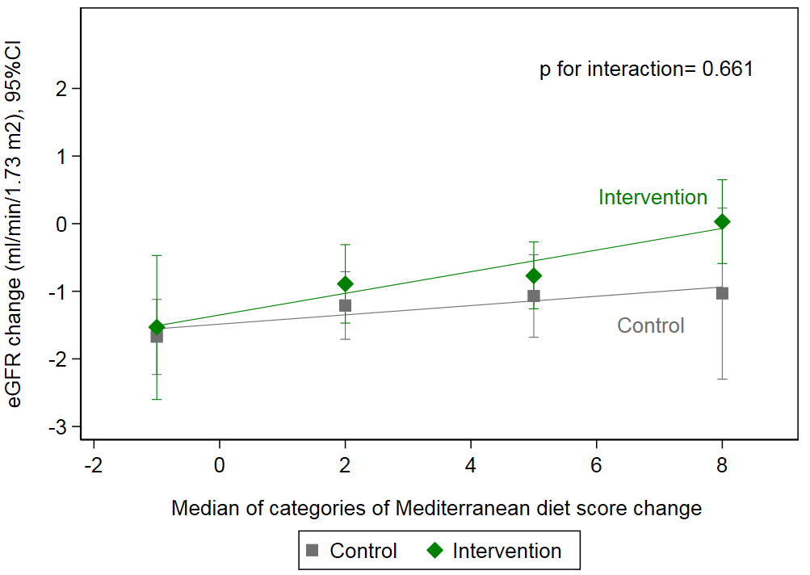
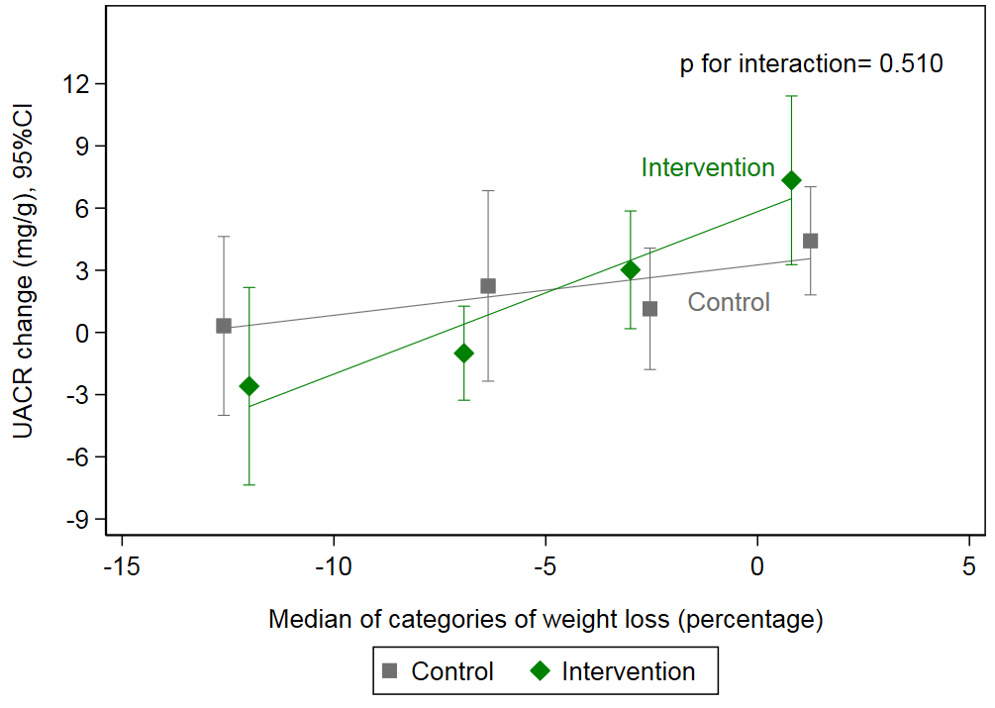 | 