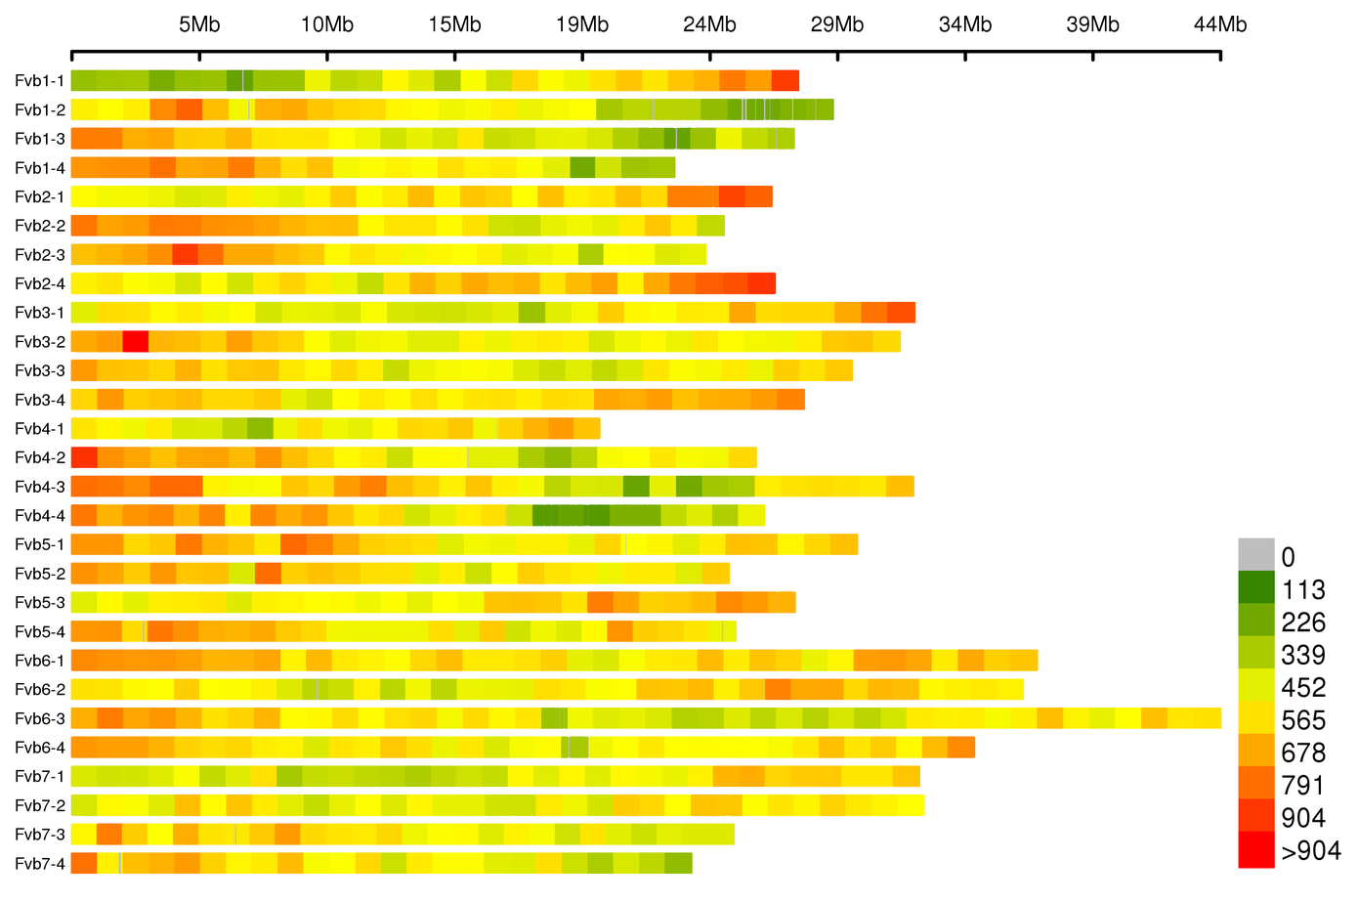
Figure S1. Heatmap of SLAF marker density on chromosomes.
The values indicate the relative density of SLAF markers per Mb window (higher values indicate greater density).
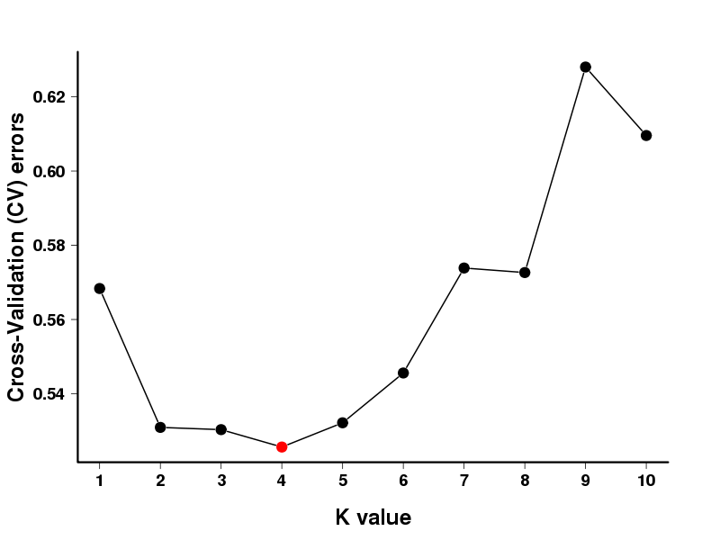
Figure S2. Cross-validation (CV) error of the entire population (76 accessions), reaching a minimum at K=4.

