Supporting Information
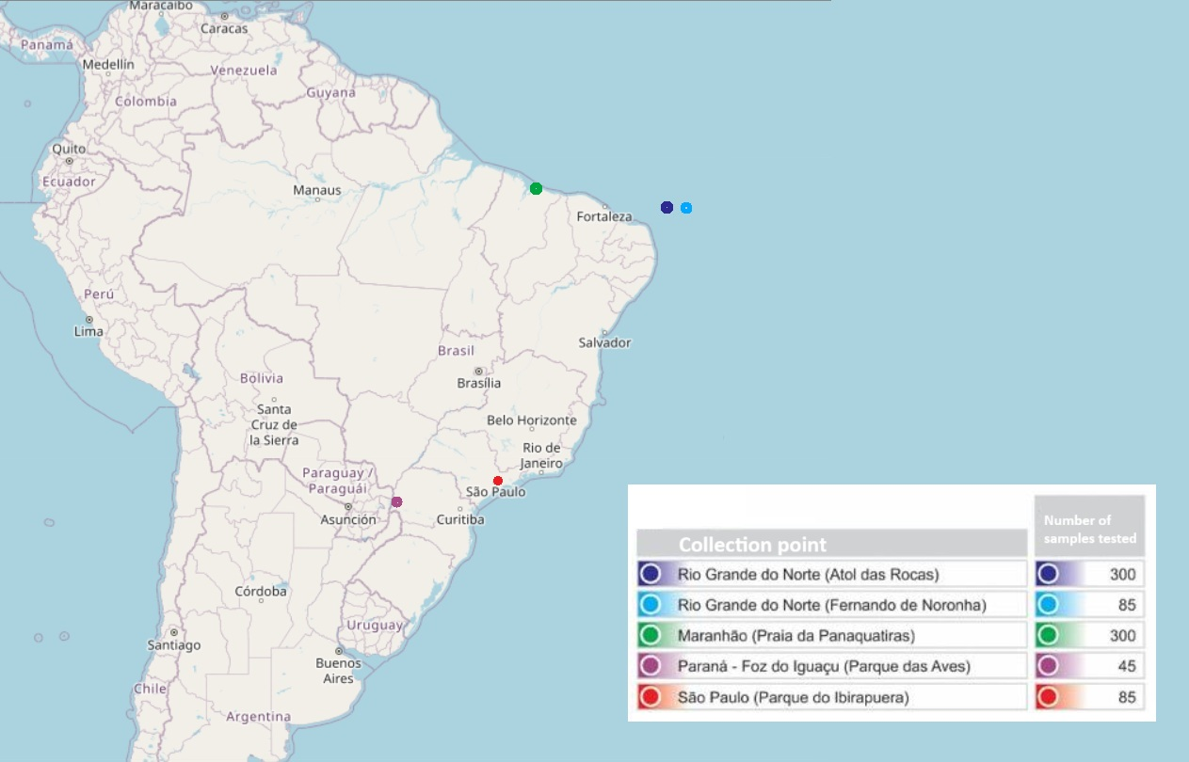
S1 Fig.1. Representation of a map of Brazil showing the bird collection points and their respective samplings.

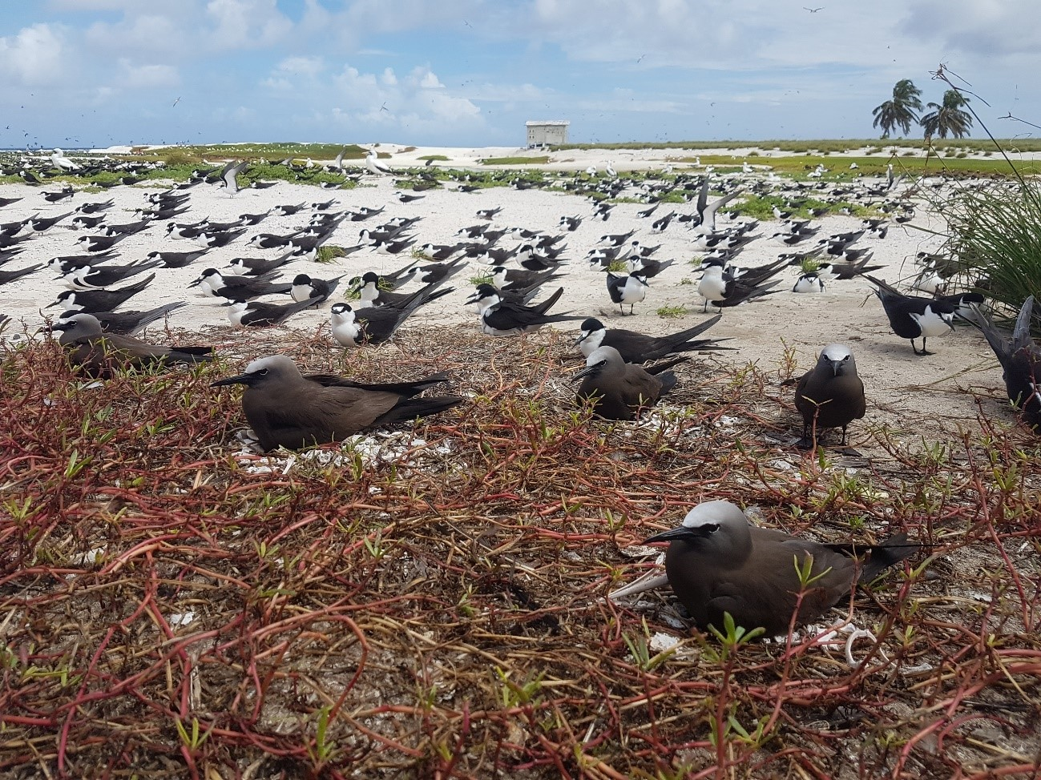
S2 Fig.2. Seabirds. Seabirds brown noddy (Anous stolidus) and Sooty tern (Onychopriom fuscatus) in REBIO Atoll of Rocks.

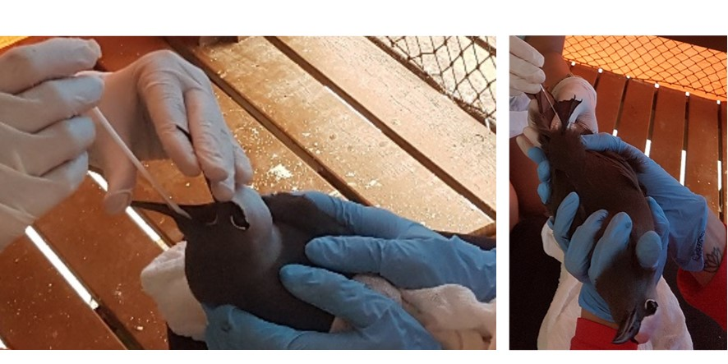

S3 Fig.3. Collecting samples. Collecting samples of brown noddy (Anous stolidus) in Rocks Atoll.

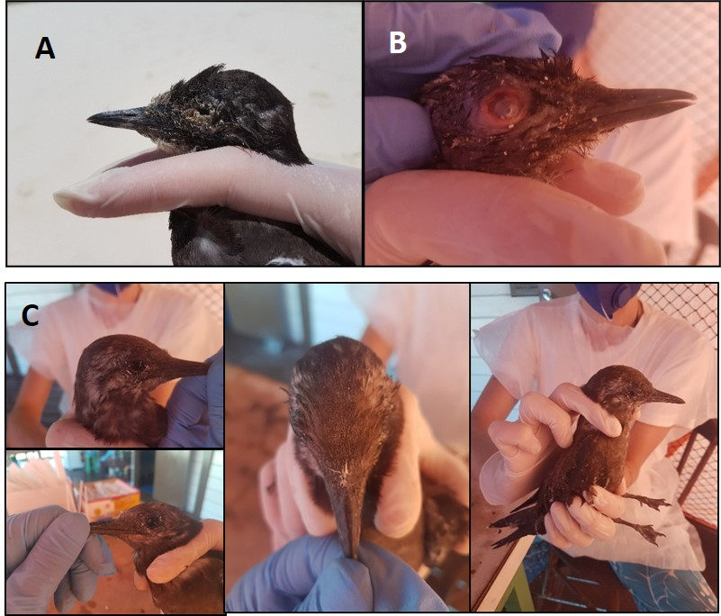
S4 Fig.4. Occular symptoms. Birds showhing ocular symptoms, such as ocular discharge and erythema in the periocular region. A) Sample AR 263; B) Sample AR269 and C) Sample AR 271.

S5 Table 1. List of positive samples. List of samples of birds sequenced positive for adenovirus, collected in Atol das Rocas, RN with and without clinical symptoms.
Table 1. List of positive samples. List of birds with positive samples of sequenced for adenovirus, collected in Atol das Rocas, RN with and without clinical symptoms.
ID | Island | Number of  GENEBANK | Ring number | Species | Commom  names | Clinical signs RE | Clinical signs LE
AR011 | Ilha do  Farol | OL436124 | H106402 | Anous minutus | Black noddy | No | No
AR012 | Ilha do  Farol | OL436125 | H106403 | Anous minutus | Black noddy | No | No
AR013 | Ilha do  Farol | OL436126 | H106404 | Anous minutus | Black noddy | No | No
AR052 | Ilha do  Farol | OL436127 | U25000 | Anous stolidus | Brown noddy | No | No
AR059 | Ilha do  Farol | OL436128 | U25000 | Sula leucogaster | Brown booby | No | No
AR074 | Ilha do  Farol | OL436129 | J85541 | Onychoprion fuscatus | Sooty tern | No | No
AR079 | Ilha do  Farol | OL436130 | No | Anous minutus | Black noddy | No | No
AR080 | Ilha do  Farol | OL436131 | H106419 | Anous minutus | Black noddy | No | No
AR089 | Ilha do  Cemitério | OL436132 | J85529 | Onychoprion fuscatus | Sooty tern | No | No
AR134 | Ilha do  Farol | OL436133 | V46523 | Sula dactylatra | Masked booby | No | No
AR154 | Ilha do  Farol | OL436134 | No | Sula Sula | Red boobies -footed | No | No
AR263 | Ilha do  Farol | OL436135 | No | Onychoprion fuscatus | Sooty tern | No | Yes
AR269 | Ilha do  Farol | OL436136 | No | Onychoprion fuscatus | Sooty tern | Yes | No
AR271 | Ilha do  Farol | OL436137 | No | Onychoprion fuscatus | Sooty tern | No | Yes
AR275 | Ilha do  Farol | OL436138 | No | Anous stolidus | Brown noddy | No | No
Legend:
ID: Gene Bank identification
AR – Atol das Rocas
RE – Right eye alteration
LE– Left eye alteration

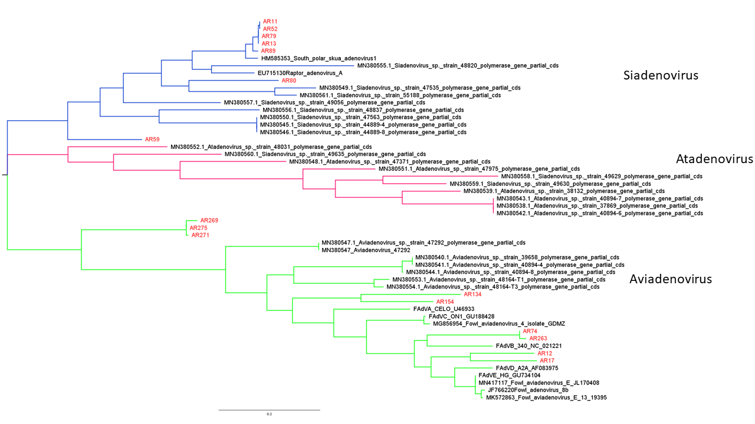
Fig.5. Phylogenetic tree. Phylogenetic tree generated with the sequences of Adenoviruses found in birds of Atol das Rocas. Phylogenetic tree by the neighbor joining tree method, with 250 base pairs and the bootstrap was performed with 1000 repetitions. The samples sequenced in this project are identified in the tree with the initials AR (Atol das Rocas) followed by their numbering.

