Antileishmanial activity of gold(I) compounds containing triphenylphosphine ligands against Leishmania amazonensis: impacts on mitochondrial bioenergetics and trypanothione reductase activity

Marcus Sávio Araujo Garcia¹; garciamarcus28@gmail.com; orcid.org/0000-0001-6338-1929
Vitor Klipel da Silva Bertolini¹; v289610@dac.unicamp.br; orcid.org/0009-0001-0562-5080
Cécile Exertier²; cecile.exertier@cnr.it; orcid.org/0000-0001-7457-6895
Fernanda Ramos Gadelha¹; frgad@unicamp.br; orcid.org/0000-0002-1075-8830
Andrea Ilari²; andrea.ilari@cnr.it; orcid.org/0000-0002-7754-399X
Annarita Fiorillo³ annarita.fiorillo@uniroma1.it; orcid.org/0000-0002-8966-8554
Jennyfer Castro⁴; jcastro.quimica@outlook.com; https://orcid.org/0009-0001-5045-8947
Camilla Abbehausen⁴; camilla@unicamp.br; orcid.org/0000-0002-8410-2252
Danilo Ciccone Miguel^{1,#} dcmiguel@unicamp.br; orcid.org/0000-0003-0522-6562

¹Institute of Biology, University of Campinas, São Paulo, Brazil.
²Institute of Molecular Biology and Pathology (IBPM) of the National Research Council of Italy (CNR), c/o Department of Biochemical Sciences, Sapienza University of Rome, Roma 00185, Italy.
³Department of Biochemical Sciences, Sapienza University of Rome, Roma 00185, Italy.
⁴Institute of Chemistry, University of Campinas, Campinas, São Paulo, Brazil.
#Corresponding author

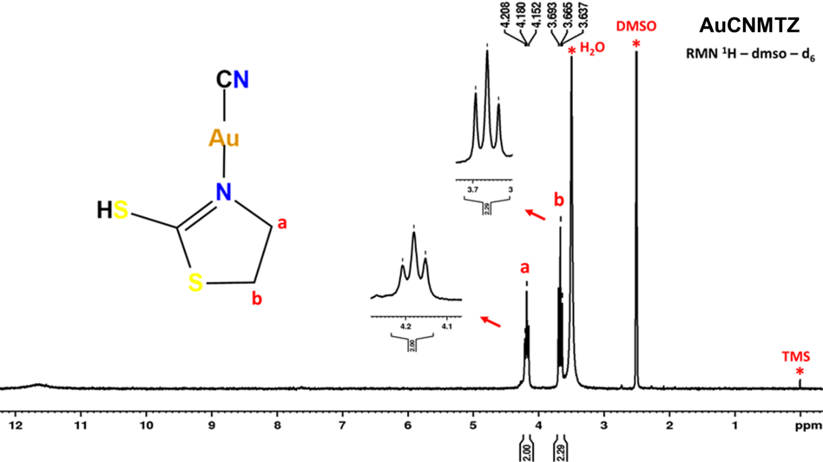
Fig. S1 1H NMR spectrum of the AuCNMTZ complex in DMSO-d6. The chemical shifts (δ) expressed in ppm corresponding to the CH2 groups of the ligand are 4.20–4.15 (t, 2H) and 3.69–3.63 (t, 2H).

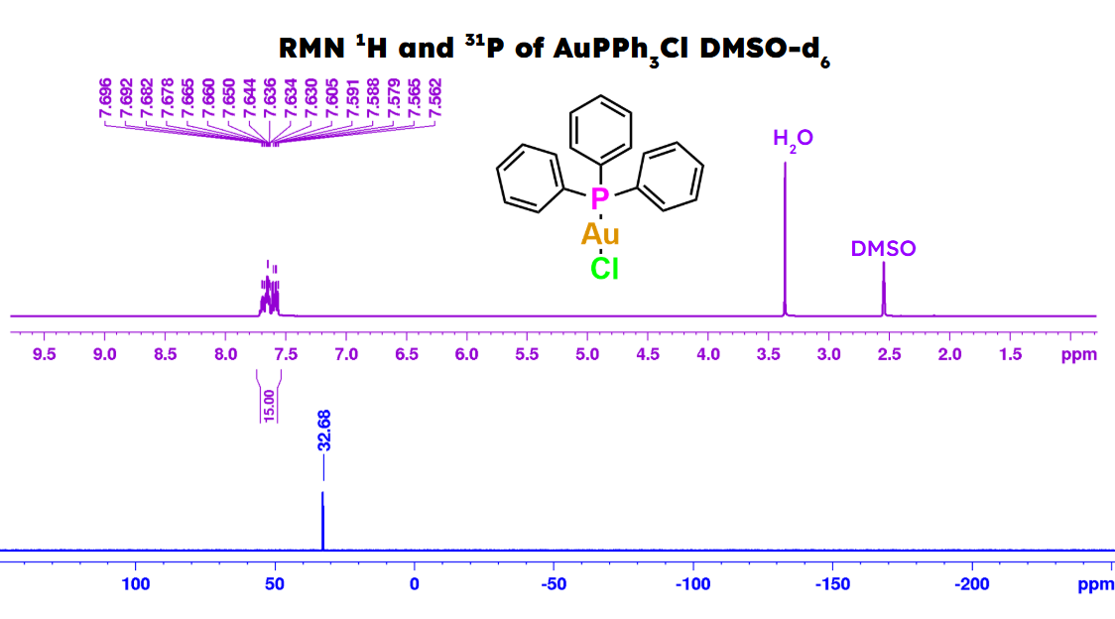
Fig. S2 1H and 31P NMR spectra of the AuPPh3Cl complex in DMSO-d6. The observed chemical shifts (δ) in ppm are 7.61–7.50 (m, 15H, Ar–H) in the 1H spectrum and 32.68 in the 31P spectrum.

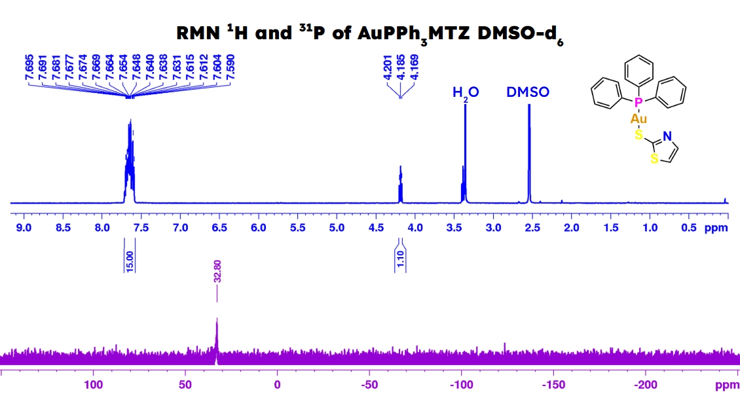
Fig. S3 1H and 31P NMR spectra of the AuPPh3MTZ complex in DMSO-d6. The observed chemical shifts (δ) in ppm are 7.61–7.50 (m, 15H, Ar–H) in the 1H spectrum and 36.05 in the 31P spectrum.

