Supplementary Material

Manuscript: Early On-Treatment AFP Increase Predicts Inferior Survival in Immune Checkpoint Inhibitor–Treated Hepatocellular Carcinoma: A Real-World Cohort Study
Corresponding Author: Alireza Tojjari, MD; tojjaria@upmc.edu

Contents:
Supplementary Table S1. AFP ratio cutoff optimization for OS and PFS
Supplementary Table S2. Baseline characteristics of included versus excluded patients
Supplementary Table S3. Sensitivity analyses, landmark analysis, incremental discrimination, and regimen interaction
Supplementary Figure S1. Waterfall plot of individual AFP changes from baseline
Supplementary Figure S2. Kaplan–Meier curves in the AFP ≥400 ng/mL subgroup
Supplementary Figure S3. Kaplan–Meier curves stratified by four AFP kinetic categories
Supplementary Table S4. Sensitivity analysis: outcomes with administrative censoring at liver transplantation

Supplementary Table S1. AFP ratio cutoff optimization for overall survival and progression-free survival
Cutoff | n responders | n non-responders | Overall Survival |  |  | Progression-Free Survival
Cutoff | n responders | n non-responders | HR | 95% CI | p | HR | 95% CI | p
≤0.50 | 25 | 130 | 1.31 | 0.77–2.24 | 0.315 | 1.59 | 0.96–2.61 | 0.071
≤0.60 | 28 | 127 | 1.25 | 0.75–2.07 | 0.397 | 1.47 | 0.92–2.35 | 0.108
≤0.70 | 39 | 116 | 1.37 | 0.86–2.17 | 0.184 | 1.33 | 0.88–2.01 | 0.180
≤0.80 | 47 | 108 | 1.19 | 0.78–1.81 | 0.425 | 1.27 | 0.87–1.86 | 0.225
≤0.90 | 49 | 106 | 1.23 | 0.81–1.87 | 0.329 | 1.22 | 0.84–1.78 | 0.296
≤1.00 | 94 | 61 | 1.64 | 1.12–2.41 | 0.011 | 1.76 | 1.24–2.51 | 0.002
≤1.20 | 119 | 36 | 1.57 | 1.02–2.40 | 0.040 | 1.73 | 1.16–2.57 | 0.008
Each row presents the HR for patients above the cutoff (non-responders) versus at/below (responders), from univariate Cox regression. The optimal cutoff (highlighted) maximized the log-rank chi-square. AFP, alpha-fetoprotein; CI, confidence interval; HR, hazard ratio; OS, overall survival; PFS, progression-free survival.

Supplementary Table S2. Baseline characteristics of included versus excluded patients
Characteristic | Included (n = 155) | Excluded (n = 124) | p value
Age, years, median (IQR) | 66 (61–71) | 68 (62–74) | 0.200
Male sex, n (%) | 130 (83.9) | 101 (81.5) | 0.710
ECOG performance status
ECOG 0–1, n (%) | 97 (62.6) | 83 (66.9)
ECOG ≥2, n (%) | 58 (37.4) | 41 (33.1) | 0.529
Liver function
Child-Pugh A, n (%) | 69 (44.5) | 49 (39.5)
Child-Pugh B/C, n (%) | 86 (55.5) | 75 (60.5) | 0.473
Cirrhosis, n (%) | 130 (83.9) | 111 (89.5) | 0.234
Tumor characteristics
Macrovascular invasion, n (%) | 62 (40.0) | 45 (36.3) | 0.611
Portal vein thrombosis, n (%) | 61 (39.4) | 45 (36.3) | 0.689
M1 stage, n (%) | 42 (27.1) | 30 (24.2) | 0.680
Laboratory parameters
AFP, ng/mL, median (IQR) | 115.1 (9.1–1,336) | 34.0 (5.7–201) | 0.011
AFP ≥400 ng/mL, n (%) | 55 (35.5) | 25 (21.9) | 0.007
NLR, median (IQR) | 3.47 (2.20–5.12) | 3.89 (2.50–6.28) | 0.089
ICI regimen, n (%)
Atezolizumab + bevacizumab | 78 (50.3) | 51 (41.1)
Nivolumab | 38 (24.5) | 27 (21.8)
Durvalumab + tremelimumab | 27 (17.4) | 30 (24.2)
Other | 12 (7.7) | 16 (12.9) | 0.193
Outcomes
Died, n (%) | 107 (69.0) | 73 (58.9) | 0.102
Continuous variables: Mann–Whitney U test; categorical variables: chi-square test. Bold p values indicate statistical significance (p < 0.05). The cohorts were broadly balanced for age, sex, performance status, liver function, and tumor burden. Included patients had higher baseline AFP, consistent with enrichment for AFP-producing tumors meeting the eligibility criterion of evaluable serial AFP measurements.

Supplementary Table S3. Sensitivity analyses: 6-week landmark analysis, incremental discrimination, and regimen interaction
Analysis | n / C-index | HR (95% CI) | p value
6-week landmark analysis (recalculated from day 42)
OS — AFP increase (univariate) | 155 | 1.64 (1.12–2.41) | 0.011
OS — AFP increase (adjusted, Model B) | 155 | 1.72 (1.16–2.56) | 0.008
PFS — AFP increase (univariate) | 150 | 1.74 (1.22–2.50) | 0.002
PFS — AFP increase (adjusted, Model B) | 150 | 1.96 (1.35–2.86) | <0.001
Incremental discrimination (base model + AFP increase)
OS C-index (base → +AFP increase) | 0.688 → 0.697 | Δ = +0.009 | 0.009
PFS C-index (base → +AFP increase) | 0.649 → 0.678 | Δ = +0.029 | <0.001
Regimen interaction
OS: AFP increase × Atezolizumab–bevacizumab | — | 0.26 | 0.001
PFS: AFP increase × Atezolizumab–bevacizumab | — | 0.50 | 0.064
AFP increase HR by regimen (univariate)
Atezolizumab + bevacizumab | 78 | 0.96 (0.55–1.68) | 0.890
Durvalumab + tremelimumab | 27 | 3.48 (1.20–10.08) | 0.022
Nivolumab | 38 | 3.11 (1.39–6.98) | 0.006
Landmark: survival recalculated from day 42; patients with PFS events before landmark were excluded (5 for PFS; 0 for OS). C-index: Harrell's concordance index. Base model includes age, sex, ECOG, Child-Pugh grade, MVI, log-baseline AFP, NLR, and PVT. Interaction: Cox model with AFP increase × regimen interaction term. Regimen subgroup HRs are univariate.

Supplementary Figure S1. Waterfall plot of individual AFP changes from baseline
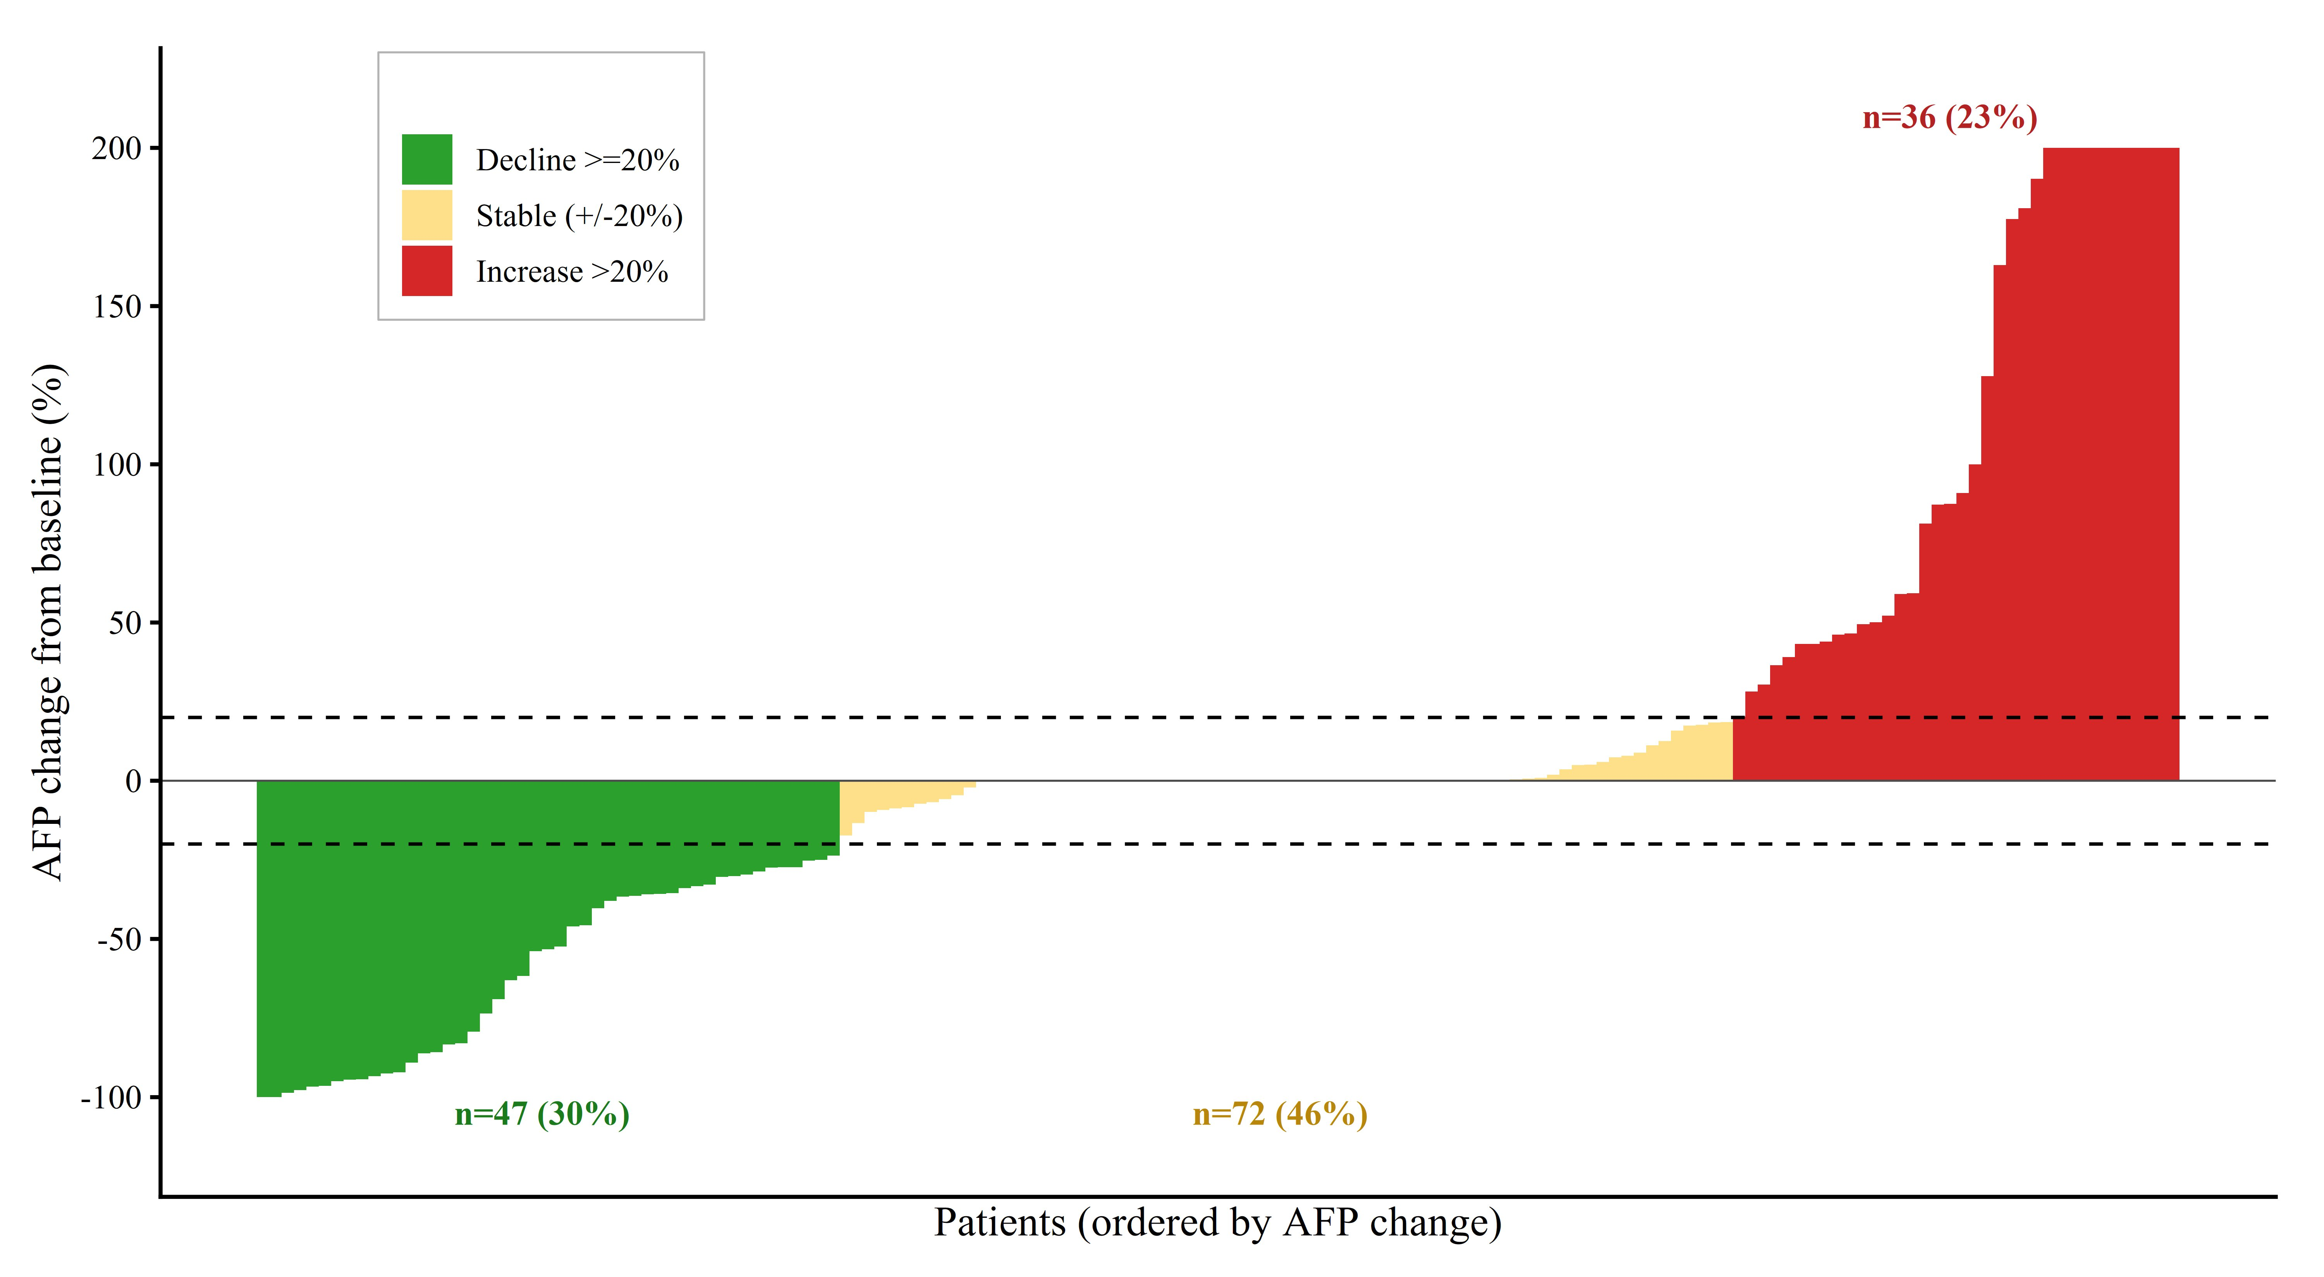
Figure S1. Waterfall plot showing the individual percent change in AFP from baseline to the early on-treatment measurement (day 14–56) for each patient in the analytic cohort (n = 155). Each vertical bar represents one patient, ordered by AFP change. Bars are color-coded by AFP kinetic category: green = decline ≥20% (n = 47, 30%); yellow = stable (within ±20%; n = 72, 46%); red = increase >20% (n = 36, 23%). Dashed horizontal lines at ±20% indicate the conventional response thresholds. Values are clipped at +200% on the y-axis for visualization.

Supplementary Figure S2. Kaplan–Meier curves in the AFP ≥400 ng/mL subgroup
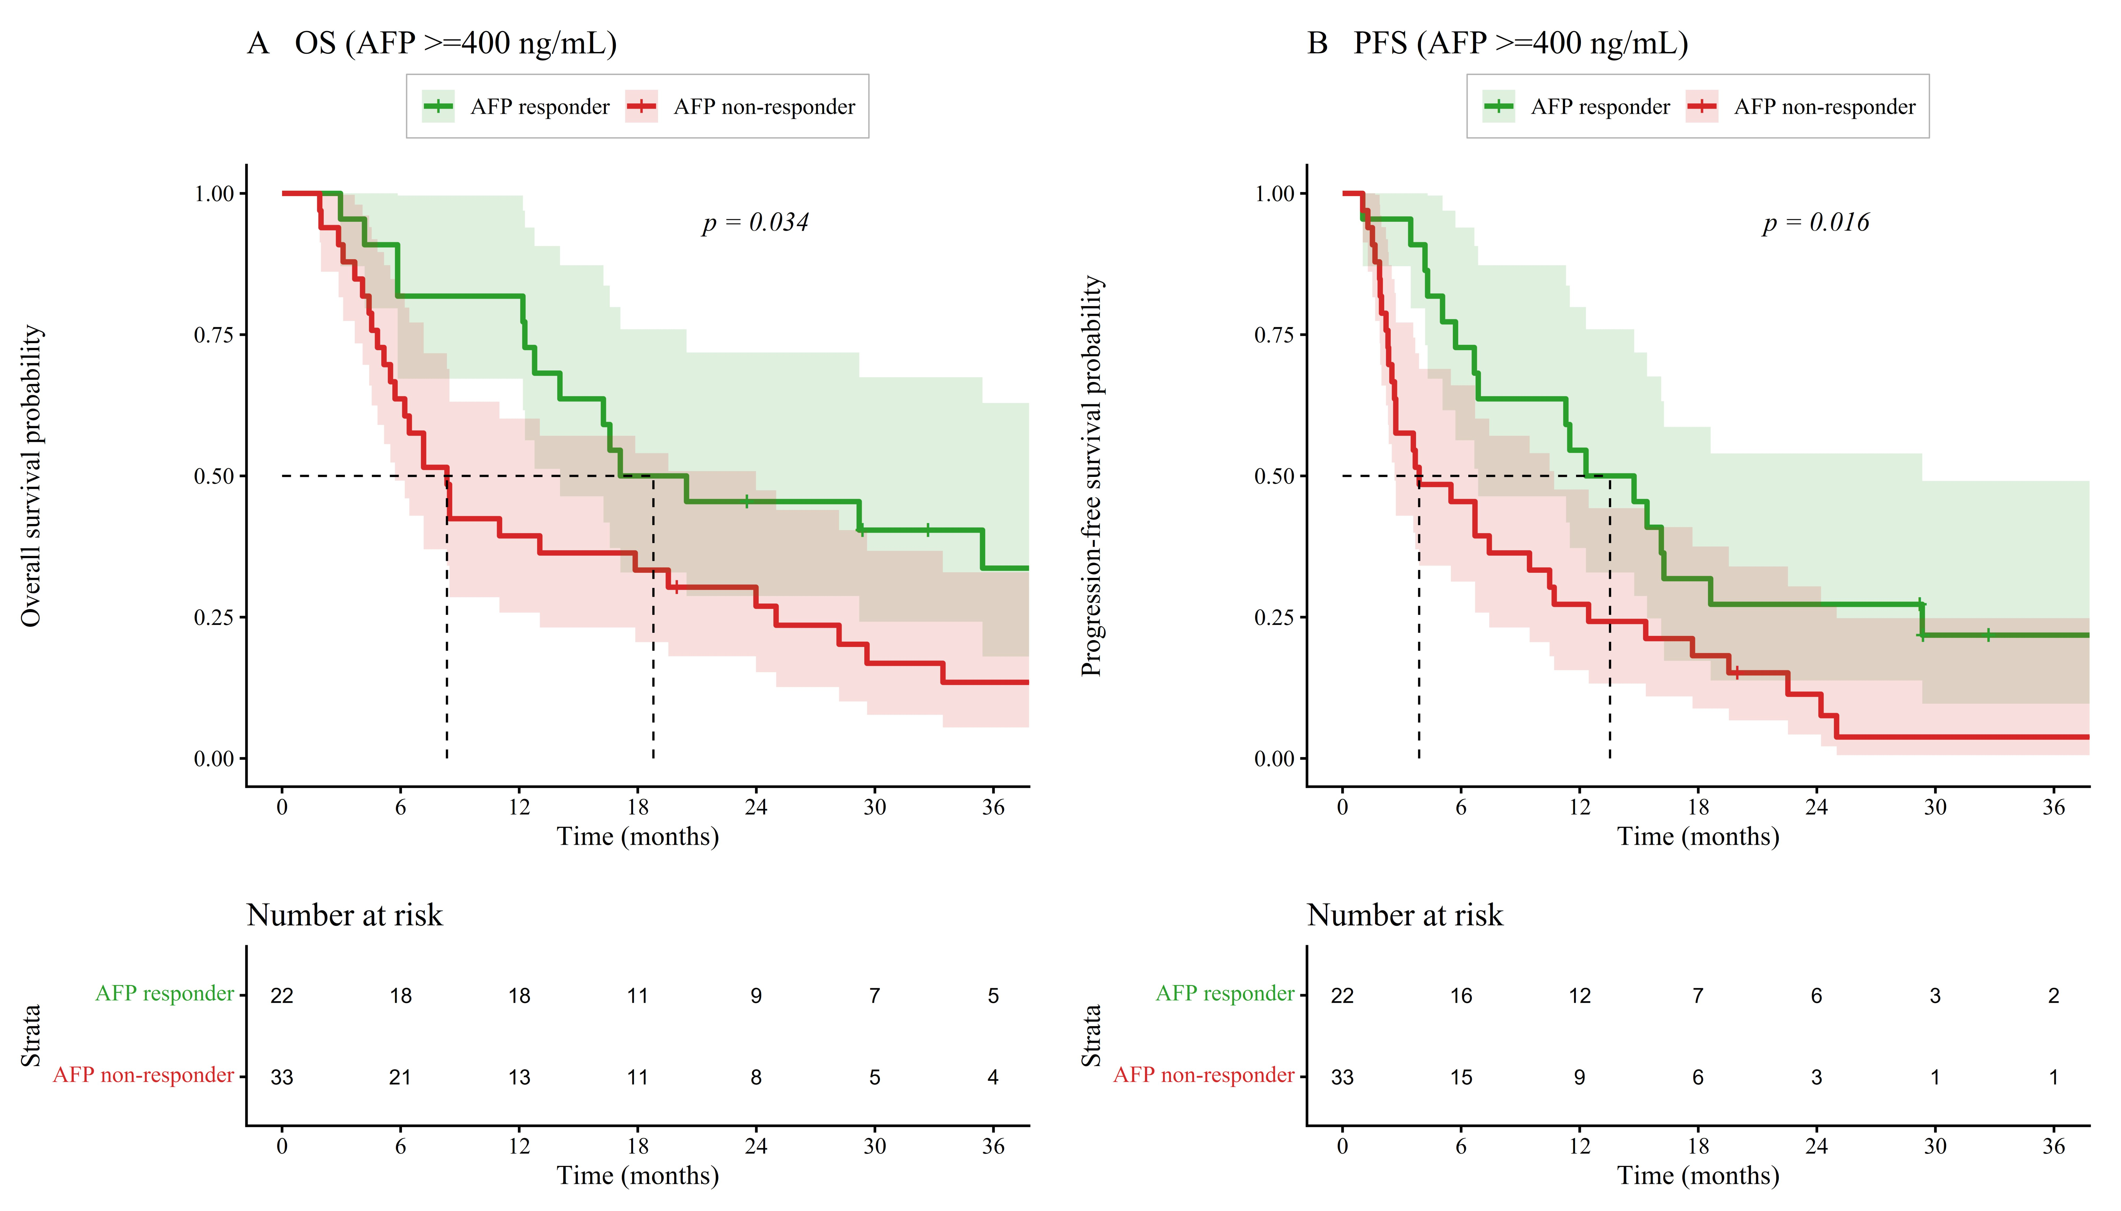
Figure S2. Kaplan–Meier estimates of (A) overall survival and (B) progression-free survival in the subgroup of patients with baseline AFP ≥400 ng/mL (n = 55), stratified by AFP response status (≥20% decline at the early on-treatment measurement). Green = AFP responders (n = 22); red = AFP non-responders (n = 33). Shaded areas represent 95% confidence intervals. P values displayed are from the log-rank test (panel A: p = 0.034; panel B: p = 0.016); the corresponding univariate Cox HR estimates reported in the main text are 1.99 (95% CI, 1.04–3.78; p = 0.037) for OS and 2.06 (95% CI, 1.13–3.76; p = 0.018) for PFS.

Supplementary Figure S3. Kaplan–Meier curves stratified by four AFP kinetic categories
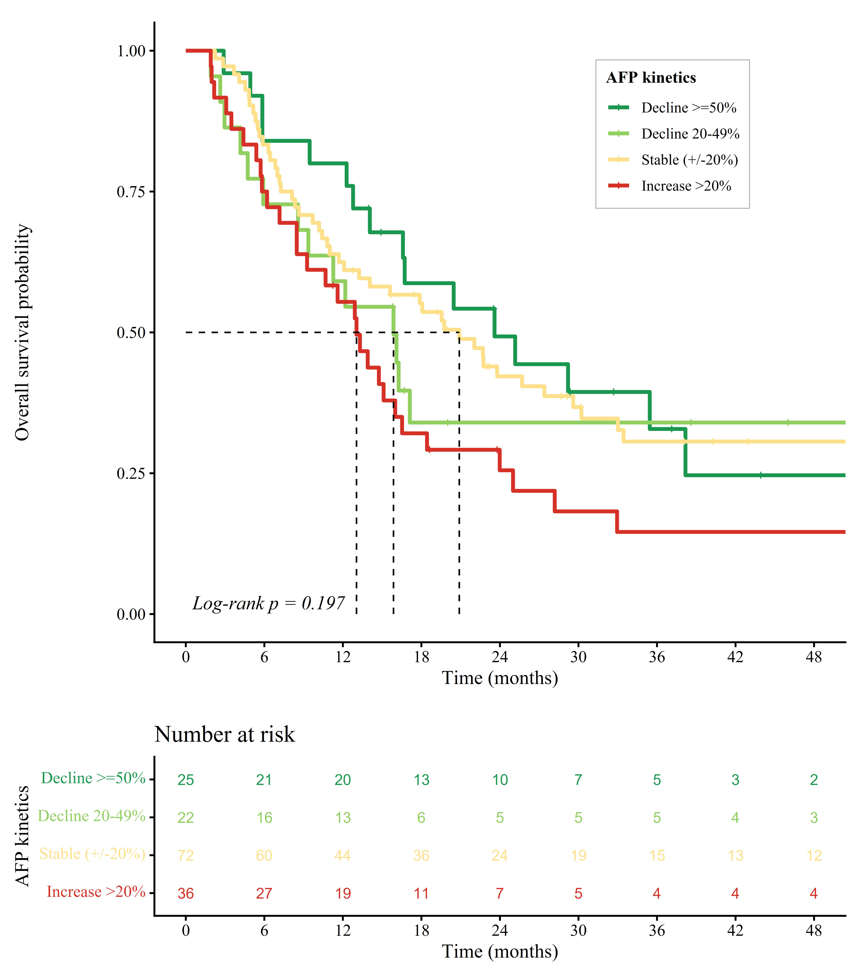
Figure S3. Kaplan–Meier curves for overall survival stratified by four AFP kinetic categories: marked decline (≥50%; n = 25), moderate decline (20–49%; n = 22), stable (±20%; n = 72), and increase (>20%; n = 36). Numbers at risk are shown below. Global log-rank p = 0.197. A numerical dose–response gradient in median OS was observed (23.6, 15.9, 20.9, and 13.0 months, respectively), although pairwise differences did not reach statistical significance, consistent with limited statistical power within individual subgroups. A similar numerical pattern was observed for progression-free survival across the four categories, although this analysis is not shown graphically (see Supplementary Table S3 for PFS hazard ratio estimates). AFP, alpha-fetoprotein.

Supplementary Table S4. Sensitivity analysis: outcomes with administrative censoring at the date of liver transplantation
Comparison of primary analyses (no transplant censoring) versus sensitivity analyses in which patients undergoing post-ICI liver transplantation (n = 8 with documented transplant dates) were administratively censored at the date of transplant. One patient who received a liver transplant prior to ICI initiation (post-transplant disease recurrence) was excluded from the sensitivity cohort. Patients with transplant indicated in the database but without a parsable transplant date in clinical notes (n = 4) retained their primary follow-up time as a conservative approach.
Analysis | n | events | HR | 95% CI | p value | Median (d) Inc / No-inc | Log-rank p
Univariate Cox regression (AFP increase; ratio >1.0)
OS — Primary | 155 | 107 | 1.64 | 1.12–2.41 | 0.011 | 353 / 691 | 0.011
OS — Sensitivity | 154 | 105 | 1.74 | 1.18–2.56 | 0.005 | 329 / 671 | 0.005
PFS — Primary | 155 | 129 | 1.76 | 1.24–2.51 | 0.002 | 190 / 368 | 0.001
PFS — Sensitivity | 154 | 126 | 1.95 | 1.36–2.80 | <0.001 | 190 / 350 | <0.001
Multivariable Cox (Model B: age, sex, ECOG, Child-Pugh, MVI, log-AFP, NLR, PVT)
OS — Primary | 151 | 104 | 1.72 | 1.16–2.56 | 0.008 | — | —
OS — Sensitivity | 150 | 102 | 1.74 | 1.17–2.61 | 0.007 | — | —
PFS — Primary | 151 | 126 | 1.98 | 1.37–2.86 | <0.001 | — | —
PFS — Sensitivity | 150 | 123 | 2.11 | 1.45–3.08 | <0.001 | — | —
Univariate Cox regression (AFP response, ≥20% decline)
OS — Primary | 155 | 107 | 1.19 | 0.78–1.81 | 0.424 | — | —
OS — Sensitivity | 154 | 105 | 1.34 | 0.88–2.05 | 0.174 | — | —
PFS — Primary | 155 | 129 | 1.27 | 0.86–1.86 | 0.226 | — | —
PFS — Sensitivity | 154 | 126 | 1.45 | 0.98–2.13 | 0.063 | — | —
Effect estimates for AFP increase, defined as any rise above baseline (AFP ratio >1.0), and AFP response, defined as at least 20% decline from baseline (AFP ratio ≤0.80), were derived from Cox proportional hazards models. Multivariable models included age, male sex, ECOG performance status, Child-Pugh B/C, macrovascular invasion (MVI), log-baseline AFP, neutrophil-to-lymphocyte ratio (NLR), and portal vein thrombosis (PVT). Median OS and PFS values are presented for the AFP-increase versus no–AFP-increase groups (in days). Across all comparisons, the magnitude and direction of the association between early on-treatment AFP increase and adverse outcomes were preserved or modestly strengthened in the sensitivity analysis, supporting the robustness of the primary findings to alternative handling of liver transplantation as a competing event. CI, confidence interval; HR, hazard ratio; ICI, immune checkpoint inhibitor; OS, overall survival; PFS, progression-free survival.

