Supplementary material
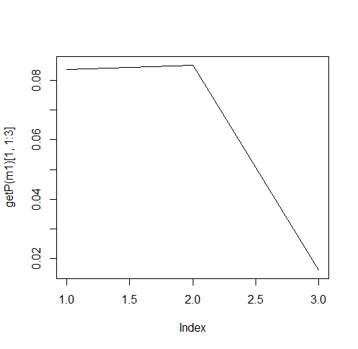
Figure S1. Fitted detection probability function (g(x)) in relation to detection distance for Yuma Ridgway’s Rails in the Cienega de Santa Clara. It demonstrates how detection probability declines as the distance from the observer increases. The x-axis shows detection distances divided into specific intervals (distance bins, m), while the y-axis shows the detection probability (g(x)) estimated for each interval. These intervals are categorized as 0–100 m, 101–200 m, 201–300 m, and 301–400 m. Distances beyond 300 m were excluded because they account for about 95% of observations, based on the detection distribution. The effective detection radius was estimated at approximately 91 m.

Table S1. Results from the negative binomial GLM used for initial covariate screening before hierarchical distance sampling analysis. The response variable was the maximum count from two repeat surveys at each station, serving as a proxy for local abundance. Continuous covariates were standardized prior to analysis. The report includes estimates (β), standard errors (SE), z statistics, and p-values.

Covariate | Estimate (β) | SE | z | p-value
Intercept | 0.653 | 0.082 | 7.946 | <0.001
Burn severity | 0.07 | 0.027 | 2.613 | 0.009
Water depth | -0.064 | 0.03 | -2.133 | 0.033
Emergent vegetation | 0.129 | 0.031 | 4.223 | <0.001
Juncus cooperi | -0.068 | 0.032 | -2.138 | 0.033
Normalized Difference Vegetation Index (NDVI) | 0.13 | 0.031 | 4.23 | <0.001
Normalized Difference Water Index (NDWI) | 0.097 | 0.03 | 3.274 | 0.001
Phragmites australis | -0.15 | 0.035 | -4.3 | <0.001
Year 2018 | 0.469 | 0.106 | 4.42 | <0.001
Year 2019 | -0.214 | 0.123 | -1.738 | 0.082
Year 2020 | -1.535 | 0.165 | -9.321 | <0.001
Year 2021 | -1.665 | 0.172 | -9.684 | <0.001
Year 2022 | -0.692 | 0.13 | -5.341 | <0.001

Table S2. Relative significance of candidate covariates used in the hierarchical distance sampling models. These are estimated as the total of Akaike weights across all subset models derived from the saturated negative binomial GLM. The model subsets were assessed using an information-theoretic approach based on Akaike’s Information Criterion (AIC), employing the dredge function from the MuMIn package in R (total of 2048 models). Covariates with a summed Akaike weight of 0.50 or higher were deemed informative and included in the final models.

Covariate | Summed Akaike weight
Year | 1
Normalized Difference Vegetation Index (NDVI) | 1
Phragmites australis | 1
Emergent vegetation | 0.99
Normalized Difference Water Index (NDWI) | 0.98
Burn severity | 0.92
Water depth | 0.85
Juncus cooperi | 0.82
Scirpus americanus | 0.4
Typha domingensis | 0.37
Surface water cover | 0.36
Cyperus odoratus | 0.29

