ROC analysis
Receiver operating characteristic (ROC) curve analysis was performed to evaluate the ability of stone area to predict PCNL selection. Stone area demonstrated a good discriminatory capacity for distinguishing patients treated with PCNL from those treated with RIRS, with an area under the curve (AUC) of 0.788 (95% CI: 0.705–0.863). Using the Youden index, the optimal cut-off value for stone area was identified as 126 mm², yielding a sensitivity of 89.9% and a specificity of 56.2% for predicting PCNL selection in the study cohort.
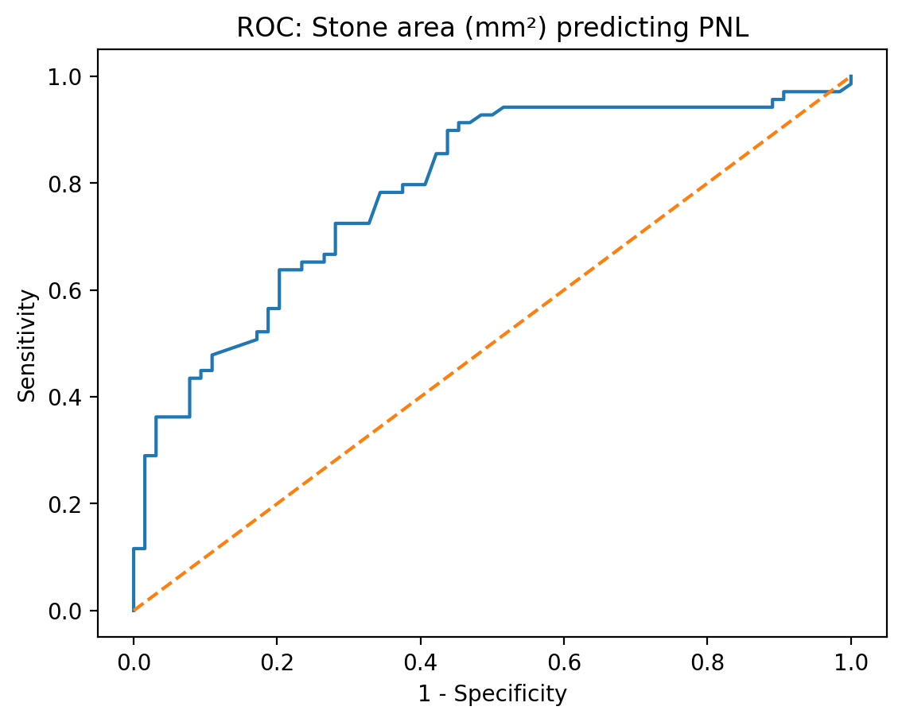
Figure 1. Receiver operating characteristic (ROC) curve of stone area for predicting the selection of percutaneous nephrolithotomy (PCNL).

