Supplemental Material

Urban Shade Shelter and Reduction in Heat-Related Mortality Across 25 Districts of Seoul, South Korea
Authors: Ayoung Kim^{1)†}, Jisung Choi^{1) †}, Seohyeon Park¹⁾, Cinoo Kang²⁾, Ejin Kim²⁾, Ho Kim^{1) 2)*}

Table of Contents
Supplemental Fig. 1 Spatial Distribution Maps among fixed folding shade shelters (left) and smart shade shelters (right)
Supplemental Fig. 2 Annual averaged number of shade shelters per district from 2017 to 2022
Supplemental Table 1 Results of Sensitivity analyses with other model specifications and thresholds

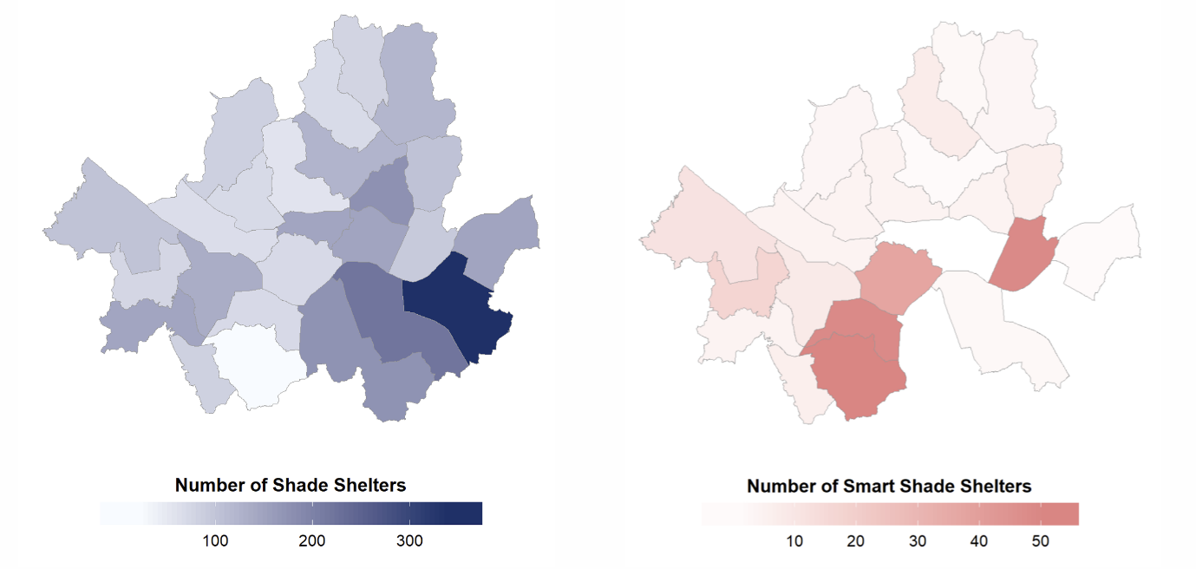
Supplemental Fig. 1 Spatial Distribution Maps among fixed folding shade shelters (left) and smart shade shelters (right)

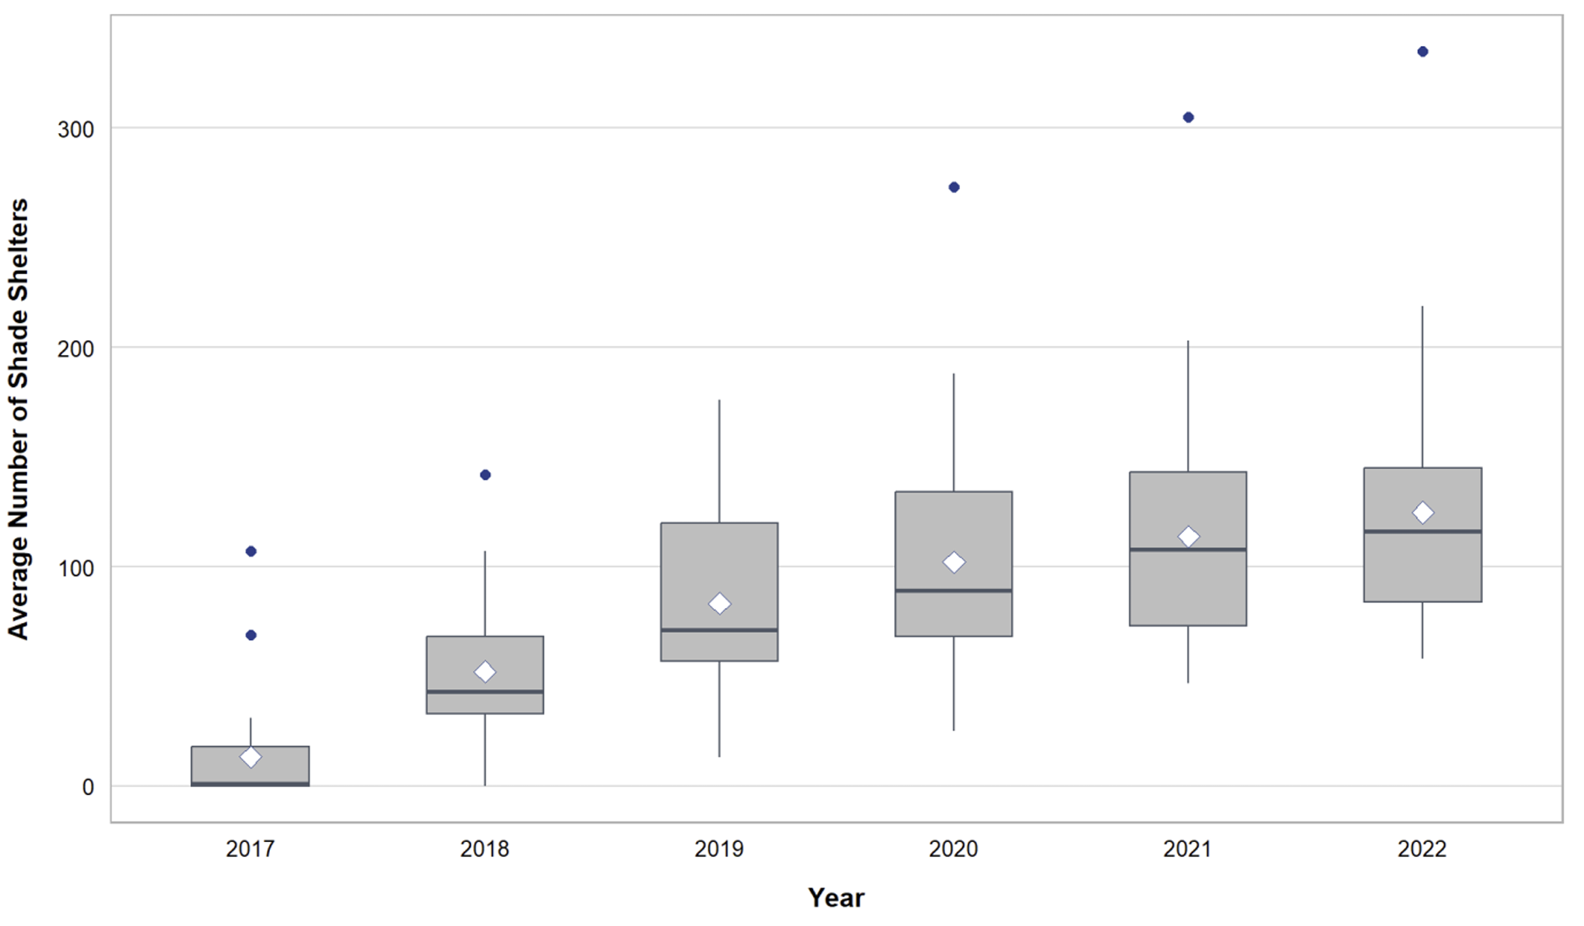
Supplemental Fig. 2 Annual averaged number of shade shelters per district from 2017 to 2022

Specification | Relative Risk (95% CI)
Specification | Low Shade Infrastructure | High Shade Infrastructure
Main model | 1.128  (1.003-1.269) | 1.073  (0.982-1.173)
Knot positions: 25th/75th percentiles. | 1.117  (1.010-1.235) | 1.063  (0.985-1.147)
Lag structure: maximum lag period to 7 days | 1.145  (1.004-1.307) | 1.088  (0.985-1.204)
Shade shelter density: 10th and 90th percentiles of shade shelter density | 1.132  (1.001-1.280) | 1.057  (0.956-1.168)
Supplemental Table 1 Results of Sensitivity analyses with other model specifications and thresholds

