Additional File 1

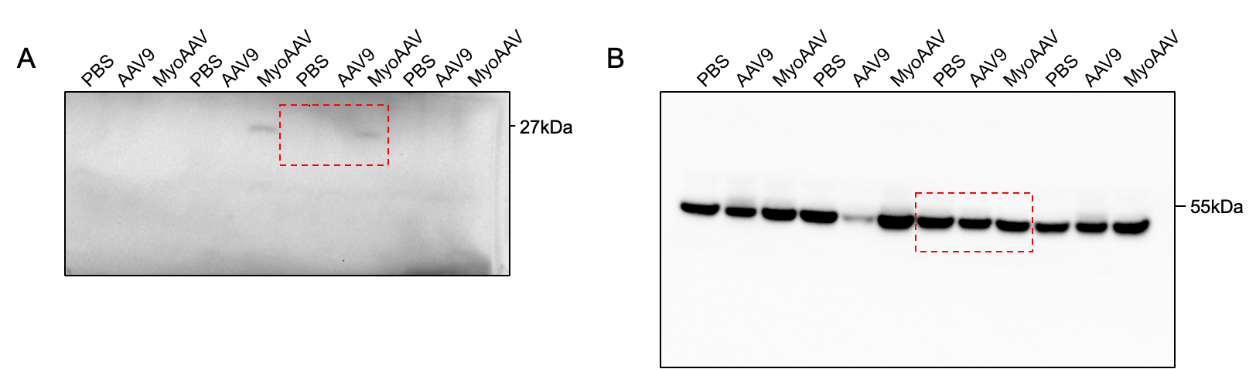
Supplementary Figure 1 – Original, unprocessed images of Western blots corresponding to Figure 1d (AAV9 vs MyoAAV GC). A) GFP B) α-Tubulin. Red box indicates image used in figure.

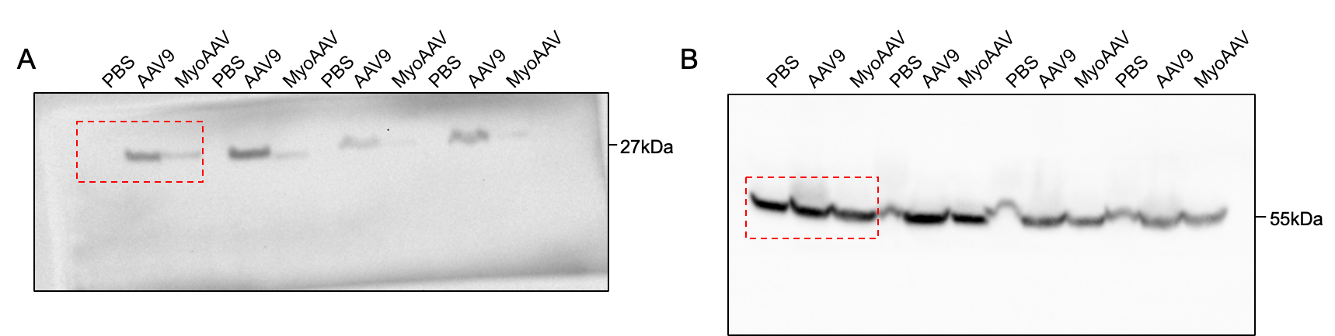

Supplementary Figure 2 – Original, unprocessed images of Western blots corresponding to Figure 1e (AAV9 vs MyoAAV Liver). A) GFP B) α-Tubulin. Red box indicates image used in figure.

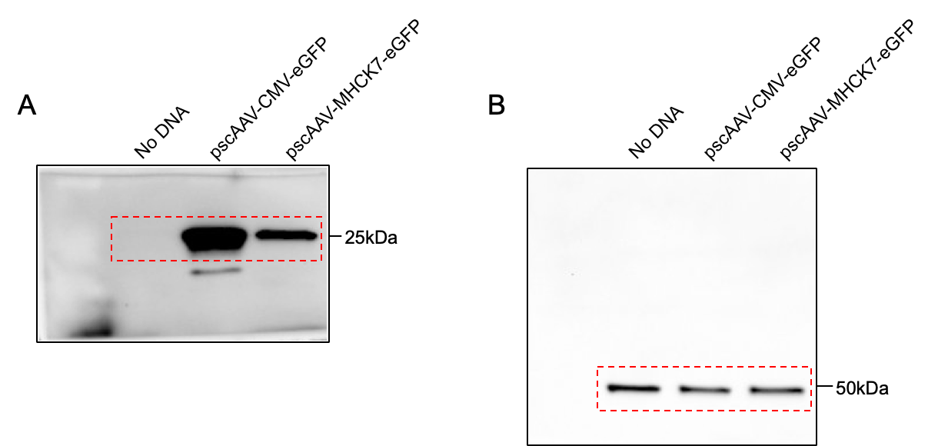
Supplementary Figure 3 – Original, unprocessed images of Western blots corresponding to Figure 2b (CMV vs MHCK7 C2C12). A) GFP B) β-Tubulin. Red box indicates image used in figure.

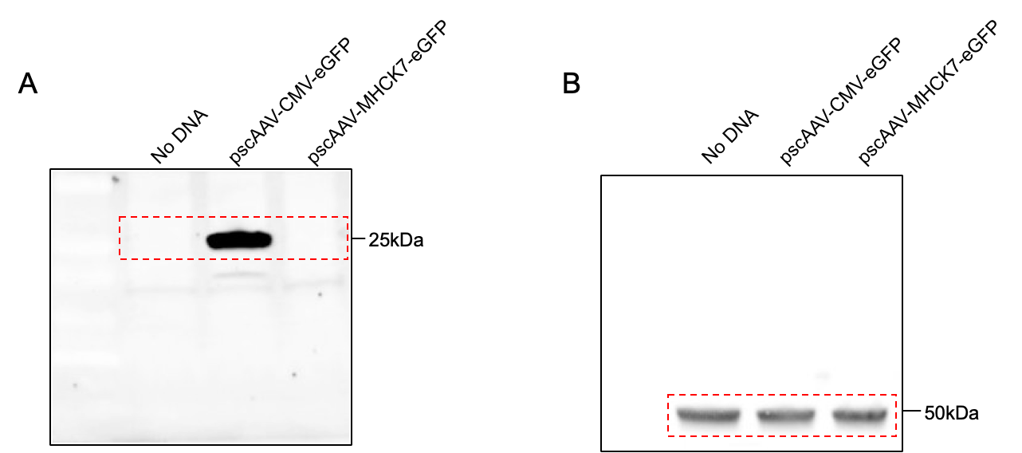
Supplementary Figure 4 – Original, unprocessed images of Western blots corresponding to Figure 2d (CMV vs MHCK7 N2A). A) GFP B) β-Tubulin. Red box indicates image used in figure.

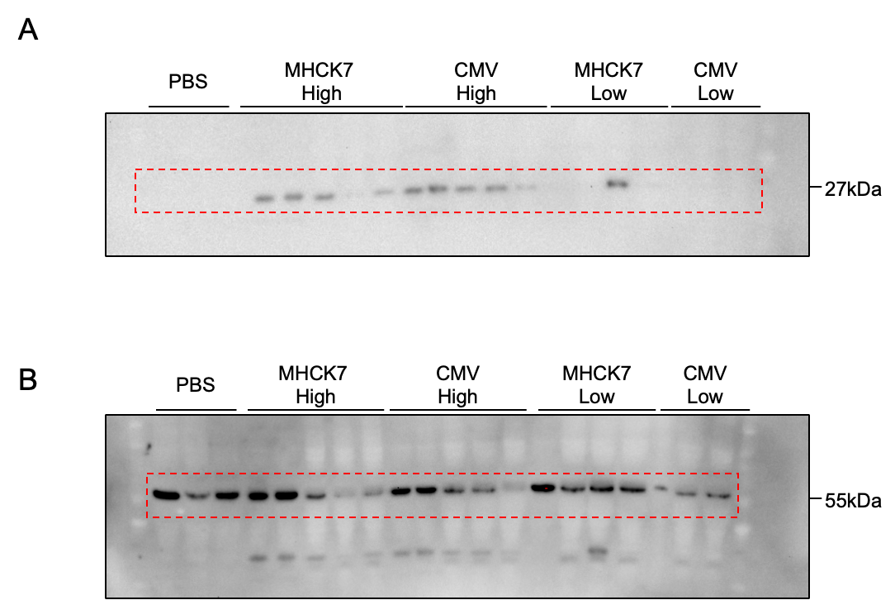
Supplementary Figure 5 – Original, unprocessed images of Western blots corresponding to Figure 3i (CMV vs MHCK7 TA). A) GFP B) α-Tubulin. Red box indicates image used in figure.

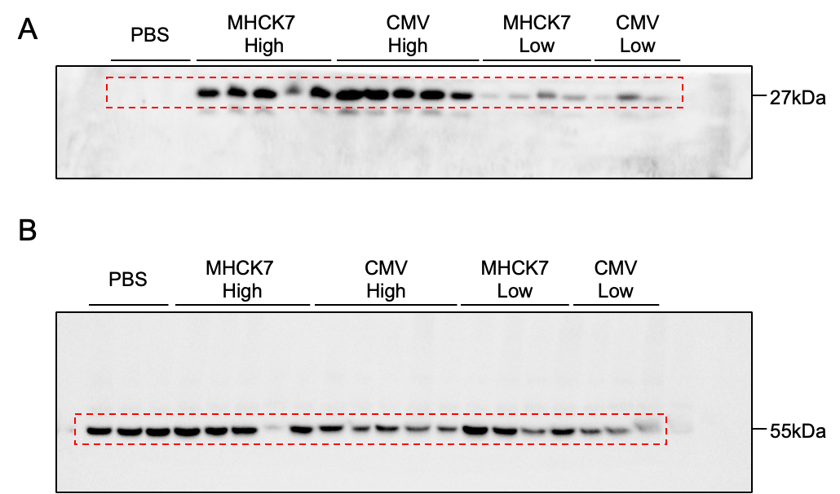
Supplementary Figure 6 – Original, unprocessed images of Western blots corresponding to Figure 3j (CMV vs MHCK7 GC). A) GFP B) α-Tubulin. Red box indicates image used in figure.

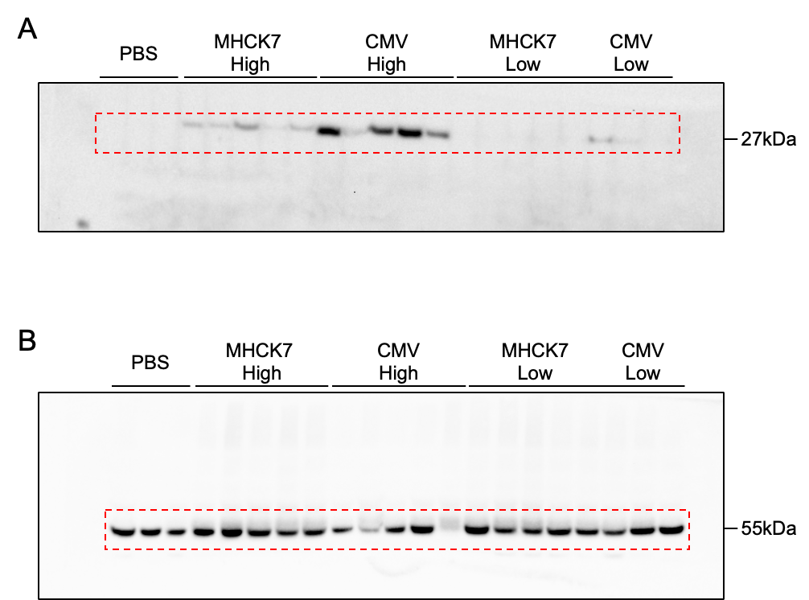

Supplementary Figure 7 – Original, unprocessed images of Western blots corresponding to Figure 3k (CMV vs MHCK7 Liver). A) GFP B) α-Tubulin. Red box indicates image used in figure.

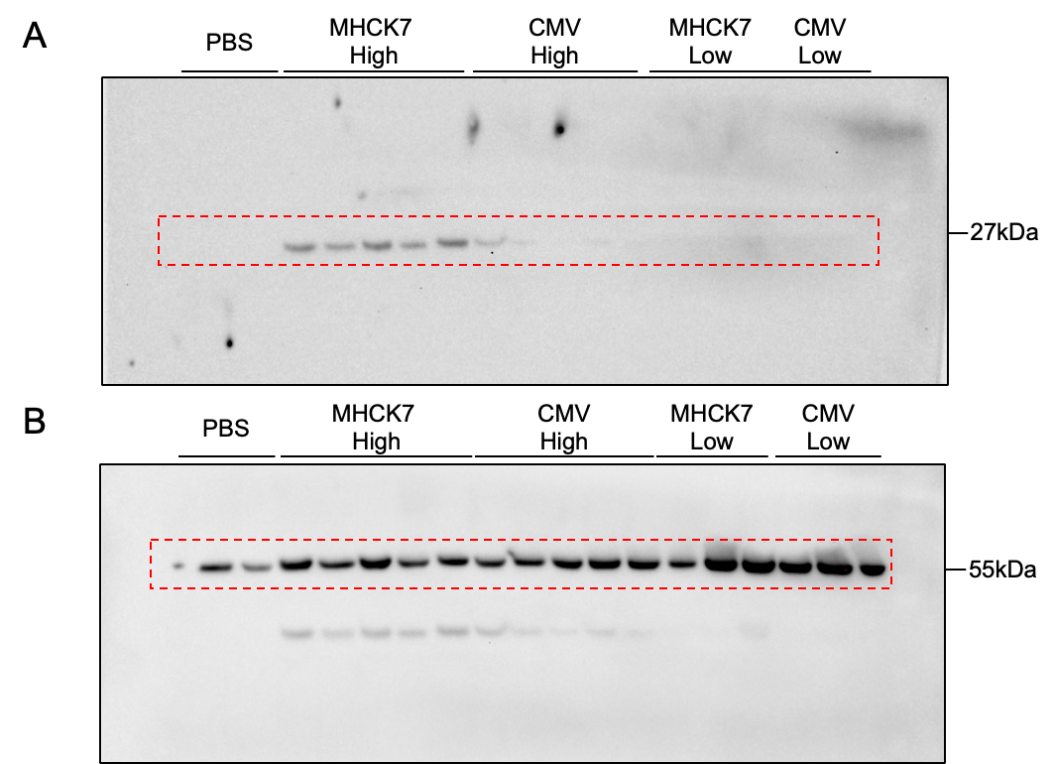

Supplementary Figure 8 – Original, unprocessed images of Western blots corresponding to Figure 3l (CMV vs MHCK7 Heart). A) GFP B) α-Tubulin. Red box indicates image used in figure.

