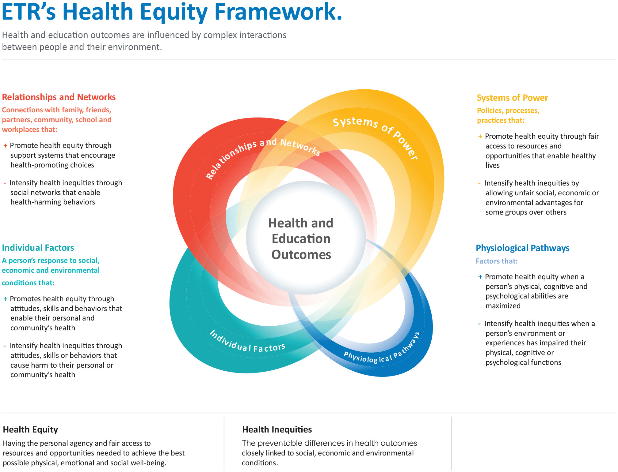
ETR’s Health Equity Framework
Gender, Economic status, Living area,
Coping mechanism,
Self-esteem, Self-efficiency,
Skill, motivation
Physical health, (Sexual Transmitted Diseases, HIV, gender transition operation)
Mental health (Alcohol and substance use)
LGBTQIA+ inclusive health care settings,
Policy,
Curricula,
Health insurance
LGBTQIA+ individuals’ relationship with family- friends -colleagues
Coming out
Health providers attitudes,
Stigmatization
Support groups

