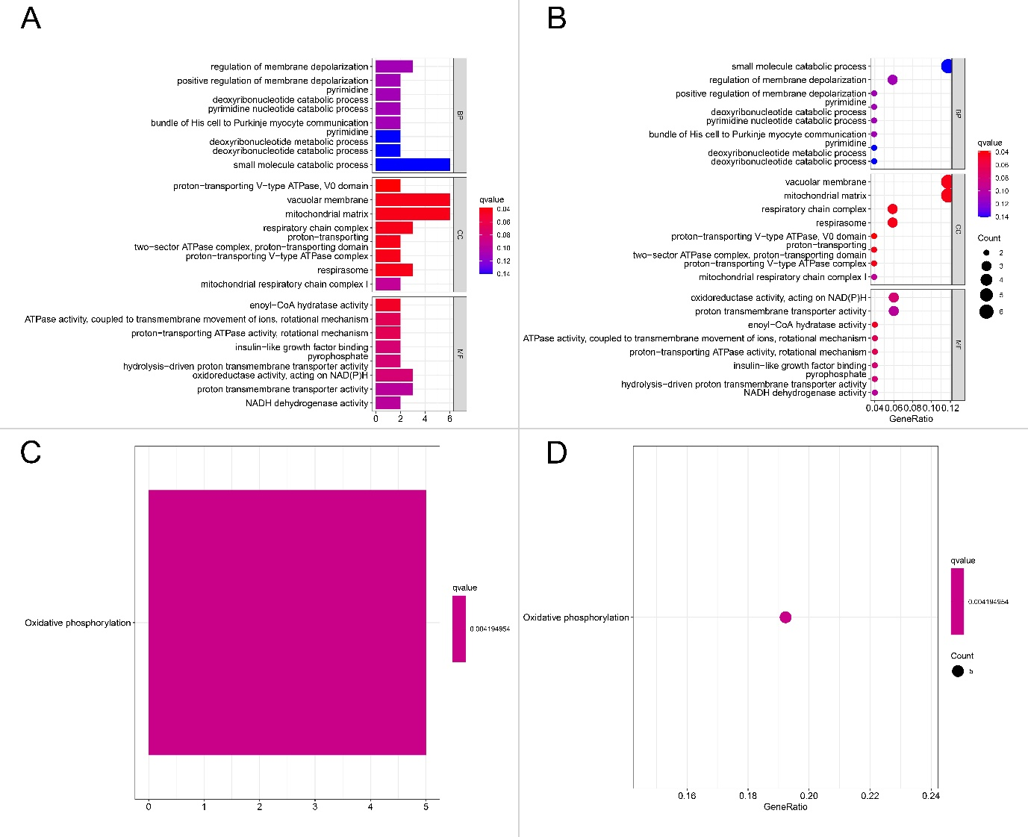

Fig. S1.
Enrichment analysis of 74 intersecting DEGs of m6A clusters. (A to B) Bar plot (A) and dotplot (B) of GO enrichment in cellular component terms, biological process terms and molecular function terms. (C to D) Bar plot (C) and dotplot (D) of KEGG enriched terms. BP: biological process; CC: cell component; MF: molecular function.
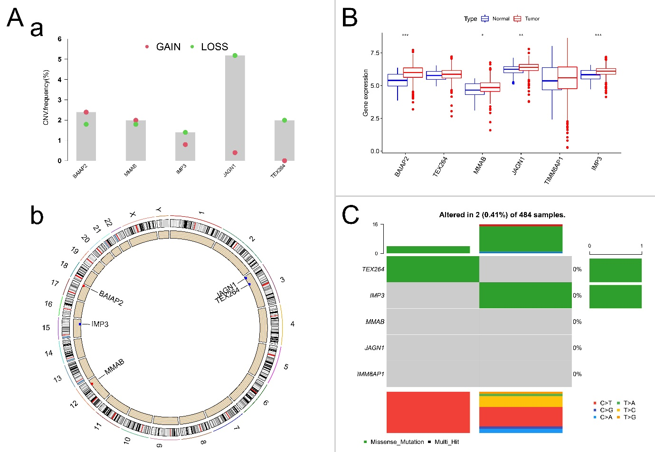

Fig. S2.
Characteristics of 6 DEGs of m6A clusters in prostate cancer. (A) (a) The CNV variation frequency of 6 DEGs in TCGA-PRAD. Green dot: deletion frequency; red dot: amplification frequency. (b) The location of CNV alterations of 6 DEGs on 23 chromosomes. (B) Box plot of expression of 6 DEGs in PCa and normal tissues. Median values ± interquartile ranges are shown in the graph. * P < 0.05, ** P < 0.01, and *** P < 0.001. (C) The mutation frequency of 6 DEGs in 475 TCGA-PRAD patients is shown on the waterfall plot. The column represents individual patients, the upper bar plot shows the TMB, the right bar plot shows the proportion of each variant type, and the stacked bar plot below shows the transformed fraction of each patient.
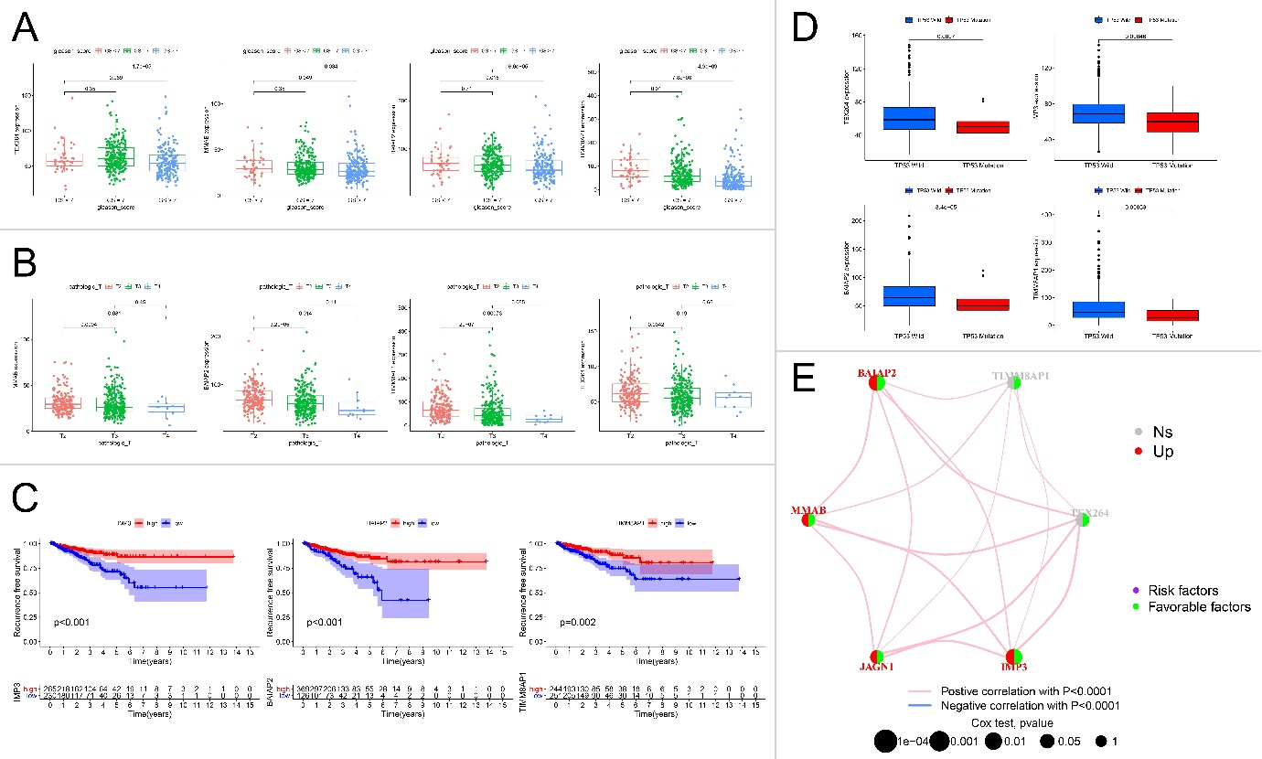

Fig. S3.
Expression of 6 DEGs of m6A clusters in PCa prognosis and different clinicopathological characteristics. (A to D) Distribution of 6 representative DEGs in TCGA-PRAD data stratified by GS (A), pT (B), RFS (C), and TP53 mutation (D). In the box plots, the median ± interquartile range of values is shown in the graph, and P values are shown above each pair of comparisons. (E) Prognosis network of interactions between 6 DEGs in PCa. The P values of each regulator on the prognosis are shown as circles of different sizes. Purple in the right hemisphere: risk factors for RFS; green in the right hemisphere: favorable factors for RFS. Upregulation (top) or no significant differences (Ns) of 6 DEGs in PCa compared with normal tissues are filled with red and gray on the left hemisphere, respectively. Positive or negative correlations of 6 DEGs are linked with lines of different colors (pink: positive, blue: negative), and the correlation strength between them is shown as lines of different thicknesses.
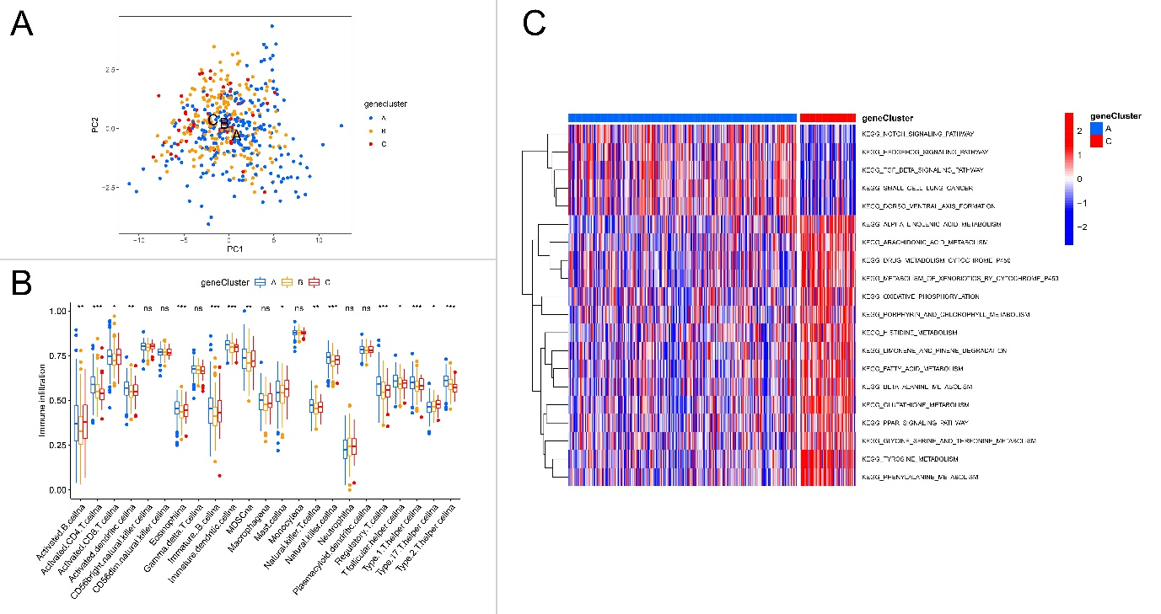

Fig. S4.
Consensus clustering analysis based on 6 DEGs of m6A clusters. (A) PCA of the transcriptome profiles of three geneClusters, showing a marked difference in the transcriptome between different m6Aclusers. (E) Abundance of each immune cell infiltration among three geneClusters in the boxplot. The median ± interquartile range of values is shown in the graph. ns P > 0.05; * P < 0.05; ** P < 0.01; ***P < 0.001. (C) Heatmap of KEGG enrichment analysis showing the activation states of biological pathways in distinct geneClusters. Red represents activation, and blue represents inhibition.
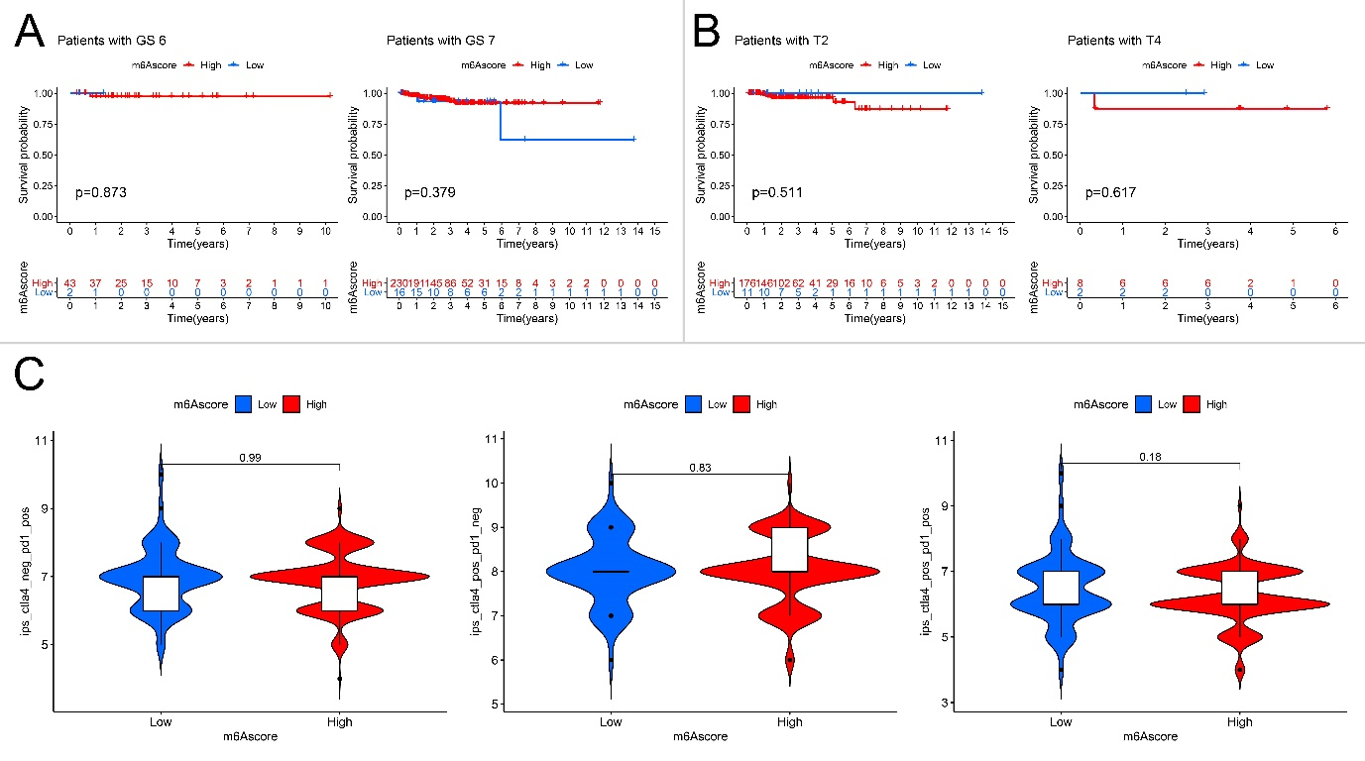

Fig. S5.
Characteristics of m6Ascore status in TCGA-PRAD tumor subtypes. (A) Survival analysis of different m6Ascore groups among TRAD patients with GS 6 (left) and GS 7 (right). (B) Survival analysis of different m6Ascore groups among TRAD patients with pT2 (left) and pT4 (right) disease. (C) Violin plot of IPS scores among CTLA4-negative and PD1-positive (left), CTLA4-positive and PD1-negative (middle), CTLA4-positive and PD1-positive (right) m6A core groups. The P value of the Wilcoxon test is shown in box plots.

