Supplementary Information for: A Machine Learning-Based Model for Cardiovascular Disease Risk Stratification in Middle-Aged and Older Adults with Diabetes: A Cross-Sectional Study based on CHARLS

Table S1. Baseline characteristics of participants in the training and test sets
 | [ALL] | Train set | Test set | p.overall
 | N=2625 | N=1837 | N=788
CVD: |  |  |  | 0.641
No CVD | 1526 (58.1%) | 1062 (57.8%) | 464 (58.9%)
CVD | 1099 (41.9%) | 775 (42.2%) | 324 (41.1%)
Age | 64.5 (8.52) | 64.6 (8.58) | 64.2 (8.39) | 0.343
Gender: |  |  |  | 0.773
female | 1422 (54.2%) | 999 (54.4%) | 423 (53.7%)
male | 1203 (45.8%) | 838 (45.6%) | 365 (46.3%)
Marry: |  |  |  | 0.094
No | 402 (15.3%) | 296 (16.1%) | 106 (13.5%)
Yes | 2223 (84.7%) | 1541 (83.9%) | 682 (86.5%)
Education: |  |  |  | 0.688
Middle school and below | 2215 (84.4%) | 1554 (84.6%) | 661 (83.9%)
High school and above | 410 (15.6%) | 283 (15.4%) | 127 (16.1%)
Family Size | 2.00 [2.00;3.00] | 2.00 [2.00;4.00] | 2.00 [2.00;3.00] | 0.488
Rural: |  |  |  | 0.098
No | 1259 (48.0%) | 901 (49.0%) | 358 (45.4%)
Yes | 1366 (52.0%) | 936 (51.0%) | 430 (54.6%)
Retire: |  |  |  | 0.472
No | 1966 (74.9%) | 1368 (74.5%) | 598 (75.9%)
Yes | 659 (25.1%) | 469 (25.5%) | 190 (24.1%)
Self Reported Health Status: |  |  |  | 0.930
very good | 280 (10.7%) | 198 (10.8%) | 82 (10.4%)
good | 679 (25.9%) | 466 (25.4%) | 213 (27.0%)
fair | 1380 (52.6%) | 971 (52.9%) | 409 (51.9%)
poor | 156 (5.94%) | 111 (6.04%) | 45 (5.71%)
very poor | 130 (4.95%) | 91 (4.95%) | 39 (4.95%)
High Intensity Exercise: |  |  |  | 0.891
No | 1862 (70.9%) | 1305 (71.0%) | 557 (70.7%)
Yes | 763 (29.1%) | 532 (29.0%) | 231 (29.3%)
Moderate Intensity Exercise: |  |  |  | 0.227
No | 1237 (47.1%) | 851 (46.3%) | 386 (49.0%)
Yes | 1388 (52.9%) | 986 (53.7%) | 402 (51.0%)
Light Intensity Exercise: |  |  |  | 0.551
No | 526 (20.0%) | 362 (19.7%) | 164 (20.8%)
Yes | 2099 (80.0%) | 1475 (80.3%) | 624 (79.2%)
Smoking: |  |  |  | 0.884
No | 2075 (79.0%) | 1454 (79.2%) | 621 (78.8%)
Yes | 550 (21.0%) | 383 (20.8%) | 167 (21.2%)
Drinking: |  |  |  | 0.209
No | 1788 (68.1%) | 1237 (67.3%) | 551 (69.9%)
Yes | 837 (31.9%) | 600 (32.7%) | 237 (30.1%)
Hypertension: |  |  |  | 0.213
No | 931 (35.5%) | 666 (36.3%) | 265 (33.6%)
Yes | 1694 (64.5%) | 1171 (63.7%) | 523 (66.4%)
Dyslipidemia: |  |  |  | 0.483
No | 1078 (41.1%) | 763 (41.5%) | 315 (40.0%)
Yes | 1547 (58.9%) | 1074 (58.5%) | 473 (60.0%)
Cancer: |  |  |  | 0.071
No | 2521 (96.0%) | 1773 (96.5%) | 748 (94.9%)
Yes | 104 (3.96%) | 64 (3.48%) | 40 (5.08%)
Lung Disease: |  |  |  | 0.292
No | 2165 (82.5%) | 1525 (83.0%) | 640 (81.2%)
Yes | 460 (17.5%) | 312 (17.0%) | 148 (18.8%)
Arthritis: |  |  |  | 0.892
No | 1466 (55.8%) | 1028 (56.0%) | 438 (55.6%)
Yes | 1159 (44.2%) | 809 (44.0%) | 350 (44.4%)
Liver Diseases: |  |  |  | 0.515
No | 2341 (89.2%) | 1633 (88.9%) | 708 (89.8%)
Yes | 284 (10.8%) | 204 (11.1%) | 80 (10.2%)
Kidney.disease: |  |  |  | 0.921
No | 2164 (82.4%) | 1513 (82.4%) | 651 (82.6%)
Yes | 461 (17.6%) | 324 (17.6%) | 137 (17.4%)
Gastric Disease: |  |  |  | 0.461
No | 1718 (65.4%) | 1211 (65.9%) | 507 (64.3%)
Yes | 907 (34.6%) | 626 (34.1%) | 281 (35.7%)
Asthma: |  |  |  | 0.064
No | 2416 (92.0%) | 1703 (92.7%) | 713 (90.5%)
Yes | 209 (7.96%) | 134 (7.29%) | 75 (9.52%)
Memory Disorders: |  |  |  | 0.455
No | 2397 (91.3%) | 1672 (91.0%) | 725 (92.0%)
Yes | 228 (8.69%) | 165 (8.98%) | 63 (7.99%)
Hospital: |  |  |  | 0.908
No | 1823 (69.4%) | 1274 (69.4%) | 549 (69.7%)
Yes | 802 (30.6%) | 563 (30.6%) | 239 (30.3%)
Doctor: |  |  |  | 0.095
No | 1899 (72.3%) | 1347 (73.3%) | 552 (70.1%)
Yes | 726 (27.7%) | 490 (26.7%) | 236 (29.9%)
ADL.Score | 0.00 [0.00;1.00] | 0.00 [0.00;1.00] | 0.00 [0.00;1.00] | 0.242
Cesd10 | 9.00 [5.00;13.0] | 9.00 [5.00;13.0] | 9.00 [5.00;13.0] | 0.600
Head pain: |  |  |  | 0.179
No | 2016 (76.8%) | 1397 (76.0%) | 619 (78.6%)
Yes | 609 (23.2%) | 440 (24.0%) | 169 (21.4%)
Chest.pain: |  |  |  | 0.434
No | 2336 (89.0%) | 1641 (89.3%) | 695 (88.2%)
Yes | 289 (11.0%) | 196 (10.7%) | 93 (11.8%)
Sleep Time | 6.10 (1.72) | 6.10 (1.72) | 6.11 (1.72) | 0.843

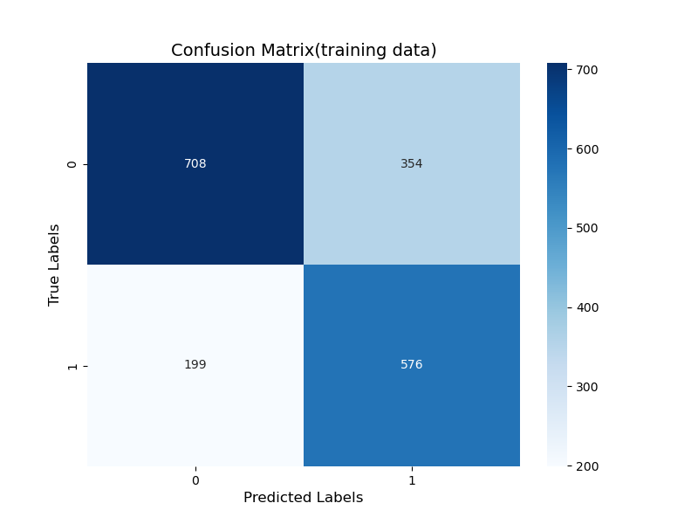
Figure S1. Confusion matrix of the cardiovascular disease prediction model on the training set
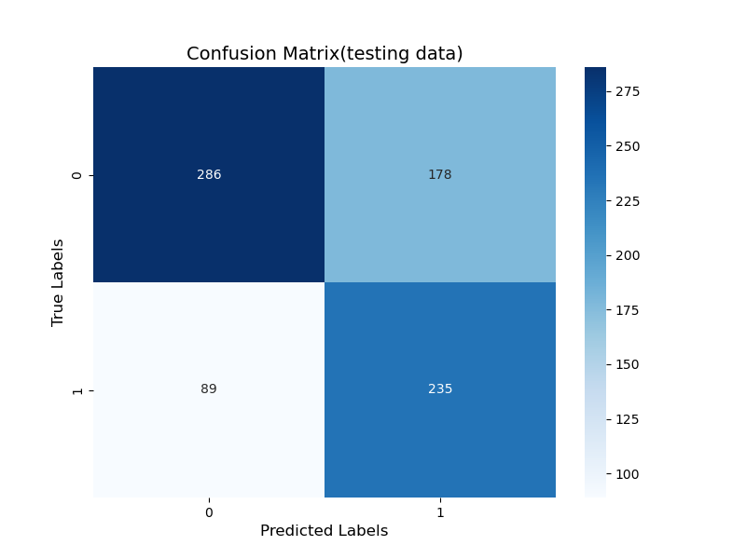
Figure S2. Confusion matrix of the cardiovascular disease prediction model on the test set

