Supplementary: Serglycin as a Preliminary Candidate Biomarker in GNE Myopathy Associated with Impaired Secretion and Autophagy Dysregulation

Supplementary Table 1. All up- and downregulated proteins in HEK GNE knockout cells compared with wildtype.
Proteins with p-value of ≤0.05 and an abundance ratio (denoted as fold change) of either ≥2 (upregulated) or ≤0.5 (down-regulated) are included in this table.
Gene | Description | Fold Change
TM9SF1 | Transmembrane 9 superfamily member 1 | 9.44
ZNF503 | Zinc finger protein 503 | 4.75
FOXC1 | Forkhead box protein C1 | 4.35
TMEM165 | Transmembrane protein 165 | 3.71
MAGED2 | Melanoma-associated antigen D2 | 3.54
SUSD5 | Sushi domain-containing protein 5 | 3.40
SLC35B2 | Adenosine 3'-phospho 5'-phosphosulfate transporter 1 | 3.26
HOXD13 | Homeobox protein Hox-D13 | 3.25
AKAP12 | A-kinase anchor protein 12 | 3.08
DDAH2 | N(G),N(G)-dimethylarginine dimethylaminohydrolase 2 | 2.91
MDC1 | Mediator of DNA damage checkpoint protein 1 | 2.74
ALDOC | Fructose-bisphosphate aldolase C | 2.66
SLC35E1 | Solute carrier family 35 member E1 | 2.61
ARID3B | AT-rich interactive domain-containing protein 3B | 2.55
RPAP1 | RNA polymerase II-associated protein 1 | 2.54
SQSTM1 | Sequestosome-1 | 2.54
CSRP2 | Cysteine and glycine-rich protein 2 | 2.50
HGH1 | Protein HGH1 homolog | 2.49
PURB | Transcriptional activator protein Pur-beta | 2.48
POFUT1 | GDP-fucose protein O-fucosyltransferase 1 | 2.45
SH3BGRL3 | SH3 domain-binding glutamic acid-rich-like protein 3 | 2.43
SNCA | Alpha-synuclein | 2.43
GLG1 | Golgi apparatus protein 1 | 2.39
MDP1 | Magnesium-dependent phosphatase 1 | 2.39
GOLIM4 | Golgi integral membrane protein 4 | 2.36
ARFGAP3 | ADP-ribosylation factor GTPase-activating protein 3 | 2.33
LIN28B | Protein lin-28 homolog B | 2.30
MPRIP | Myosin phosphatase Rho-interacting protein | 2.21
H1-3 | Histone H1.3 | 2.21
ILK | Integrin-linked protein kinase | 2.19
ARAF | Serine/threonine-protein kinase A-Raf | 2.18
GALNT2 | Polypeptide N-acetylgalactosaminyltransferase 2 | 2.18
KCTD12 | BTB/POZ domain-containing protein KCTD12 | 2.15
ASPSCR1 | Tether containing UBX domain for GLUT4 | 2.15
STX7 | Syntaxin-7 | 2.15
GLMN | Glomulin | 2.14
SMAP2 | Stromal membrane-associated protein 2 | 2.14
NEU1 | Sialidase-1 | 2.09
RANBP9 | Ran-binding protein 9 | 2.07
CEP131 | Centrosomal protein of 131 kDa | 2.07
ETFA | Electron transfer flavoprotein subunit alpha, mitochondrial | 0.50
HNRNPH2 | Heterogeneous nuclear ribonucleoprotein H2 | 0.50
SPTLC2 | Serine palmitoyltransferase 2 | 0.50
MTPAP | Poly(A) RNA polymerase, mitochondrial | 0.49
TMEM237 | Transmembrane protein 237 | 0.49
ACAA2 | 3-ketoacyl-CoA thiolase, mitochondrial | 0.49
RPL22L1 | 60S ribosomal protein L22-like 1 | 0.49
ALDH4A1 | Delta-1-pyrroline-5-carboxylate dehydrogenase, mitochondrial | 0.49
MRRF | Ribosome-recycling factor, mitochondrial | 0.49
LARS2 | Leucine--tRNA ligase, mitochondrial | 0.48
SELENOI | Ethanolaminephosphotransferase 1 | 0.48
JAGN1 | Protein jagunal homolog 1 | 0.48
NDUFA9 | NADH dehydrogenase [ubiquinone] 1 alpha subcomplex subunit 9, mitochondrial | 0.47
TIMM13 | Mitochondrial import inner membrane translocase subunit Tim13 | 0.47
FHL1 | Four and a half LIM domains protein 1 | 0.47
ALDH5A1 | Succinate-semialdehyde dehydrogenase, mitochondrial | 0.47
ACSL1 | Long-chain-fatty-acid--CoA ligase 1 | 0.47
FUNDC2 | FUN14 domain-containing protein 2 | 0.46
MSN | Moesin | 0.46
SARM1 | NAD(+) hydrolase SARM1 | 0.45
TMEM11 | Transmembrane protein 11, mitochondrial | 0.45
TWNK | Twinkle mtDNA helicase | 0.44
TRMT10C | tRNA methyltransferase 10 homolog C | 0.44
NUDT8 | Mitochondrial coenzyme A diphosphatase NUDT8 | 0.44
AIFM1 | Apoptosis-inducing factor 1, mitochondrial | 0.43
SLC4A7 | Sodium bicarbonate cotransporter 3 | 0.43
NDUFB8 | NADH dehydrogenase [ubiquinone] 1 beta subcomplex subunit 8, mitochondrial | 0.43
CDC27 | Cell division cycle protein 27 homolog | 0.43
HDHD5 | Haloacid dehalogenase-like hydrolase domain-containing 5 | 0.43
RAB9A | Ras-related protein Rab-9A | 0.43
MORF4L2 | Mortality factor 4-like protein 2 | 0.42
ABCB7 | Iron-sulfur clusters transporter ABCB7, mitochondrial | 0.42
HSCB | Iron-sulfur cluster co-chaperone protein HscB | 0.41
FLNC | Filamin-C | 0.41
XPNPEP3 | Xaa-Pro aminopeptidase 3 | 0.41
SPG21 | Maspardin | 0.40
UTP23 | rRNA-processing protein UTP23 homolog | 0.40
STK26 | Serine/threonine-protein kinase 26 | 0.40
VAMP7 | Vesicle-associated membrane protein 7 | 0.40
PNPO | Pyridoxine-5'-phosphate oxidase | 0.40
GHDC | GH3 domain-containing protein | 0.38
TBC1D23 | TBC1 domain family member 23 | 0.38
RBMX2 | RNA-binding motif protein, X-linked 2 | 0.38
PPP1R9B | Neurabin-2 | 0.38
CEBPB | CCAAT/enhancer-binding protein beta | 0.37
SLC7A1 | High affinity cationic amino acid transporter 1 | 0.37
ACSL4 | Long-chain-fatty-acid--CoA ligase 4 | 0.37
NUDT19 | Acyl-coenzyme A diphosphatase NUDT19 | 0.36
PTPMT1 | Phosphatidylglycerophosphatase and protein-tyrosine phosphatase 1 | 0.35
NDUFA11 | NADH dehydrogenase [ubiquinone] 1 alpha subcomplex subunit 11 | 0.34
TAMM41 | Phosphatidate cytidylyltransferase, mitochondrial | 0.34
ARMCX3 | Armadillo repeat-containing X-linked protein 3 | 0.33
ACSS1 | Acetyl-coenzyme A synthetase 2-like, mitochondrial | 0.33
GTPBP6 | Putative GTP-binding protein 6 | 0.33
SLC2A1 | Solute carrier family 2, facilitated glucose transporter member 1 | 0.33
APLP2 | Amyloid beta precursor like protein 2 | 0.33
CCDC51 | Mitochondrial potassium channel | 0.32
ABHD10 | Palmitoyl-protein thioesterase ABHD10, mitochondrial | 0.32
CRAT | Carnitine O-acetyltransferase | 0.31
SPAG9 | C-Jun-amino-terminal kinase-interacting protein 4 | 0.28
LRRC59 | Leucine-rich repeat-containing protein 59 | 0.22
SLC39A14 | Metal cation symporter ZIP14 | 0.18
ATP11C | Phospholipid-transporting ATPase IG | 0.18
COX15 | Cytochrome c oxidase assembly protein COX15 homolog | 0.16
GSTP1 | Glutathione S-transferase P | 0.10

Uncropped Immunoblots
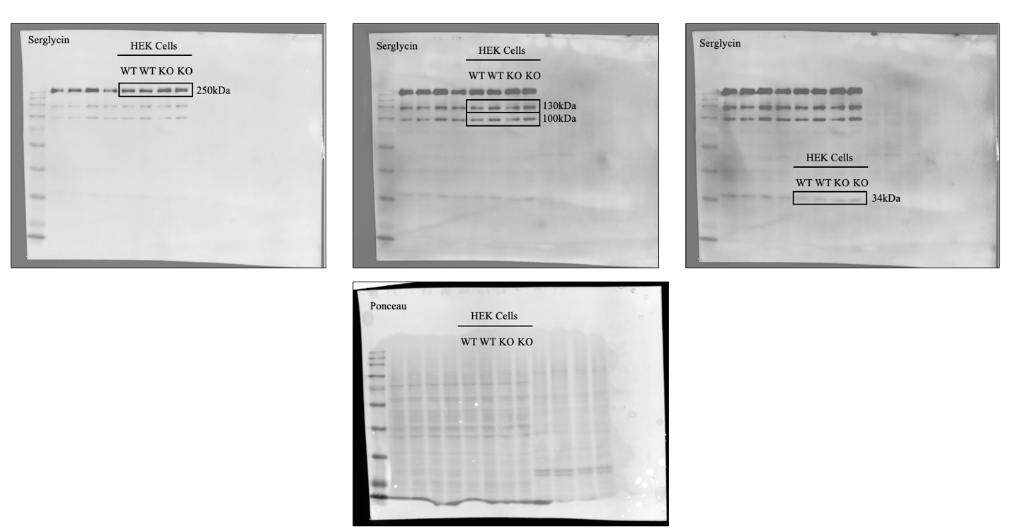
Supplementary Figure 1. HEK cell serglycin immunoblots
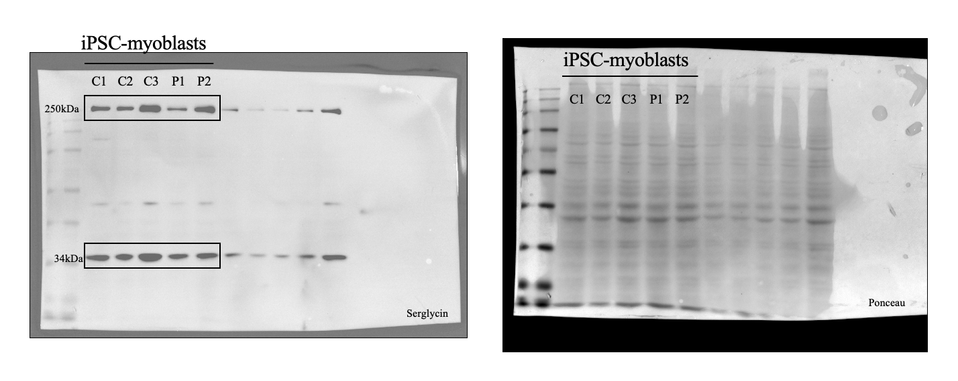
Supplementary Figure 2. iPSC-myoblast serglycin immunoblots

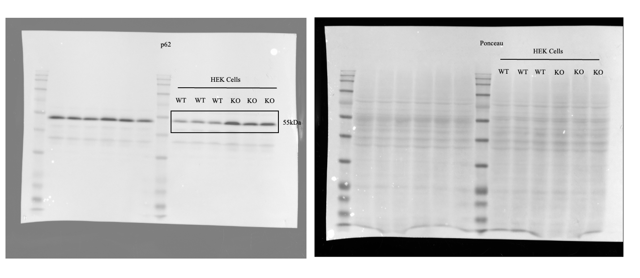
Supplementary Figure 3. HEK cell p62 immunoblot

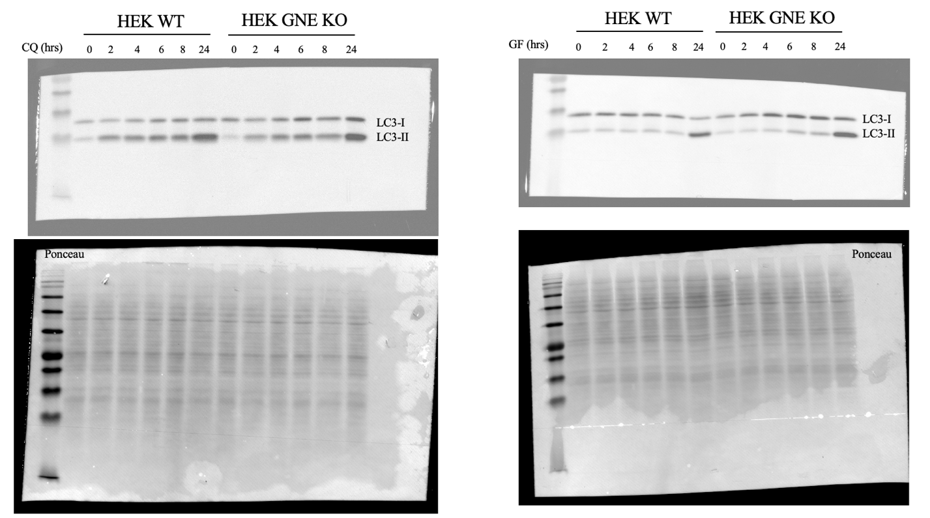
Supplementary Figure 3. HEK cell LC3-I and LC3-II chloroquine (CQ) and glucose free media (GF) treated immunoblots

