Supplementary Materials

Table of contents:
- Supplementary Methods
- Supplementary Table S1
- Supplementary Figures S1 – S9
- References

Supplementary Methods
16s rRNA gene amplicon sequencing and data processing
For 16S rRNA gene amplicon sequencing, PCR amplification of the full length 16S rRNA gene was performed with 27F and 1492R primers[1] and purification of the PCR product was conducted with Magnetic AMPure Beads XP (Thermo Fisher Scientific, MA, USA). Further, DNA concentrations were measured with a QubitTM Flex fluorometer (Thermo Fisher Scientific, MA, USA), and the DNA fragment size was assessed by gel electrophoresis. The 16S rRNA gene amplicons were indexed and pooled for library preparation following the Native Barcoding Kit 96 V14 protocol (Oxford Nanopore Technologies, UK). Long read sequencing was performed on a R10.4.1 flow cell with the MinION MK1C device (Oxford Nanopore Technologies, UK).
16S Amplicon data were base-called using real-time dorado v0.7.3 including adaptor removal and demultiplexing ([2]). Porechop v0.2.4 was used to remove remaining adapter contents and split reads with inner adapter content, then we used chopper v0.9.0 to remove low quality reads (quality index < 12) and filtered reads between 1200-1800 bp length[3,4]. The ASVs were taxonomically assigned using the naive bayes classifier of the feature-classifier module of Qiime2 v2024.5.0, the classifier was based on the SILVA 138 non-redundant 99% database (available at https://docs.qiime2.org/2024.10/data-resources/)[5,6]. Data analysis was conducted in R with the same procedure as the metagenomics and MAG-based NMDS (see Material and Methods, Section “Statistical analysis of microbial taxonomy”, see Supplementary file S4).
Specialist vs. generalist MAG classification – test comparisons
Metagenome-assembled genome (MAG) abundances were analyzed to classify taxa as specialists, generalists, or intermediate using three complementary approaches. Absolute MAG abundances were normalized by cell counts prior to analysis. A presence–absence matrix was additionally derived to quantify the number of MAGs per category within each sample.
(A) Levins’ niche breadth index
Specialist and generalist MAGs were first identified using Levins’ niche breadth index[7] as implemented in the spec.gen() function of the R package “spaa”[8]. Because the method requires integer inputs, abundance values were scaled to integers prior to analysis. This approach estimates niche breadth based on the distribution of MAG abundances across samples, integrating both occurrence and abundance patterns. MAGs were classified into specialist, generalist, or intermediate categories according to the output of the model.
(B) Occupancy–abundance classification
As an alternative, a threshold-based occupancy approach was applied. Occupancy was calculated as the proportion of samples in which each MAG was detected. This was combined with mean abundance to classify taxa: MAGs with high occupancy (≥0.9) and above-median abundance were defined as generalists, whereas MAGs with low occupancy (≤0.5) and below-median abundance were defined as specialists. All remaining MAGs were considered intermediate. This method emphasizes distributional extent across samples while accounting for overall abundance.
(C) Abundance-weighted niche breadth (inverse Simpson)
A third approach quantified niche breadth using an abundance-weighted index equivalent to the inverse Simpson concentration across samples. For each MAG, relative abundances were calculated across all samples, and niche breadth was computed as the inverse of the sum of squared proportions. Values were subsequently standardized to account for sample number. MAGs were classified into specialists and generalists based on the lower and upper quartiles of the resulting distribution, respectively.
For each method, the number of specialist and generalist MAGs per sample was calculated from the presence–absence matrix, and specialist-to-generalist ratios were derived. Relationships between these ratios and vegetation cover were assessed using generalized additive models (GAMs) with a smoothing term for vegetation (log1(x) transformed).

Supplementary Table S1
Table S1. Environmental and physicochemical soil properties with ranges across the ten alpine permafrost-affected soil sites. Site information and the associated environmental and physicochemical soil properties altitude, vegetation cover extent, pH, soil water content (SWC), carbon to nitrogen ratio (C:N), total organic carbon (TOC) and total nitrogen (TN). All values are averages per site. Detailed information can be found in Supplementary material Table S1 and Supplementary file S1-2.
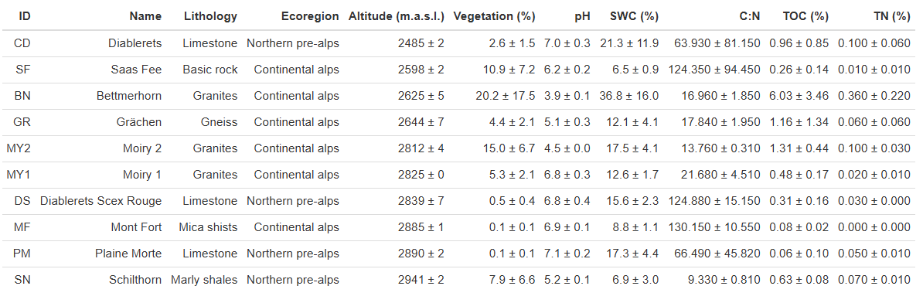

Supplementary Figures S1 – S8
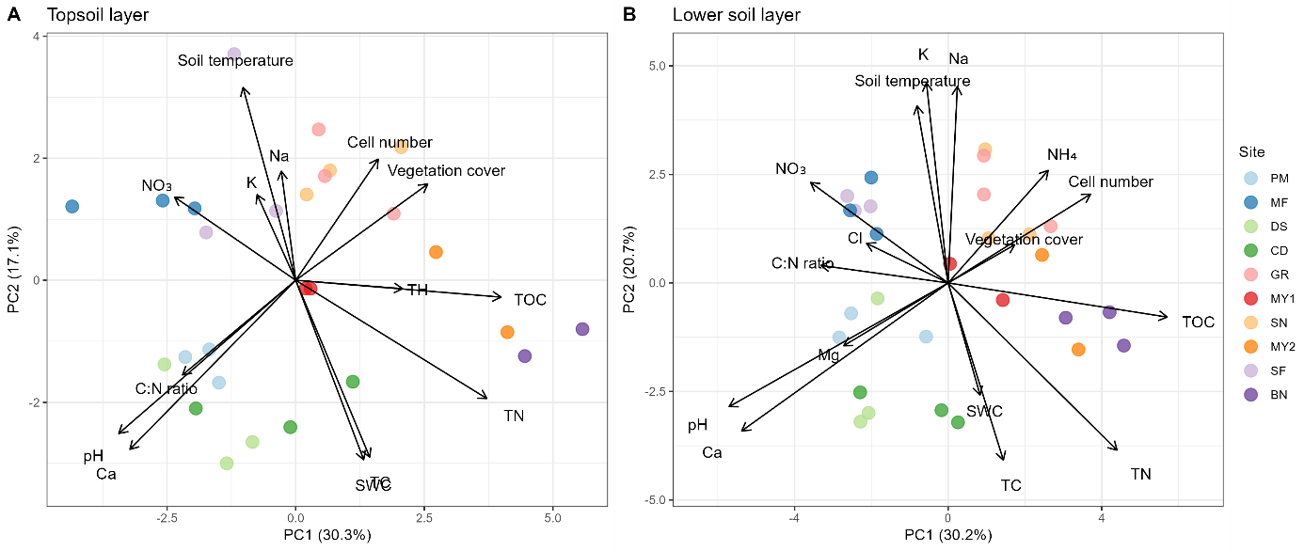
Figure S1. Environmental variables of ten alpine high-altitude soils (see Figure 1 for site abbreviations). Principal Component Analysis (PCA) of soil physicochemical variables across sites at A) topsoil (0 – 5 cm) and b) lower soil layer (5 – 15 cm). Only significant environmental drivers (adj. p <0.01) are shown, see Supplementary file S6-7. SWC: soil water content; TOC: total organic carbon; TC: total carbon; TN: total nitrogen; TH: total hydrogen.
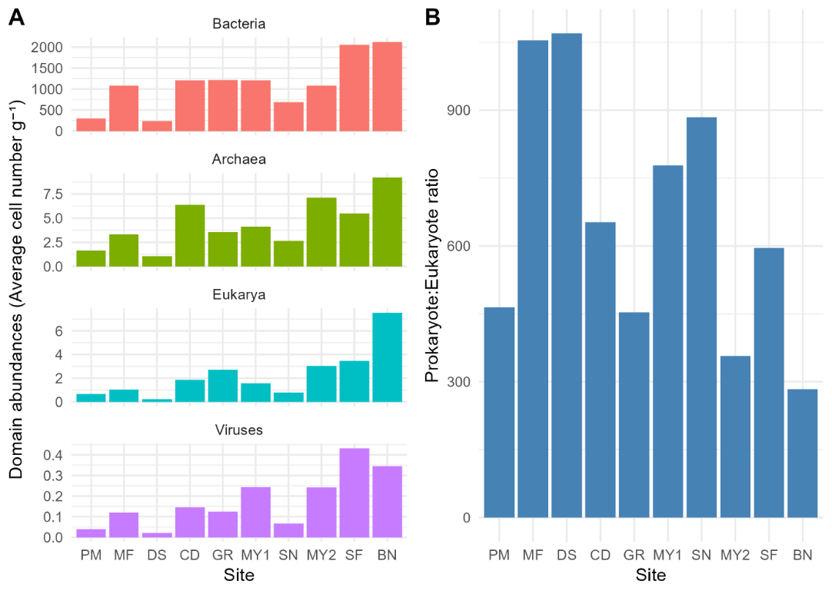
Figure S2. Microbial community composition on domain level of the ten alpine permafrost-affected soils (see Table S1 for site abbreviations). A) Barplots of metagenome-based abundances of archaea, bacteria, eukarya and viruses across sites. B) Ratio of Prokaryotes (bacteria and archaea) to Eukaryotes across sites (see Supplementary file S8). Sites are ordered from barren to vegetated soils based on vegetation cover extent (see Table S1).

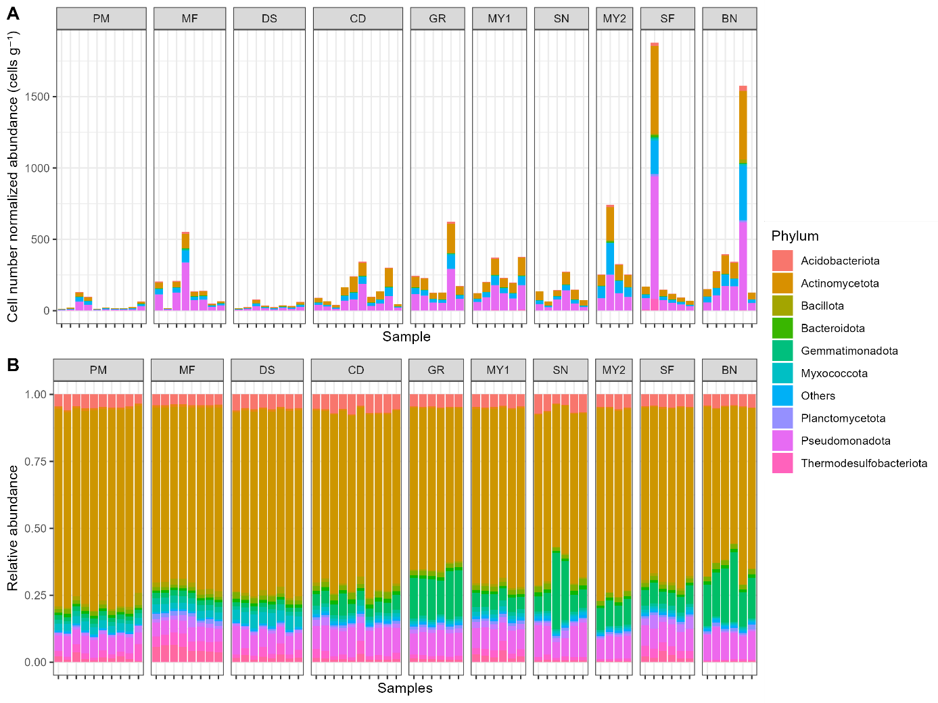
Figure S3. Microbial community composition of the ten alpine permafrost-affected soils. Barplots of A) cell number normalized and B) relative abundance of full metagenome based community composition across soils.
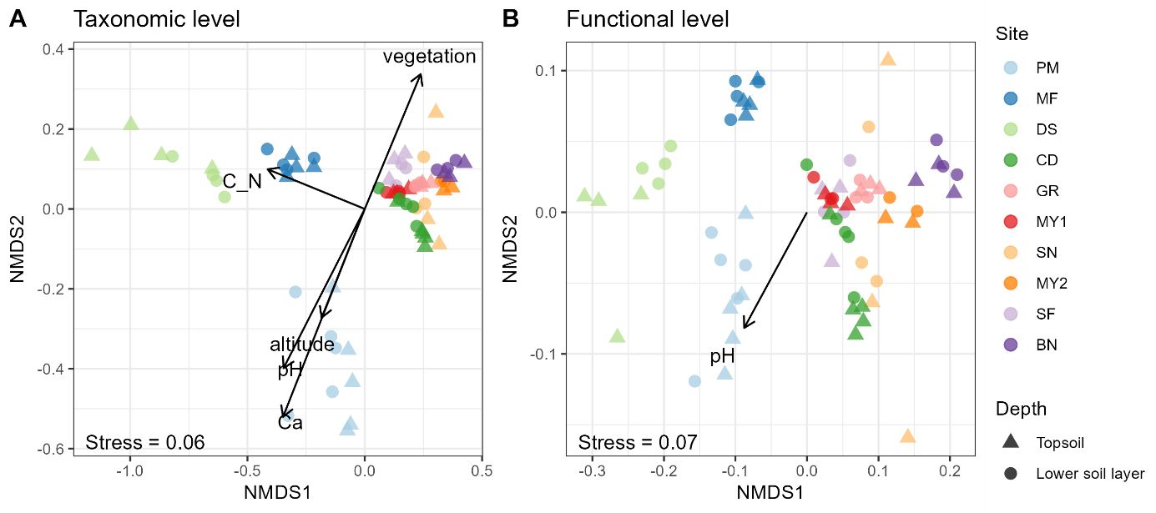Figure S4. Microbial community characteristics of the ten alpine permafrost-affected soils (see Table S1 for site abbreviations). Metagenome assembled genome (MAG) based non-metric multidimensional scaling (NMDS) of A) taxonomic profiles and B) functional composition using KEGG Orthology. Only significant drivers (p < 0.05) are shown, see Supplementary file S9-10. C_N: carbon to nitrogen ratio; TH: total hydrogen content.
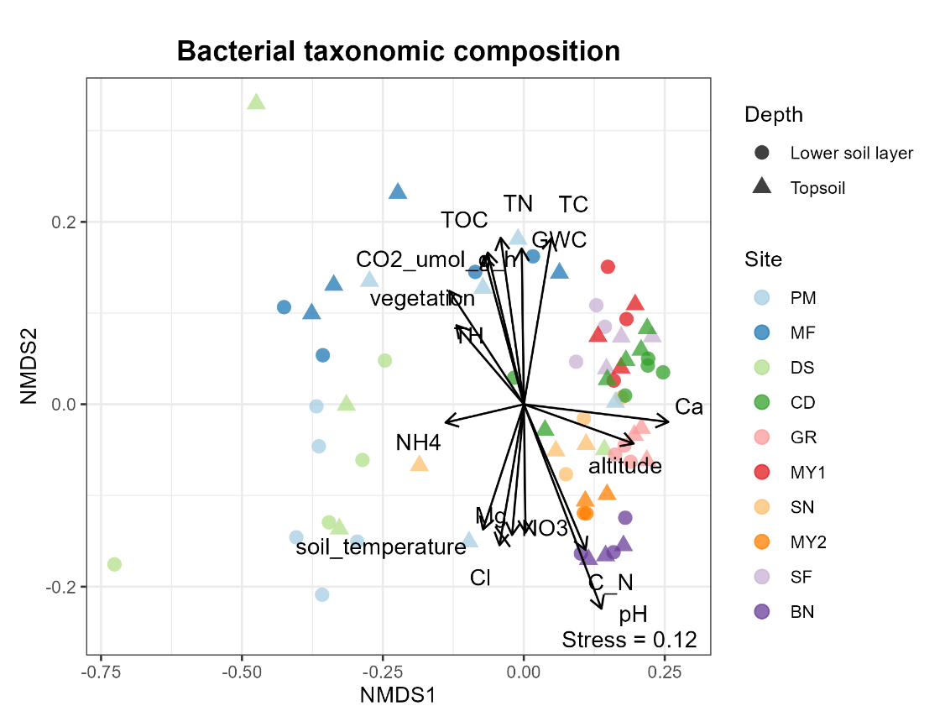
Figure S5. Bacterial community characteristics of the ten alpine permafrost-affected soils (see Table S1 for site abbreviations). Non-metric multidimensional scaling (NMDS) of bacterial community composition across sites based on 16S rRNA gene amplicon sequencing (Oxford Nanopore Technologies). Only significant drivers (p < 0.05) are shown, see Supplementary file S11. GWC: gravimetric water content; TOC: total organic carbon; TC: total carbon; TN: total nitrogen; TH: total hydrogen; . C_N: carbon to nitrogen ratio.

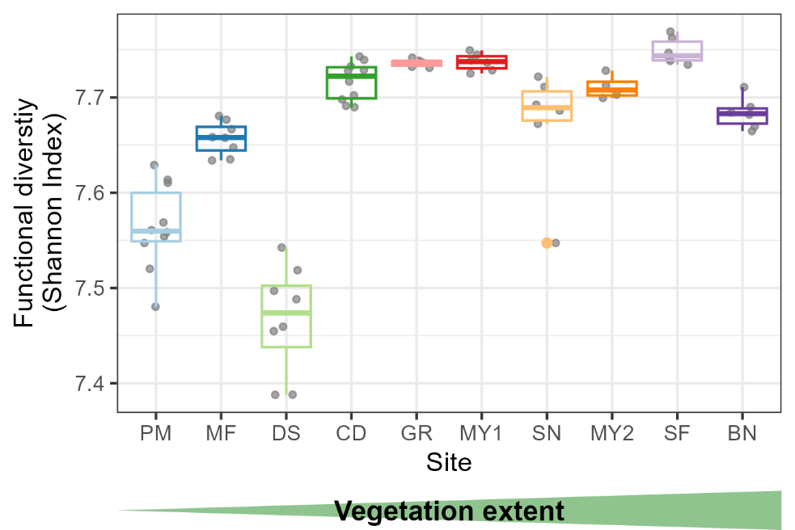
Figure S6. Impact of vegetation cover on functional gene diversity in the ten alpine permafrost-affected soils. Boxplots of mean functional gene diversity (MAG-based Shannon alpha diversity indices) based on KEGG Orthology across sites ordered from barren to more vegetated soils (see Supplementary file S13).

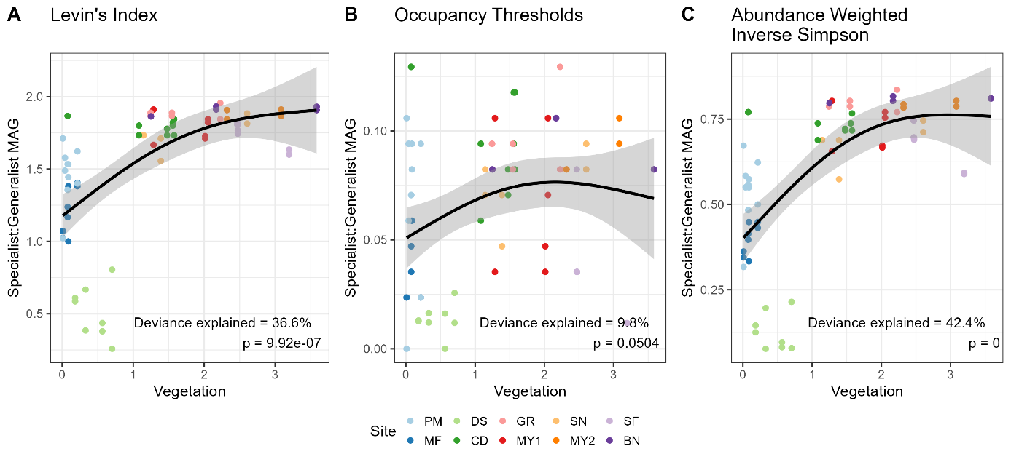
Figure S7. Specialist to Generalist MAG ratio across vegetation using different methods. Generalized additive models (GAMs) of the ratio of the number of specialist MAGs to the number of generalist MAGs (specialist:generalist MAG) with vegetation cover extent as a predictor variable (log1p(x) transformed) A) using Levin’s niche breadth index, B) using occupation and abundance based metrics (thresholds 0.9 ≥ generalists, 0.5 ≤ specialists) and C) abundance weighted nice breadths (inverse Simpson). See Supplementary Methods and file S17-18.

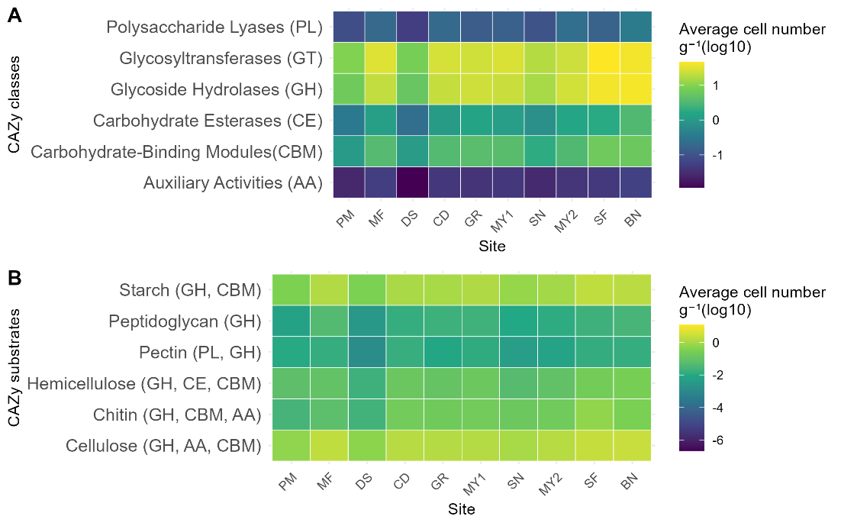
Figure S8. Carbon cycling functional potential of the ten alpine permafrost-affected soils. Heatmaps of functional gene abundances of A) CAZy classes and B) CAZy substrates across sites (see Supplementary file S20-21).
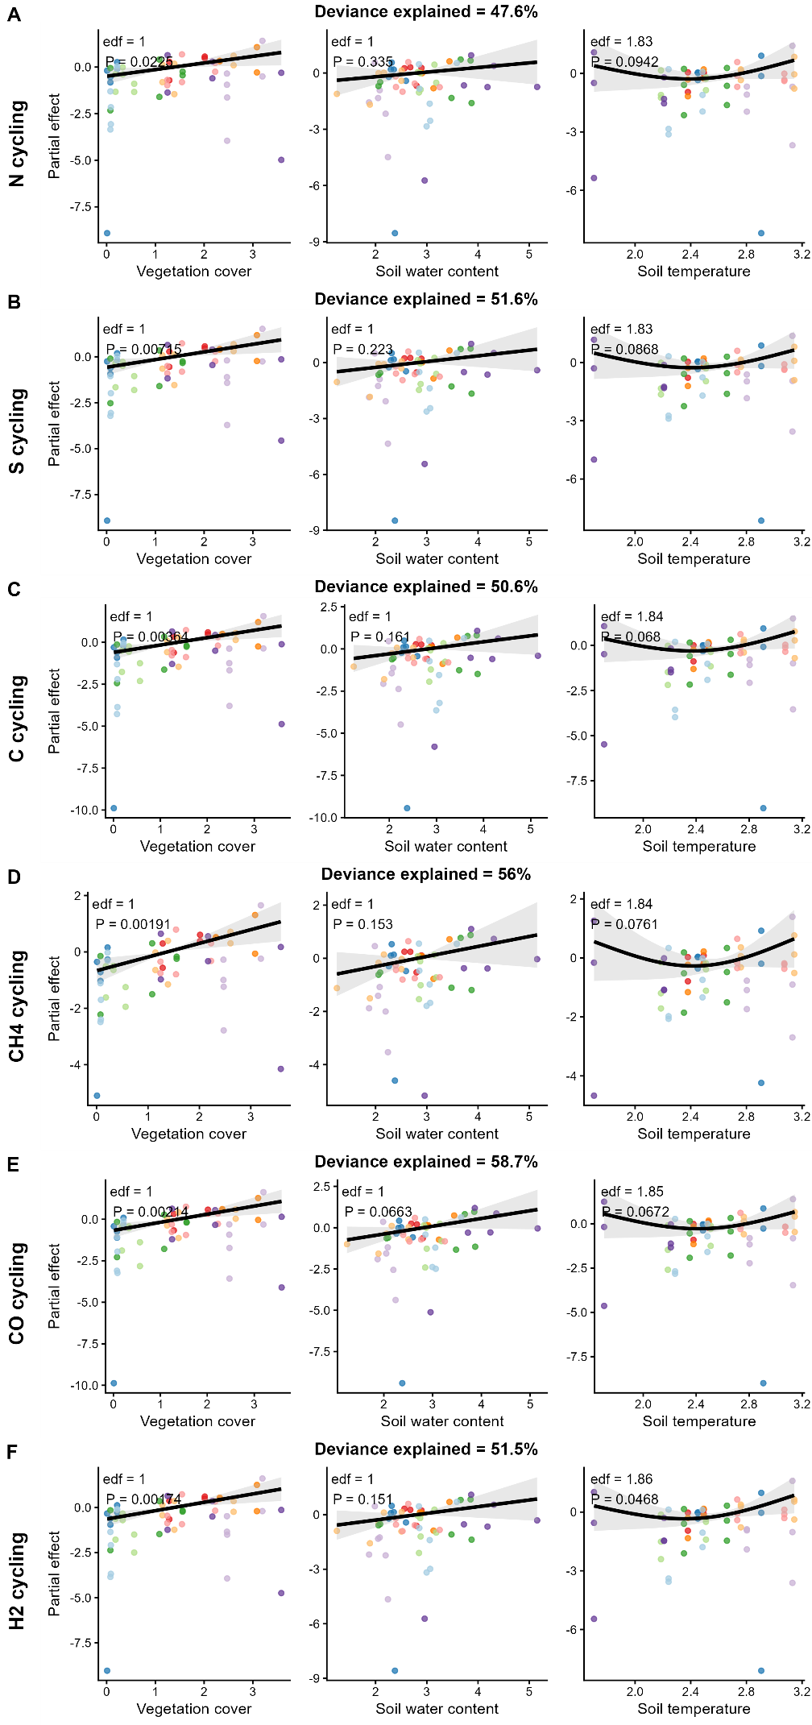
Figure S9. Lithotrophic functional potential of the ten alpine permafrost-affected soils. Generalized additive models (GAMs) of functional gene abundance of A) nitrogen (N), B) sulfur (S), C) carbon (C), D) methane (CH₄), E) carbon monoxide (CO) and F) hydrogen (H₂) cycling with vegetation cover extent, soil water content (SWC) and soil temperature as predictor variables and site as random effect (see Supplementary file S23).
References
1. Frank JA, Reich CI, Sharma S, Weisbaum JS, Wilson BA, Olsen GJ. Critical Evaluation of Two Primers Commonly Used for Amplification of Bacterial 16S rRNA Genes. Appl Environ Microbiol. 2008;74:2461–70. https://doi.org/10.1128/AEM.02272-07
2. nanoporetech/dorado [Internet]. Oxford Nanopore Technologies; 2025 [cited 2026 Apr 17]. https://github.com/nanoporetech/dorado. Accessed 17 Apr 2026
3. De Coster W, Rademakers R. NanoPack2: population-scale evaluation of long-read sequencing data. Bioinformatics. 2023;39:btad311. https://doi.org/10.1093/bioinformatics/btad311
4. Wick R. VJ. Porechop: adapter trimmer for Oxford Nanopore reads. Github. 2018.
5. Quast C, Pruesse E, Yilmaz P, Gerken J, Schweer T, Yarza P, et al. The SILVA ribosomal RNA gene database project: improved data processing and web-based tools. Nucleic Acids Res. 2013;41:D590–6. https://doi.org/10.1093/nar/gks1219
6. Bolyen E, Rideout JR, Dillon MR, Bokulich NA, Abnet CC, Al-Ghalith GA, et al. Reproducible, interactive, scalable and extensible microbiome data science using QIIME 2. Nat Biotechnol. Nature Publishing Group; 2019;37:852–7. https://doi.org/10.1038/s41587-019-0209-9
7. LEVINS R. Evolution in Changing Environments [Internet]. Princeton University Press; 1968 [cited 2026 Feb 26]. https://doi.org/10.2307/j.ctvx5wbbh
8. Zhang J, Ma K. spaa: An R package for computing species association and niche overlap. 2014;Volume X:165–74.

