Supplementary Figure 1. Document-level citation impact and reference burst dynamics.
- Most globally cited documents ranked by total citations, reflecting the broad academic influence of landmark studies across artificial intelligence, medical robotics, augmented reality, advanced materials, and clinical robotic surgery. (B) Most locally cited documents ranked by local citation counts, identifying the field-specific intellectual backbone related to surgical workflow analysis, computer vision, medical image analysis, robotic skill assessment, and computer-assisted intervention. (C) Reference burst detection from 2010 to 2026, showing publications with strong and time-specific citation bursts.

Supplementary Figure 2 Keyword structure, temporal evolution, and burst dynamics of research themes.
- Most frequent keywords ranked by occurrence, showing the dominant terms in the field. (B) Treemap visualization of high-frequency keywords, illustrating the relative thematic weight and hierarchical distribution of major research concepts. (C) Ridgeline plot of keyword trends from 2010 to 2026, showing the temporal evolution of major keywords across the study period. (D) Trend-topic bar chart identifying frequently occurring and emerging research topics. (E) Keyword burst detection from 2010 to 2026; red segments indicate burst periods, whereas blue segments indicate non-burst intervals. (F) Word cloud visualization of frequently occurring terms, where larger font size indicates higher keyword frequency.

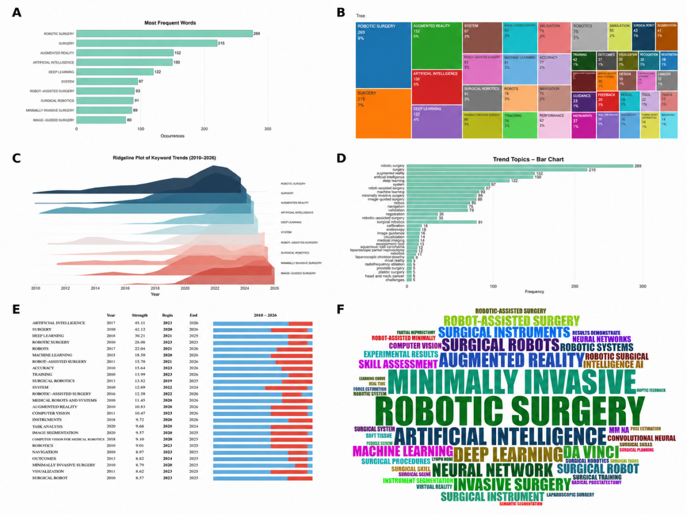

Supplementary Figure 3. Knowledge structure, keyword co-occurrence, and thematic evolution of deep learning and computer vision research in robotic surgery.(A) Bibliographic coupling-based clustering network (B) Keyword co-occurrence network (C) Thematic evolution network across predefined time slices, illustrating the continuity, divergence, convergence, and reorganization of major research themes over time. (D) Conceptual structure map of high-frequency terms in factorial space

