Understanding the electronic interactions, vertical excitation analysis, and the photovoltaic properties of 5-(2-ethylhexyl)-1,3-di(furan-2-yl)-4H-thieno[3,4-c]pyrrole-4,6-dione
Obieze C. Enudi^{1,2,3}*, Hitler Louis^{1,2}*, Goodness J. Ogunwale³, Michael T. Kadiri³, Prince M. Okibe³, Isaiah A. Adejoro³, Terkumbur E. Gber^{1,2}, Anthony M.S. Pembere⁴, and Adedotun E. Adewale³
¹Computational and Bio-simulation Research Group, University of Calabar, Calabar, Nigeria
²Department of Pure and Applied Chemistry, Faculty of Physical Sciences, University of Calabar, Calabar, Nigeria.
³Department of Chemistry, Faculty of Sciences, University of Ibadan, Ibadan, Nigeria.
⁴Department of Physical Sciences, Jaramogi Oginga Odinga University of Science and Technology, Bondo, Kenya
*Corresponding author’s email; enudij@gmail.com; and louismuzong@gmail.com
SUPPLEMENTARY INFORMATION
Fig. S1. IR spectrum of FTPF generated with CAM-B3LYP method at 6-31+G(d,p) basis set.
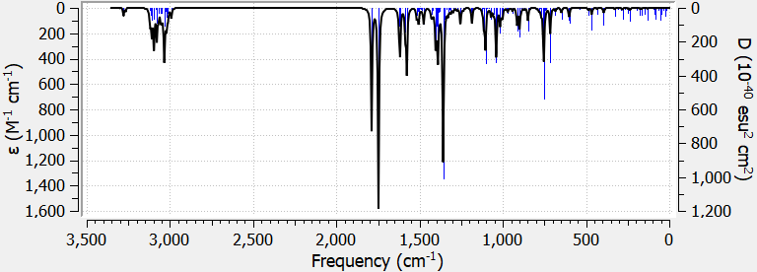

Fig. S2. 1H and 13C NMR spectrum of FTPF generated with CAM-B3LYP method at 6-31+G(d,p) basis set
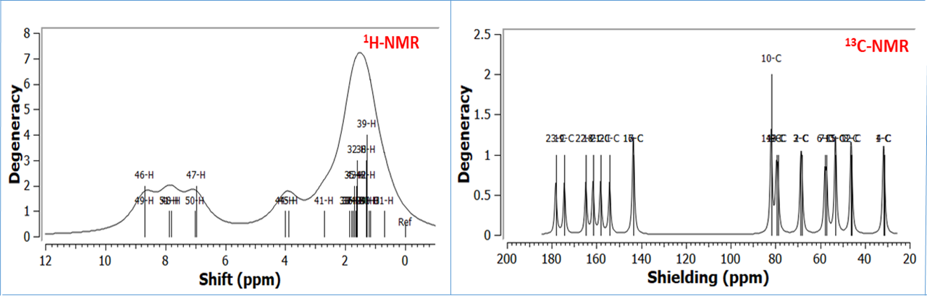

Table S1. Bond lengths of FTPF calculated with CAM-B3LYP method at 6-31+G(d,p) basis set.
Bonds | Bond Length (Å) | Bonds | Bond Length (Å) | Bonds | Bond Length (Å)
C₁ – C₂ | 1.4761 | C12 – C13 | 1.3768 | C₁₆ – H₄₄ | 1.0939
C₂ – C₃ | 1.4192 | C13 – C14 | 1.4269 | C₁₆ – H₄₅ | 1.0939
C₃ – C₄ | 1.4762 | C14 – C15 | 1.3660 | C₁₇ – H₄₃ | 1.1018
C₁ – N₅ | 1.4115 | C15 – O25 | 1.3617 | C₁₈ – H₄₁ | 1.0942
C₄ – N₅ | 1.4123 | C17 – O25 | 1.3757 | C₁₈ – H₄₂ | 1.0985
C₄– O₂₆ | 1.2217 | C16 – N5 | 1.4671 | C₁₉ – H₃₉ | 1.0942
C₁ – O₂₇ | 1.2283 | C16 – C17 | 1.5479 | C₁₉ – H₃₈ | 1.0958
C₂ –C₆ | 1.3785 | C17 – C18 | 1.5539 | C₁₉ – H₄₀ | 1.0967
C₂ –C₃ | 1.4172 | C18 – C19 | 1.5364 | C₂₀ – H₃₆ | 1.0974
C₃ – C₇ | 1.3784 | C17 – C20 | 1.5437 | C₂₀ – H₃₇ | 1.0977
C₆ – S₂₈ | 1.7657 | C20 – C21 | 1.5361 | C₂₁ – H₃₄ | 1.0981
C₇ – S₂₈ | 1.7655 | C21 – C22 | 1.5394 | C₂₁ – H₃₅ | 1.0991
C₆ – C₈ | 1.4347 | C22 – C23 | 1.5345 | C₂₂ – H₃₂ | 1.0990
C₈ – C₉ | 1.3769 | C9 – H49 | 1.0804 | C₂₂ – H₃₃ | 1.0980
C₉ – C₁₀ | 1.4270 | C10 – H50 | 1.0805 | C₂₃ – H₂₉ | 1.0949
C₁₀ – C₁₁ | 1.3660 | C11 – H51 | 1.0788 | C₂₃ – H₃₀ | 1.0956
C₈ – O₂₄ | 1.3758 | C13 – H46 | 1.0804 | C₂₃ – H₃₁ | 1.0972
C₁₁ – O₂₄ | 1.3616 | C14 – H47 | 1.0805
C₇ – C₁₂ | 1.4347 | C15 – H48 | 1.0788

Table S2. Bond Angles (º) of FTPF calculated with CAM-B3LYP method at 6-31+G(d,p) basis set.
Bonds | Bond Angle (º) | Bonds | Bond Angle (º) | Bonds | Bond Angle (º)
C₁ – C₂ – C₃ | 108.31 | C₈ – C₉ – H₄₉ | 124.98 | C₁ – N₅ – C₁₆ | 123.74
C₂ – C₃ – C₄ | 108.29 | C₈ – O₂₄ – C₁₁ | 107.12 | N₅ – C₁₆ – C₁₇ | 115.99
C₃ – C₄ – O₂₆ | 129.96 | O₂₄ – C₁₁ – H₅₁ | 115.78 | N₅ – C₁₆ – H₄₄ | 106.45
C₃ – C₄ – N₅ | 105.40 | C₉ – C₁₀ – H₅₀ | 127.14 | C₁₆ – C₁₇ – C₁₈ | 112.64
C₁ – N₅ – C₄ | 112.38 | C₉ – C₁₀ – C₁₁ | 106.54 | C₁₆ – C₁₇ – H₄₃ | 103.54
C₂ – C₁ – O₂₇ | 129.84 | C₁₀ – C₁₁ – H₅₁ | 133.77 | C₁₇ – C₁₈ – C₁₉ | 114.28
N₅ – C₁ – O₂₇ | 124.74 | C₃ – C₇ – C₁₂ | 130.21 | C₁₇ – C₁₈ – H₄₁ | 109.51
N₅ – C₄ – O₂₆ | 124.63 | C₇ – C₁₂ – C₁₃ | 133.42 | C₁₈ – C₁₉ – H₃₉ | 112.41
C₁ – C₂ – C₆ | 137.26 | C₇ – C₁₂ – O₂₅ | 116.95 | C₁₇ – C₂₀ – H₃₆ | 108.49
C₂ – C₆ – S₂₈ | 109.11 | C₁₂ – C₁₃ – H₄₆ | 124.93 | C₁₇ – C₂₀ – C₂₁ | 115.21
C₆ – S₂₈ – C₇ | 92.91 | C₁₂ – C₁₃ – C₁₄ | 106.28 | C₁₇ – C₂₀ – H₃₇ | 108.73
C₂ – C₃ – C₇ | 114.44 | C₁₃ – C₁₄ – H₄₇ | 127.14 | C₂₀ – C₂₁ – H₃₄ | 110.06
C₃ – C₇ – S₂₈ | 109.11 | C₁₂ – C₁₄ – C₁₅ | 106.54 | C₂₀ – C₂₁ – C₂₂ | 113.95
C₂ – C₆ – C₈ | 130.28 | C₁₄ – C₁₅ – H₄₈ | 133.77 | C₂₁ – C₂₂ – H₃₂ | 109.12
C₆ – C₈ – C₉ | 133.49 | O₂₅ – C₁₅ – H₄₈ | 115.79 | C₂₂ – C₂₃ – H₂₉ | 111.95
C₆ – C₈ – O₂₄ | 116.89 | O₂₅ – C₁₅ – C₁₄ | 110.44 | C₂₂ – C₂₃ – H₃₀ | 110.97

Table S3. Dihedral Angles (º) of FTPF calculated with CAM-B3LYP method at 6-31+G(d,p) basis set.
Bonds | Dihedral Angle (º) | Bonds | Dihedral Angle (º)
C₁ – C₂ – C₃ – C₄ | -0.044 | C₁₂ – C₁₃ – C₁₄ – C₁₅ | -0.04
C₁ – C₂ – C₃ – C₇ | -180.75 | C₁₂ – C₁₃ – C₁₄ – H₄₇ | -179.98
N₅ – C₁ – C₂ – C₃ | 2.654 | C₁₂ – O₂₅ – C₁₅ – H₄₈ | -179.97
O₂₇ – C₁ – C₂ – C₆ | 2.716 | O₂₅ – C₁₂ – C₇ – S₂₈ | 1.18
O₂₇ – C₁ – N₅ – C₄ | -185.38 | C₆ – C₈ – C₉ – H₄₉ | -0.03
O₂₆ – C₄ – C₃ - C₇ | -2.58 | C₆ – C₈ – C₉ – C₁₀ | -179.85
C₂ – C₃ – C₄ – O₂₆ | -183.52 | C₆ – C₈ – O₂₄ – C₁₁ | -180.11
C₂ – C₆ – S₂₈ – C₇ | 0.27 | C₈ – O₂₄ – C₁₁ – H₅₁ | -180.02
C₆ – S₂₈ – C₇ – C₃ | -0.31 | C₈ – O24 – C₁₁ – C₁₀ | -0.03
C₆ – S₂₈ – C₇ – C₁₂ | -180.51 | H₅₀ – C₁₀ – C₁₁ – H₅₁ | 0.05
C₇ – C₁₂ – C₁₃ – C₁₄ | -180.23 | O₂₄ – C₈ – C₆ – S₂₈ | -1.12
C₇ – C₁₂ – C₁₃ – H₄₆ | -0.05

