Analysis of Multiple Pesticides Residues in Market Samples of Okra and Associated Dietary Risk Assessment for Consumers
Syeda Nazish Ali¹, Nazia Rafique¹, Shazia Akhtar¹, Touqeer Taj¹, Farrakh Mehboob^{1*}
¹ Ecotoxicology Research Program, IPEP, NARC, Islamabad, Pakistan

*Corresponding Author(s):
Farrakh Mehboob
Postal Address: Ecotoxicology Research Program, IPEP,
National Agriculture Research Center, Park Road, Islamabad, Pakistan.
Phone No. +92-51-90733230
Fax: +92-51-9255034
E-mail: farrakhmehboob@parc.gov.pk
Supplementary Information
Table S1: List of selected pesticides, the target pests and comparison of Maximum Residual Limits (MRLs) of different countries for the selected pesticides in Okra
Sr. # | Pesticides | Category | Pest (s) | Maximum Residual Limits (MRLs)
 |  |  |  | EU | US-FDA | FAO Codex | Thai Agricultural Standard | Canada | Hong Kong |  | Japan | ASEAN
 | Acetamiprid | I | Jassid (leafhoppers) | 0.2 | 0.2 | NA | NA | NA | NA | 1 |  | NA
 | Bifenthrin | I | Jassid, Mites, Fruit borers | 0.2 | 0.5 | NA | NA | 0.5 | 0.5 | NA |  | NA
 | Carbendazim | F | - | 2 | NA | NA | NA | NA | 2 | 3 |  | NA
 | Carbofuran | I | Root-knot Nematodes | 0.002 | NA | NA | 0.15 | NA | NA | 0.5 |  | NA
 | α-Cypermethrin | I | Shoot and fruit borer | 0.5 | NA | 0.5 | 0.5 | NA | NA | 0.2 |  | 0.03
 | Dimethoate | I | Aphid, Jassid, Mites | 0.01 | NA | NA | NA | NA | NA | 1 |  | NA
 | Ethion | I | Leaf Hopper, Fruit Borer | 0.01 | NA | NA | NA | NA | NA | 0.3 |  | NA
 | Fipronil | I | Fruit Borer | 0.005 | NA | NA | NA | NA | NA | NA |  | NA
 | Flonicamid | I | Aphid, White fly | 0.03 | 3 | NA | NA | 3 | NA | 0.4 |  | NA
 | Flusilazol | F | - | 0.01 | NA | NA | NA | NA | NA | NA |  | NA
 | Hexaconazole | F | - | 0.01 | NA | NA | NA | NA | NA | NA |  | NA
 | Imidacloprid | I | Fruit Borers, Jassid | 0.5 | 1 | NA | NA | 1 | NA | 0.7 |  | NA
 | Indoxacarb | I | Fruit Borers | 0.02 | 0.5 | NA | NA | NA | NA | NA |  | NA
 | Methomyl | I | Shoot and fruit borers, Jassid | 0.01 | NA | NA | 0.5 | NA | NA | NA |  | NA
 | Monocrotophos | I | Fruit Borers, bugs | 0.01 | NA | NA | NA | NA | NA | 0.05 |  | 0.5
 | Profenofos | I | Shoot and fruit borers | 0.01 | NA | NA | NA | NA | NA | NA |  | NA
 | Pyridaben | I | Mites, white flies | 0.01 | NA | NA | NA | NA | NA | NA |  | NA
 | Spinosade | I | Fruit Borers | 0.02 | 0.4 | NA | NA | 0.4 | NA | NA |  | NA
 | Thiacloprid | I | Jassid | 0.01 | NA | NA | NA | NA | NA | NA |  | NA
 | Thiamethoxam | I | Jassid | 0.01 | NA | NA | NA | 0.25 | NA | 0.7 |  | NA
 | Triazophos | I | Fruit borers | 0.01 | NA | NA | NA | NA | NA | NA |  | NA
F; Fungicide, I; Insecticide; NA; Not available, ASEAN; Association of Southeast Asian Nations

Table S2: Spiked concentrations (mg/kg) of pesticides for method validation in Okra
Sr. # | Compound Name | EU MRL (mg/kg) | Spiked Concentration (mg/kg)
Sr. # | Compound Name | EU MRL (mg/kg) | Level 1 | Level 2 | Level 3
 | Acetamiprid | 0.2 | 0.05 | 0.1 | 0.5
 | Bifenthrin | 0.2 | 0.1 | 0.2 | 1
 | Carbendazim | 2 | 0.025 | 0.05 | 0.25
 | Carbofuran | 0.002 | 0.002 | 0.004 | 0.02
 | α-Cypermethrin | 0.5 | 0.05 | 0.1 | 0.5
 | Dimethoate | 0.01 | 0.005 | 0.01 | 0.05
 | Ethion | 0.01 | 0.005 | 0.01 | 0.05
 | Fipronil | 0.005 | 0.0025 | 0.005 | 0.025
 | Flonicamid | 0.03 | 0.015 | 0.03 | 0.15
 | Flusilazol | 0.01 | 0.005 | 0.01 | 0.05
 | Hexaconazole | 0.01 | 0.005 | 0.01 | 0.05
 | Imidacloprid | 0.5 | 0.25 | 0.5 | 2.5
 | Indoxacarb | 0.02 | 0.01 | 0.02 | 0.1
 | Methomyl | 0.01 | 0.005 | 0.01 | 0.05
 | Monocrotophos | 0.01 | 0.005 | 0.01 | 0.05
 | Profenofos | 0.01 | 0.005 | 0.01 | 0.05
 | Pyridaben | 0.01 | 0.005 | 0.01 | 0.05
 | Spinosade | 0.02 | 0.01 | 0.02 | 0.1
 | Thiacloprid | 0.01 | 0.005 | 0.01 | 0.05
 | Thiamethoxam | 0.01 | 0.005 | 0.01 | 0.05
 | Triazophos | 0.01 | 0.005 | 0.01 | 0.05

Table S3: Method linearity for targeted pesticides in Okra
Sr. # | Pesticides | Linearity in Solvent Standards | Linearity in MMS
 | Acetamiprid | 0.999 | 0.999
 | Bifenthrin | 0.999 | 0.999
 | Carbendazim | 0.999 | 0.999
 | Carbofuran | 0.999 | 0.999
 | α-Cypermethrin | 0.999 | 0.999
 | Dimethoate | 0.998 | 0.999
 | Ethion | 0.999 | 0.999
 | Fipronil | 0.999 | 0.999
 | Flonicamid | 0.993 | 0.992
 | Flusilazol | 0.999 | 0.999
 | Hexaconazole | 0.999 | 0.998
 | Imidacloprid | 0.999 | 0.999
 | Indoxacarb | 0.999 | 0.998
 | Methomyl | 0.999 | 0.999
 | Monocrotophos | 0.999 | 0.999
 | Profenofos | 0.999 | 0.999
 | Pyridaben | 0.999 | 0.999
 | Spinosade | 0.999 | 0.999
 | Thiacloprid | 0.999 | 0.999
 | Thiamethoxam | 0.999 | 0.999
 | Triazophos | 0.999 | 0.999
MMS; Matrix Matched Standards
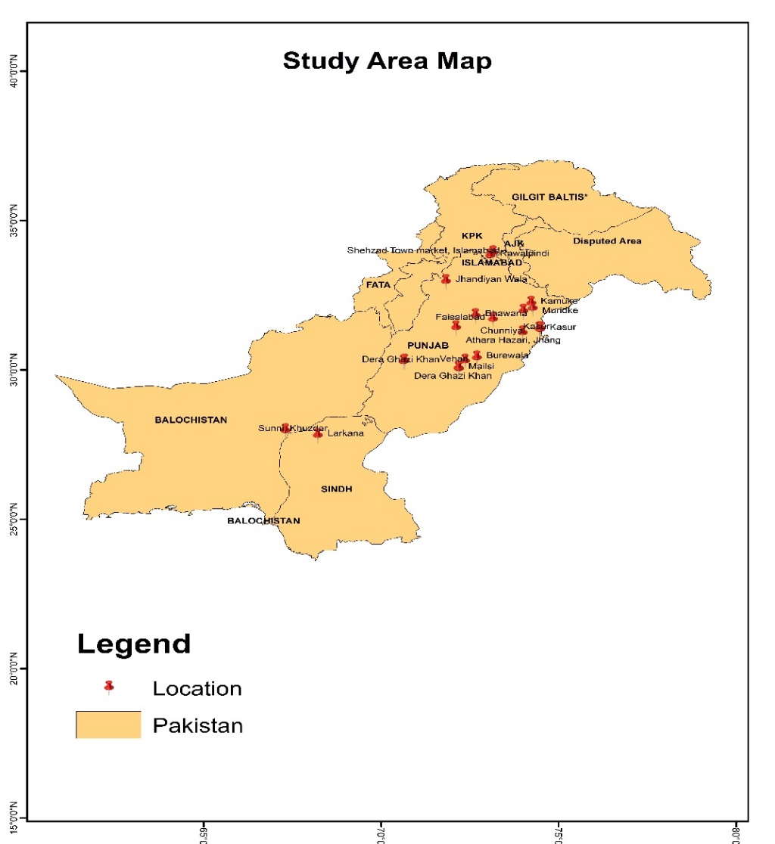
Fig.S1: Map of okra sampling locations

