Supplementary figures and figure legends
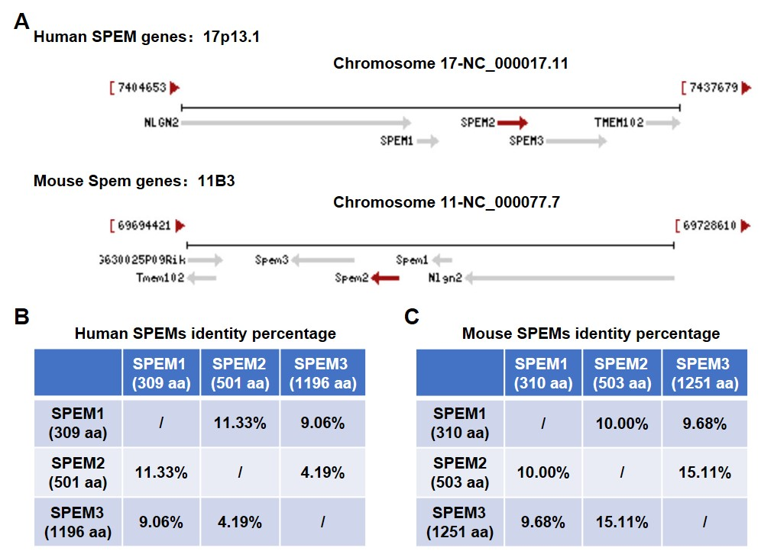
Supplementary Fig. S1 Chromosomal localization of the three SPEM genes and sequence homology of the three SPEM proteins in humans and mice. A The SPEM1, SPEM2, and SPEM3 genes are located adjacent to each other on the same chromosome in a gene-cluster-like manner in both humans and mice. B Sequence homology among human SPEM1, SPEM2, and SPEM3 proteins. C Sequence homology among mouse SPEM1, SPEM2, and SPEM3 proteins.

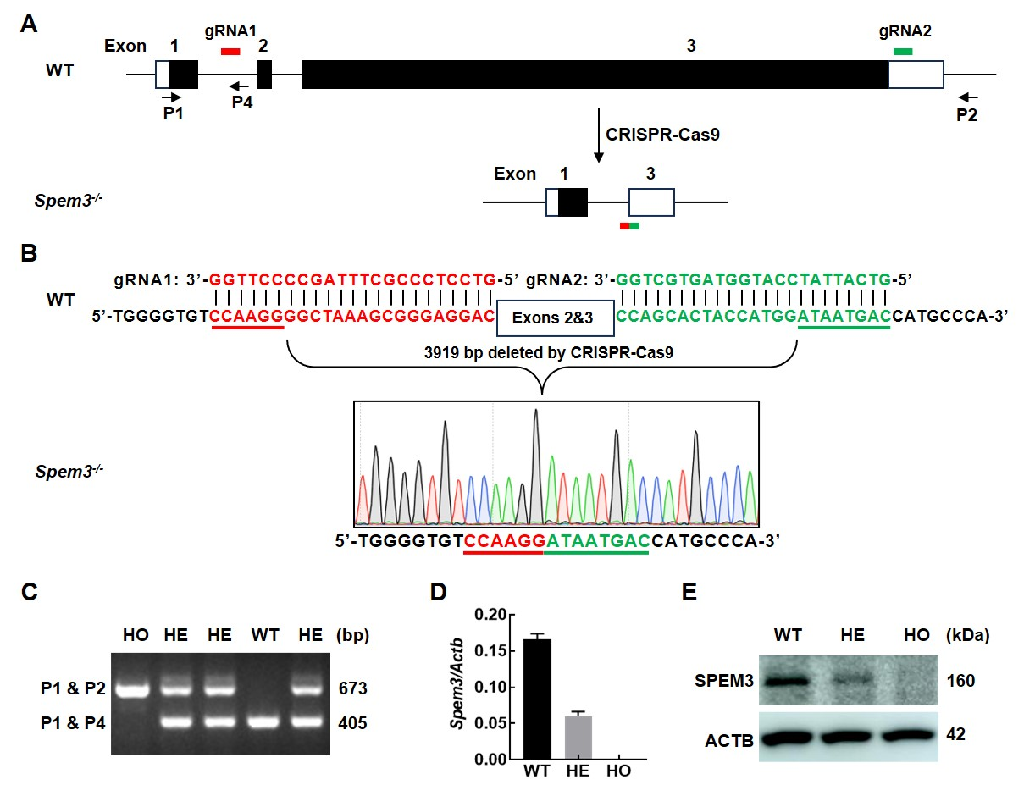
Supplementary Fig. S2 Generation of Spem3 knockout mice. A Schematic of the Spem3 gene knockout strategy. Guide RNAs (gRNAs) were designed targeting intron 1 and exon 3, leading to Cas9-mediated deletion of a 3919-bp fragment encompassing exon 2 and most of exon 3, thereby functionally inactivating the Spem3 gene. B Complementary pairing between the gRNAs and the wild-type (WT) genomic sequence, and validation of the 3919-bp deletion in Spem3^{-/-} mice by sequencing. C PCR genotyping of the obtained mice. A WT band of 405 bp was amplified using primers P1 and P4; a homozygous (HO) band of 673 bp was amplified using primers P1 and P2. Heterozygous (HE) mice showed both bands. D qPCR analysis of Spem3 mRNA expression levels in testis tissues of WT, HE, and HO mice. Actb was used as an internal control for relative quantification. E Western blot detection of SPEM3 protein levels in testis tissues of WT, HE, and HO mice. ACTB served as a loading control.

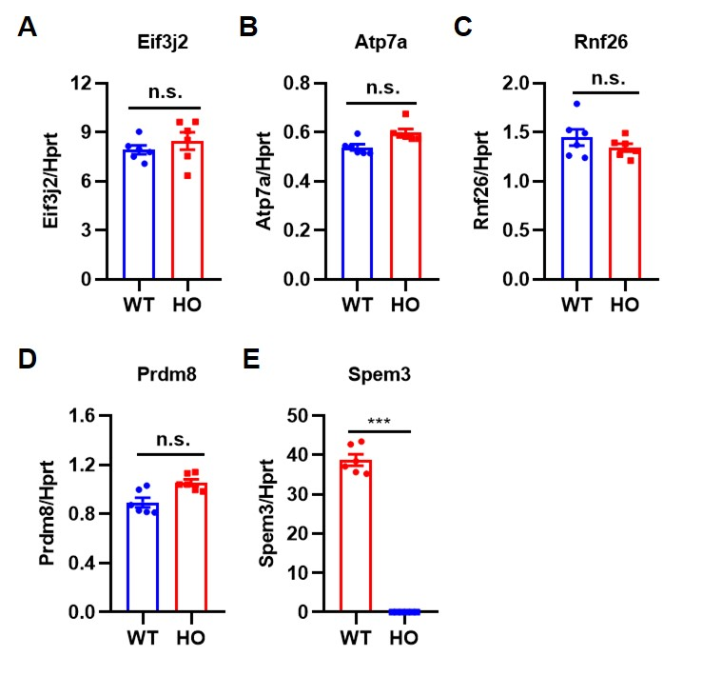
Supplementary Fig. S3 qPCR validation of five differentially expressed genes (DEGs) identified by mRNA sequencing. The relative expression levels of Eif3j2 (A), Atp7a (B), Rnf26 (C), Prdm8 (D), and Spem3 (E) in the seminiferous tubules of 8-week-old WT and Spem3-HO mice were measured by qPCR. Hprt was used as an internal reference gene.

