Climate adaptation pathways for agri-food systems: a conceptual framework for scalable application
Supplementary Information

Roberto O. Valdivia, Valeria Di Fant, Simona Pedde, Edmond Totin

Supplementary Figure 1. National agricultural pathways under SSP4 (Inequality): Benin.
To further test the relevance of SSPs to the available solution space, we compare the pathways map for Benin in SSP5 to one in SSP4. Under SSP4, we imagine that only the most cost-effective low-regret measures would be plausible for Benin, such as seasonal forecast, early warning systems and traditional forms of irrigation. In the medium-term, measures compatible with the Technological Intensification Strategy would exist globally (e.g. in the Netherlands), but would remain largely inaccessible in Benin due to capacity and inequality constraints. Climate adaptation in Benin would thus need to rely on crop diversification, soil health improvements and traditional knowledge. The combination of these measures would grant some resilience, but their limits will most probably be reached in the mid-term already. Relocation of agricultural zones (and reliance on export) or of people (through migration) would be valuable in principle for the long-term, but neither are plausible under an SSP4 scenario, given limited governance capacity and inequitable access to international trade. Overall, in an SSP scenario world adaptation pathways globally would be highly fragmented, with high-capacity actors (e.g. global agribusiness) advancing, while vulnerable groups remain exposed to growing climate impacts and associated agricultural production loss.
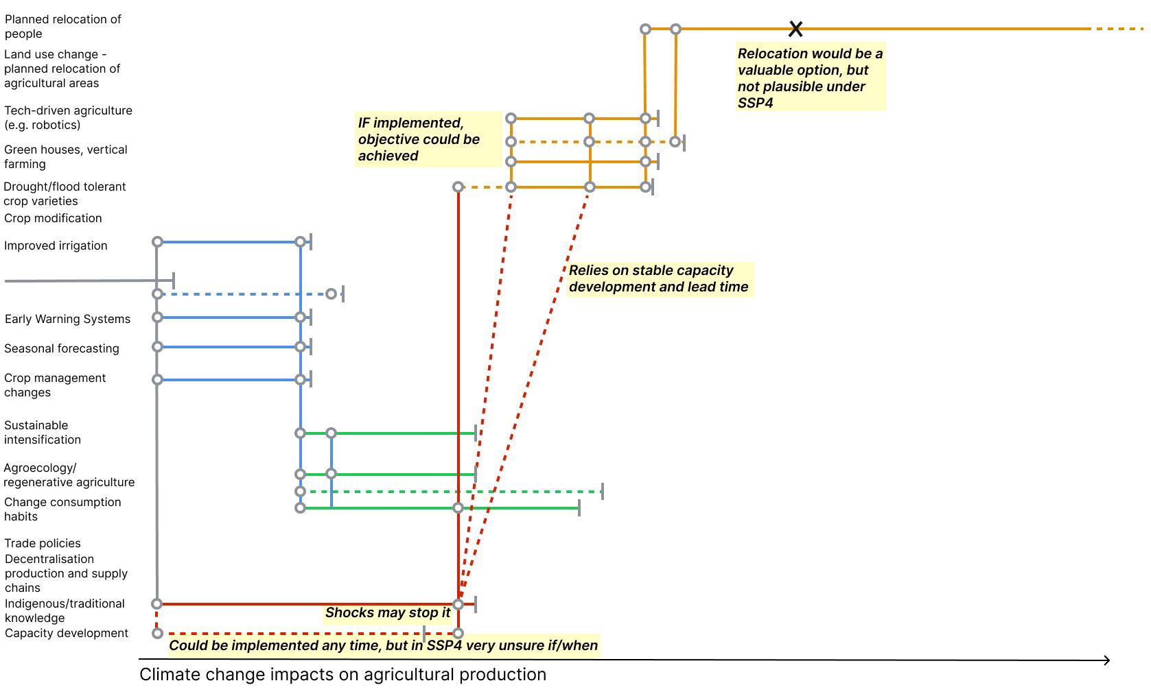
Supplementary Figure 1: Pathways map of Benin under SSP4.

Supplementary Figure 2. Direction of transformation of measures in the adaptation pathways map (Global - SSP1).
This figure showcases the adaptation pathways map of Figure 1 in the main text

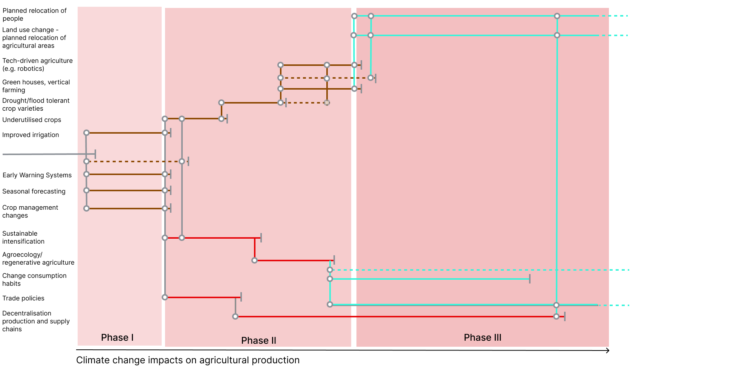
Supplementary Figure 2: Adaptation pathways map for agri-food systems under growing climate change impacts, providing information on direction of transformation of included measures. Line colours indicate whether the direction of transformation implied for the implementation of each measure is hold (in brown), bend (red) or shift (light-blue).

Supplementary Table 1. Key concepts used in the Framework
This table summarizes the main concepts used in the framework and clarifies how terms such as SSPs/scenarios, worldviews, guiding principles, and adaptation pathways are used and related in this study. It is included to support consistent interpretation of the framework and its application to agri-food systems.

Term | What it is | Main purpose | Typical question it answers | Example in the context of the paper
SSPs (Scenarios) | Alternative socioeconomic futures | To describe plausible future development contexts | What kind of future world are we in? | SSP1, SSP3, SSP5 as different socioeconomic futures affecting governance, inequality, technology, trade, etc.
Worldviews | Broader societal logics, value systems, or interpretive lenses | To characterize how societies think about risk, governance, technology, equity, nature, etc. | What underlying logic or social outlook shapes responses? | Egalitarian, hierarchical, market-led, fatalistic types of societal orientation
Guiding / organizing principles | Dimensions used to structure and compare adaptation options | To organize the analysis in a consistent way | Along what dimensions do we compare strategies? | Technological vs nature-based; hold–bend–shift; incremental vs systemic vs transformational
Pathways | Sequences of actions or strategies over time under changing conditions | To show how adaptation unfolds over time, including shifts and thresholds | How do decisions and measures evolve over time? | Moving from early warning systems and crop management to irrigation, then to system redesign or relocation

Supplementary Table 2. Guiding principles considered for structuring adaptation pathways
This table summarizes the guiding principles discussed in Garschagen et al. (submitted) and considered in the development of adaptation pathways. The principles shown in bold are those applied in this study. Together, these principles capture different dimensions along which adaptation pathways can be compared and structured, including the depth and direction of transformation, the intensity of effort, agility and flexibility, equity, the balance between technological and nature-based approaches, and the primary risk component targeted.

Guiding principle | Description | Categories
Depth of transformation | Captures the extent of change pursued. In SSP1, deep early transformation is plausible; in SSP3, adaptation may be piecemeal and defensive. Direction can be framed using clear archetypes (e.g., advance, protect, retreat, accommodate) rather than abstract “depth” labels. | Incremental adjustments
Depth of transformation |  | Systemic shifts
Depth of transformation |  | Transformational restructuring
Direction of transformation | Captures the type of change pursued. Initially described in coastal adaptation as advance, protect, retreat, accommodate, here more broadly described. | New categories here
Intensity of effort | Reflects how much capital, institutional capacity, and political will is committed to adaptation. High-intensity pathways (full-in) deploy large investments rapidly; low-intensity pathways spread limited action over time. This is a key differentiator across SSPs, with SSP5 enabling rapid tech-driven intensification and SSP4 showing disparities in who can afford such intensity. | High intensity
Intensity of effort |  | Low intensity
Agility and flexibility | Indicates the ability to adjust strategies as conditions change. Agility is about speed of learning and iteration, while flexibility concerns whether measures are rigid and locked-in (e.g., large, fixed infrastructure) or modular and adjustable (e.g., adaptive governance, NbS). SSP1 and SSP2 worlds may prioritize adaptive management, while SSP3’s political fragmentation may limit agility. | High agility
Agility and flexibility |  | Low agility
Equity | Equity can be embedded into the design of adaptation strategies (procedural and distributive justice from the outset) or treated as an explicit outcome goal. SSP4’s inequality narrative illustrates the risk of high adaptation performance for some but exclusion of others; SSP1 aligns equity with transformation from the start | Equity in process
Equity |  | Equity in outcome
Technological - Nature-based balance | Considers the degree of reliance on grey/technological infrastructure (e.g., robotics, vertical farming) versus nature-based solutions (e.g., agroecology, regenerative practices). The balance varies by SSP and affects co-benefits for mitigation, biodiversity, and resilience.
Risk component focus | Clearly define whether a pathway reduces hazard (e.g., climate-smart infrastructure), exposure (e.g., relocation, decentralization), or vulnerability (e.g., poverty reduction, livelihood diversification). This focus helps align adaptation with impact modelling needs. | Hazard
Risk component focus |  | Exposure
Risk component focus |  | Vulnerability

Supplementary Table 3. Extended list of adaptation measures considered for agri-food systems
This table lists the adaptation measures considered in the study, their plausible timing of implementation (short-, medium-, or long-term), the adaptation strategy or strategies with which they align (Technological Adaptation, System Redesign, and Structural and Institutional Strategy), and a short description of what each measure entails. Measures shown in italics were discussed during the expert workshop and included in the adaptation pathways presented in this paper.

Adaptation measure | Timing | Relevant adaptation strategies | Description
Drought/flood-tolerant crop varieties | Medium | TA | Breeding and deploying crop varieties with enhanced drought tolerance.
Climate-resilient livestock breeds | Medium | TA | Developing and raising animal breeds adapted to heat and disease stress.
Conservation agriculture | Medium | SR | No-till, cover cropping, and crop rotations to improve soil health.
Agroforestry | Medium | SR | Integrating trees with crops or livestock for shade and soil conservation.
Integrated soil fertility management | Short | No-regret | Combining organic and inorganic amendments to optimize soil nutrients.
Integrated pest management | Short | No-regret | Leveraging biological, cultural, and chemical controls to reduce pests.
Crop-livestock integration | Medium | TA; SR | Coordinating crop and animal production for nutrient cycling benefits.
Livelihood diversification (off-farm activities) | Short | SR | Generating income through non-agricultural enterprises.
Index-based insurance | Short | TA; S&I | Payouts triggered by predefined climate indices to buffer losses.
Early warning systems | Short | No-regret | Real-time alerts for extreme weather events to inform preparedness.
Seasonal forecasting | Short | No-regret | Predicting seasonal climate trends to guide planting and resource use.
Improved irrigation (drip, sprinkler) | Medium | No-regret | Installing efficient water-delivery systems to reduce water stress.
Rainwater harvesting | Medium | TA; SR | Capturing and storing runoff for supplemental irrigation.
Climate information services | Short | TA | Delivering weather and climate advisories via digital platforms.
Extension services & capacity building | Short | SR; S&I | Training farmers on adaptive practices and new technologies.
Financial incentives (subsidies, carbon credits) | Short | S&I | Subsidies or credits to encourage adoption of adaptive investments.
Crop management changes | Short | No-regret | Adjusting planting dates, densities, and variety mixes for resilience.
Increased use of underutilised (opportunity) crops | Medium | TA | Promoting nutrient-rich minor crops to diversify diets and income.
Regenerative agriculture | Long | SR | Practices that rebuild soil organic matter and ecosystem function.
Trade policies | Medium | S&I | Adjusting tariffs and quotas to stabilize food supply and prices.
Agroecology | Long | SR | Applying ecological principles across the farming system.
Greenhouses | Medium | TA | Protected cultivation to manage temperature, humidity, and pests.
Vertical farming | Medium | TA | Stacked indoor systems to grow crops with minimal land footprint.
Floating farms | Long | TA | Hydroponic systems on waterways to expand cultivation area.
Robotics & AI in Agriculture | Long | TA | Automated machinery and AI tools for precision farming operations.
Change in consumption habits | Short | S&I | Shifting diets toward less resource-intensive foods.
Decentralization of production & supply chains | Medium | S&I | Localizing food systems to reduce transport risks and increase access.
Planned relocation of people | Long | S&I | Moving vulnerable populations away from high-risk agricultural zones.
Land use change | Long | S&I | Reassigning land to more climate-suitable agricultural uses.
Relocation of agricultural areas | Long | S&I | Shifting farming zones to match future climate suitability.

Supplementary Table 4. Guiding principles and adaptation measures.

This table classifies the shortlisted adaptation measures along the hold–bend–shift continuum used in the paper to distinguish their depth and direction of transformation. Hold measures refer to incremental adjustments that aim to maintain existing production systems and reduce near-term vulnerability; bend measures involve more systemic changes that reconfigure practices, markets, or institutions while remaining broadly within existing system structures; and shift measures imply deeper transformations that alter the configuration of agri-food systems, including land use, supply chains, or patterns of consumption. The classification is illustrative and intended to support comparison of measures and pathways across different worldviews and contexts.

Adaptation measure | Adaptation transformation type
Drought/flood-tolerant crop varieties | Bend
Early warning systems | Hold
Seasonal forecasting | Hold
Improved irrigation (drip, sprinkler) | Hold
Crop management changes | Hold
Increased use of underutilized (opportunity) crops | Bend
Regenerative agriculture | Bend
Trade policies | Bend
Agroecology | Bend
Greenhouses | Hold
Vertical farming | Hold
Robotics & AI in agriculture | Hold
Change in consumption habits | Shift
Decentralization of production & supply chains | Bend
Planned relocation of people | Shift
Land use change | Shift
Relocation of agricultural areas | Shift

Supplementary Table 5. Selected global and regional agri-food system initiatives and actors relevant to adaptation pathways
This table provides an overview of selected global and regional initiatives, programmes, and organizations relevant to agri-food systems transformation, climate adaptation, food security, and related policy, research, finance, and innovation agendas. It includes information on the lead organization(s), regional or geographic scope, type of initiative, and website. The table is illustrative rather than exhaustive and is intended to situate the proposed framework within the broader landscape of actors and initiatives shaping agri-food adaptation and transformation across scales.
Initiative / Program | Lead Organization(s) | Region / Scope | Type | Website
Sustainable Development Goals (SDGs – SDG2, 1, 13, 15 ) | United Nations | Global | Policy framework | https://sdgs.un.org
UN Food Systems Coordination Hub | United Nations (FAO-led) | Global | Policy / coordination | https://www.unfoodsystemshub.org
CGIAR (One CGIAR Initiatives) | CGIAR system | Global | Research / international organization | https://www.cgiar.org
FAO Strategic Framework | FAO | Global | Multilateral / policy | https://www.fao.org
World Bank Agriculture & Food | World Bank | Global | Finance / development | https://www.worldbank.org/en/topic/agriculture
IFAD Programs | IFAD | Global | Finance / development | https://www.ifad.org
Food and Land Use Coalition (FOLU) | Multi-stakeholder | Global | Policy / systems | https://www.foodandlandusecoalition.org
Climate-Smart Agriculture (CSA) | FAO, World Bank | Global | Policy / implementation | https://www.fao.org/climate-smart-agriculture
Global Methane Pledge | Governments | Global | Climate policy | https://www.globalmethanepledge.org
GODAN | GODAN Secretariat | Global | Data / platform | https://www.godan.info
50x2030 Initiative | FAO, World Bank, IFAD | Global | Data / capacity | https://www.50x2030.org
Gates Foundation | Bill & Melinda Gates Foundation | Global | Philanthropy | https://www.gatesfoundation.org
Bezos Earth Fund | Bezos Earth Fund | Global | Philanthropy | https://www.bezosearthfund.org
Rockefeller Foundation | Rockefeller Foundation | Global | Philanthropy | https://www.rockefellerfoundation.org
McKnight Foundation (CRFS) | McKnight Foundation | Africa / Andes/US | Philanthropy / research | https://www.mcknight.org
W.K. Kellogg Foundation | Kellogg Foundation | Global / Americas | Philanthropy | https://www.wkkf.org
FFAR | Foundation for Food & Agriculture Research | U.S. / Global | Philanthropy / research | https://foundationfar.org
The Nature Conservancy | TNC | Global | NGO / conservation | https://www.nature.org
Conservation International | Conservation International | Global | NGO | https://www.conservation.org
Action Against Hunger | ACF | Global | NGO | https://www.actionagainsthunger.org
Partners of the Americas | Partners Network | Americas / Africa | NGO / partnerships | https://www.partners.net
RedEAmérica | RedEAmérica | Latin America | Philanthropy network | https://www.redeamerica.org
AGRA | AGRA + donors | Africa | Development / philanthropy | https://agra.org
CAADP | African Union / NEPAD | Africa | Policy | https://www.nepad.org/caadp
Africa Food Systems Forum | Multi-stakeholder | Africa | Policy platform | https://agrf.org
Feed Africa Strategy | African Development Bank (AfDB) | Africa | Finance / development | https://www.afdb.org
ILRI Nutrition, health and food security | ILRI (CGIAR) | Africa | Research / Livestock | https://www.ilri.org
Vision for Adapted Crops and Soils (VACS) | Multiple Organizations | Africa/Global | Research | https://vacs.theplotline.org/#/?crop=africaneggplant&metric=yieldratio&model=future_ssp126
ADB Agriculture Programs | Asian Development Bank | Asia | Finance / development | https://www.adb.org
Grow Asia | WEF + ASEAN partners | Asia | Public-private platform | https://www.growasia.org
ASEAN Food Security Initiatives | ASEAN | Asia | Policy | https://asean.org
ASEAN-CGIAR Food Security | ASEAN + CGIAR (IRRI) | Asia | Research / policy | https://www.irri.org/node/2132
IRRI Programs | IRRI | Asia / Global | Research | https://www.irri.org
TAFSSA, Transforming Agri-Food Systems in South Asia | ARU-One CGIAR - Others | South Asia | Research / policy | https://www.aru.ac.uk/research/why-research-at-aru/sustainable-futures/transforming-agri-food-systems-in-south-asia-tafssa
SIGMA, Southeast Asia Innovation Alliance for a Global Model of Future Agri-food System | Multi-partner US-Singapore | Asia | Research | https://asc.illinois.edu/sigma/
ASSET, Agroecology and Safe Food System Transitions | Multi-partner, GRET, CIRAD | Asia | Policy / research | https://www.asset-project.org/
IICA Programs | IICA – Multi-country | Latin America | Regional development | https://www.iica.int
FONTAGRO | IDB + partners | Latin America | Research / innovation | https://www.fontagro.org
CELAC Food Security Plan | CELAC | Latin America | Policy | https://www.cepal.org/en
PLACA, Platform of Latin America and the Caribbean for Climate Action on Agriculture | Governments + partners | Latin America | Climate / policy | https://accionclimaticaplaca.org/en/
Inter-American Development Bank (IDB) IDB Strategy+ | IDB | Latin America | Finance | https://www.iadb.org/en/who-we-are/institutional-strategy
Common Agricultural Policy (CAP) | European Commission | EU | Policy / finance | https://agriculture.ec.europa.eu/common-agricultural-policy_en
Farm to Fork Strategy | European Commission | EU | Policy | https://food.ec.europa.eu
Food 2030 | European Commission | EU | Research / policy | https://research-and-innovation.ec.europa.eu/research-area/environment/bioeconomy/food-systems/food-2030_en
Horizon Europe (Cluster 6) | European Commission | EU | Research funding | https://research-and-innovation.ec.europa.eu/funding/funding-opportunities/funding-programmes-and-open-calls/horizon-europe/cluster-6-food-bioeconomy-natural-resources-agriculture-and-environment_en
FABLE Consortium | SDSN | Global / EU nodes | Research / foresight | https://www.fableconsortium.org
Foresight4Food | Oxford, Wageningen & partners | Global | Research / foresight | https://foresight4food.net
AgMIP | Global network | Global | Research / foresight/ modeling | https://agmip.org
Global Research Alliance on Agricultural GHGs | Governments + research | Global | Research | https://globalresearchalliance.org

