APPENDICES
Appendix 1. STROBE Statement—Checklist of items that should be included in reports of cross-sectional studies
 | Item No | Recommendation | Page/Line
Title and abstract | 1 | (a) Indicate the study’s design with a commonly used term in the title or the abstract | Pag. 1 / 2, 5–6
Title and abstract | 1 | (b) Provide in the abstract an informative and balanced summary of what was done and what was found | Pag. 1 / 3–24
Introduction
Background/rationale | 2 | Explain the scientific background and rationale for the investigation being reported | Pag. 2 / 26–50; Pag. 3 / 51–61
Objectives | 3 | State specific objectives, including any prespecified hypotheses | Pag. 3 / 62–64
Methods
Study design | 4 | Present key elements of study design early in the paper | Pag. 4 / 65–79
Setting | 5 | Describe the setting, locations, and relevant dates, including periods of recruitment, exposure, follow-up, and data collection | Pag. 4 / 67–78; Pag. 4 / 80–88; Pag. 5 / 89–94
Participants | 6 | (a) Give the eligibility criteria, and the sources and methods of selection of participants | Pag. 5 / 89–94
Variables | 7 | Clearly define all outcomes, exposures, predictors, potential confounders, and effect modifiers. Give diagnostic criteria, if applicable | Pag. 5 / 95–114; Pag. 6 / 115–131
Data sources/ measurement | 8* | For each variable of interest, give sources of data and details of methods of assessment (measurement). Describe comparability of assessment methods if there is more than one group | Pag. 5 / 96–114; Pag. 6 / 117–131
Bias | 9 | Describe any efforts to address potential sources of bias | Pag. 7 / 140–155; Pag. 8 / 163–168
Study size | 10 | Explain how the study size was arrived at | Pag. 5 / 89–94; Pag. 9 / Line 185
Quantitative variables | 11 | Explain how quantitative variables were handled in the analyses. If applicable, describe which groupings were chosen and why | Pag. 6 / 116–131; Pag. 7 / 135–155
Statistical methods | 12 | (a) Describe all statistical methods, including those used to control for confounding | Pag. 6 / 132 – Pag. 7 / 155
Statistical methods | 12 | (b) Describe any methods used to examine subgroups and interactions | Pag. 7 / 145–155
Statistical methods | 12 | (c) Explain how missing data were addressed | Pag. 5 / 91–94
Statistical methods | 12 | (d) If applicable, describe analytical methods taking account of sampling strategy | Pag. 6 / 132–139
Statistical methods | 12 | (e) Describe any sensitivity analyses | Pag. 7 / 157 – Pag. 8 / 168
Results
Participants | 13* | (a) Report numbers of individuals at each stage of study—eg numbers potentially eligible, examined for eligibility, confirmed eligible, included in the study, completing follow-up, and analysed | Pag. 9 / 183–191; Appendix 5
Participants | 13* | (b) Give reasons for non-participation at each stage | Pag. 5 / 91–94
Participants | 13* | (c) Consider use of a flow diagram | Appendix 5
Descriptive data | 14* | (a) Give characteristics of study participants (eg demographic, clinical, social) and information on exposures and potential confounders | Pag. 9 / 185–199; Table 1 (Pag. 26)
Descriptive data | 14* | (b) Indicate number of participants with missing data for each variable of interest | Pag. 5 / 91–94
Outcome data | 15* | Report numbers of outcome events or summary measures | Pag. 9 / 185–199; Table 1 (Pag. 26)
Main results | 16 | (a) Give unadjusted estimates and, if applicable, confounder-adjusted estimates and their precision (eg, 95% confidence interval). Make clear which confounders were adjusted for and why they were included | Pag. 10 / 212–223; Table 2 (Pag. 27); Table 3 (Pag. 28)
Main results | 16 | (b) Report category boundaries when continuous variables were categorized | Pag. 6 / 118–122; Pag. 28 / Table 3
Main results | 16 | (c) If relevant, consider translating estimates of relative risk into absolute risk for a meaningful time period | Not applicable
Other analyses | 17 | Report other analyses done—eg analyses of subgroups and interactions, and sensitivity analyses | Pag. 10 / 224 – Pag. 11 / 254
Discussion
Key results | 18 | Summarise key results with reference to study objectives | Pag. 12 / 255–277
Limitations | 19 | Discuss limitations of the study, taking into account sources of potential bias or imprecision. Discuss both direction and magnitude of any potential bias | Pag. 15 / 335–357
Interpretation | 20 | Give a cautious overall interpretation of results considering objectives, limitations, multiplicity of analyses, results from similar studies, and other relevant evidence | Pag. 12 / 278 – Pag. 16 / 360
Generalisability | 21 | Discuss the generalisability (external validity) of the study results | Pag. 15 / 347–357
Other information
Funding | 22 | Give the source of funding and the role of the funders for the present study and, if applicable, for the original study on which the present article is based | Pag. 17 / 383

Appendix 2. Altitude Adjustment Factors for Hemoglobin Concentration
The altitude-adjusted hemoglobin (Hb) concentration was calculated as follows:
$$Hb_{adjusted}=Hb_{observed}-Adjustment_{altitude}$$
where the altitude correction factor was estimated using the CDC equation:
$$Adjustment_{altitude}=-0.032×alt+0.022×alt^{2}$$
with:
$$alt=\frac{Altitude (m)}{1,000}×3.3$$
This was based on the following Table S1.
Table S1. Altitude Adjustment Factors for Hemoglobin Concentration
Altitude (masl) | Adjustment factor (g/dL) | Adjusted hemoglobin calculation
<1000 | 0 | Hb adjusted = Hb observed
1000–1041 | 0.1 | Hb adjusted = Hb observed − 0.1
1042–1265 | 0.2 | Hb adjusted = Hb observed − 0.2
1266–1448 | 0.3 | Hb adjusted = Hb observed − 0.3
1449–1608 | 0.4 | Hb adjusted = Hb observed − 0.4
1609–1751 | 0.5 | Hb adjusted = Hb observed − 0.5
1752–1882 | 0.6 | Hb adjusted = Hb observed − 0.6
1883–2003 | 0.7 | Hb adjusted = Hb observed − 0.7
2004–2116 | 0.8 | Hb adjusted = Hb observed − 0.8
2117–2223 | 0.9 | Hb adjusted = Hb observed − 0.9
2224–2325 | 1 | Hb adjusted = Hb observed − 1.0
2326–2422 | 1.1 | Hb adjusted = Hb observed − 1.1
2423–2515 | 1.2 | Hb adjusted = Hb observed − 1.2
2516–2604 | 1.3 | Hb adjusted = Hb observed − 1.3
2605–2690 | 1.4 | Hb adjusted = Hb observed − 1.4
2691–2773 | 1.5 | Hb adjusted = Hb observed − 1.5
2774–2853 | 1.6 | Hb adjusted = Hb observed − 1.6
2854–2932 | 1.7 | Hb adjusted = Hb observed − 1.7
2933–3007 | 1.8 | Hb adjusted = Hb observed − 1.8
3008–3081 | 1.9 | Hb adjusted = Hb observed − 1.9
3082–3153 | 2 | Hb adjusted = Hb observed − 2.0
3154–3224 | 2.1 | Hb adjusted = Hb observed − 2.1
3225–3292 | 2.2 | Hb adjusted = Hb observed − 2.2
3293–3360 | 2.3 | Hb adjusted = Hb observed − 2.3
3361–3425 | 2.4 | Hb adjusted = Hb observed − 2.4
3426–3490 | 2.5 | Hb adjusted = Hb observed − 2.5
3491–3553 | 2.6 | Hb adjusted = Hb observed − 2.6
3554–3615 | 2.7 | Hb adjusted = Hb observed − 2.7
3616–3676 | 2.8 | Hb adjusted = Hb observed − 2.8
3677–3736 | 2.9 | Hb adjusted = Hb observed − 2.9
3737–3795 | 3 | Hb adjusted = Hb observed − 3.0
3796–3853 | 3.1 | Hb adjusted = Hb observed − 3.1
3854–3910 | 3.2 | Hb adjusted = Hb observed − 3.2
3911–3966 | 3.3 | Hb adjusted = Hb observed − 3.3
3967–4021 | 3.4 | Hb adjusted = Hb observed − 3.4
4022–4076 | 3.5 | Hb adjusted = Hb observed − 3.5
4077–4129 | 3.6 | Hb adjusted = Hb observed − 3.6
4130–4182 | 3.7 | Hb adjusted = Hb observed − 3.7
4183–4235 | 3.8 | Hb adjusted = Hb observed − 3.8
4236–4286 | 3.9 | Hb adjusted = Hb observed − 3.9
4287–4337 | 4 | Hb adjusted = Hb observed − 4.0
4338–4388 | 4.1 | Hb adjusted = Hb observed − 4.1
4389–4437 | 4.2 | Hb adjusted = Hb observed − 4.2
4438–4487 | 4.3 | Hb adjusted = Hb observed − 4.3
4488–4535 | 4.4 | Hb adjusted = Hb observed − 4.4
4536–4583 | 4.5 | Hb adjusted = Hb observed − 4.5
4584–4631 | 4.6 | Hb adjusted = Hb observed − 4.6
4632–4678 | 4.7 | Hb adjusted = Hb observed − 4.7
4679–4725 | 4.8 | Hb adjusted = Hb observed − 4.8
4726–4771 | 4.9 | Hb adjusted = Hb observed − 4.9
4772–4816 | 5 | Hb adjusted = Hb observed − 5.0
masl: meters above sea level; Hb: hemoglobin.
Source of Health Ministry: https://cdn.www.gob.pe/uploads/document/file/3115430/Guia%20Tecnica.pdf?v=1653052987
Appendix 3. Directed Acyclic Graph for the study
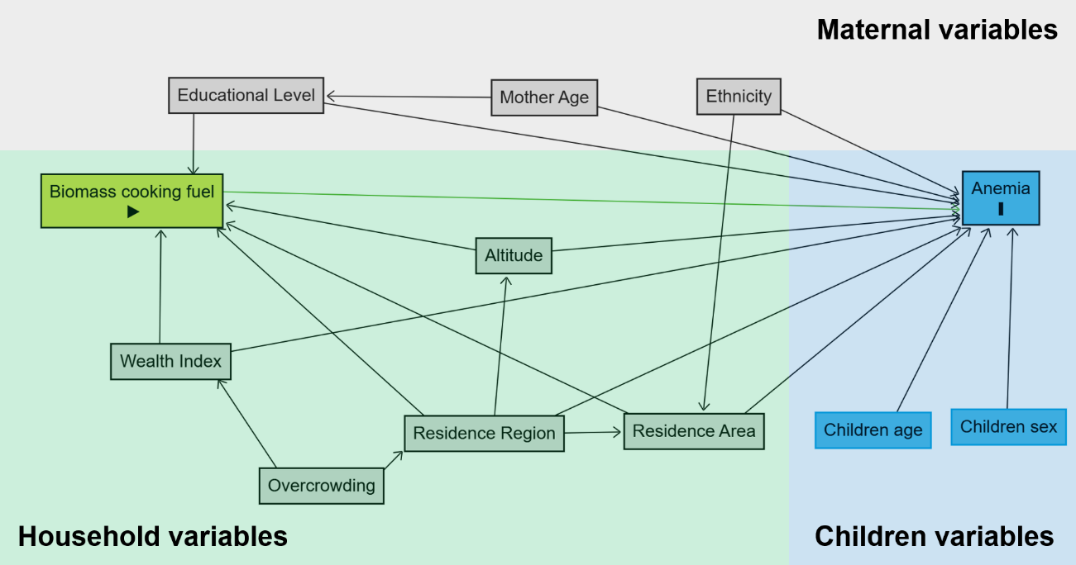

Appendix 4. Altitude levels across 25 Peruvian regions
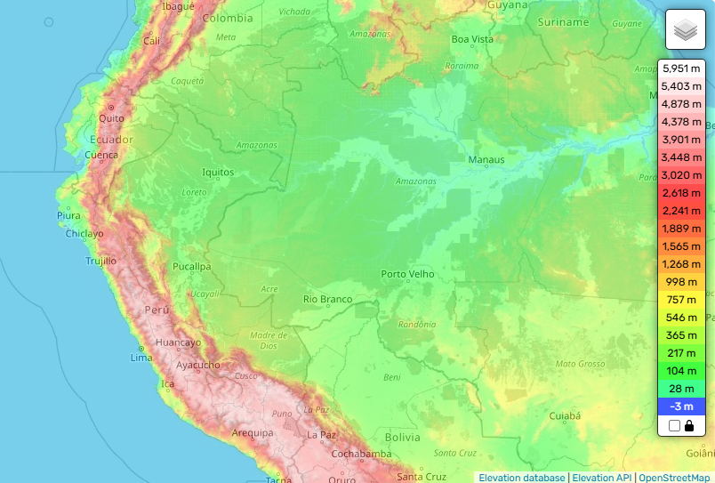
Source: Topographic interactive map of Peru that show altitude in meters above the sea level specially in highlands (https://en-gb.topographic-map.com/map-d8nnh/Peru/).

Appendix 5. Flowchart selection for the study population, ENDES 2017-2024
Population included in the 2017–2024 DHSs
(n = 162,511)
Peruvian children under five years old in the
2017–2024 DHSs
(n = 140,086)
Exclusion criteria:
- Participants without Hb measure (n=20,632)
- Mothers younger than 18 years old (n=1,793)
2017 DHS
(n = 21,545)
2018 DHS
(n = 23,154)
2019 DHS
(n = 21,144)
2020 DHS
(n = 12,953)
2021 DHS
(n = 21,951)
2022 DHS
(n = 21,529)
2023 DHS
(n = 20,707)
2024 DHS
(n = 19,528)

Appendix 6. Annual
Table S2. Characteristics and their distribution according to the anemia status in Peruvian children under five years old, ENDES 2017-2024
Variable | Anemia Status |  | P
Variable | No  n (%) | Yes  n (%) | P
Maternal characteristic
Age (years)* | 31.3 ± 6.6 | 30.0 ± 7.1 | <0.001
Educational level
None/Primary | 16,383 (61.4) | 10,914 (38.6) | <0.001
Secondary | 42,211 (66.2) | 24,132 (33.8)
Higher | 33,700 (75.1) | 12,746 (24.9)
Ethnicity†
Mestizo/White | 47,434 (72.2) | 20,326 (27.8) | <0.001
Indigenous/Afroperuvian | 38,709 (63.1) | 24,519 (36.9)
Household characteristics
Place of residence
Urban | 67,787 (71.4) | 30,402 (28.6) | <0.001
Rural | 24,507 (59.9) | 17,390 (40.1)
Natural region
Metropolitan Lima | 12,807 (75.8) | 4,197 (24.2) | <0.001
Rest of the coast | 30,809 (73.5) | 11,241 (26.5)
Highlands | 26,817 (59.9) | 18,700 (40.1)
Jungle | 21,861 (62) | 13,654 (38)
Poverty estatus?
No | 45,706 (74.9) | 16,575 (25.1) | <0.001
Yes | 46,588 (61.5) | 31,217 (38.5)
Household overcrowding
No | 58,888 (70.7) | 27,355 (29.3) | <0.001
Yes | 33,405 (64.5) | 20,436 (35.5)
Biomass cooking fuel exposure?
No | 72,577 (70.8) | 33,390 (29.2) | <0.001
Yes | 19,717 (59.2) | 14,402 (40.8)
Altitude of residence?
Low (<2500 masl) | 70,805 (71.8) | 30,956 (28.2) | <0.001
High (≥2500 masl) | 21,489 (56.9) | 16,836 (43.1)
Child characteristics
Child age (months)* | 35.9 ± 14.5 | 25.9 ± 15.8 | <0.001
Sex
Male | 45,895 (67) | 25,348 (33) | <0.001
Female | 46,399 (69.9) | 22,444 (30.1)
95%CI: Confidence Interval at 95%; masl: meters above sea level.
*Mean and standard deviation.
† Percentages for ethnicity were calculated excluding missing values (n=130,988).
Note: The estimates were weighted by the complex sample in ENDES.

Appendix 7.

Table S3. Effect modification of the association between biomass cooking fuel exposure and anemia by high altitude residence in Peruvian children under five years old from households without a separate room for kitchen, ENDES 2017-2024
 | Biomass cooking fuel exposure |  |  |  | Association between anemia with biomass according to altitude residence
 | No |  | Yes
High altitude residence? | n (%)* | PRa (95%CI) | n (%)* | PRa (95%CI) | PRa (95%CI)
No (<2500 masl) | 18,688 (85.8) | REF | 4,504 (14.2) | 1.68 (01.48 to 1.87) | 1.11 (1.05 to 1.18)
Yes (≥2500 masl) | 4,113 (73.5) | 1.11 (1.05 to 1.17) | 2,073 (26.5) | 1.59 (1.39 to 1.78) | 0.95 (0.88 to 1.03)*
Measure of effect modification on additive scale: RERI = −0.20 (95%CI: −0.33 to −0.07; p=0.002).
Measure of effect modification on multiplicative scale: PRa: 0.85 (95%CI: 0.78 to 0.93; p<0.001).

Table S4. Effect modification of the association between biomass cooking fuel exposure and anemia by high altitude residence in Peruvian children under five years old from households without windows, ENDES 2017-2024
 | Biomass cooking fuel exposure |  |  |  | Association between anemia with biomass according to altitude residence
 | No |  | Yes
High altitude residence? | n (%)* | PRa (95%CI) | n (%)* | PRa (95%CI) | PRa (95%CI)
No (<2500 masl) | 6,575 (84.7) | REF | 5,206 (15.3) | 1.40 (1.18 to 1.62) | 1.11 (1.03 to 1.19)
Yes (≥2500 masl) | 1,451 (64.5) | 1.10 (1.03 to 1.18) | 3,194 (35.5) | 1.26 (1.07 to 1.45) | 0.89 (0.80 to 0.99)
Measure of effect modification on additive scale: RERI = −0.24 (95%CI: −0.38 to −0.10; p=0.001).
Measure of effect modification on multiplicative scale: PRa: 0.82 (95%CI: 0.74 to 0.91; p<0.001).

95%CI: Confidence Interval at 95%; PRa: Prevalence Ratio adjusted by child age, sex, maternal age, area and region of residence, wealth index, household overcrowding, educational level, and ethnicity; REF: Category used as a reference for estimating the measure of association between the variables; RERI: relative excess risk due to interaction; masl: meters above sea level.
*The row percentages were weighted estimation for the complex sampling design of ENDES.

Table S5. Estimations for models with continuous variables
Variable | Linear Model |  | Non-Linear Model
Variable | β | 95%CI | β | 95%CI
Household characteristics
Biomass cooking fuel exposure
No | REF |  | REF
Yes | -0.094 | -0.131 to -0.056 | -0.093 | -0.185 to -0.001
Altitude of residence  (per each 1,000 masl) | -0.164 | -0.193 to -0.136
Spline 1 |  |  | 0.428 | 0.353 to 0.503
Spline 2 |  |  | 0.219 | 0.043 to 0.395
Spline 3 |  |  | -1.120 | -1.26 to -0.981
Spline 4 |  |  | -1.650 | -1.79 to -1.51
Place of residence
Urban | REF |  | REF
Rural | 0.028 | 0.002 to 0.055 | -0.019 | -0.043 to 0.005*
Natural region
Metropolitan Lima | REF |  | REF
Rest of the coast | 0.024 | 0.000 to 0.049* | 0.005 | -0.021 to 0.032*
Highlands | 0.176 | 0.089 to 0.262 | -0.017 | -0.123 to 0.089*
Jungle | -0.112 | -0.144 to -0.081 | -0.234 | -0.264 to -0.204
Poverty estatus?
No | REF |  | REF
Yes | -0.149 | -0.170 to -0.129 | -0.127 | -0.146 to -0.107
Household overcrowding
No | REF |  | REF
Yes | -0.004 | -0.020 to 0.012* | -0.003 | -0.019 to 0.013*
Child characteristics
Age (per each +1 month)* | 0.014 | 0.014 to 0.015 | 0.014 | 0.014 to 0.015
Sex
Male | REF |  | REF
Female | 0.098 | 0.084 to 0.113 | 0.097 | 0.083 to 0.112
Maternal characteristic
Age (per each +1 year) | 0.010 | 0.009 to 0.011 | 0.010 | 0.009 to 0.011
Educational level
None/Primary | REF |  | REF
Secondary | 0.058 | 0.036 to 0.080 | 0.058 | 0.037 to 0.079
Higher | 0.196 | 0.171 to 0.221 | 0.191 | 0.167 to 0.216
Ethnicity
Mestizo/White | REF |  | REF
Indigenous/Afroperuvian | -0.079 | -0.096 to -0.062 | -0.062 | -0.079 to -0.046
β: beta coefficient; 95%CI: Confidence Interval at 95%; masl: meters above sea level; REF: Category used as a reference for estimating the measure of association between the variables.
Note: Estimates were obtained using survey-weighted linear regression models accounting for the complex sampling design of ENDES 2017–2024.
Appendix 8. Alternative models with continuous variables for evaluating the association between adjusted hemoglobin concentration and characteristics related to Peruvian children under five years old, ENDES 2017–2024
In the linear model the multiplicative scale of interaction term between biomass cooking fuel exposure and altitude is significant (β=0.052; 95%CI: 0.037 to 0.067; p<0.001). In non-linear splines model only spline 1 (β=0.236; 95%CI: 0.109 to 0.363; p<0.001), spline 2 (β=0.155; 95%CI: 0.016 to 0.295; p=0.029), and spline 4 (β=0.434; 95%CI: 0.252 to 0.616; p<0.001) are significant.

Appendix 9. Predicted margins of adjusted hemoglobin concentration according to residence altitude and biomass cooking fuel exposure in Peruvian children under five years old, ENDES 2017-2024
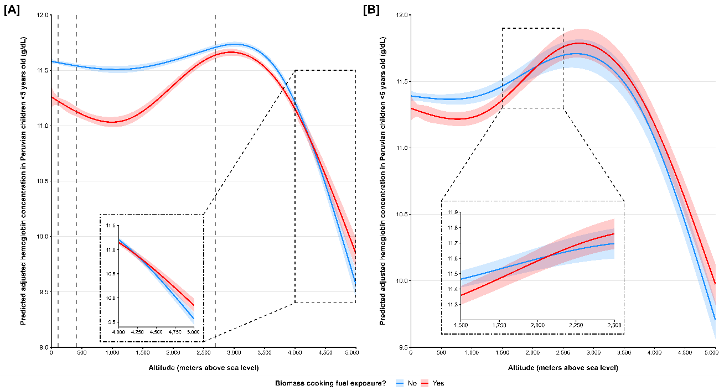
A. Crude non-linear splines model for detailing the spline 1 (altitude=107 masl), spline 2 (altitude=414 masl), and spline 3 (altitude=2,694 masl) for residence altitude.
B. Crude non-linear splines model for assess de interaction and curve modification at 2,500 masl in Peruvian children under five years old.
Appendix 10. Annual estimation of association and interaction between anemia and biomass cooking fuel exposure with altitude in Peruvian children under five years old, ENDES 2017-2024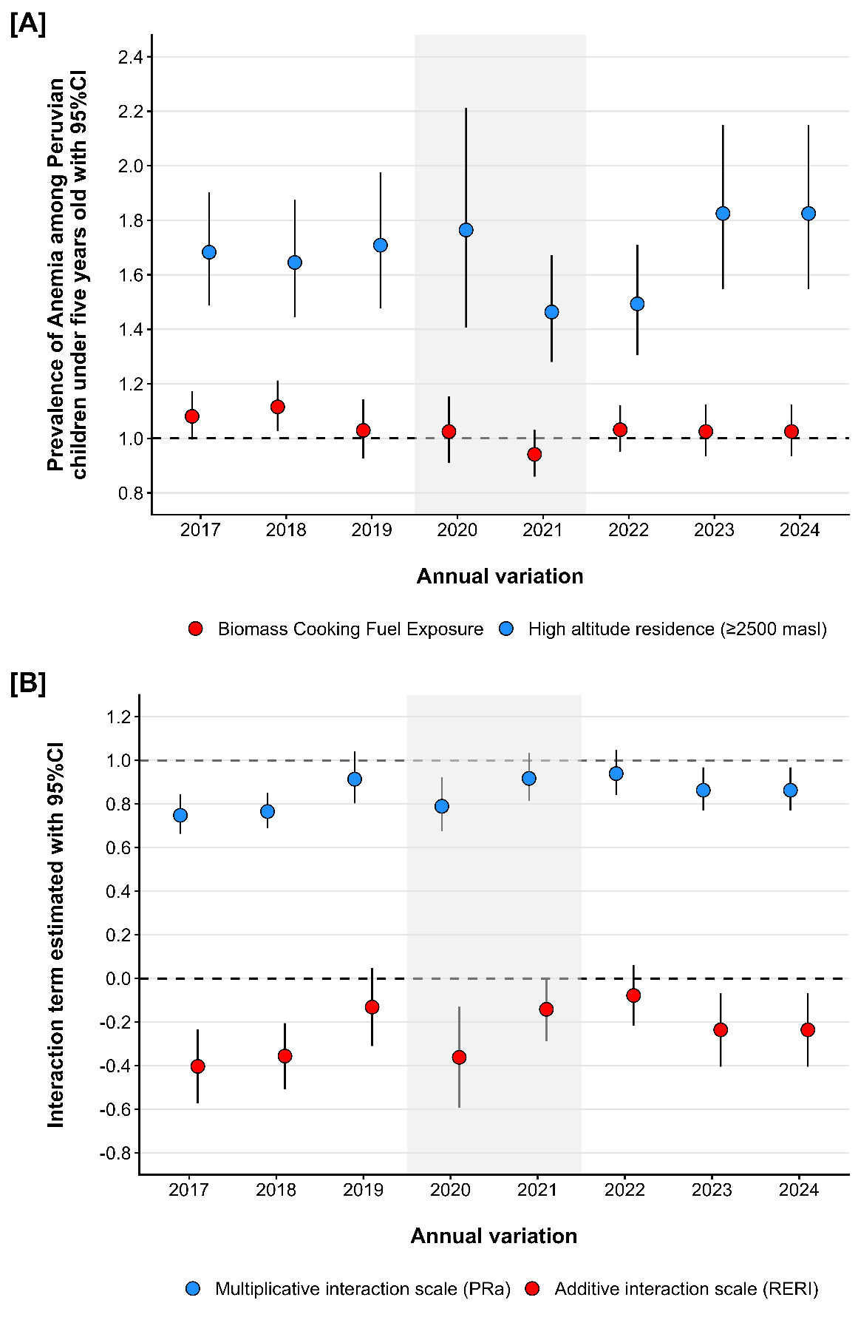
masl: meters above sea level; 95%CI: Confidence Interval at 95%; PRa: Prevalence Ratio adjusted by child age, sex, maternal age, area and region of residence, wealth index, household overcrowding, educational level, and ethnicity; RERI: relative excess risk due to interaction.
Appendix 11. Multicollinearity in the regression models with interaction term for variables in Peruvian children under five years old, ENDES 2017-2024
Table S6. Multicollinearity in Poisson regression model for dichotomous variables
Variable | VIF | 1/VIF
Household characteristics
Biomass cooking fuel exposure
No | REF
Yes | 2.85 | 0.35
Altitude of residence
Low (<2500 masl) | REF
High (≥2500 masl) | 5.38 | 0.19
Place of residence
Urban | REF
Rural | 1.85 | 0.54
Natural region
Metropolitan Lima | REF
Rest of the coast | 2.48 | 0.40
Highlands | 6.36 | 0.16
Jungle | 2.76 | 0.35
Poverty Status
No | REF
Yes | 1.86 | 0.67
Household overcrowding
No | REF
Yes | 1.13 | 0.87
Child characteristics
Age (per each +1 month)* | 1.02 | 0.98
Sex
Male | REF
Female | 1.00 | 1.00
Maternal characteristic
Age (per each +1 year) | 1.14 | 0.88
Educational level
None/Primary | REF
Secondary | 2.22 | 0.45
Higher | 2.62 | 0.37
Ethnicity
Mestizo/White | REF
Indigenous/Afroperuvian | 1.23 | 0.81
VIF: Variance Inflation Factor; REF: Category used as a reference for estimating the measure of association between the variables.
The VIF for the interaction term was 3.07, while mean VIF was 2.43

Table S7. Multicollinearity in Poisson regression model for continuous variables
Variable | VIF
Household characteristics
Biomass cooking fuel exposure
No | REF
Yes | 31.99
Altitude of residence
(per each 1,000 masl)
Spline 1 | 2.24
Spline 2 | 18.21
Spline 3 | 5.52
Spline 4 | 9.12
Place of residence
Urban | REF
Rural | 1.88
Natural region
Metropolitan Lima | REF
Rest of the coast | 2.71
Highlands | 15.69
Jungle | 3.05
Poverty estatus?
No | REF
Yes | 1.88
Household overcrowding
No | REF
Yes | 1.14
Child characteristics
Age (per each +1 month)* | 1.02
Sex
Male | REF
Female | 1.00
Maternal characteristic
Age (per each +1 year) | 1.14
Educational level
None/Primary | REF
Secondary | 2.23
Higher | 2.62
Ethnicity
Mestizo/White | REF
Indigenous/Afroperuvian | 1.26
VIF: Variance Inflation Factor; REF: Category used as a reference for estimating the measure of association between the variables.
The VIF for the interaction term in spline 1 (VIF=4.19), spline 2 (VIF=10.09), spline 3 (VIF=19.81), and spline 4 (VIF=6.40).

