Appendix A: Ablation Study Graph
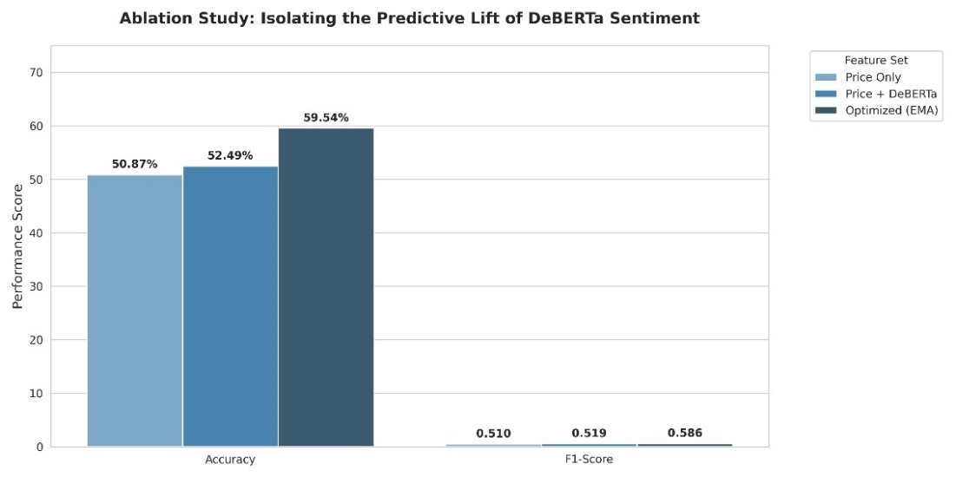

Appendix B: Top 15 Feature Sentiment Dominance

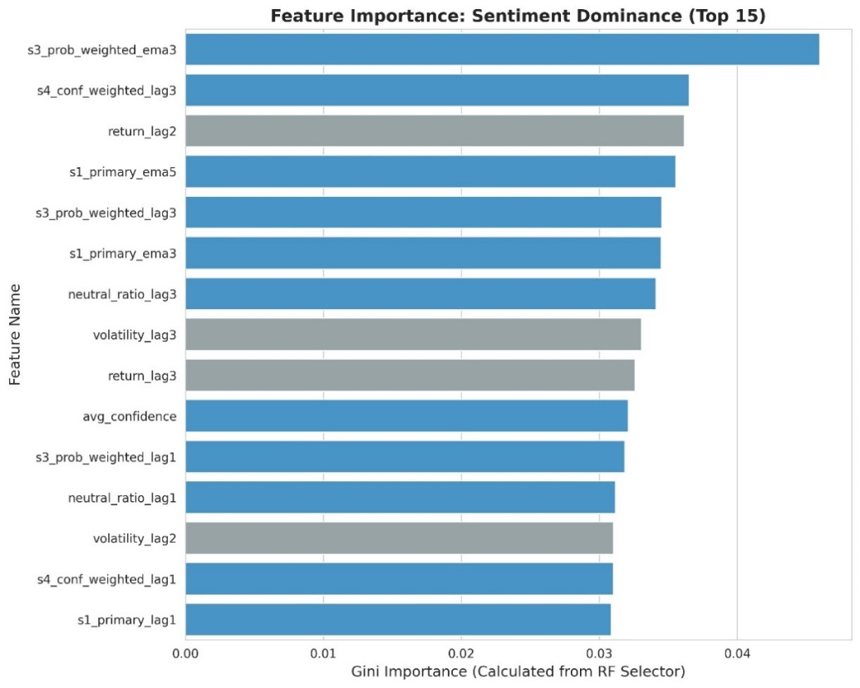

Appendix C: Sentiment Correlation Graph

