Supplemental Materials
Supplemental Methods
Acquisition Methods and Parameters for PET/CMR
[⁶⁸Ga]Ga-FAPI-04 PET imaging started approximately 60 minutes post-injection. The PET scan covered the thoracic region, focusing on the heart, with an acquisition time of 40-45 minutes. The PET scan was performed as a volumetric scan with a field of view of 300 and a matrix size of 150×150. The reconstruction was done using the ordered subset expectation maximization algorithm with 4 iterations and 20 subsets. Simultaneously, CMR imaging was performed with a 12-channel phased array body surface coil and a 24-channel phased array spine coil. PET and CMR images were acquired with respiratory gating signals recorded simultaneously, and only data collected during the end-expiratory phase were used to reconstruct the PET images. The CMR imaging parameters were a field of view of 500×350 mm, a matrix of 493×384, an acquisition resolution of 0.91×0.91×2 mm³, a repetition time of 4.91 ms, an echo time of 2.24/3.19 ms, a flip angle of 10°, and an acquisition time of 150 s. Sequences included balanced steady-state free precession for cine imaging, T2-weighted imaging, T1-weighted imaging, T1 mapping (naïve and post-contrast), T2 mapping, and LGE imaging post-contrast administration. Gadopentetate dimeglumine (Magnevist; Bayer HealthCare, Wayne, NJ, 0.15 mmol/kg) was used as the contrast agent for LGE imaging, administered intravenously approximately 10-15 minutes before the LGE sequence.

The Control Group
The control group consisted of healthy volunteers who underwent [⁶⁸Ga]Ga-FAPI PET/CMR at our institution during the same period for research purposes unrelated to atrial fibrillation. All controls were free of known cardiovascular disease, hypertension, diabetes mellitus, or systemic inflammatory disorders, and none had a history of cardiac surgery or ablation. Inclusion criteria for the control group were: (1) age- and sex-matched to AF patients; (2) normal left atrial and ventricular structure and function on CMR; (3) normal electrocardiogram findings. Exclusion criteria included: (1) prior cardiovascular disease or cardiac intervention; (2) systemic autoimmune or inflammatory disease; (3) renal insufficiency or contraindication to MRI; and (4) poor image quality or motion artifacts.

The criteria for referral to radiofrequency ablation treatment
Patients were referred for catheter ablation if they met the following criteria: 1) Symptomatic paroxysmal or persistent atrial fibrillation refractory or intolerant to at least one class I or III antiarrhythmic drug; 2) Absence of contraindications to ablation or severe structural heart disease (e.g., significant valvular disease or marked atrial enlargement); 3) Preserved or mildly reduced left ventricular systolic function and no evidence of advanced atrial remodeling on echocardiography or CMR; 4)Willingness to undergo ablation and provide written informed consent. All procedures were performed after multidisciplinary review and in accordance with the 2020 ESC Guidelines for the Diagnosis and Management of AF[1].

The definitions of six regions in left atrial myocardium
- LAAW: left atrial anterior wall, the region between the atrial appendage and the atrial septum.
- LAPW: left atrial posterior wall, the myocardial area between the left and right pulmonary veins.
- AS: atrial septum, the septum of the left and right atria.
- Left PVs: left pulmonary veins.
- Right PVs: right pulmonary veins.
- LALW: left atrial lateral wall, the curved myocardial region between atrial appendage anteriorly and left pulmonary veins posteriorly.

Supplemental Tables
Supplemental Table 1. Results of Reproducibility Analysis
Parameter | Inter-observer ICC (95% CI) | Intra-observer ICC (95% CI)
LA SUV_{max} | 0.87 (0.68–0.96) | 0.88 (0.71–0.95)
LA SUV_{mean} | 0.96 (0.92–0.98) | 0.92 (0.81–0.97)
LA SV (cm³) | 0.82 (0.58–0.93) | 0.79 (0.46–0.92)
LA SFA | 0.78 (0.50–0.91) | 0.83 (0.49–0.94)
GLRS (%) | 0.89(0.73–0.96) | 0.96(0.91–0.98)
GLCdS ( %) | 0.92(0.76–0.97) | 0.90(0.74–0.96)
GLCtS (%) | 0.80(0.56–0.92) | 0.90(0.76–0.96)
SRs (%) | 0.86(0.67–0.94) | 0.88(0.72–0.95)
SRe (%) | 0.92(0.81–0.97) | 0.84(0.62–0.94)
SRa (%) | 0.90(0.76–0.96) | 0.80(0.54–0.92)
EAT Volume(mL) | 0.77(0.50–0.90) | 0.89(0.53–0.95)
Abbreviations: SUV_{max}: maximum standardized uptake value; SUV_{mean}: mean standardized uptake value; SV: surface volume; SFA: surface fibroblast activity; ICC: intraclass correlation coefficient; LA: left atrium; GLRS: global longitudinal reservoir strain; GLCdS: global longitudinal conduit strain; GLCtS: global longitudinal contractile strain; SRs: peak positive strain rate; SRe: early peak negative strain rate; SRa: late peak negative strain rate; EAT: epicardial adipose tissue.

Supplemental Table 2. Clinical characteristics and CMR parameters based on different AF type
 | paroxysmal AF(n=19） | persistent  AF(n=12) | p-value
Demographics
Age (y) | 69.2 ± 6.7 | 69.1 ± 4.3 | 0.49
Male, n (%) | 10(52.3%) | 8(66.6%) | 0.29
Height (m) | 1.6 ± 0.1 | 1.7 ± 0.1 | 0.29
Weight (kg) | 68.1 ± 12.7 | 76.0 ± 11.9 | 0.05
BMI (kg/m²) | 25.6 ± 3.1 | 28.5 ± 3.9 | 0.01
BSA (m²) | 1.7 ± 0.2 | 1.9 ± 0.2 | 0.03
Smoking, n (%) | 2(10.3%) | 3(25.0%) | 0.37
AF
No recurrence:Recurrence | 13:6 | 5:7
Duration of AF (y) | 2.0(1.0~6.0) | 5.5(1.5~10.5) | 0.04
Comorbidities
HTN, n (%) | 14 (73.7%) | 10 (83.3%) | 0.69
DM, n (%) | 6 (31.5%) | 5 (41.7%) | 0.73
CVD, n (%) | 5 (26.3%) | 3 (25.0%) | 0.99
HLD, n (%) | 4 (21.1%) | 2(16.7) | 0.99
Risk score
CHA2DS2-VASc | 3.0 ± 1.2 | 3.4 ± 0.9 | 0.40
CHA2DS2-VA | 2.5 ± 1.2 | 3.1 ± 1.2 | 0.15
HAS-BLED | 1.4 ± 0.8 | 1.5 ± 0.5 | 0.09
CMR Parameters
LV
LVEF (%) | 60.9 ± 10.7 | 58.6 ± 6.4 | 0.26
LVEDV (mL) | 133.6 ± 36.5 | 129.8 ± 39.6 | 0.39
LVESV (mL) | 54.4 ± 27.4 | 53.3 ± 17.4 | 0.45
GCS (%) | -19.8 ± 6.9 | -21.5 ± 4.2 | 0.24
GLS (%) | -12.9 ± 5.4 | 14.3 ± 4.4 | 0.23
Short-axis GRS (%) | 37.1 ± 16.3 | 33.5 ± 8.3 | 0.26
Long-axis GRS (%) | 32.3 ± 18.6 | 31.8 ± 12.2 | 0.47
EAT Volume (mL) | 161.1 ± 46.6 | 165.9 ± 50.3 | 0.39
EAT Vi (ml/m²) | 92.3 ± 21.7 | 79.3 ± 32.1 | 0.09
T1-native (ms) | 1181.4 ± 75.3 | 1140.6 ± 97.6 | 0.11
T1-post-contrast (ms) | 534.5 ± 52.7 | 539.1 ± 42.0 | 0.40
ECV (%) | 35.9 ± 7.1 | 34.0 ± 4.8 | 0.23
RV
RVEF (%) | 51.9 ± 16.5 | 51.8 ± 9.9 | 0.49
RVEDV (mL) | 111.7 ± 51.2 | 120.9 ± 50.4 | 0.32
RVESV (mL) | 56.0 ± 41.7 | 58.6 ± 28.7 | 0.43
Abbreviations: BMI: body mass index; BSA: body surface area; AF: atrial fibrillation; HTN: hypertension; DM: diabetes mellitus; CAD: coronary artery disease; HLD: hyperlipidemia; LVEF: left ventricle ejection fraction; LVEDV: left ventricle end-diastolic volume; LVESV: left ventricle end-systolic volume; GCS: global circumferential strain; GLS: global longitudinal strain; GRS: global radial strain; EAT: epicardial adipose tissue; EAT Vi: epicardial adipose tissue volume index; RVEF: right ventricle ejection fraction; RVEDV: right ventricle end-diastolic volume; RVESV: right ventricle end-systolic volume.

Supplemental Table 3. Clinical characteristics and CMR parameters based on recurrence
 | No recurrence  (n=18） | Recurrence  (n=13) | p-value
Demographics
Age (y) | 68.5 ± 6.5 | 70.0 ± 4.9 | 0.24
Male, n (%) | 12(66.7%) | 5 (38.5%)
Height (m) | 1.6 ± 0.1 | 1.7 ± 0.1 | 0.26
Weight (kg) | 70.5 ± 12.2 | 72.1 ± 14.0 | 0.37
BMI (kg/m²) | 26.0 ± 3.2 | 27.8 ± 4.1 | 0.09
BSA (m²) | 1.7 ± 0.2 | 1.8 ± 0.2 | 0.25
Smoking, n (%) | 2 (11.1%) | 3 (23.1%) | 0.66
AF
AF type  (Paroxysmal: persistent) | 13:5 | 6:7
Duration of AF (y) | 1.0(0.5~3.0) | 6(3.1~9.0) | 0.003
Comorbidities
HTN, n (%) | 14 (77.8%) | 10 (76.9%) | 0.99
DM, n (%) | 6 (33.3%) | 5 (38.5%) | 0.99
CVD, n (%) | 4 (22.2%) | 4 (30.8%) | 0.71
HLD, n (%) | 4 (22.2%) | 2(15.4%) | 0.68
Risk score
CHA2DS2-VASc | 2.8 ± 1.2 | 3.6 ± 0.8 | 0.02
CHA2DS2-VA | 2.4 ± 1.3 | 3.2 ± 0.9 | 0.04
HAS-BLED | 1.5 ± 0.9 | 1.5 ± 0.5 | 0.44
CMR Parameters
LV
LVEF (%) | 59.0 ± 10.3 | 60.7 ± 8.9 | 0.31
LVEDV (mL) | 122.3 ± 47.0 | 138.9 ± 28.1 | 0.14
LVESV (mL) | 53.4 ± 32.6 | 54.5 ± 16.9 | 0.45
GCS (%) | -17.9 ± 6.9 | -21.9 ± 5.2 | 0.04
GLS (%) | -11.6 ± 5.2 | 14.5 ± 4.7 | 0.06
Short-axis GRS (%) | 31.2 ± 12.4 | 38.7 ± 14.5 | 0.08
Long-axis GRS (%) | 29.2 ± 15.3 | 33.9 ± 17.3 | 0.23
EAT Volume (mL) | 172.5 ± 46.5 | 156.5 ± 47.8 | 0.18
EAT Vi (mL/m²) | 87.3 ± 32.9 | 87.7 ± 21.8 | 0.48
T1-native (ms) | 1165.9 ± 122.5 | 1165.5 ± 62.6 | 0.49
T1-post-contrast (ms) | 520.1 ± 54.9 | 544.3 ± 44.0 | 0.11
ECV (%) | 33.8 ± 4.1 | 35.8 ± 7.2 | 0.22
RV
RVEF (%) | 48.85 ± 14.4 | 53.9 ± 14.2 | 0.17
RVEDV (mL) | 118.5 ± 62.9 | 112.8 ± 41.6 | 0.38
RVESV (mL) | 65.4 ± 50.9 | 51.3 ± 23.8 | 0.15
Abbreviations: BMI: body mass index; BSA: body surface area; AF: atrial fibrillation; HTN: hypertension; DM: diabetes mellitus; CAD: coronary artery disease; HLD: hyperlipidemia; LVEF: left ventricle ejection fraction; LVEDV: left ventricle end-diastolic volume; LVESV: left ventricle end-systolic volume; GCS: global circumferential strain; GLS: global longitudinal strain; GRS: global radial strain; EAT: epicardial adipose tissue; EAT Vi: epicardial adipose tissue volume index; RVEF: right ventricle ejection fraction; RVEDV: right ventricle end-diastolic volume; RVESV: right ventricle end-systolic volume.

Supplemental Table 4. Comparison of left atrial FAPI PET parameters between patients imaged ≤15 months and >15 months after ablation.
 | surgery-examination time interval  ＜15month(n=13) | surgery-examination time interval  ≥15month(n=18) | p-value
PET parameters
LA SUVmax | 1.48 ± 0.30 | 1.46 ± 0.27 | 0.41
LA SUVmean | 0.888 ± 0.22 | 0.82 ± 0.18 | 0.21
LA SV (cm³) | 32.90 ± 8.30 | 37.65 ± 11.61 | 0.11
LA SFA | 37.00 ± 10.78 | 40.50 ± 13.47 | 0.13
EAT SUVmean | 0.55 ± 0.25 | 0.55 ± 0.22 | 0.47
EAT FA | 89.87 ± 37.71 | 110.62 ± 54.95 | 0.13
Abbreviations: LA: left atrium; SUV_{max}: maximum standardized uptake value; SUV_{mean}; mean standardized uptake value; SV: surface volume; SFA: surface fibroblast activity; EAT: epicardial adipose tissue; FA: fibroblast activity.

Supplemental Table 5. Description of LA PET characteristics based on comorbidities
 |  | LA SUV_{max} |  | LA SUV_{mean} |  | LA SV (cm³) |  | LA SFA |  | EAT SUV_{mean} |  | EAT FA
 |  | Mean±  SD | p-value | Mean±  SD | p-value | Mean±  SD | p-value | Mean±  SD | p-value | Mean±  SD | p-value | Mean±  SD | p-value
HTN | YES  (n=24) | 1.47  ±  0.25 | 0.37 | 0.85  ±  0.18 | 0.41 | 35.25±  5.28 | 0.11 | 40.37±  13.08 | 0.13 | 0.55  ±  0.19 | 0.39 | 104.97±  50.41 | 0.27
 | NO  (n=7) | 1.43  ±  0.37 |  | 0.83  ±  0.26 |  | 31.40±  9.57 |  | 34.47±  8.61 |  | 0.57  ±  0.34 |  | 91.45±  45.15
DM | YES  (n=11) | 1.50  ±  0.30 | 0.19 | 0.81  ±  0.21 | 0.21 | 37.87±  11.57 | 0.36 | 37.41±  9.80 | 0.28 | 0.57  ±  0.23 | 0.39 | 100.76±  64.41 | 0.46
 | NO  (n=20) | 1.40  ±  0.27 |  | 0.79  ±  0.19 |  | 35.15±  10.94 |  | 30.02±  7.84 |  | 0.54  ±  0.23 |  | 102.56±  39.83
CAD | YES  (n=8) | 1.50  ±  0.30 | 0.32 | 0.84  ±  0.18 | 0.43 | 36.22±  14.68 | 0.45 | 44.50±  15.11 | 0.07 | 0.59  ±  0.27 | 0.30 | 115.14±  70.65 | 0.19
 | NO  (n＝23) | 1.45  ±  0.27 |  | 0.85  ±  0.21 |  | 35.47±  9.00 |  | 37.13±  10.98 |  | 0.54  ±  0.21 |  | 97.32±  39.79
HLD | YES  (n=6) | 1.51  ±  0.30 | 0.02 | 0.86  ±  0.20 | 0.29 | 35.98±  10.35 | 0.36 | 40.86±  7.64 | 0.34 | 0.56±0.22 | 0.28 | 118.24±  81.74 | 0.18
 | NO  (n=25) | 1.27  ±  0.24 |  | 0.81  ±  0.22 |  | 34.33±  11.91 |  | 38.60±  13.31 |  | 0.50  ±  0.26 |  | 98.00±  38.87
BMI | LOW  (n=7) | 1.61  ±  0.25 | 0.06 | 0.93  ±  0.22 | 0.12 | 27.63±  5.18 | 0.009 | 32.38±  7.28 | 0.05 | 0.58  ±  0.31 | 0.34 | 75.98  ±  41.38 | 0.05
 | HIGH  (n=24) | 1.42  ±  0.28 |  | 0.83  ±  0.19 |  | 38.00±  10.52 |  | 40.98±  12.94 |  | 0.54  ±  0.20 |  | 109.48±  49.03
Abbreviations: LA: left atrium; LASV: left atrial surface volume; LA SFA: left atrial surface fibroblast activity; EAT: epicardial adipose tissue; EAT FA: epicardial adipose tissue fibroblast activity; HTN: hypertension; DM: diabetes mellitus; CAD: coronary artery disease; HLD: hyperlipidemia; BMI: body mass index.

Supplemental Table 6. Description of LA CMR characteristics based on comorbidities
 |  | HTN |  | DM |  | CAD |  | HLD |  | BMI
 |  | YES  (n=24) | NO (n=7) | YES (n=11) | NO (n=20) | YES (n=8) | NO  (n=23) | YES (n=6) | NO (n=25) | ＜24 (n=7) | ≥24 (n=24)
LA volume  (mL） | Mean  ±  SD | 84.68±  38.78 | 53.43±  18.68 | 68.50±  21.47 | 82.65±  43.50 | 70.68±  26.22 | 80.04±  40.82 | 84.61±  45.12 | 75.95±  36.19 | 51.99±  11.00 | 85.11±  39.19
 | p-value | 0.02 |  | 0.12 |  | 0.27 |  | 0.31 |  | 0.02
LA volume index (mL/m²) | Mean  ±  SD | 46.31±  21.25 | 32.93±  11.57 | 37.85±  11.70 | 46.28±  23.27 | 37.28±  10.15 | 45.38±  22.41 | 45.66±  25.82 | 42.72±  19.13 | 33.62±  7.79 | 46.11±  21.82
 | p-value | 0.06 |  | 0.14 |  | 0.16 |  | 0.37 |  | 0.07
LAEF(%) | Mean  ±  SD | 39.88±  13.05 | 37.59±  15.79 | 38.60±  9.84 | 39.78±  15.32 | 39.19±  10.98 | 39.42±  14.44 | 43.76±  17.76 | 38.30±  12.44 | 43.50±  12.49 | 38.15±  13.74
 | p-value | 0.35 |  | 0.4 |  | 0.48 |  | 0.19 |  | 0.18
LGE(%) | Mean  ±  SD | 19.32±  8.39 | 20.16±  4.79 | 21.77±  9.23 | 18.33±  6.92 | 19.81±  9.16 | 19.46±  7.56 | 21.23±  7.93 | 19.14±  7.94 | 16.09±  4.41 | 20.56±  8.40
 | p-value | 0.38 |  | 0.13 |  | 0.46 |  | 0.28 |  | 0.03
GLRS(%) | Mean  ±  SD | 18.47±  10.08 | 22.60±  13.53 | 19.71±  10.1 | 19.24±  11.48 | 19.98±  6.97 | 20.25±  11.92 | 20.83±  12.87 | 19.06±  10.58 | 21.17±  9.37 | 18.89±  11.37
 | p-value | 0.19 |  | 0.46 |  | 0.24 |  | 0.36 |  | 0.31
GLCdS(%) | Mean  ±  SD | 9.67  ±6.89 | 13.21±  8.91 | 9.37  ±5.74 | 11.07±  8.22 | 8.86  ±5.22 | 11.03±  8.02 | 12.60±  10.76 | 9.96±6.53 | 10.77±  7.16 | 10.38±  7.59
 | p-value | 0.14 |  | 0.27 |  | 0.24 |  | 0.22 |  | 0.45
GLCtS(%) | Mean  ±  SD | 8.39  ±  4.77 | 9.38  ±  5.34 | 9.43  ±  5.77 | 8.17  ±  4.33 | 8.11  ±  4.13 | 8.79  ±  5.12 | 8.23  ±  3.26 | 8.70  ±  5.19 | 10.40±  4.20 | 8.09  ±  4.96
 | p-value | 0.32 |  | 0.25 |  | 0.37 |  | 0.41 |  | 0.13
SRs(s⁻¹) | Mean ± SD | 0.86±0.41 | 1.13±0.62 | 0.94±0.43 | 0.91±0.50 | 0.79±0.41 | 0.97±0.49 | 1.3±0.73 | 0.89±0.40 | 0.97±0.35 | 0.90±0.51
 | p-value | 0.15 |  | 0.44 |  | 0.18 |  | 0.26 |  | 0.37
SRe(s⁻¹) | Mean  ±  SD | -0.92  ±  0.49 | -1.41  ±  0.92 | -0.93  ±  0.37 | -1.09  ±  0.74 | -0.90  ±  0.39 | -1.07  ±  0.70 | -1.18  ±  0.74 | -0.99  ±  0.61 | -1.20  ±  0.76 | -0.98  ±  0.62
 | p-value | 0.11 |  | 0.26 |  | 0.26 |  | 0.26 |  | 0.21
SRa(s⁻¹) | Mean  ±  SD | -0.78  ±  0.42 | -1.14  ±  0.75 | -0.80  ±  0.51 | -0.90  ±  0.54 | -0.80  ±  0.38 | -0.88  ±  0.57 | -0.98  ±  0.46 | -0.84  ±  0.54 | -0.97  ±  0.51 | -0.83  ±  0.53
 | p-value | 0.05 |  | 0.32 |  | 0.36 |  | 0.30 |  | 0.27
Abbreviations: LAEF: left atrium ejection fraction; LGE: late gadolinium enhancement; GLRS: global longitudinal reservoir strain; GLCdS: global longitudinal conduit strain; GLCtS: global longitudinal contractile strain; SRs: peak positive strain rate; SRe: early peak negative strain rate; SRa: late peak negative strain rate.

Supplemental Figures and Figure Legends

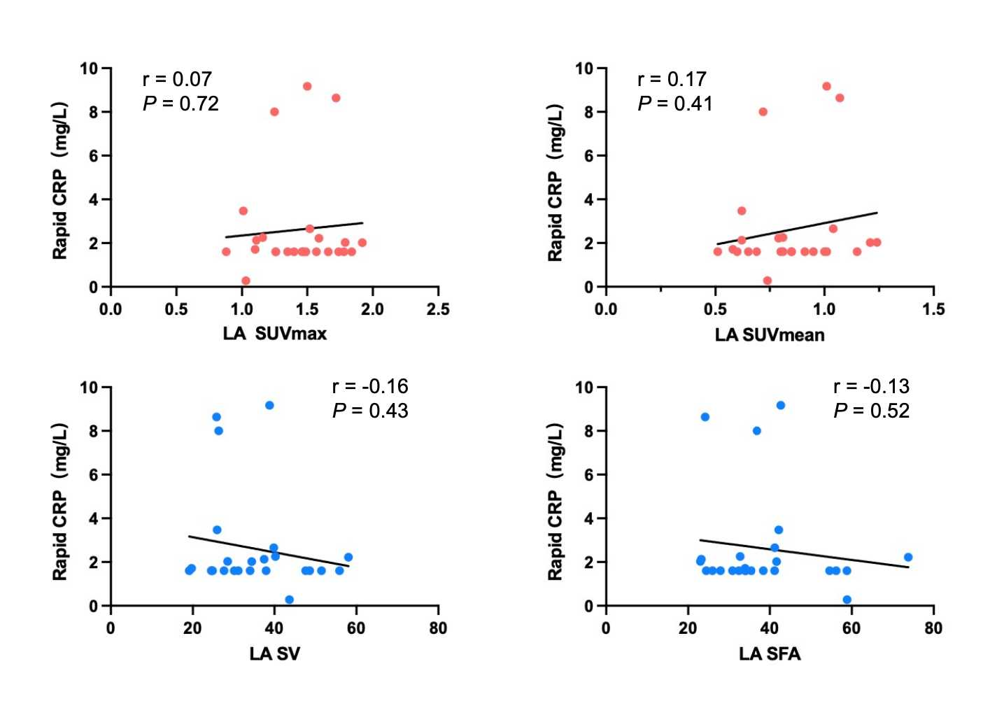
Supplemental Fig. 1. No correlation was showed between serum rapid CRP levels (measured within 2–3 months of PET/CMR imaging and [⁶⁸Ga]Ga-FAPI-04 uptake and burden. Abbreviations: CRP: c-reaction protein; LA: left atrium; LA SV: left atrial surface volume; LA SFA: left atrial surface fibroblast activity.

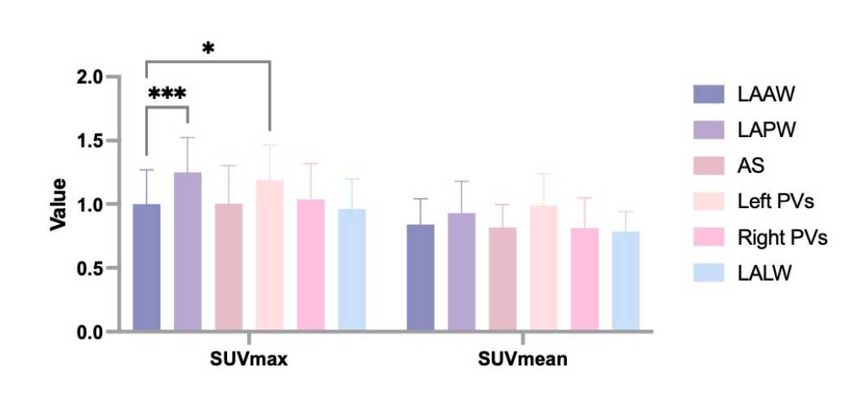
Supplemental Fig. 2 The SUVs in different region of left atrial wall. LAAW: left atrial anterior wall; LAPW: left atrial posterior wall; AS: atrial septum; Left PVs: left pulmonary veins; Right PVs: right pulmonary veins; LALW: left atrial lateral wall.

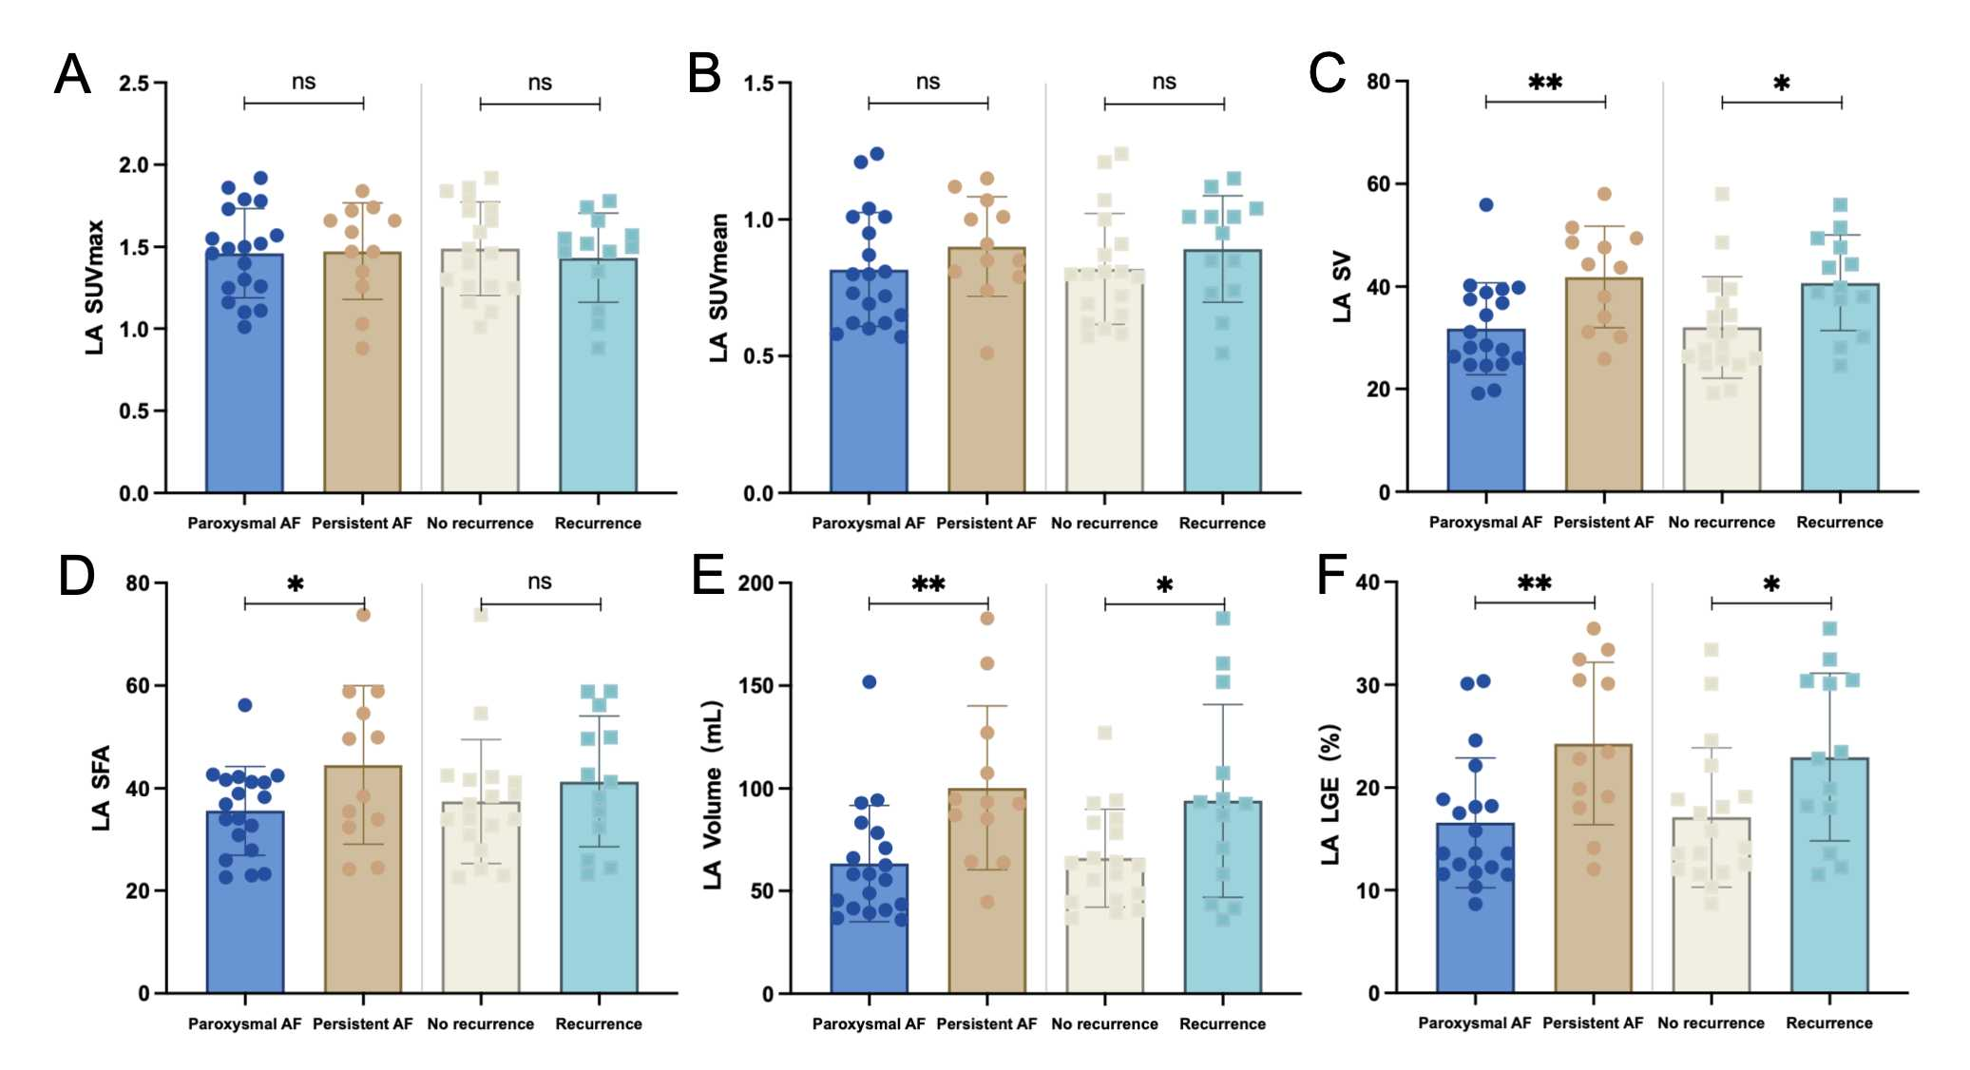
Supplemental Fig. 3 The comparison of PET parameters between different patients. Abbreviations: LA: left atrium; SUV_{max}: maximum standardized uptake value; SUV_{mean}; mean standardized uptake value; SFA: surface fibroblast activity; EAT: epicardial adipose tissue; FA: fibroblast activity.

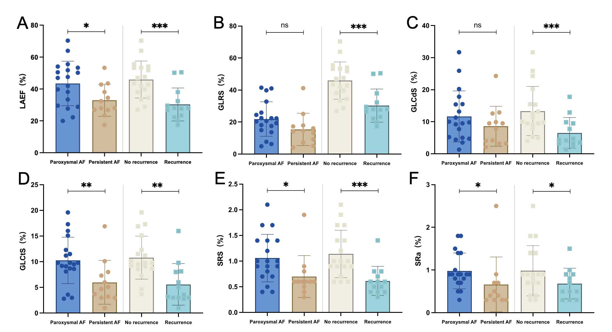
Supplemental Fig. 4 The comparison of left atrial function and strain between different patients. Abbreviations: LAEF: left atrium ejection fraction; SRe: early peak negative strain rate; SRs: peak positive strain rate; GLRS: global longitudinal reservoir strain; GLCdS: global longitudinal conduit strain; GLCtS: global longitudinal contractile strain.

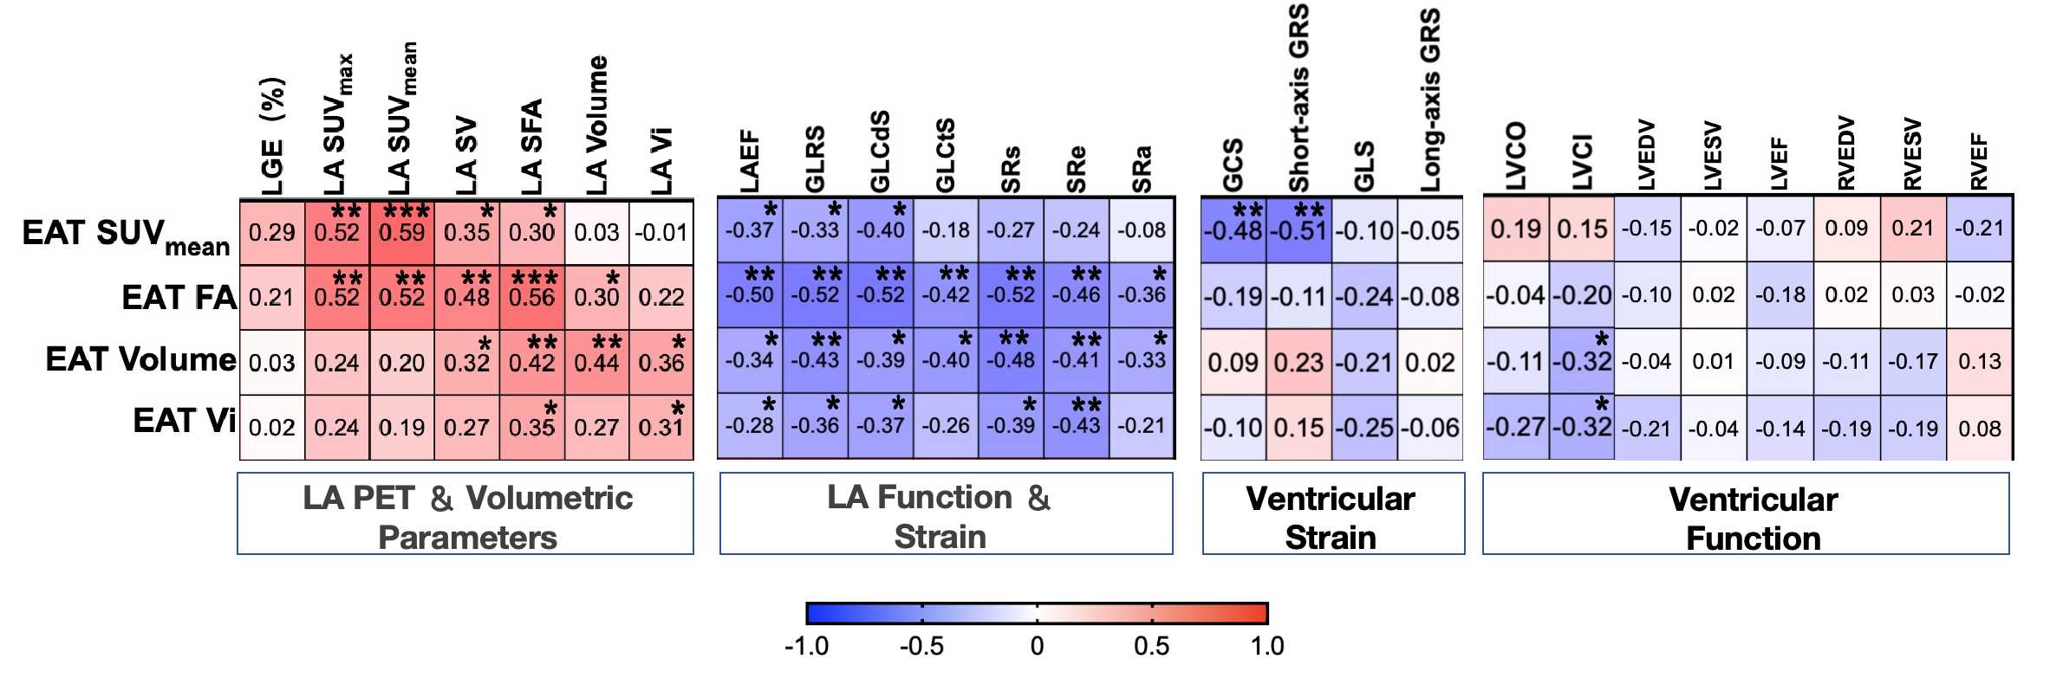
Supplemental Fig. 5 The correlations between EAT parameters and PET/CMR parameters. Abbreviations: EAT: epicardial adipose tissue; EAT Vi: epicardial adipose tissue volume index; EAT FA: epicardial adipose tissue fibroblast activity; LA SFA: left atrial surface fibroblast activity; LASV: left atrial surface volume; LA Vi: left atrium volume index; LAEF: left atrium ejection fraction; GLRS: global longitudinal reservoir strain; GLCdS: global longitudinal conduit strain; GLCtS: global longitudinal contractile strain; SRs: peak positive strain rate; SRe: early peak negative strain rate; SRa: late peak negative strain rate; GCS: global circumferential strain; GRS: global radical strain; GLS: global longitudinal strain; LVEDV: left ventricle end-diastolic volume; LVESV: left ventricle end-systolic volume; LVEF: left ejection fraction; RVEDV: right ventricle end-diastolic volume; RVESV: right ventricle end-systolic volume; RVEF: right ventricle ejection fraction.

Supplemental References
1 Hindricks G, Potpara T, Dagres N et al (2021) 2020 ESC Guidelines for the diagnosis and management of atrial fibrillation developed in collaboration with the European Association for Cardio-Thoracic Surgery (EACTS): The Task Force for the diagnosis and management of atrial fibrillation of the European Society of Cardiology (ESC) Developed with the special contribution of the European Heart Rhythm Association (EHRA) of the ESC. EUROPEAN HEART JOURNAL 42:373-498

